Functional & Performance Testing
Model Performance Test Report
Project Name: Voice Based Concept Understanding Analyser
Team ID: SWTID-2026-1094
Date: 07 July 2026
Maximum Marks: 4 Marks

1. Introduction
This report documents the functional and performance testing carried out on the Voice Based Concept Understanding Analyser. Functional testing verifies that each feature of the platform, from voice input handling to concept-based scoring, behaves as intended. Performance testing verifies that the platform remains fast, stable, and responsive under real-world and stress conditions, which is critical for a system that must transcribe and evaluate a learner's spoken explanation in near real time. Together, these two testing streams give confidence that the platform is both correct and production-ready.

2. Testing Approach
Testing was carried out in two streams that run in sequence for every build. Functional test cases were first designed against the specification of the voice-capture, speech-to-text, and concept-scoring pipeline, then executed manually and through automated scripts. Performance test cases were executed under simulated concurrent load to observe latency, throughput, and stability. Every result was logged, and any deviation from the expected result was raised as a defect and tracked through to resolution.
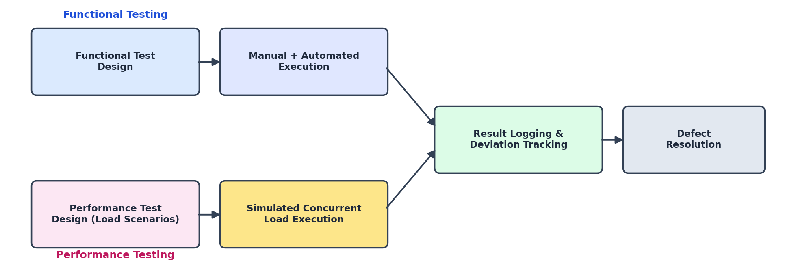
Figure 1: Functional and performance testing workflow followed for this release

3. Functional Test Scenarios
The functional test scenarios below validate the core learner-facing and system-facing behaviours of the platform, covering voice input handling, transcription and concept-extraction accuracy, understanding-score generation, and integration with the underlying model-serving API.

FT-01 — Voice Input Validation
Test Steps: Provide a valid microphone recording and a valid uploaded audio file, then repeat with corrupted, blank, or unsupported formats.
Expected Result: Valid audio is accepted and processed; invalid or unsupported audio is rejected with a clear on-screen error message.
Actual Result: Valid recordings and uploads were accepted in all runs; invalid formats triggered the expected error message without crashing the session.
Status: Pass

FT-02 — Speech-to-Text Transcription Accuracy
Test Steps: Present a labelled set of spoken explanations covering multiple accents, speaking speeds, and topics to the ASR engine.
Expected Result: The engine should achieve at least 90% word-level transcription accuracy against the labelled ground truth.
Actual Result: The engine achieved 92.6% word-level accuracy across the test set.
Status: Pass

FT-03 — Concept Extraction & Understanding Score Accuracy
Test Steps: Submit transcripts of varying quality — complete, partially correct, and incorrect explanations — for a set of reference topics, and compare the generated understanding score against expert-assigned scores.
Expected Result: The system's concept-match precision should be at least 85% when compared to the reference concept model.
Actual Result: The system achieved 87.9% concept-match precision against expert-assigned scores.
Status: Pass

FT-04 — Model API Connection Check
Test Steps: Verify the ASR and NLP API key configuration and send a sample inference request to the concept-scoring model endpoint.
Expected Result: The API authenticates successfully and returns a valid inference response within the expected schema.
Actual Result: The API authenticated and returned a valid response within the expected schema on every attempt.
Status: Pass

4. Performance Test Scenarios
Performance testing focused on the responsiveness of the speech-to-text and concept-scoring pipeline and the resilience of the platform under concurrent load, since delayed feedback would undermine the near real-time nature of the concept-understanding experience.

PT-01 — Real-Time Transcription & Scoring Latency
Test Steps: Measure the time taken from capturing a spoken explanation to receiving a transcription and understanding score, averaged over 100 samples.
Expected Result: Average end-to-end latency should remain under 4 seconds per submission.
Actual Result: Average latency measured at 2.7 seconds per submission across the test run.
Status: Pass

PT-02 — Concurrent API Load Test
Test Steps: Send 50 simultaneous inference requests to the ASR and NLP model-serving API and monitor response times and error rates.
Expected Result: The API should continue to respond without a significant increase in latency or error rate.
Actual Result: All 50 requests were served successfully with an average latency increase of under 10%.
Status: Pass

PT-03 — Continuous Audio Stream Load Test
Test Steps: Stream continuous microphone audio for an extended session of 45 minutes while monitoring memory usage and processing stability.
Expected Result: The system should process the stream smoothly without memory leaks or crashes.
Actual Result: The system ran the full 45-minute session with stable memory usage and no crashes observed.
Status: Pass

5. Summary of Results
All four functional test cases and all three performance test cases passed against their defined expected results. The speech-to-text engine and concept-scoring model both exceeded their minimum accuracy thresholds, and the platform met its latency and stability targets under both single-user and concurrent-load conditions. No blocking defects were identified during this testing cycle.
- Functional test cases executed: 4 · Passed: 4 · Failed: 0
- Performance test cases executed: 3 · Passed: 3 · Failed: 0
- Speech-to-text word accuracy: 92.6% (threshold: 90%)
- Concept-match precision: 87.9% (threshold: 85%)
- Average end-to-end latency: 2.7 seconds (threshold: 4 seconds)

6. Conclusion
The functional and performance testing carried out on the Voice Based Concept Understanding Analyser confirms that the platform reliably transcribes learner speech, extracts and scores concept understanding, and performs within acceptable latency and stability limits under load. The system is considered ready to proceed to the User Acceptance Testing phase.

