Project Design Phase
Problem – Solution Fit Template
Date: 07 July 2026
Team ID: SWTID-2026-1094
Project Name: Voice Based Concept Understanding Analyser
Maximum Marks: 2 Marks
Problem – Solution Fit Template:
Problem-Solution Fit means confirming that a real problem exists for a real customer, and that the solution being built actually solves that problem for them. It helps a team identify behavioural patterns and recognize what will work, and why, before committing to a full build.
Purpose:
- Solve a genuinely felt problem in a way that fits how the target learners already behave.
- Succeed faster and increase adoption by tapping into existing study habits and classroom tools rather than fighting against them.
- Sharpen communication and positioning around the right trigger — the moment a learner realizes they can't explain something out loud.
- Increase trust and touch-points by solving a frequent, costly annoyance: not knowing whether you truly understand a concept until it's too late.
- Understand the existing situation of learners and teachers in order to improve it, rather than designing in a vacuum.
Template:
The canvas below lays out the customer segment, their top problems, the alternatives they use today, and their current behaviour, so the fit between problem and solution can be checked at a glance rather than read row by row in a table.
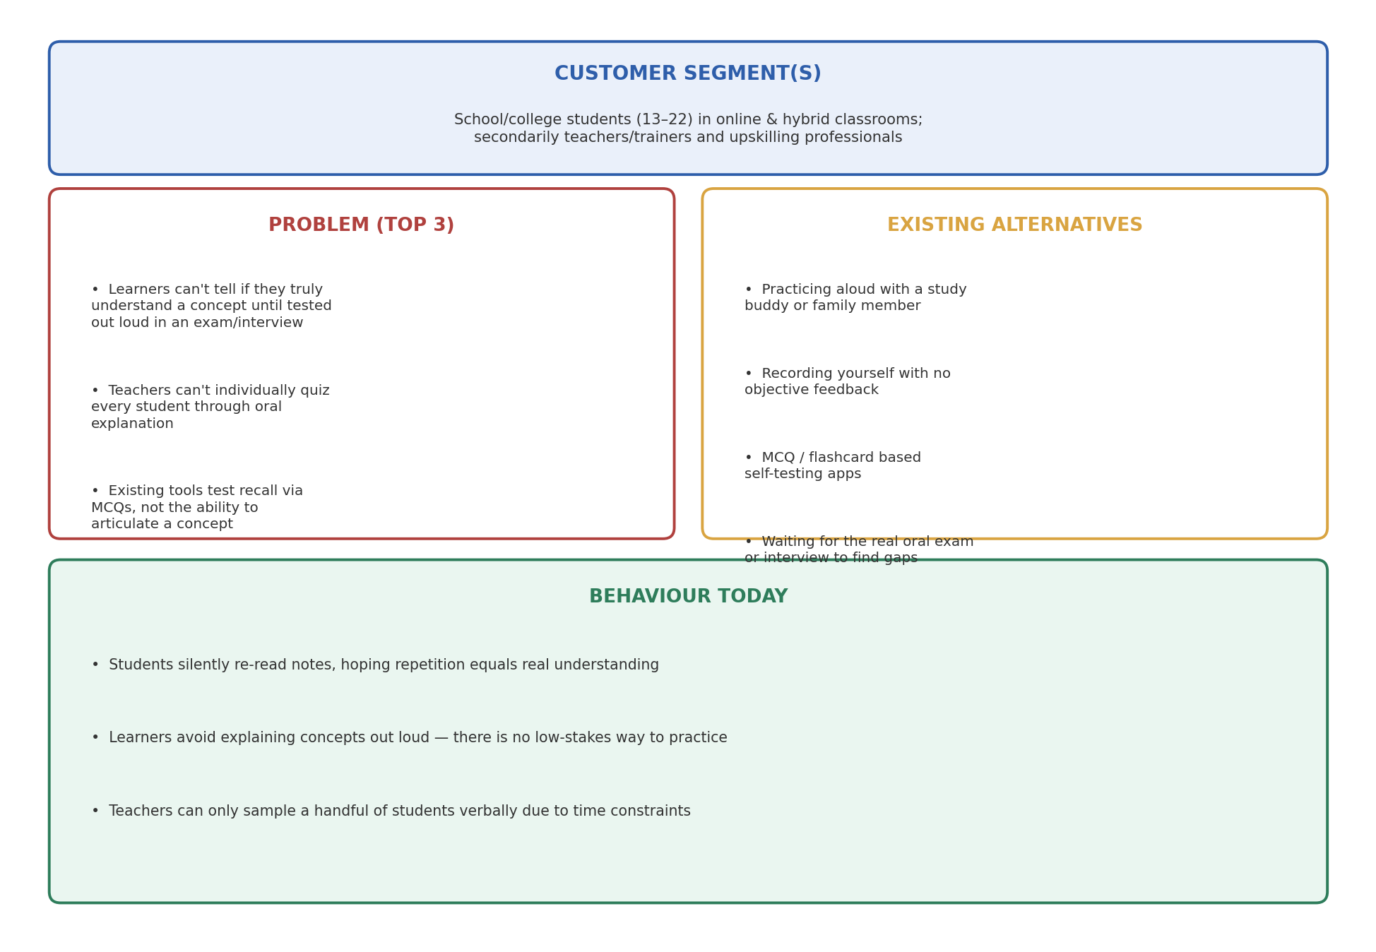
Fig 1: Problem–Solution Fit canvas for the Voice Based Concept Understanding Analyser
Problem – Solution Fit Details:
Customer Segment(s)
School and college students (age 13–22) in online and hybrid classrooms who are preparing for exams, vivas, or interviews; secondarily, teachers and trainers who need to verify class-wide understanding, and working professionals upskilling through online courses.
Problem (Top 3)
- Learners can't tell whether they truly understand a concept until they are forced to explain it out loud in an exam, viva, or interview — by which point it's too late to fix.
- Teachers cannot individually question every student through oral explanation to verify real comprehension, so many misunderstandings go unnoticed.
- Existing adaptive learning tools react only to quiz scores and click patterns, not to how clearly or correctly a learner can articulate the concept in their own words.
Existing Alternatives
- Practicing explanations out loud with a study buddy or family member, with no objective or consistent feedback.
- Recording oneself and re-listening, without any structured scoring of what was actually covered.
- MCQ and flashcard based self-testing apps that check recall, not spoken articulation.
- Waiting until the real oral exam, viva, or interview to discover where the understanding gaps are.
Behaviour Today
- Students silently re-read notes and highlight text, treating repetition as a proxy for real understanding.
- Learners avoid explaining concepts out loud altogether, since there is no private, low-stakes way to practice and get feedback.
- Teachers can only verbally sample a handful of students per class due to time constraints, leaving most understanding gaps invisible until assessment time.

