Project Planning Phase
Project Planning Template (Product Backlog, Sprint Planning, Stories, Story Points)
Date: 07 July 2026
Team ID: SWTID-2026-1094
Project Name: Voice Based Concept Understanding Analyser
Maximum Marks: 5 Marks

1. Project Overview
The Voice Based Concept Understanding Analyser is an application that lets a user explain a concept verbally. The system converts the spoken explanation into text, extracts the key concepts using Natural Language Processing (NLP), and evaluates how well the user understands the topic by comparing it against a reference concept model. The tool then generates an understanding score along with targeted feedback and recommendations, helping students and self-learners identify gaps in their conceptual clarity.

2. System Architecture
The diagram below shows the high-level flow of data through the system, from voice capture to feedback generation.
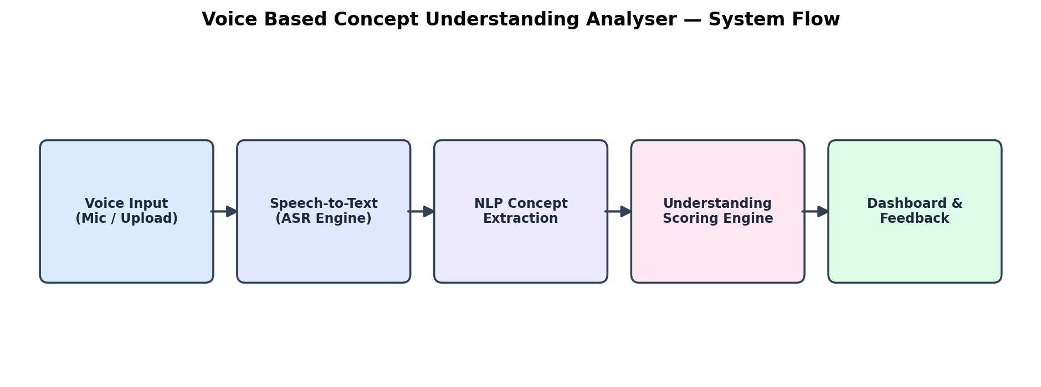

3. Product Backlog, Sprint Schedule, and Estimation (4 Marks)
The backlog below breaks the project into epics and user stories, organised sprint by sprint, with story points, priority, and the owning role noted against each story.

Sprint-1 (07 Jul 2026 – 12 Jul 2026 (6 Days) — 20 Story Points)
Registration
- USN-1 — As a user, I can register for the application by entering my email, password, and confirming my password. (Story Points: 3 | Priority: High | Owner: Backend Dev)
- USN-2 — As a user, I will receive a confirmation email once I have registered for the application. (Story Points: 1 | Priority: High | Owner: Backend Dev)
- USN-3 — As a user, I can register for the application through my Google account for faster sign-up. (Story Points: 2 | Priority: Medium | Owner: Backend Dev)
Login
- USN-4 — As a user, I can log into the application by entering my registered email & password. (Story Points: 2 | Priority: High | Owner: Frontend Dev)
- USN-5 — As a user, I can reset my password if I forget it, via a secure email link. (Story Points: 1 | Priority: Medium | Owner: Backend Dev)
Voice Input
- USN-6 — As a user, I can record my spoken explanation of a concept directly through the microphone. (Story Points: 5 | Priority: High | Owner: Frontend Dev)
- USN-7 — As a user, I can upload a pre-recorded audio file instead of recording live. (Story Points: 3 | Priority: Medium | Owner: Frontend Dev)
- USN-8 — As a user, I can choose from multiple supported languages before recording my explanation. (Story Points: 3 | Priority: Low | Owner: ML/NLP Engineer)

Sprint-2 (14 Jul 2026 – 19 Jul 2026 (6 Days) — 20 Story Points)
Speech-to-Text
- USN-9 — As a system, I can convert the recorded voice input into accurate text using an ASR engine. (Story Points: 5 | Priority: High | Owner: ML/NLP Engineer)
- USN-10 — As a user, I can view the transcribed text and edit it before submitting for analysis. (Story Points: 3 | Priority: Medium | Owner: Frontend Dev)
Concept Extraction
- USN-11 — As a system, I can extract key concepts and keywords from the transcript using NLP techniques. (Story Points: 5 | Priority: High | Owner: ML/NLP Engineer)
- USN-12 — As a system, I can compare the extracted concepts against a reference concept model for the topic. (Story Points: 4 | Priority: High | Owner: ML/NLP Engineer)
- USN-13 — As a user, I can see matched and missing concepts highlighted in my transcript. (Story Points: 3 | Priority: Medium | Owner: Frontend Dev)

Sprint-3 (21 Jul 2026 – 26 Jul 2026 (6 Days) — 20 Story Points)
Scoring Engine
- USN-14 — As a system, I can generate an understanding score based on the percentage of concept coverage. (Story Points: 6 | Priority: High | Owner: ML/NLP Engineer)
- USN-15 — As a system, I can detect misconceptions or incorrect statements within the user's explanation. (Story Points: 5 | Priority: High | Owner: ML/NLP Engineer)
- USN-16 — As a system, I can assign a confidence level to the score using semantic similarity analysis. (Story Points: 4 | Priority: Medium | Owner: ML/NLP Engineer)
Feedback
- USN-17 — As a user, I can receive textual feedback highlighting the gaps in my explanation. (Story Points: 3 | Priority: Medium | Owner: Backend Dev)
- USN-18 — As a user, I can receive suggested topics or resources to improve my understanding. (Story Points: 2 | Priority: Low | Owner: Backend Dev)

Sprint-4 (28 Jul 2026 – 02 Aug 2026 (6 Days) — 20 Story Points)
Dashboard
- USN-19 — As a user, I can view my score history and progress over time as visual charts. (Story Points: 5 | Priority: High | Owner: Frontend Dev)
- USN-20 — As a user, I can export my session report as a downloadable PDF. (Story Points: 4 | Priority: Medium | Owner: Backend Dev)
Recommendation
- USN-21 — As a system, I can recommend practice topics to the user based on identified weak areas. (Story Points: 4 | Priority: Medium | Owner: ML/NLP Engineer)
- USN-22 — As a user, I can compare my performance with peers on an optional leaderboard. (Story Points: 3 | Priority: Low | Owner: Frontend Dev)
Admin
- USN-23 — As an admin, I can manage and update the concept reference models used for scoring. (Story Points: 4 | Priority: Medium | Owner: Backend Dev)

Backlog Summary
- Total epics: Registration, Login, Voice Input, Speech-to-Text, Concept Extraction, Scoring Engine, Feedback, Dashboard, Recommendation, Admin
- Total user stories: 23 (USN-1 to USN-23)
- Total story points planned: 80 (20 per sprint across 4 sprints)
- Team roles involved: Frontend Developer, Backend Developer, ML/NLP Engineer

4. Project Tracker, Velocity & Burndown Chart (4 Marks)
The project runs across four 6-day sprints, each planned for 20 story points. The timeline below shows how the sprints are scheduled:
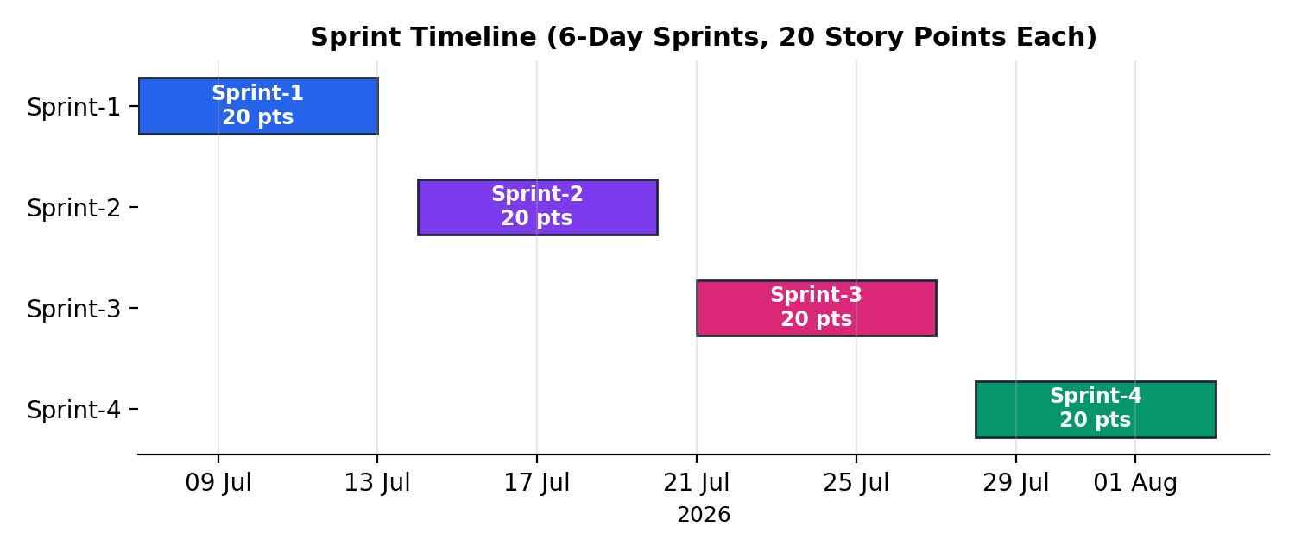

Sprint-wise Tracker
- Sprint-1: 20 story points planned · Start 07 Jul 2026 · Planned end 12 Jul 2026 · 20 points completed · Released 12 Jul 2026
- Sprint-2: 20 story points planned · Start 14 Jul 2026 · Planned end 19 Jul 2026 · in progress
- Sprint-3: 20 story points planned · Start 21 Jul 2026 · Planned end 26 Jul 2026 · not yet started
- Sprint-4: 20 story points planned · Start 28 Jul 2026 · Planned end 02 Aug 2026 · not yet started

Velocity
Velocity measures the average amount of work (in story points) a team completes per sprint or per day. Imagine a 10-day sprint duration with a team velocity of 20 points per sprint. The team's average velocity (AV) per iteration unit (story points per day) is calculated as shown below:

For this project, each sprint runs for 6 working days with a planned velocity of 20 story points per sprint, giving an average velocity of approximately 3.33 story points per day. Sprint-1 was completed on schedule with all 20 planned story points delivered, confirming the estimation was realistic for the team's current capacity.
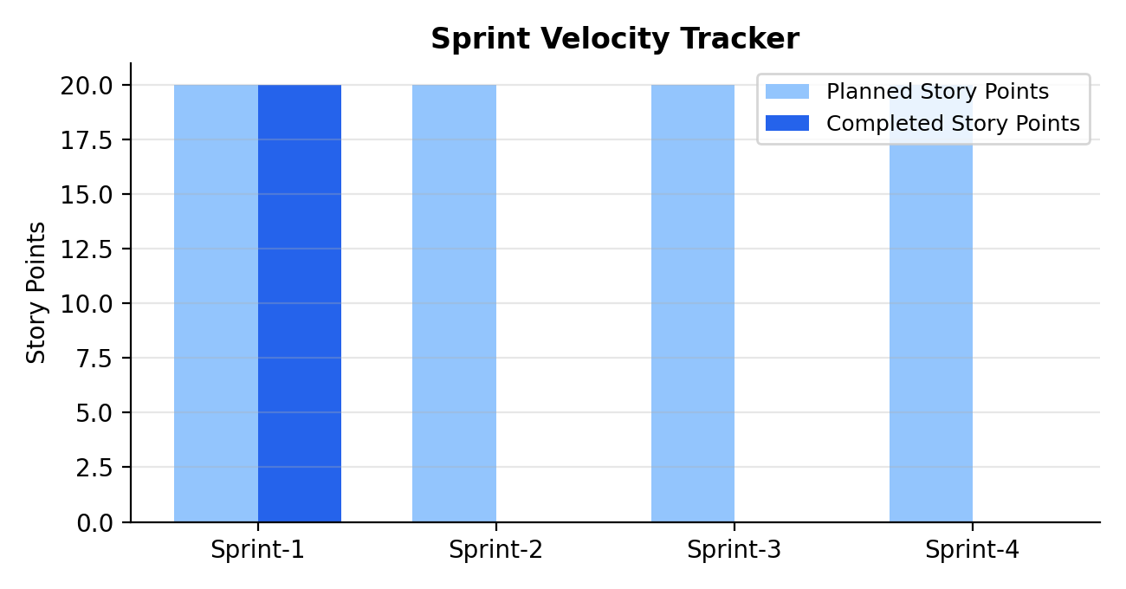

Burndown Chart
A burndown chart is a graphical representation of work remaining versus time. It is widely used in agile software development methodologies such as Scrum, and can be applied to any project with measurable progress over time. The chart below tracks Sprint-1, where the team's actual progress stayed close to the ideal line and all story points were completed by day 6.
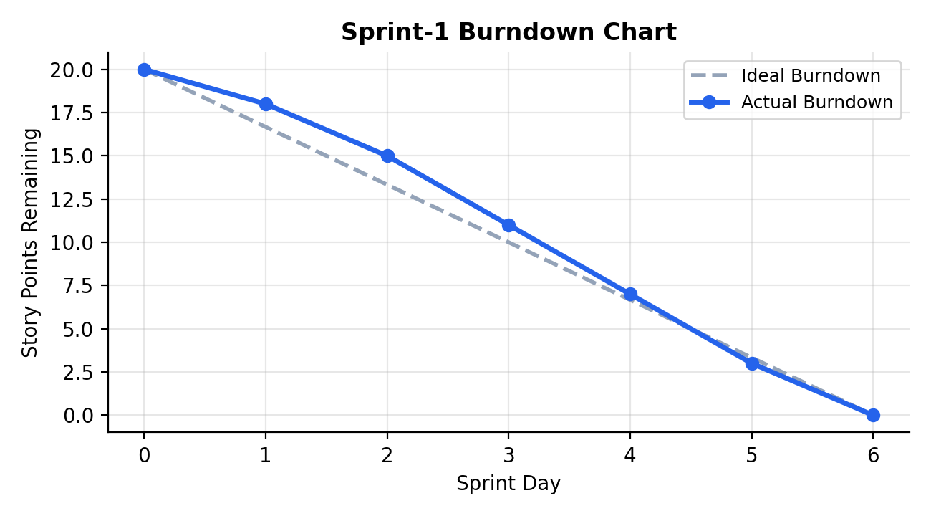
https://www.visual-paradigm.com/scrum/scrum-burndown-chart/
https://www.atlassian.com/agile/tutorials/burndown-charts

5. Risks & Mitigation
- ASR accuracy for accented or noisy audio — mitigate with noise-cancellation preprocessing and a text-edit step before analysis.
- Ambiguity in NLP concept matching — mitigate by maintaining a curated reference concept model per topic and allowing manual review.
- Scope creep from optional features (leaderboard) — timebox to Sprint-4 and de-prioritize if earlier sprints slip.

6. Reference
https://www.visual-paradigm.com/scrum/scrum-burndown-chart/
https://www.atlassian.com/agile/project-management
https://www.atlassian.com/agile/tutorials/how-to-do-scrum-with-jira-software
https://www.atlassian.com/agile/tutorials/epics
https://www.atlassian.com/agile/tutorials/sprints
https://www.atlassian.com/agile/project-management/estimation
https://www.atlassian.com/agile/tutorials/burndown-charts

