Project Design Phase
Proposed Solution Template
Date: 07 July 2026
Team ID: SWTID-2026-1094
Project Name: Voice Based Concept Understanding Analyser
Maximum Marks: 2 Marks
Proposed Solution Template:
The proposed solution is described below across problem framing, the core idea, what makes it new, the impact it creates, how it can be monetized, and how it scales — written out in full rather than compressed into a parameter table, so the reasoning behind each choice stays visible.
1. Problem Statement (Problem to be Solved)
- Learners preparing for exams, interviews, or real-world application of a topic have no reliable way to check whether they can actually explain a concept out loud, only whether they can select the right answer on a quiz.
- Existing e-learning platforms adapt only to quiz scores or time spent, not to how clearly and correctly a learner can articulate an idea, leaving genuine understanding gaps undetected until a high-stakes oral moment.
2. Idea / Solution Description
- A Voice Based Concept Understanding Analyser that captures a learner's spoken explanation of a concept through the microphone, converts it to text, and extracts the concepts and relationships actually expressed.
- Compares the extracted explanation against a reference concept model to produce an objective understanding score, highlighting exactly which sub-concepts were covered well and which were missed, and feeds this into a feedback engine that offers targeted, specific guidance rather than a generic grade.
- Integrates directly into existing LMS platforms and classroom tools rather than requiring a completely separate app, so it fits into a learner's and teacher's existing workflow.
3. Novelty / Uniqueness
- Understanding-focused scoring based on semantic concept coverage, instead of keyword matching or multiple-choice recall.
- Direct plug-in integration into existing classroom tools (LMS, video-conferencing platforms) rather than a standalone platform learners must separately adopt.
- Closed-loop design: the spoken explanation directly drives targeted feedback and follow-up practice, not just an analytics dashboard nobody acts on.
- Privacy-first handling of voice recordings, with encryption, configurable retention, and consent-gated capture suited for learners who may be minors.
4. Social Impact / Customer Satisfaction
- Reduces exam-day and interview-day surprises by catching shallow or incomplete understanding early, while there is still time to fix it.
- Empowers teachers with actionable, per-topic insight into which concepts a class has genuinely understood, instead of guessing from quiz averages.
- Builds learner confidence by giving them a private, low-stakes space to practice explaining out loud without fear of judgment.
- Promotes inclusive learning by supporting students who are reluctant to speak up or ask questions in a live classroom setting.
5. Business Model (Revenue Model)
- SaaS subscription for schools, colleges, and coaching institutes with per-student or per-classroom tiered licensing.
- Freemium model for individual learners and tutors, with a premium tier for detailed analytics and unlimited topic practice.
- B2B2C partnerships with LMS providers (Google Classroom, Moodle, Canvas) for bundled integration.
- Aggregated, anonymized understanding-trend reporting offered as a premium add-on for institutions and corporate training teams.
6. Scalability of the Solution
- Cloud-native microservices architecture (Docker + Kubernetes) scales from a single classroom pilot to institution-wide and multi-institution deployment.
- Multi-language speech and concept models enable expansion across regions and curricula.
- API-first design allows integration with any LMS or video platform for horizontal market growth.
- Modular AI models extend the same core engine to new subjects, corporate upskilling, and interview-preparation use cases.
Solution Diagrams:
1. Solution Concept Overview
The diagram below shows the continuous loop at the heart of the solution: a learner speaks a concept, the AI analyses it and returns an understanding score and feedback, the learner uses that feedback to improve and re-attempt, and the teacher sees aggregated class insight that guides where to offer extra support.
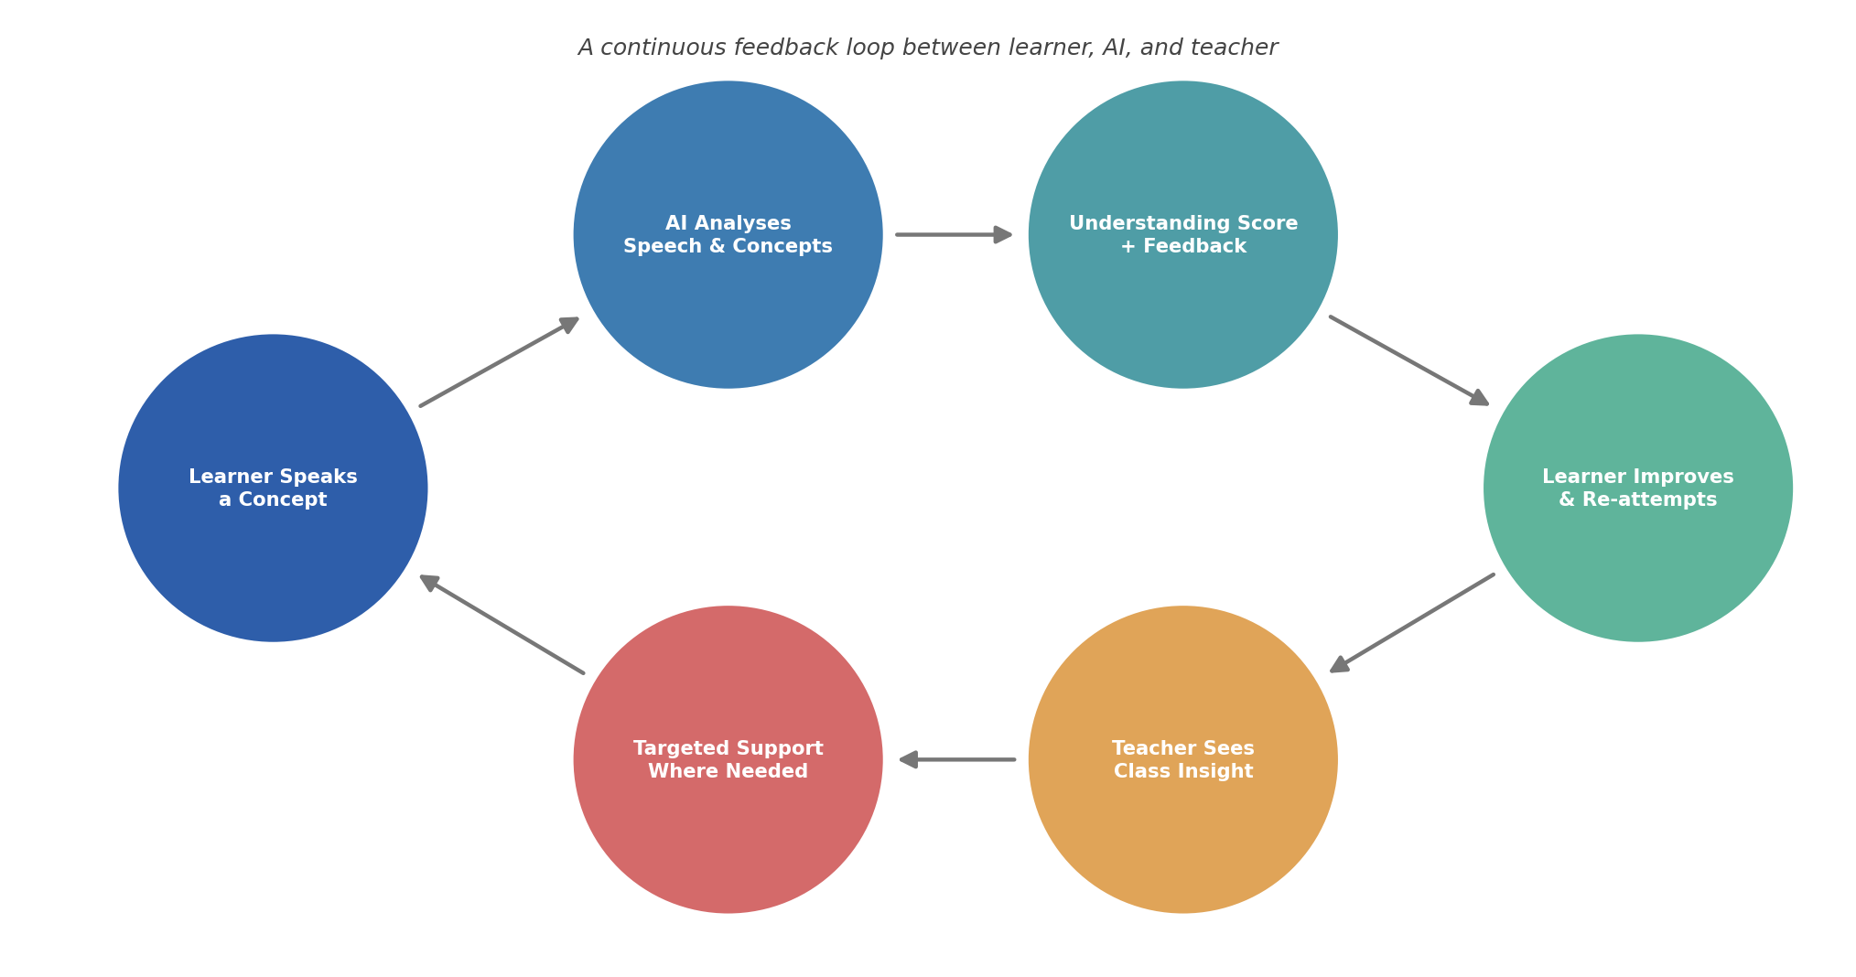
Fig 1: Solution concept overview — the learner–AI–teacher feedback loop
2. Scalability Path
The diagram below shows the intended growth path of the solution, from a single classroom pilot through institution-wide rollout to multi-institution, regional, and eventually national or global scale.
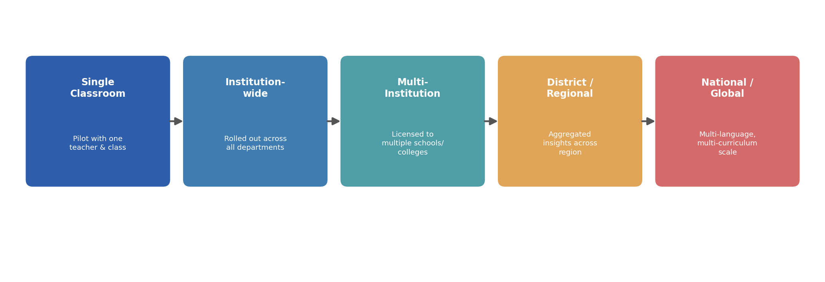
Fig 2: Scalability path from single classroom to national/global reach

