Project Design Phase
Solution Architecture
Project Name: Voice Based Concept Understanding Analyser
Team ID: SWTID-2026-1094
Date: 07 July 2026
Maximum Marks: 4 Marks
1. Introduction
The Voice Based Concept Understanding Analyser is an intelligent educational platform designed to listen to a learner explaining a concept out loud and determine how well they actually understand it, rather than how well they can recall or recognize it. Unlike conventional e-learning systems that treat a correct multiple-choice answer as proof of understanding, this system captures the learner's spoken explanation, converts it to text, extracts the concepts discussed, and compares them against a reference model of the topic to produce an objective understanding score and targeted feedback.
Solution architecture, in the context of this project, is the blueprint that connects the real problem — learners and teachers having no reliable way to verify spoken conceptual understanding — with a concrete technical solution. It defines how the voice capture layer, the speech and language processing layer, the scoring engine, and the feedback layer interact, and it gives project stakeholders a shared, unambiguous picture of what is being built and why.
1.1 Purpose of the Solution Architecture
- Translate the problem of unverifiable spoken understanding into a well-defined, implementable technical design.
- Describe the structure, behaviour, and responsibilities of every module in the system.
- Establish clear interfaces between the voice capture layer, the concept-understanding layer, and the feedback delivery layer.
- Provide a specification that guides development, testing, and future scaling of the platform.
2. Problem Statement
Traditional online learning and self-assessment platforms judge understanding almost entirely through written answers — multiple-choice questions, fill-in-the-blanks, or short text responses. A learner can select the right option or copy the right phrase without ever having to organize and articulate the concept themselves, and the moment that gap is exposed is usually a high-stakes oral exam, viva, or interview, when it is too late to fix. Teachers, meanwhile, cannot individually question every student out loud to check real comprehension, so silent misunderstanding persists undetected until it shows up in poor performance. There is a clear need for a system that can listen to a learner's spoken explanation and translate it into an honest, immediate measure of conceptual understanding.
3. Proposed Solution Overview
The proposed system captures a learner's spoken explanation of a chosen concept through a microphone, converts the audio into text using a speech-to-text engine, and extracts the key concepts, terms, and relationships present in that explanation. These extracted concepts are compared against a reference concept model for the topic — built from trusted source material — using a semantic similarity and coverage model, which produces an understanding score along with the specific sub-concepts that were covered well or missed. Based on this analysis, the system generates targeted feedback, for example highlighting a misunderstood relationship, suggesting the learner revisit a specific sub-topic, or confirming strong understanding and suggesting a harder follow-up concept.
The architecture is designed to be modular, so that the speech-to-text component, the concept-scoring model, and the feedback-generation logic can each be improved or replaced independently without disturbing the rest of the system.
4. High-Level Architecture
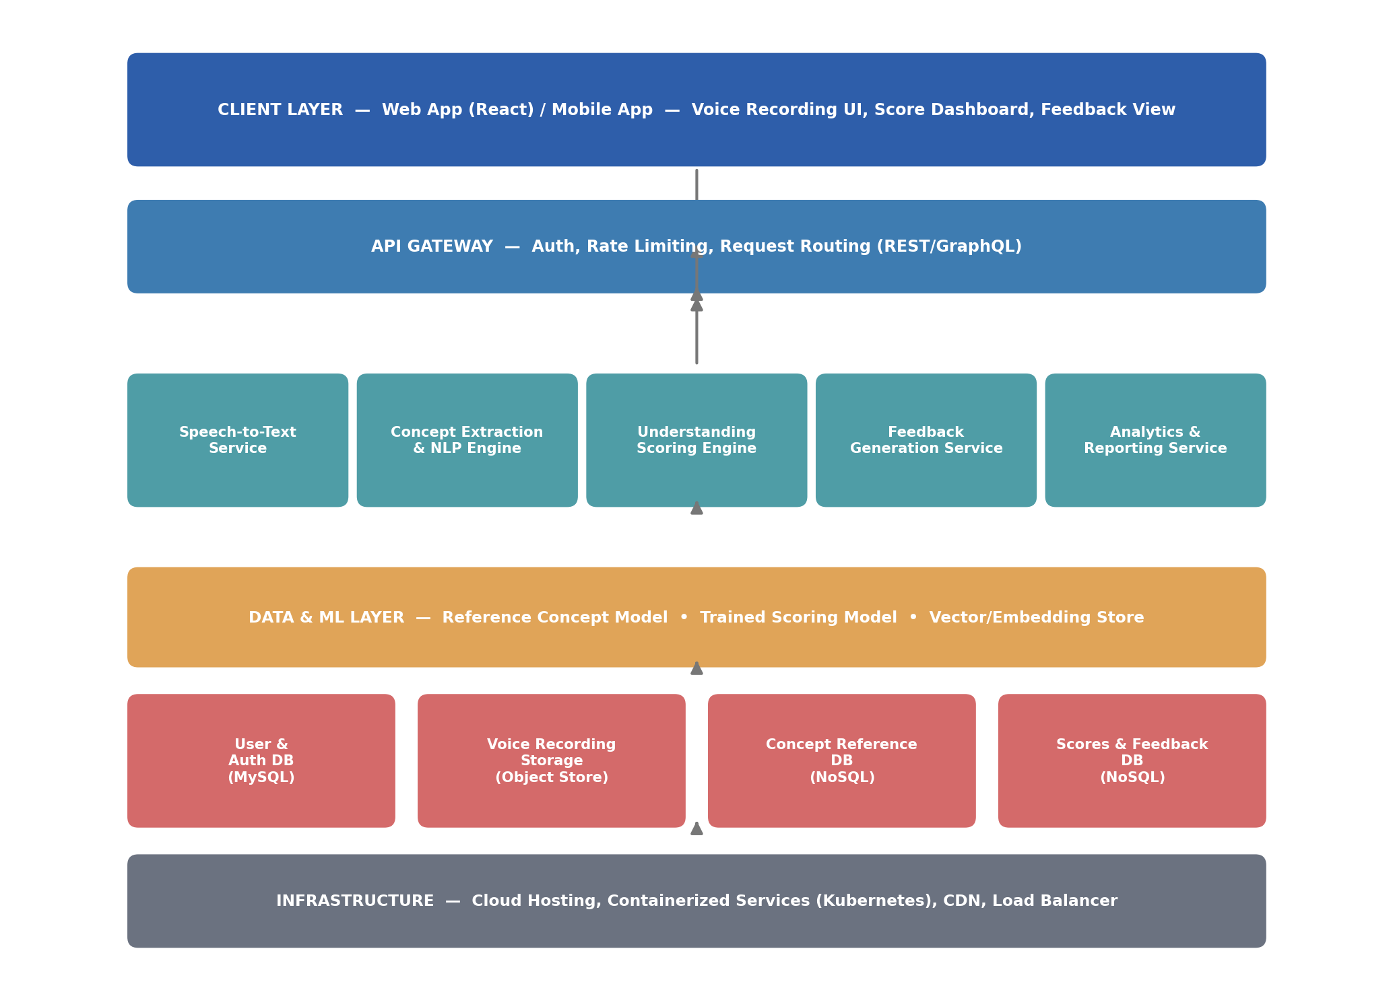
Figure 1: High-level system architecture of the Voice Based Concept Understanding Analyser
The architecture is organised into distinct layers. The learner interacts with the system through a web or mobile client, recording their spoken explanation. The audio moves through an API gateway into a set of application services — speech-to-text conversion, concept extraction, understanding scoring, and feedback generation — each of which draws on a data and machine-learning layer containing the reference concept models and trained scoring model. Results are persisted in dedicated stores and surfaced back to the learner as a score and feedback, and to instructors as class-level analytics.
5. Architecture Layers
5.1 Voice Capture Layer
This layer is responsible for capturing the learner's spoken explanation in a straightforward, low-friction way. It records audio from the device microphone once explicit consent is given, allows the learner to review and re-record before submitting, and uploads the audio securely for processing. Capture is designed to feel like a natural practice session rather than a test, to reduce anxiety and encourage honest explanation.
5.2 Speech-to-Text & Feature Extraction Layer
Raw audio is rarely usable in its original form. This layer applies noise filtering and voice-activity detection, then transcribes the speech into text using a speech-to-text engine. From the transcript, key terms, phrases, and concept relationships are extracted using natural language processing, producing a compact, structured representation of what the learner actually said.
5.3 Concept Understanding Module
The core intelligence of the system lies in this module, which compares the extracted concepts against a reference model of the topic using a semantic similarity and coverage-scoring approach. A transformer-based embedding model represents both the learner's explanation and the reference concepts in the same semantic space, allowing the system to identify which sub-concepts were covered accurately, which were partially covered, and which were missed entirely, and to output an overall understanding score.
5.4 Feedback & Guidance Engine
Once an understanding score and gap analysis are produced, the Feedback & Guidance Engine decides how to respond to the learner. It applies a rule-based and model-assisted policy that maps specific gaps to specific guidance, for instance pointing to a missed sub-concept, suggesting a simpler explanation of a confused relationship, or recommending a related concept once mastery is confirmed. The engine draws on a knowledge base of reference explanations and hints to personalise its response.
5.5 User Interaction and Feedback Layer
This layer presents the score and feedback back to the learner and simultaneously logs the outcome. A feedback and analytics dashboard is made available to instructors, allowing them to review aggregated understanding trends across a class and identify learners or topics that may need additional support. This closes the loop between capturing speech, scoring understanding, and real-world instructional impact.
6. Data Flow Design
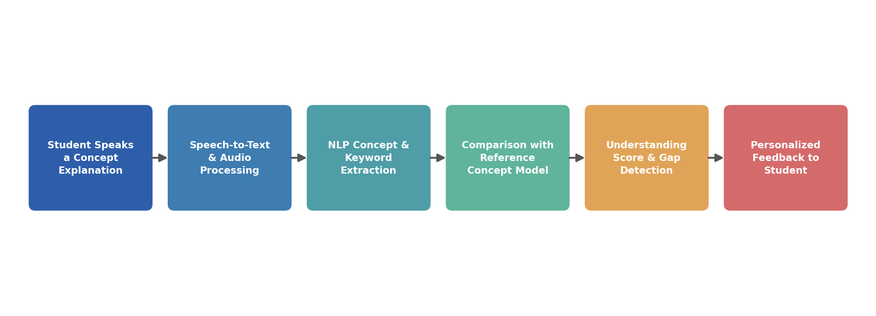
Figure 2: Data flow across the capture, understanding, and feedback pipeline
Data flows through the system in a well-defined sequence. Raw audio from the learner's spoken explanation is first conditioned to remove noise, then transcribed into text. Concepts are extracted from the transcript and compared against the reference concept model, producing an understanding score and a list of covered and missing sub-concepts. This result updates the learner's running understanding profile. The Feedback & Guidance Engine reads this profile to select the most useful response, which is delivered back to the learner, while outcomes are also fed into class-level analytics for instructors.
7. Technology Stack
- Frontend: React based web interface with a lightweight audio-recording module (with a Flutter mobile client for on-the-go practice).
- Backend: Python with FastAPI for serving the speech, concept-extraction, and scoring services.
- Machine Learning: A speech-to-text engine (Whisper / Cloud STT) plus a transformer-based sentence-embedding model for concept similarity scoring.
- Data Storage: PostgreSQL for learner profiles and topic metadata, MongoDB or a vector store for reference concept embeddings and scoring history.
- Deployment: Docker containers orchestrated on a cloud platform such as AWS or Google Cloud.
- Monitoring: A dashboard built with a charting library to visualise understanding trends for instructors.
8. Advantages of the Proposed Architecture
- Modular design allows each layer — speech-to-text, concept scoring, feedback — to be upgraded independently as better models become available.
- Objective, near-real-time scoring gives learners honest insight into their understanding well before a high-stakes exam or interview.
- Semantic concept matching is more reliable than keyword matching, catching correct explanations phrased in the learner's own words.
- Instructor-facing analytics provide actionable insight into class-wide understanding gaps by topic.
- The architecture is scalable and can be extended to new subjects, languages, and assessment formats such as group discussions.
9. Conclusion
The Voice Based Concept Understanding Analyser architecture presented here provides a structured pathway from a learner's spoken explanation to a meaningful, personalised understanding score and feedback. By combining a simple voice-capture experience with a robust speech-to-text and concept-scoring pipeline and an adaptive feedback engine, the system is able to respond to learners in a way that mirrors the honesty of a one-on-one oral check-in with a tutor. This design forms a strong foundation for the subsequent implementation and testing phases of the project.

