Project Design Phase-II
Technology Stack (Architecture & Stack)
Date | 7 July 2026
Team ID | SWTID-2026-1094
Project Name | Voice Based Concept Understanding Analyser
Maximum Marks | 4 Marks

Technical Architecture:
The Voice Based Concept Understanding Analyser follows a layered architecture that takes a learner's spoken explanation of a concept and turns it into a concrete understanding score and personalized feedback. A learner records their explanation through the client application, the audio is converted to text and analysed for concept coverage against a reference model of the topic, and the resulting score, gaps, and feedback are stored and surfaced back to the learner as well as to instructors through class-level analytics.
The architecture is organized into six layers — client, API gateway, application services, data & ML, storage, and infrastructure — so that each concern (capturing voice, converting speech, understanding concepts, scoring, and reporting) can scale and evolve independently. The diagram below shows how these layers connect.
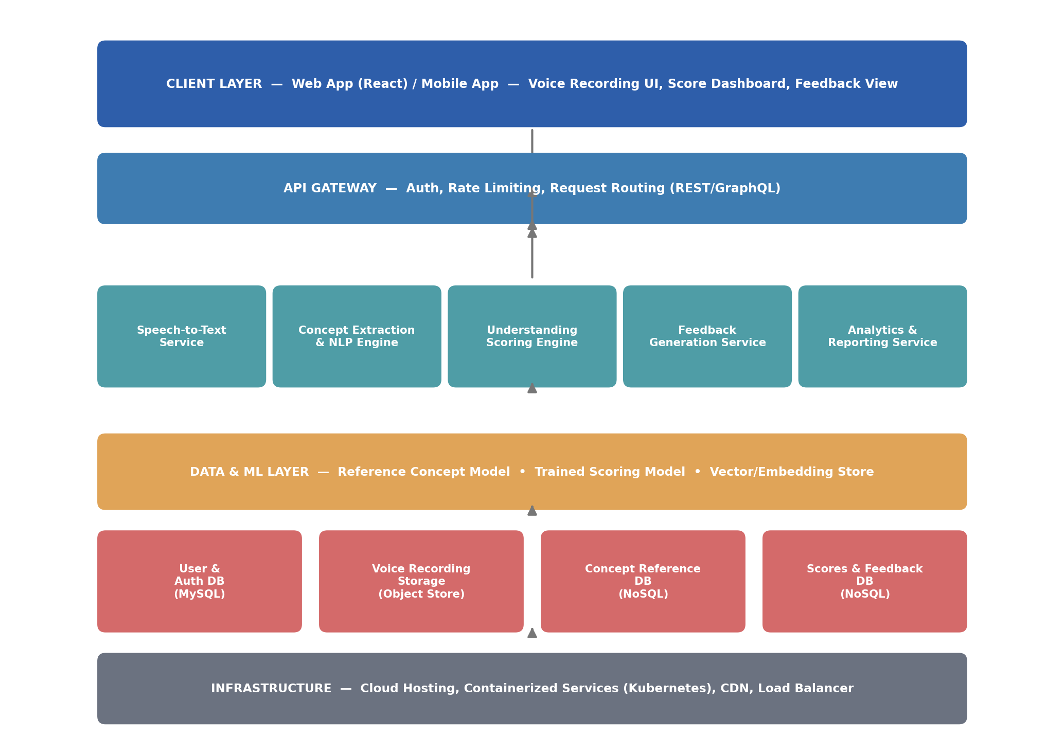
Fig 1: Layered technical architecture of the Voice Based Concept Understanding Analyser
Components & Technologies:
Rather than a flat table, the components are grouped below by the role they play in the system, each with the technology proposed for it.
Client & Interaction
User Interface: How the learner records explanations and views scores — Web app, mobile app, or embedded LMS widget — React JS / Flutter, HTML, CSS, JavaScript
Application Logic
Speech-to-Text Service: Converts the learner's recorded voice explanation into text — Google Cloud Speech-to-Text / IBM Watson STT / Whisper API
Concept Extraction & NLP Engine: Extracts key concepts and terminology from the transcript — spaCy / Transformer-based NLP model (BERT family)
Understanding Scoring Engine: Compares extracted concepts against the reference model and computes an understanding score — Python, scikit-learn / custom similarity model
Feedback Generation Service: Turns the score and gaps into specific, readable feedback for the learner — Python microservice, template + LLM-assisted generation
Data & Storage
Database: Stores user accounts, topics, and session metadata — MySQL / PostgreSQL
Cloud Database: Stores concept-reference models and scoring results at scale — MongoDB Atlas / IBM Cloudant
File / Voice Storage: Stores raw and processed voice recordings — Cloud Object Storage (S3-compatible) or local filesystem in development
External API-1: Speech recognition capability used by the system — Cloud Speech-to-Text API
External API-2: Single sign-on for learner/instructor login — Google/Institutional SSO API
Machine Learning Model: Concept-understanding scoring model trained on reference explanations — Fine-tuned transformer / sentence-embedding similarity model
Infrastructure
Infrastructure (Server / Cloud): Hosting and deployment of the application and services — Docker containers on Kubernetes, deployed on a cloud provider (AWS/GCP/Azure)
Application Characteristics:
Open-Source Frameworks: Frameworks used to build and accelerate development — React JS, Flask/FastAPI, spaCy, scikit-learn
Security Implementations: Access control and data protection measures — JWT-based auth, HTTPS/TLS, encryption at rest, consent-gated microphone access
Scalable Architecture: How the system scales as usage grows — Micro-services architecture with independently scalable speech, scoring, and feedback services
Availability: How the system stays available under load or partial failure — Load-balanced service instances with a fallback "manual review" mode if scoring is unavailable
Performance: Design considerations for responsiveness — Caching of reference concept models, async processing queue for scoring, CDN for static assets

