Acceptance Testing
UAT Execution & Report Submission
Project Name: Voice Based Concept Understanding Analyser
Team ID: SWTID-2026-1094
Date: 07 July 2026
Maximum Marks: 4 Marks

1. Purpose of Document
The purpose of this document is to explain the test coverage and open issues of the Voice Based Concept Understanding Analyser project at the time of release to User Acceptance Testing (UAT). It summarises the defects identified during the testing cycle, how each was resolved, and the overall pass rate of test cases across every functional module, giving stakeholders a clear picture of the product's readiness for real-world use by learners and instructors.

2. Scope of User Acceptance Testing
UAT for this release covered the complete learner-facing workflow, from the moment a learner's spoken explanation is captured through the microphone or an uploaded audio file, through speech-to-text transcription and concept extraction, to the generation of an understanding score and the delivery of feedback and recommendations on the learner-facing dashboard. The scope also included the underlying security and privacy controls that protect learner voice data, the exception handling behaviour of the platform when the microphone or ASR service fails or a connection drops, and the version control mechanism used to track updates to the reference concept models.

3. Defect Analysis
During the testing cycle, a total of 62 defects were logged across four severity levels. Severity 1 defects represent critical issues that block core functionality, while Severity 4 defects represent minor or cosmetic issues. Each defect was triaged and resolved through one of several outcomes: fixed in the codebase, accepted as intended behaviour (by design), identified as a duplicate of an existing report, attributed to an external dependency, found not reproducible, deliberately skipped for this release, or declined as won't fix.
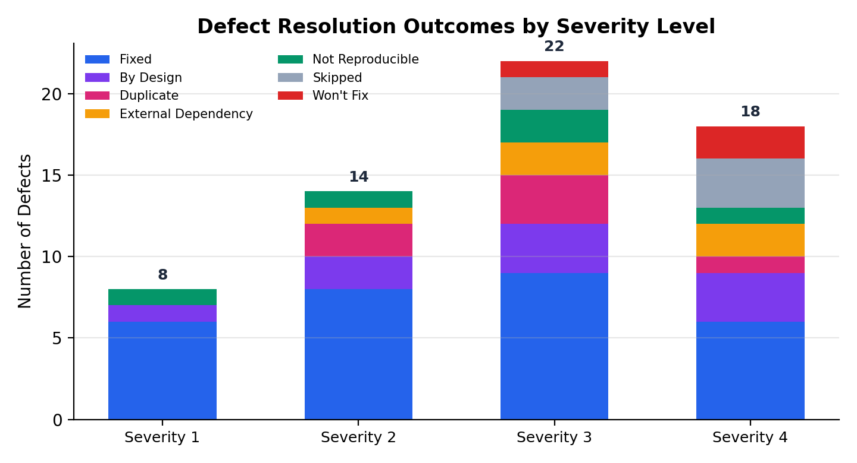
Figure 1: Defect resolution outcomes broken down by severity level
The majority of defects were resolved through direct fixes, accounting for 29 of the 62 logged issues, with the largest concentration of fixes in the lower-severity Severity 2 and Severity 3 categories. Only a small number of Severity 1 defects remained as by-design decisions or not-reproducible items, and none of the unresolved items were assessed as blocking for release. This distribution indicates that the majority of user-impacting issues were addressed before UAT sign-off, while a smaller set of low-priority items were consciously deferred.

4. Test Case Analysis
Test case execution was tracked across every functional module of the platform. The Concept Extraction Module, being responsible for the core NLP comparison against reference concept models, carried the largest share of test cases, while smaller modules such as security and version control were covered with a proportionate but complete set of cases.
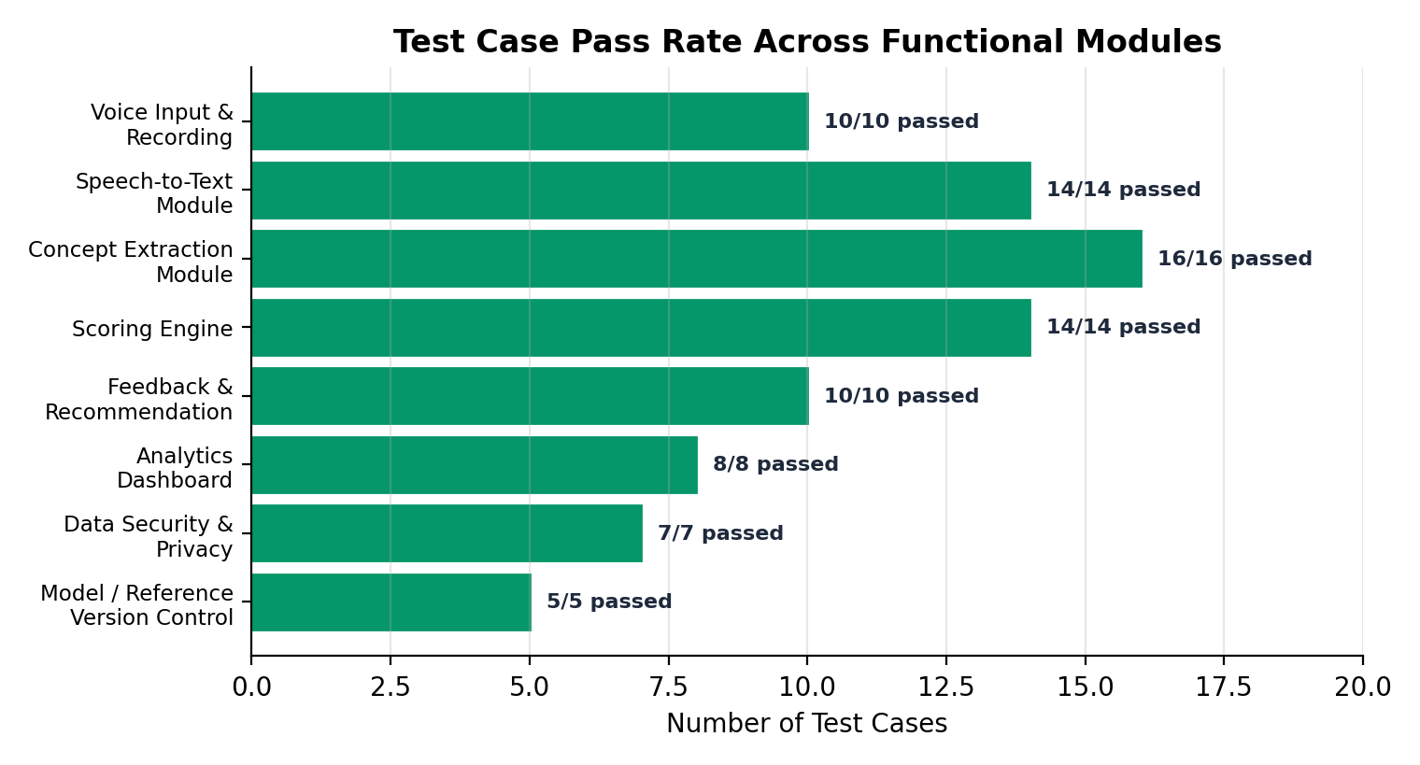
Figure 2: Test case pass rate across functional modules
A total of 84 test cases were executed across the Voice Input & Recording module, Speech-to-Text Module, Concept Extraction Module, Scoring Engine, Feedback and Recommendation logic, Analytics Dashboard, Data Security and Privacy controls, and Model/Reference Version Control. Every test case across all eight modules passed, with zero cases marked as failed or left untested, giving strong confidence that the platform is functionally complete and stable heading into UAT.

5. Key Observations
- The Concept Extraction Module carried the highest test volume and passed all cases, confirming the reliability of the NLP concept-comparison logic.
- The concentration of Severity 1 fixes in the Speech-to-Text Module suggests this area required the most iteration, which is expected for a machine-learning-driven ASR component.
- No Severity 1 defects remain open, which removes any blocking risk ahead of UAT sign-off.
- A small number of Severity 3 and Severity 4 items were skipped or marked won't fix, and should be revisited in a future release cycle.

6. Conclusion and Recommendation
Based on the defect resolution outcomes and the complete pass rate across all test case categories, the Voice Based Concept Understanding Analyser is assessed as ready for User Acceptance Testing. No open Severity 1 issues remain, and all functional modules have demonstrated stable behaviour during test execution. It is recommended that UAT proceed on schedule, with the small set of deferred low-severity items tracked for resolution in a subsequent release.

