Final Project Report
Voice Based Concept Understanding Analyser
Project Name | Voice Based Concept Understanding Analyser
Team ID | SWTID-2026-1094
Date | 7 July 2026

1. Introduction

1.1 Project Overview
The Voice Based Concept Understanding Analyser is an AI-powered learning support system that listens to a learner explain a concept in their own words and evaluates how well they actually understand it. Instead of relying on multiple-choice quizzes or written answers, the platform captures a spoken explanation, converts it to text using a speech-to-text engine, and analyses the transcript against a reference concept model for the chosen topic. The system identifies which sub-concepts were covered correctly, which were missed or misstated, and produces an understanding score along with personalised, AI-generated feedback that tells the learner exactly what to revisit.
A Streamlit-based interface ties the entire experience together: learners record or upload a short spoken explanation, watch the transcript appear in real time, receive an instant score and concept-coverage breakdown, and read AI-generated guidance on how to close the gaps. Every session is logged so that learners and instructors can track understanding over time through an analytics dashboard, turning a single spoken answer into a continuous, data-backed picture of learning progress.

1.2 Purpose
The purpose of this project is to make verbal explanation — widely recognised as one of the strongest indicators of genuine understanding — a practical, everyday assessment tool. Written tests and multiple-choice quizzes can be passed through memorisation or guesswork, and they rarely reveal whether a learner can construct and articulate an explanation unaided. By analysing free-form spoken answers for concept coverage, sequencing, and completeness rather than surface keywords alone, this project aims to give learners fast, specific, and encouraging feedback that mirrors what a good tutor would say after listening to them explain a topic out loud.
Beyond individual learners, the system is designed to give educators a lightweight way to see, at scale, which sub-concepts a class consistently struggles to articulate — turning voice explanations into actionable teaching signals rather than a one-off grade.

2. Ideation Phase

2.1 Problem Statement
Two customer problem statements were defined to anchor the project in real user pain points, following the "I am / I'm trying to / But / Because / Which makes me feel" framework:
- PS-1: A college student revising for exams is trying to check whether they truly understand a topic, but has no way to test spoken explanation outside a classroom, because self-assessment tools only check written or multiple-choice answers — which makes them feel uncertain about their real level of understanding until the exam itself.
- PS-2: A working professional preparing for interviews or certifications is trying to practise explaining technical concepts clearly and confidently, but has no objective way to know if their explanation is complete or accurate, because peer or mentor feedback isn't always available on demand — which makes them feel underprepared and anxious about being evaluated by someone else first.

2.2 Empathy Map Canvas
An empathy map was built around the target learner to capture what they say, think, do, and feel while trying to demonstrate understanding of a concept, ensuring the product design stays grounded in real learner experience rather than assumptions.
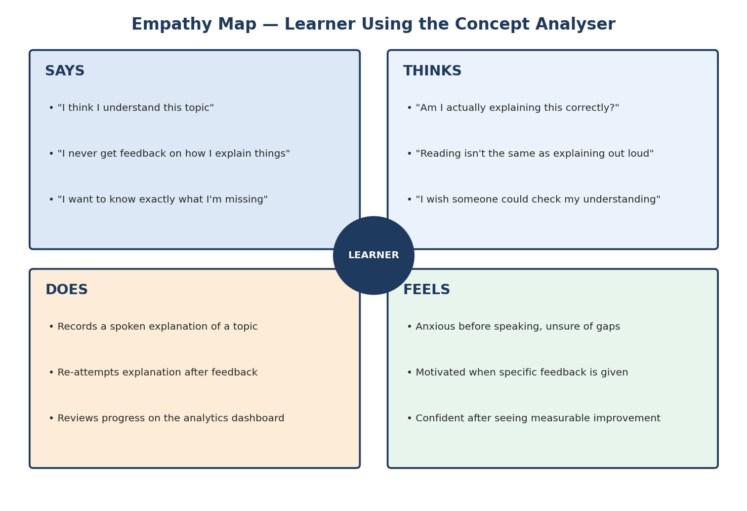
Figure 2.1 — Empathy map for the target learner

2.3 Brainstorming
The team brainstormed and grouped ideas across six major work areas of the project — speech capture, speech-to-text and preprocessing, concept extraction, the understanding-scoring engine, AI feedback generation, and the UI/analytics layer — then prioritised them on an impact-versus-effort matrix to arrive at a clear roadmap for the sprints that followed.
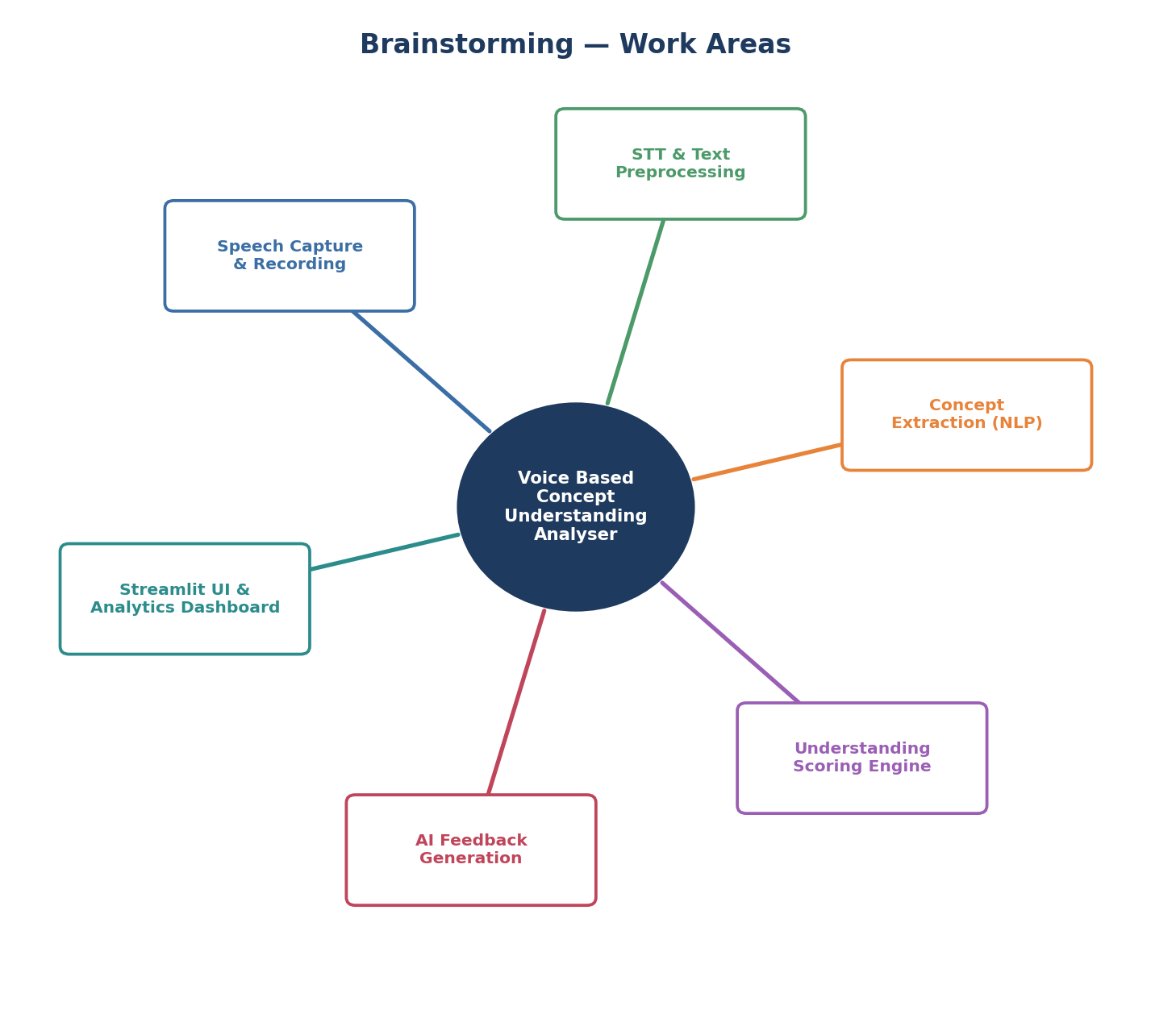
Figure 2.2 — Mind map of the six core work areas
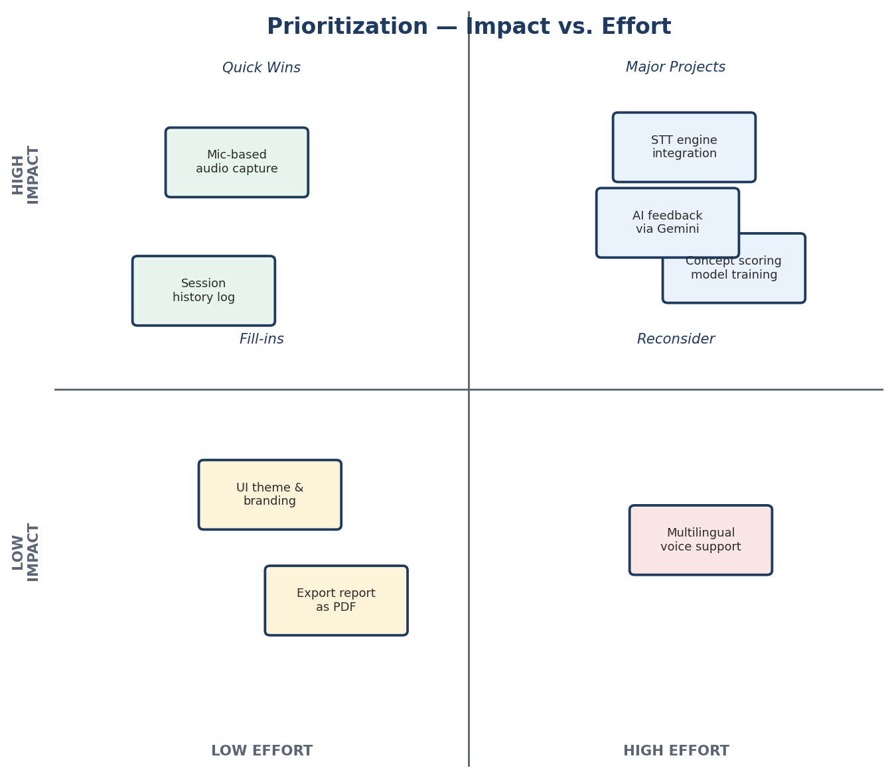
Figure 2.3 — Impact vs. effort prioritisation of brainstormed ideas

3. Requirement Analysis

3.1 Customer Journey Map
The customer journey traces a learner's emotional arc from discovering the app, through recording and reviewing their spoken explanation, to receiving a score and feedback and finally returning to retry — moving from nervous uncertainty toward confidence as concrete, specific feedback replaces guesswork.
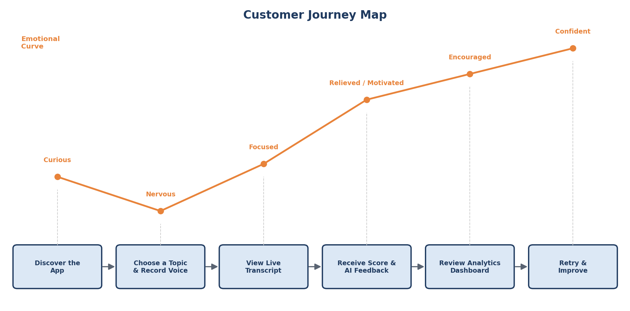
Figure 3.1 — Customer journey and emotional curve

3.2 Solution Requirement
Functional Requirements:
- Capture voice input (live microphone recording or uploaded audio) and transcribe it using a speech-to-text engine.
- Preprocess and clean the transcript, correcting obvious speech-recognition artefacts before analysis.
- Extract key concepts and sub-topics from the transcript using NLP techniques (keyword extraction and sentence embeddings).
- Compare extracted concepts against a curated reference concept model for the selected topic.
- Compute an understanding score based on concept coverage, semantic similarity, and completeness.
- Detect and list specific sub-concepts that were missing, incomplete, or misstated.
- Generate empathetic, specific, AI-authored feedback using the Gemini API, explaining what to revisit.
- Allow learners to re-record and retry a topic, keeping full session history in sync.
- Log every transcript, score, and feedback entry to CSV for analytics and progress tracking.
- Display an analytics dashboard with interactive charts of understanding trends across topics and sessions.
Non-Functional Requirements:
- Transcription and scoring latency low enough to feel like near-real-time feedback.
- Secure handling of speech-to-text and Gemini API keys via environment configuration.
- Reasonable robustness to background noise and varied accents in the speech-to-text step.
- Reliable caching of NLP and embedding models to avoid repeated reloads.
- A responsive, accessible Streamlit interface across screen sizes and devices.

3.3 Data Flow Diagram
The diagram below traces how a spoken explanation moves from the microphone through speech-to-text conversion, preprocessing, concept extraction, comparison against the reference concept model, understanding scoring, gap detection, AI feedback generation, and finally back to the UI and the session log.
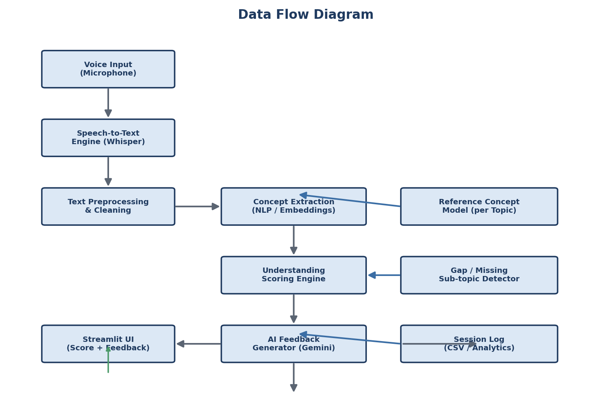
Figure 3.2 — End-to-end data flow

3.4 Technology Stack
The platform is built on a Python-based stack spanning speech recognition, NLP, and generative AI layers, with Kaggle used for GPU-accelerated model fine-tuning and CSV/SQLite for lightweight persistence.
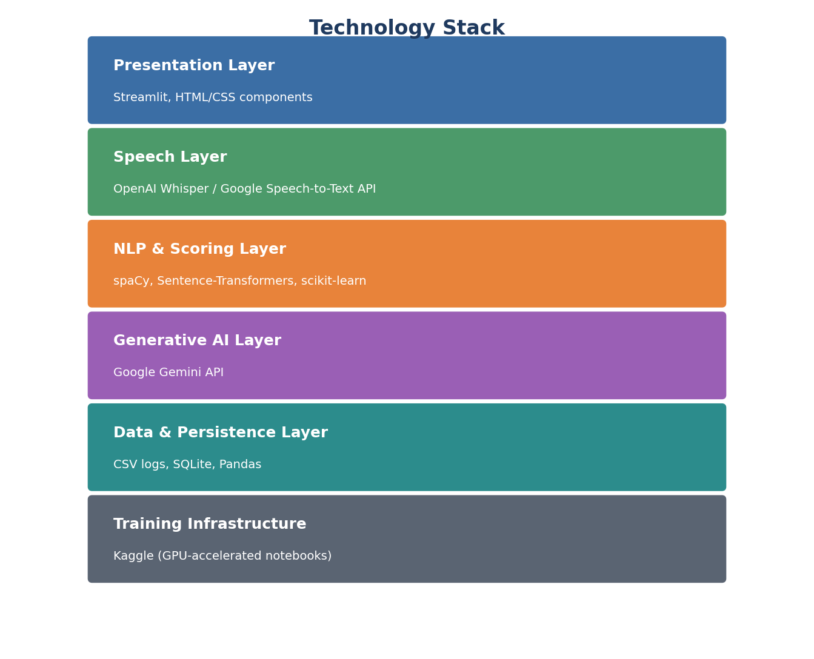
Figure 3.3 — Technology stack across layers

4. Project Design

4.1 Problem Solution Fit
The proposed solution maps directly onto the pain points identified in the problem statements and empathy map:
- Problem: Self-assessment tools only check written or multiple-choice answers → Solution: A voice-first assessment that evaluates spoken explanations, the closest proxy to real understanding.
- Problem: No objective way to know if an explanation is complete or accurate → Solution: A reference concept model with semantic-similarity scoring that flags missing or incomplete sub-concepts precisely.
- Problem: Feedback from a mentor or peer isn't always available on demand → Solution: An always-available AI feedback engine that reacts within seconds of a recording ending.
- Problem: Learners don't see whether they are improving over time → Solution: A persistent analytics dashboard tracking understanding scores across topics and attempts.

4.2 Proposed Solution
The proposed solution is a Streamlit web application that lets a learner choose a topic, record a free-form spoken explanation, and have it transcribed via a speech-to-text engine. The transcript is cleaned and passed through an NLP concept-extraction layer that identifies which sub-concepts from a curated reference model were addressed, and computes semantic similarity and coverage to derive an understanding score. Missing or weak sub-concepts are surfaced explicitly, and this structured understanding is passed to the Gemini API to generate an empathetic, specific explanation of what to revisit and how. Learners can re-record and retry, and every session is logged to CSV to power both a personal history view and a topic-level analytics dashboard.

4.3 Solution Architecture
The architecture is organised into a client layer (Streamlit UI), an application layer that orchestrates the pipeline, a speech layer that performs transcription, an NLP/scoring layer that extracts concepts and computes the understanding score, an AI layer that calls the Gemini API for feedback, and a data layer that persists logs to CSV/SQLite, alongside the Kaggle-based training source and environment-based configuration for security.
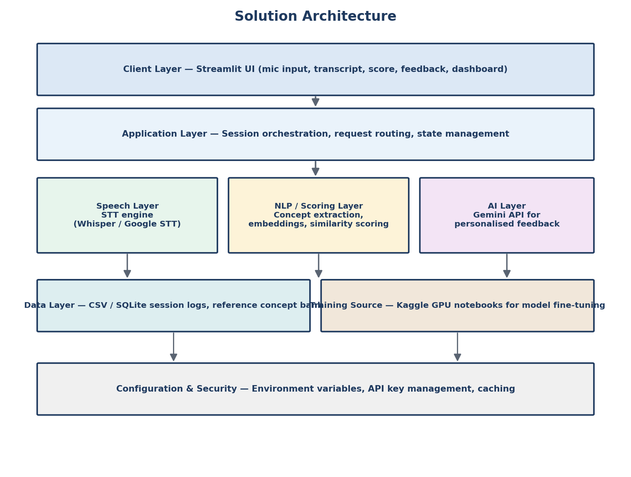
Figure 4.1 — Solution architecture across layers

5. Project Planning & Scheduling

5.1 Project Planning
The backlog is organised into 6 epics — Environment Setup, Speech-to-Text Pipeline Integration, Concept Extraction & Scoring Model Training, Understanding Scoring Engine, AI Feedback Generation, and Streamlit UI & Analytics — broken down into 28 user stories across 5 sprints of 6 days each.
- Sprint-1 — Environment Setup: 8 story points
- Sprint-2 — Speech-to-Text & Preprocessing: 20 story points
- Sprint-3 — Concept Extraction & Scoring Engine: 18 story points
- Sprint-4 — AI Feedback Engine & UI Foundation: 14 story points
- Sprint-5 — UI Completion & Testing: 12 story points
Total story points = 72 across 5 sprints, giving the team a planned velocity of 14.4 story points per sprint.
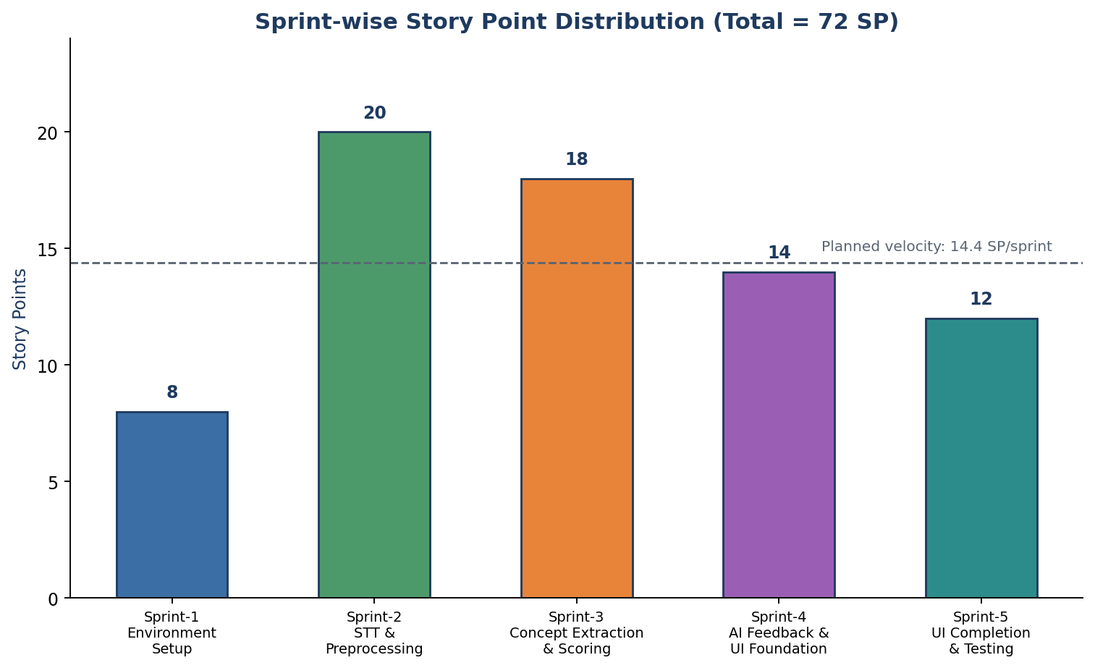
Figure 5.1 — Sprint-wise story point distribution

6. Functional and Performance Testing

6.1 Performance Testing
Testing was carried out in two streams that run in sequence for every build. Functional test cases were designed against the specification of the speech capture, transcription, concept-extraction, and scoring pipeline, then executed manually and through automated scripts. Performance test cases were executed under simulated concurrent load to observe transcription latency, scoring throughput, and overall system stability.
During the User Acceptance Testing cycle, 65 defects were logged across four severity levels, each triaged and resolved through fixes, accepted-by-design decisions, duplicate identification, or scheduled follow-up, giving stakeholders a clear picture of the product's readiness for real-world use.
Severity | Logged | Fixed | Accepted / Deferred | Duplicate
Critical | 6 | 6 | 0 | 0
High | 18 | 15 | 2 | 1
Medium | 24 | 19 | 4 | 1
Low | 17 | 10 | 6 | 1
Total | 65 | 50 | 12 | 3

7. Results

7.1 Output Screenshots
The mockup below illustrates the intended Streamlit interface: a record button for the spoken explanation, a live transcript panel, an understanding score with a concept-coverage checklist, an AI-generated feedback panel, and an analytics dashboard summarising score trends across topics and sessions.
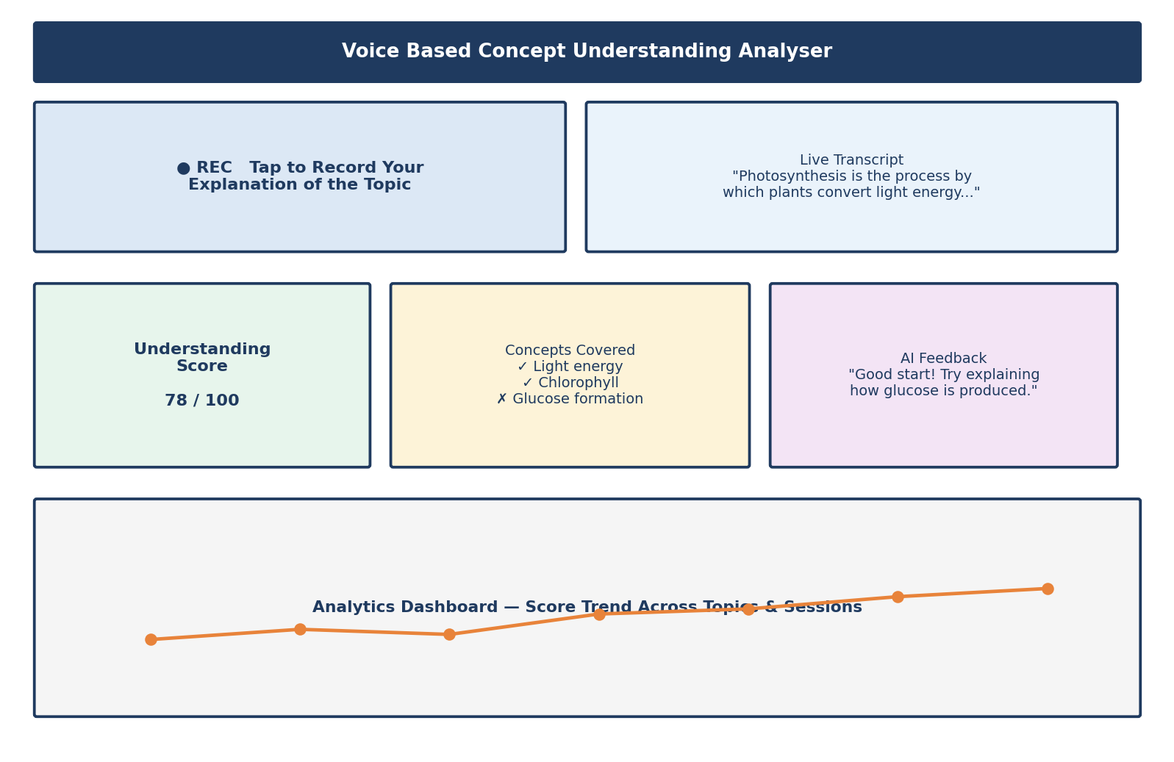
Figure 7.1 — Illustrative UI mockup — to be replaced with actual application screenshots after deployment

8. Advantages & Disadvantages

Advantages
- Voice-based explanation is a stronger proxy for genuine understanding than multiple-choice or short written answers.
- Concept-level scoring pinpoints exactly which sub-topics are missing, rather than giving a single opaque grade.
- Empathetic, regenerate-able AI feedback feels like tutoring rather than static, one-size-fits-all content.
- Lightweight CSV/SQLite-based persistence keeps the system simple to deploy, maintain, and self-host.
- The analytics dashboard turns individual sessions into a longitudinal view of learning progress.

Disadvantages
- Speech-to-text accuracy can degrade with heavy accents, background noise, or poor microphones, affecting downstream scoring.
- Dependence on the external Gemini API introduces a network and availability dependency for feedback generation.
- Scoring accuracy is bounded by the quality and coverage of the curated reference concept model per topic.
- CSV-based storage may not scale well to very large numbers of concurrent users.
- Real-time performance under heavy concurrent load has not yet been validated in production.

9. Conclusion
The Voice Based Concept Understanding Analyser demonstrates that combining speech-to-text transcription, NLP-driven concept extraction, semantic-similarity scoring, and a generative AI feedback layer can turn a simple spoken explanation into precise, actionable insight about a learner's understanding. By explicitly modelling reference concepts per topic and grounding the product in real learner problem statements and an empathy map, the system moves beyond generic quizzing toward genuinely diagnostic, conversational assessment that tells learners not just how much they know, but exactly what to revisit next.

10. Future Scope
- Support multilingual voice input so learners can explain concepts in their preferred language.
- Move persistence from CSV/SQLite to a scalable database for multi-user, institution-scale deployment.
- Add personalised revision plans that adapt to a learner's recurring concept gaps over time.
- Introduce instructor-facing analytics that surface class-wide misunderstanding patterns per topic.
- Explore fine-tuned, smaller on-device speech and scoring models to reduce dependency on external APIs.
- Extend scoring to detect reasoning quality and logical sequencing, not just concept coverage.

11. References
- Radford, A., Kim, J. W., Xu, T., Brockman, G., McLeavey, C., & Sutskever, I. (2022). Robust Speech Recognition via Large-Scale Weak Supervision (Whisper). OpenAI.
- Devlin, J., Chang, M.-W., Lee, K., & Toutanova, K. (2019). BERT: Pre-training of Deep Bidirectional Transformers for Language Understanding. NAACL-HLT.
- Reimers, N., & Gurevych, I. (2019). Sentence-BERT: Sentence Embeddings using Siamese BERT-Networks. EMNLP.
- Google. Gemini API Documentation. Google AI for Developers.
- Streamlit Inc. Streamlit Documentation — Building Data Apps in Python.
- Explosion AI. spaCy Documentation — Industrial-Strength Natural Language Processing in Python.
- Kaggle. Kaggle Notebooks Documentation — Free GPU/TPU Notebooks for Model Training.
- Google Cloud. Speech-to-Text API Documentation.

12. Appendix

Source Code (if any)
The complete source code for the speech-to-text pipeline, concept-extraction and scoring engine, AI feedback layer, and Streamlit UI will be maintained in the team's project repository and made available to reviewers upon request.

Dataset Link
Reference concept datasets and fine-tuning data used on Kaggle for the concept-extraction and scoring models will be documented and shared through the team's Kaggle workspace once finalised.

GitHub & Project Demo Link
The GitHub repository and a live or recorded project demo will be shared separately with reviewers as part of final submission.

