1. Here is the start of the application:

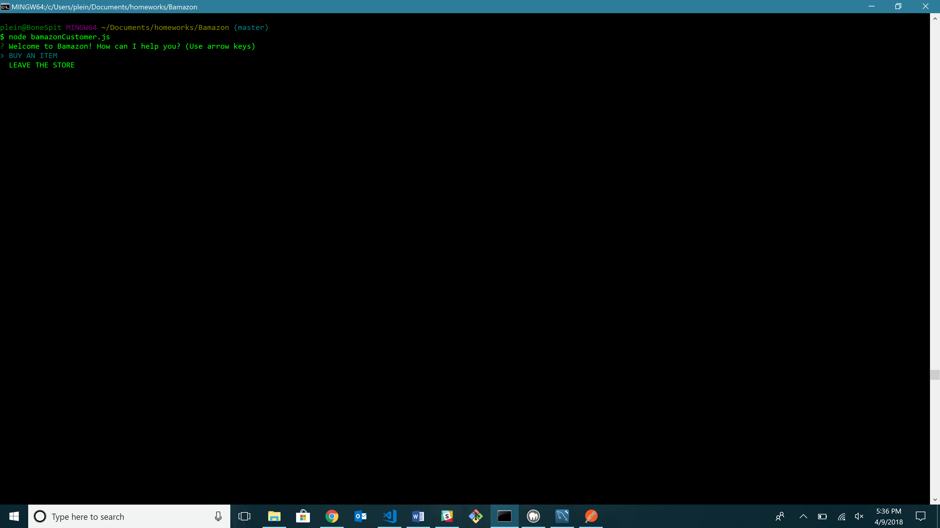

1. Here is what displays if “LEAVE THE STORE” is selected:

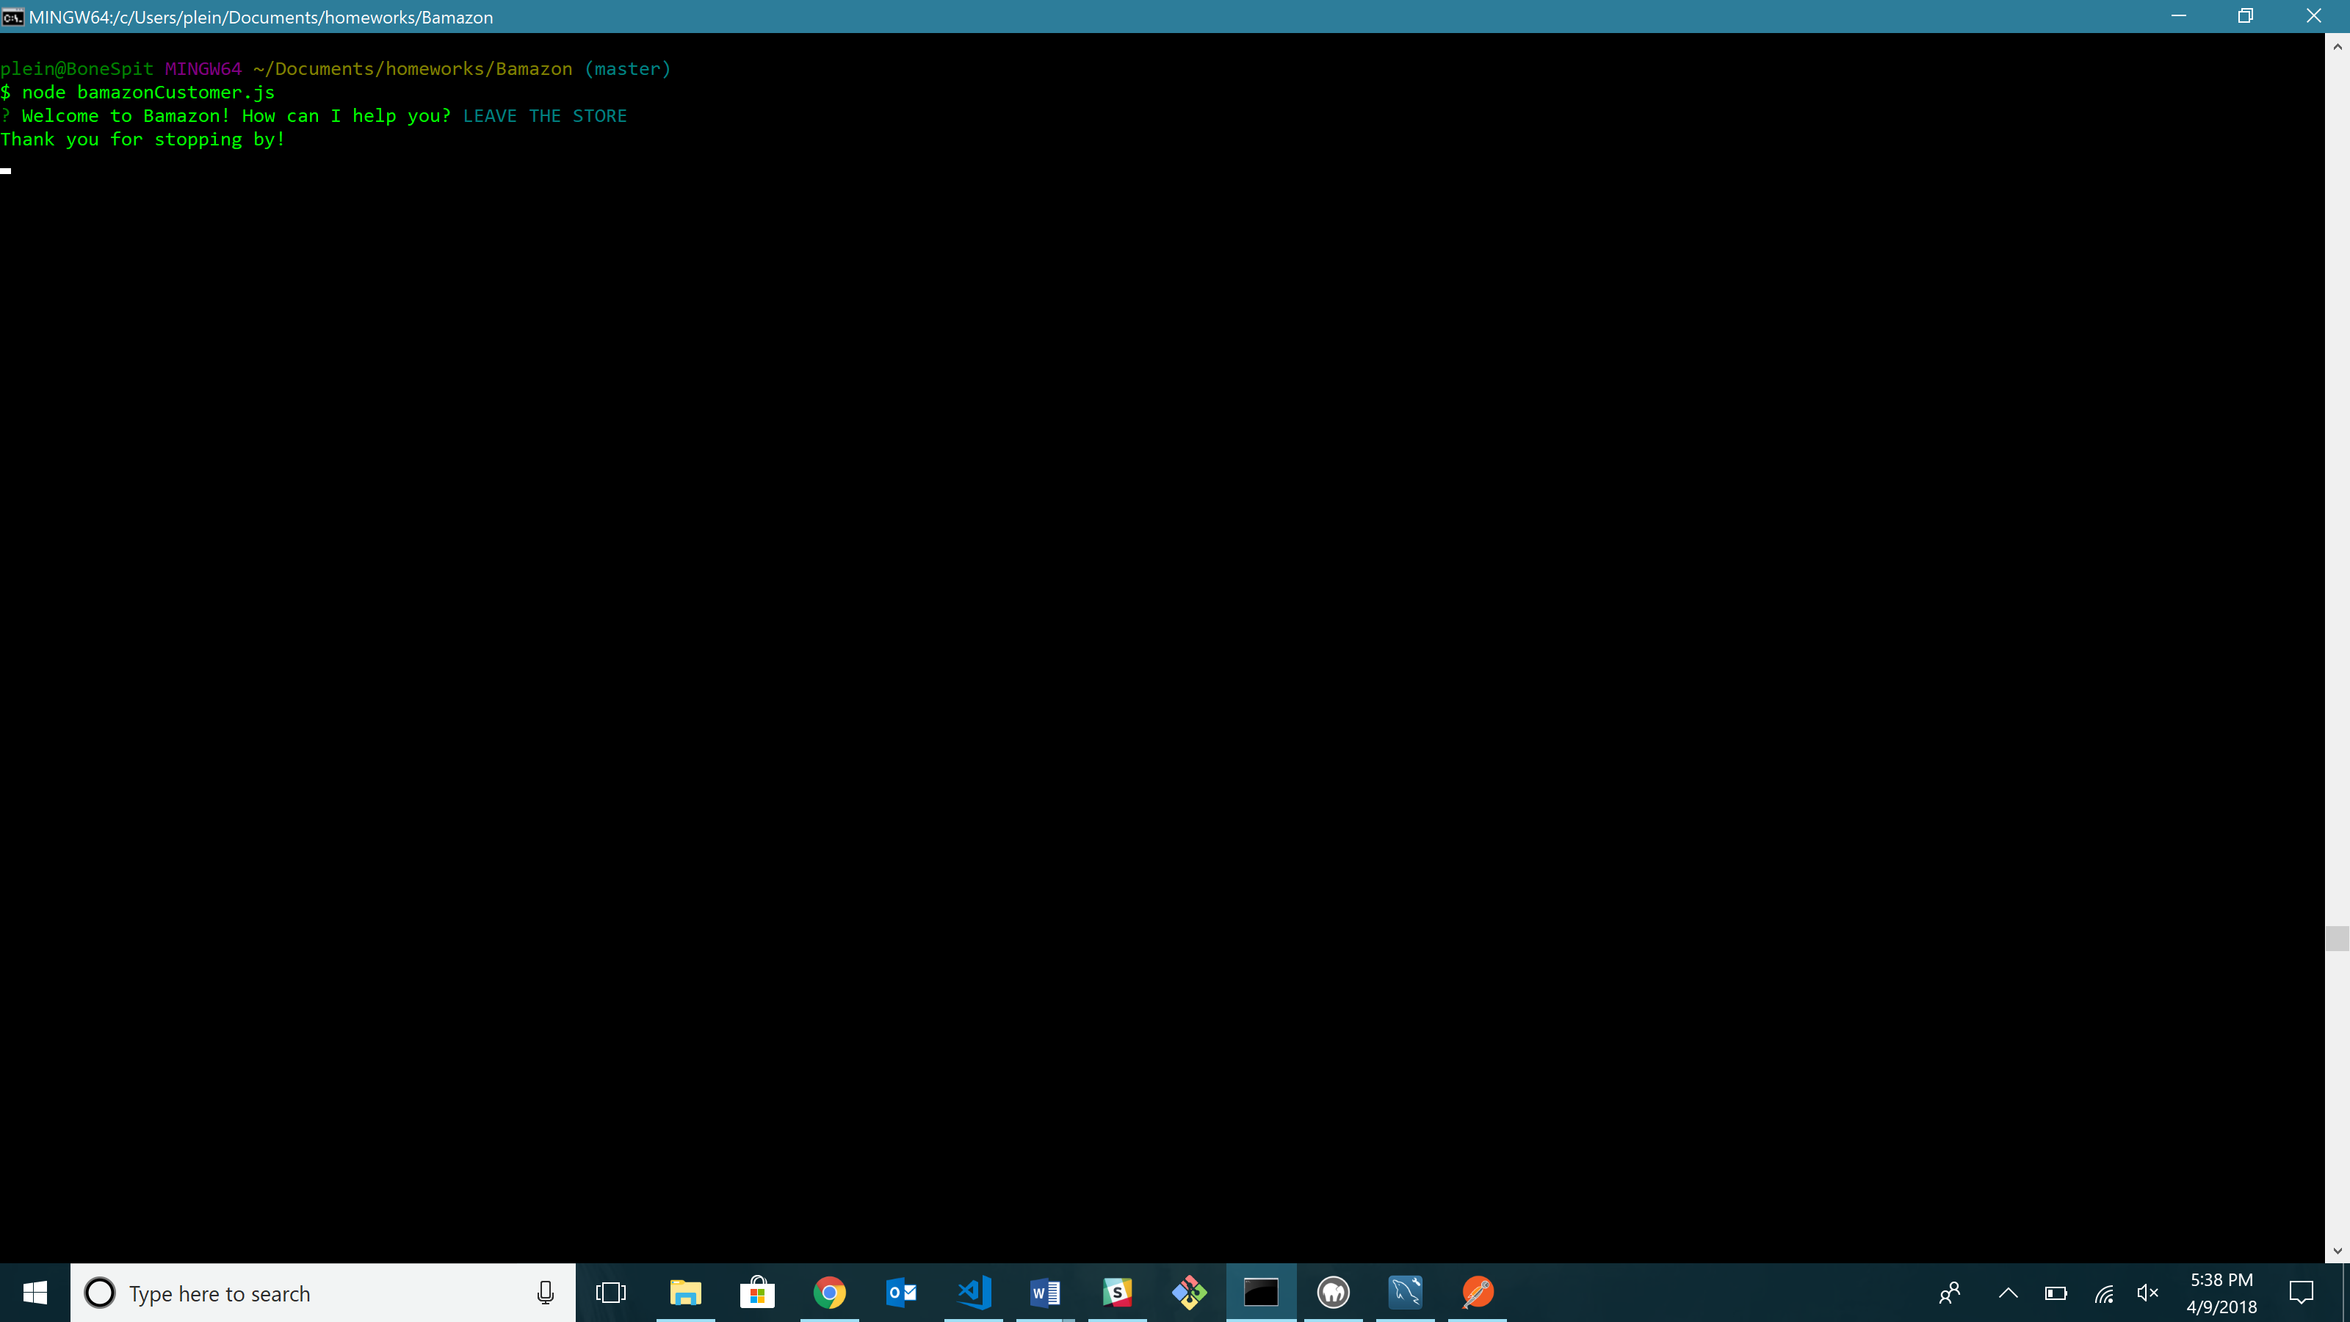

1. Here is what displays if “BUY AN ITEM” is selected:

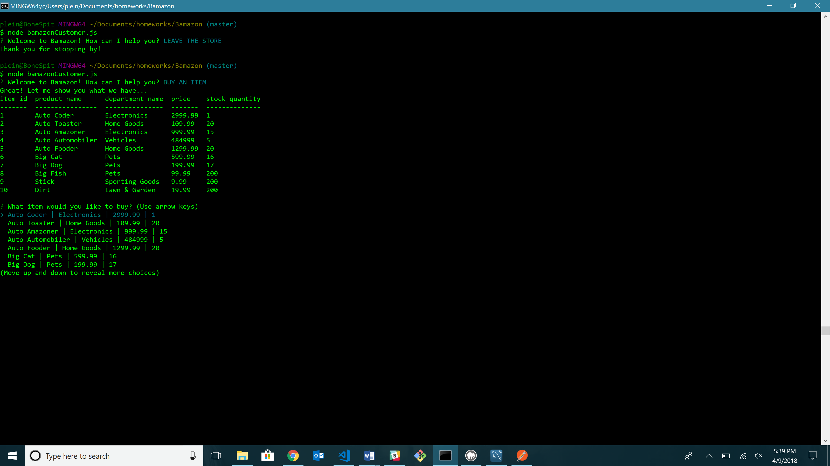

1. Here is what happens when an item is selected: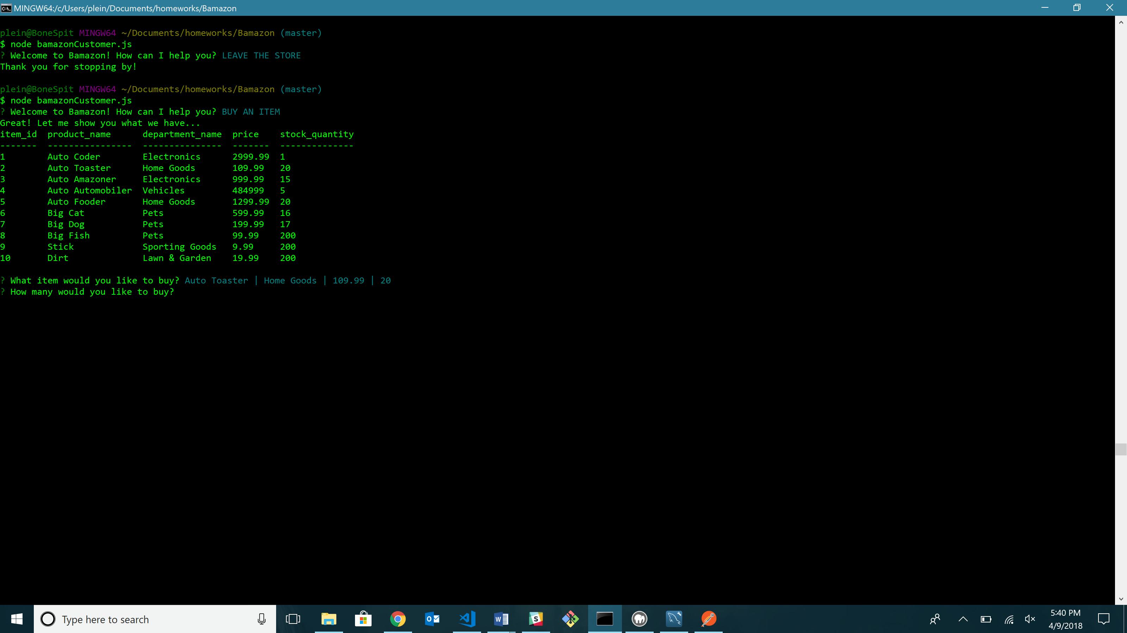
2. Here is what happens when a quantity is chosen (error occurs):

