**Costco Project Handover**

**File Structure:**

1. **HTML files**
   1. **Index.html**
   2. **Account Pages**
      1. Account.html
      2. Orders.html
      3. Order-detail.html
      4. Orders-empty.html
      5. Prescription-empty.html
      6. Prescriptions.html
   3. **Product Pages**
      1. Favorites.html
      2. Favorites-empty.html
      3. Listing.html
      4. Prod-detail.html
   4. **VTO Pages**
      1. Vto-landing-noscan.html
      2. Vto-landing-postscan.html
2. **Assets Folder**
   1. **Css**
      1. Style.css
   2. **Dist**
      1. Css
      2. Style.css
   3. **Fonts**
   4. **Icon**
   5. **Img**
   6. **Js**
      1. Scripts.js
3. **SCSS**
   1. **General Styles**
      1. style.scss
      2. _reset.scss
      3. _variable.scss
      4. _standard.scss
      5. _home.scss
      6. _header.scss
      7. _footer.scss
   2. **Account Styles**
      1. _account.scss
      2. _order.scss
      3. _order-detail.scss
      4. _presc.scss
   3. **Product Styles**
      1. _listing.scss
      2. _detail.scss
      3. _fav.scss
   4. **VTO Styles**
      1. _vto.scss
4. **Gulpfile.js**
5. **Package.json**
6. **Package-lock.json**

**Dev Installation:**

In console or command prompt, change directory to the project path e.g ***‘/e/costco/dev’*** and run command ***‘npm install’.*** It will install all the dev dependencies and will install all the node modules needed for the project.

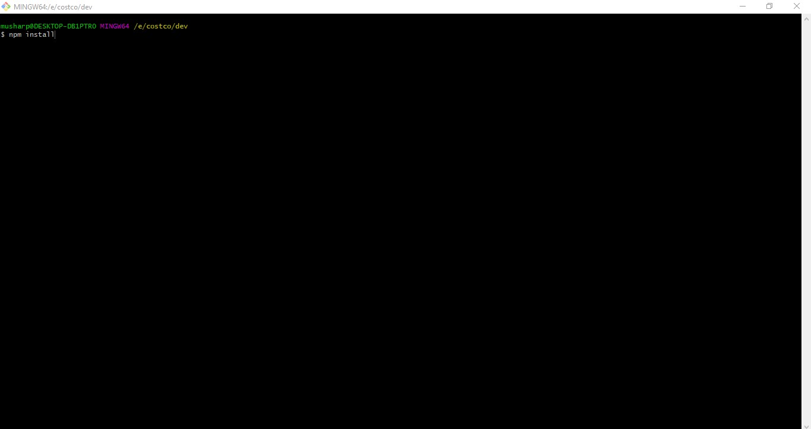

**Run / Serve Project:**

To Serve project in browser, you can just run command ***‘gulp watch’.*** It will serve the project on ***‘localhost:3000’*** and will watch for the changes on html and scss files, whenever we save any file it will automatically loads the browser with changes.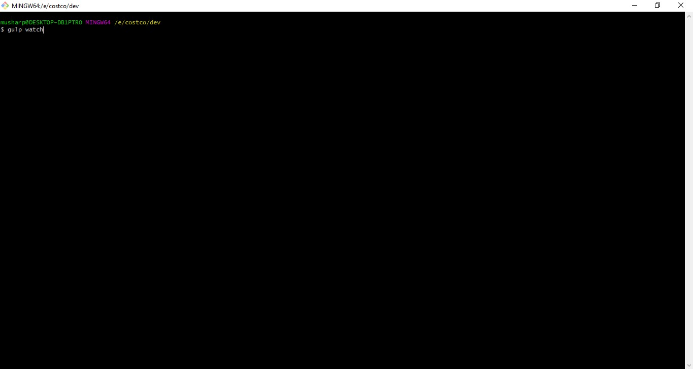

**Deployment on Staging:**

We deploy files on staging setup at **SG5 server** <https://costco.optiserver.co.uk> . Just deploy **html files** and **assets folder.** Don’t upload any other file or folder e.g (scss, gulpfile …. etc).