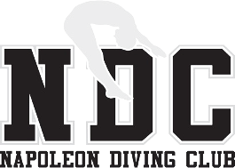 Napoleon Diving Club
Welcome Information & Registration Guide
Welcome to Napoleon Diving Club!
Napoleon Diving Club (NDC) is excited that you're considering our program! Please take a few minutes to read the information below, and don't hesitate to reach out with any questions.
NDC is a competitive diving club, and we'll work with your athlete to be just as successful in the pool as they are out of it. Practices are designed to be flexible — start and end times can be adjusted with a coach's approval to accommodate other activities and commitments, though we always encourage full attendance at your practice's scheduled time, since consistency drives the fastest improvement. To reflect that flexibility, we also offer two separate pricing options to fit your family's needs.
NDC is led by Head Coach Mike Retcher, who also serves as the Bowling Green State University Head Diving Coach. Coach Retcher brings 18 years of coaching experience to the sport and serves in leadership roles within USA Diving and the diving community as a whole. Together with Coach Kristin Shepard, NDC has had over 50 athletes compete at the OHSAA State Diving Championships, more than 30 athletes qualify for AAU and USA Nationals, and a multitude of top-12 national finalists.
We're also proud to welcome Luna Castellanos as Head Coach, Developmental Programming. Luna is a five-time NCAA Division II individual national champion and the 2025 CSCAA Division II Diver of the Year, diving collegiately for Clarion University's nationally elite program after coming to the U.S. from Colombia to pursue diving. She's tied for the second-most individual women's diving national championships in NCAA history and broke an 11-year-old school scoring record along the way. NDC is also assisted by multiple collegiate athlete coaches who bring a tremendous amount of knowledge from all over the country and the world!

Register & create your family account online
Visit napoleondivingclub.com/register to submit your athlete's information and set up a family login. Once a coach reviews and approves your registration, you'll be able to sign in any time to sign up for practices, update your RSVP if plans change, and view invoices.
New to diving? Every new athlete gets 1–3 trial practices at no cost before we ask for any commitment — just a chance to get your feet wet and see what diving is all about. Note: the BGSU SRC waiver is still required for any trial practice held at BGSU, no exceptions.

A note on cost
Please know that we do not want any current financial situation to act as a barrier to participation. If your family has economic hardship, please reach out privately to Coach Retcher and we will make sure to come up with a plan so your athlete can participate.

Practice Fees
Option 1 — Monthly Flat Rate
Best for the athlete who is motivated, focused, and enthusiastically working toward developing their diving career. It's also the most economical option and a good fit for any level of diver.
Group | Monthly Rate | What it looks like
Lesson Program | $70 | Introduces basic fundamentals. Meets twice weekly; bonus practice available Sundays.
Beginner (Orange Team) | $110 | Develops all five categories of dives; introduction to 3-meter.
Intermediate (Brown Team) | $145 | At least 3 of 5 dive categories; proficient in basics.
Elite (Navy Team) | $200 | Full competition list. Participation in all practices and meets expected.
High School Only | $550 total | Split evenly and billed across November, December, January, and February.

Option 2 — Per-Practice Fee
Intended for athletes with commitments to other sports or clubs that keep them from regular practice attendance. Coaches track each practice attended electronically, and your family is billed at the end of the month.
Group | Weekday | Saturday & Sunday
Lesson & Beginner | $15.00 | $18.00
Intermediate & Elite | $20.00 | $25.00

The BGSU facility pass is separate — and not part of registration
Practices held at the Bowling Green State University Student Rec Center (SRC) require a facility pass. This is a separate fee paid directly to the SRC, in person — it is not collected through NDC's registration or billing.
Option 1: $25, 30-day pass. Option 2: $5 day pass (requires a waiver each time).

Meets & Insurance
Dive 419
Local meets held at one of three rotating locations: Napoleon High School, Wauseon High School, and Sylvania Northview High School (Toledo). Typically one meet per month, held Sunday mornings. Cost is typically $10–$20 per meet.
Ohio Diving League (ODL)
Held at university pools throughout Ohio, based on skill levels 1–6. Cost is typically $30–$45 per meet.
Amateur Athletic Union (AAU)
A step up in competitive nature. Main season is March–May, with an additional national meet in mid-July.
USA Diving
A Regional meet in spring, followed by Zones, East/West/Central Championships, and Nationals. For intermediate and elite divers only, and invitation-based.
Insurance — every NDC member registers with the AAU
This is a once-a-year membership that carries insurance coverage for your athlete no matter what pool they practice or compete in. NDC recommends the Extended Coverage (AB) membership.
Current fees (verify at diveaau.org): Regular Youth Athlete Membership $22, Extended Coverage (AB) $24. Membership year runs September 1 – August 31.

Registering for AAU Diving
Registration is completely online at diveaau.org. A copy of your membership card should be given to your coach before your first day of practice — but don't let this hold up signing up!
- Go to diveaau.org and create or sign in to your account.
- Click “Get a Membership,” then “Youth Athlete Membership.”
- Select Diving as the sport.
- Select Extended Coverage (AB) — our recommended option.
- When asked for your club or team code, enter Napoleon Diving Club's code: U5MJ4HGTJ.
- Fill in the athlete's information, then review and sign the terms.
- On the payment page, confirm the charge shows $24 and the sport is Diving, then pay.
- Your membership is issued right away — send or upload a copy of the card to the club.

Practice Expectations, Location & Equipment
Napoleon Diving Club operates out of two facilities: Bowling Green State University (BGSU) and Napoleon High School (NHS).
BGSU's facility
Two 3-meter diving boards, two 1-meter diving boards, a 5- and 7.5-meter platform, above-the-board harness systems on 1- and 3-meter, full bubbles under all boards and towers, two dry boards, trampoline and spotting rig, sideline scout video playback, and numerous additional on-deck and dryland training aids.
NHS's pool
Two 1-meter diving boards, one 3-meter diving board, an above-the-board harness system, training pool-side platforms, a state-of-the-art soft-landing bubbler system, and sideline scout video playback.
We can't wait to share our time and experience with you! When you're ready, visit napoleondivingclub.com/register to get started.

Sincerely,
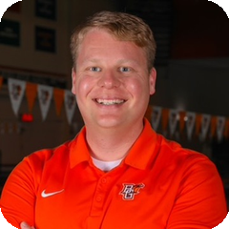 | Mike Retcher — Head Coach of Elite Programming  Napoleon Diving Club · mretche@bgsu.edu · (419) 789-0594

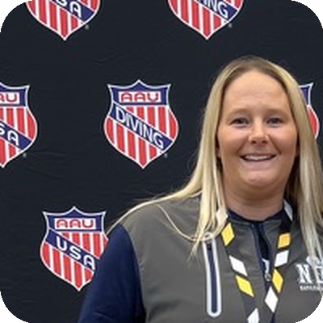 | Kristin Shepard — Head Coach of High School Programming  Napoleon Diving Club · kshepard@napoleonareaschools.org · (419) 260-7366

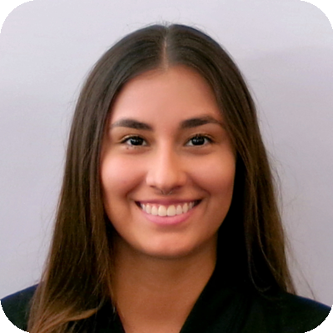 | Luna Castellanos — Head Coach, Developmental Programming  Napoleon Diving Club · lunav@bgsu.edu
The BGSU Student Rec Center waiver is available separately at napoleondivingclub.com/documents/bgsu-src-waiver.pdf — print it in advance to save time at the SRC.

