AWS
1.Which of the following AWS services have data encryption automatically enabled? (Select two)?
Your selection is correct
AWS Storage Gateway
Amazon Elastic File System (Amazon EFS)
Amazon Redshift
Amazon Elastic Block Store (Amazon EBS)
Your selection is correct
Amazon Simple Storage Service (Amazon S3)
Overall explanation
Correct option:
Amazon Simple Storage Service (Amazon S3)
All Amazon S3 buckets have encryption configured by default, and objects are automatically encrypted by using server-side encryption with Amazon S3 managed keys (SSE-S3). This encryption setting applies to all objects in your Amazon S3 buckets.
AWS Storage Gateway
AWS Storage Gateway is a hybrid cloud storage service that gives you on-premises access to virtually unlimited cloud storage. All data transferred between the gateway and AWS storage is encrypted using SSL (for all three types of gateways - File, Volume and Tape Gateways).
Incorrect options:
Amazon Elastic Block Store (Amazon EBS) - Amazon Elastic Block Store (Amazon EBS) volumes are not encrypted, by default. You can configure your AWS account to enforce the encryption of the new EBS volumes and snapshot copies that you create.
Amazon Redshift - Encryption is an optional setting in Amazon Redshift. When you enable encryption for a cluster, the data-blocks and system metadata are encrypted for the cluster and its snapshots.
Amazon Elastic File System (Amazon EFS) - Encryption is not a default setting, but an optional configuration for Amazon EFS drives. Amazon EFS supports two forms of encryption for file systems, encryption of data in transit and encryption at rest.
2. A silicon valley based healthcare startup stores anonymized patient health data on Amazon S3. The CTO further wants to ensure that any sensitive data on S3 is discovered and identified to prevent any sensitive data leaks. As a Cloud Practitioner, which AWS service would you recommend addressing this use-case?
Amazon Polly
Correct answer
Amazon Macie
AWS Secrets Manager
Your answer is incorrect
AWS Glue
Overall explanation
Correct option:
Amazon Macie
Amazon Macie is a fully managed data security and data privacy service that uses machine learning and pattern matching to discover and protect your sensitive data in AWS. Macie automatically provides an inventory of Amazon S3 buckets including a list of unencrypted buckets, publicly accessible buckets, and buckets shared with AWS accounts outside those you have defined in AWS Organizations. Then, Macie applies machine learning and pattern matching techniques to the buckets you select to identify and alert you to sensitive data, such as personally identifiable information (PII).
How Macie Works:
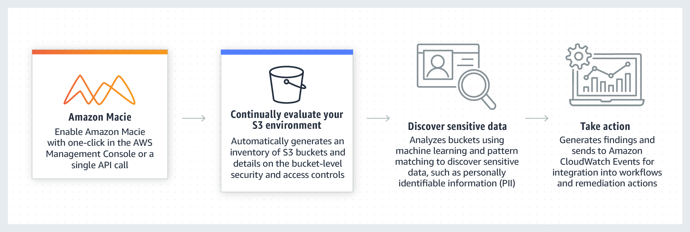
via - https://aws.amazon.com/macie/
Incorrect options:
AWS Glue - AWS Glue is a fully managed extract, transform, and load (ETL) service that makes it easy for customers to prepare and load their data for analytics. AWS Glue job is meant to be used for batch ETL data processing. It cannot be used to discover and protect your sensitive data in AWS.
Amazon Polly - Amazon Polly is a service that turns text into lifelike speech, allowing you to create applications that talk, and build entirely new categories of speech-enabled products. Polly's Text-to-Speech (TTS) service uses advanced deep learning technologies to synthesize natural sounding human speech. It cannot be used to discover and protect your sensitive data in AWS.
AWS Secrets Manager - AWS Secrets Manager helps you protect secrets needed to access your applications, services, and IT resources. The service enables you to easily rotate, manage, and retrieve database credentials, API keys, and other secrets throughout their lifecycle. Users and applications retrieve secrets with a call to Secrets Manager APIs, eliminating the need to hardcode sensitive information in plain text. It cannot be used to discover and protect your sensitive data in AWS.
Reference: https://aws.amazon.com/macie/
3.A startup runs its proprietary application on docker containers. As a Cloud Practitioner, which AWS service would you recommend so that the startup can run containers and still have access to the underlying servers?
Your answer is correct
Amazon Elastic Container Service (Amazon ECS)
AWS Fargate
Amazon Elastic Container Registry (Amazon ECR)
AWS Lambda
Overall explanation
Correct option:
Amazon Elastic Container Service (Amazon ECS)
Amazon Elastic Container Service (Amazon ECS) is a highly scalable, fast, container management service that makes it easy to run, stop, and manage Docker containers on a cluster. This is not a fully managed service and you can manage the underlying servers yourself.
Incorrect options:
AWS Fargate - AWS Fargate is a serverless compute engine for containers. It works with both Amazon Elastic Container Service (Amazon ECS) and Amazon Elastic Kubernetes Service (Amazon EKS). AWS Fargate makes it easy for you to focus on building your applications. AWS Fargate removes the need to provision and manage servers, lets you specify and pay for resources per application, and improves security through application isolation by design. With AWS Fargate, you do not have access to the underlying servers, so this option is incorrect.
How AWS Fargate Works:
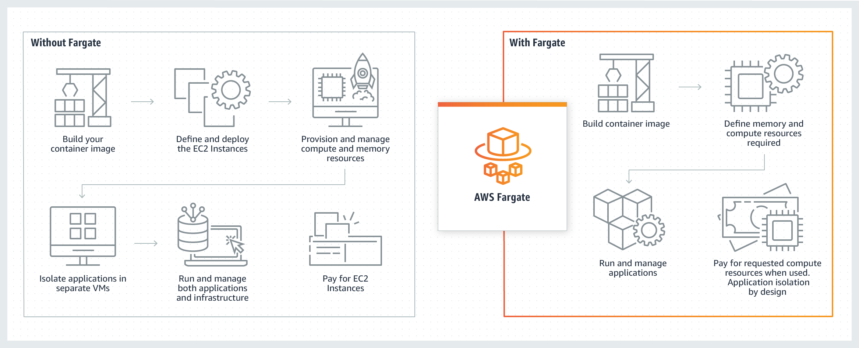
via - https://aws.amazon.com/fargate/
AWS Lambda - AWS Lambda is a compute service that lets you run code without provisioning or managing servers. AWS Lambda executes your code only when needed and scales automatically, from a few requests per day to thousands per second. AWS Lambda does not support running container applications.
Amazon Elastic Container Registry (Amazon ECR) - Amazon Elastic Container Registry (Amazon ECR) can be used to store, manage, and deploy Docker container images. Amazon Elastic Container Registry (Amazon ECR) eliminates the need to operate your container repositories. Amazon Elastic Container Registry (Amazon ECR) does not support running container applications.
Reference:
https://aws.amazon.com/fargate/
4. An IT company has a hybrid cloud architecture and it wants to centralize the server logs for its Amazon Elastic Compute Cloud (Amazon EC2) instances and on-premises servers. Which of the following is the MOST effective for this use-case?
Correct answer
Use Amazon CloudWatch Logs for both the Amazon Elastic Compute Cloud (Amazon EC2) instance and the on-premises servers
Use Amazon CloudWatch Logs for the Amazon Elastic Compute Cloud (Amazon EC2) instance and AWS CloudTrail for the on-premises servers
Your answer is incorrect
Use AWS CloudTrail for the Amazon Elastic Compute Cloud (Amazon EC2) instance and Amazon CloudWatch Logs for the on-premises servers
Use AWS Lambda to send log data from Amazon Elastic Compute Cloud (Amazon EC2) instance as well as on-premises servers to Amazon CloudWatch Logs
Overall explanation
Correct option:
Use Amazon CloudWatch Logs for both the Amazon Elastic Compute Cloud (Amazon EC2) instance and the on-premises servers
You can use Amazon CloudWatch Logs to monitor, store, and access your log files from Amazon Elastic Compute Cloud (Amazon EC2) instances, AWS CloudTrail, Route 53, and other sources such as on-premises servers.
Amazon CloudWatch Logs enables you to centralize the logs from all of your systems, applications, and AWS services that you use, in a single, highly scalable service. You can then easily view them, search them for specific error codes or patterns, filter them based on specific fields, or archive them securely for future analysis.
Incorrect options:
Use AWS Lambda to send log data from Amazon Elastic Compute Cloud (Amazon EC2) instance as well as on-premises servers to Amazon CloudWatch Logs
AWS Lambda lets you run code without provisioning or managing servers. You pay only for the compute time you consume. Lambda cannot be used to centralize the logs from Amazon Elastic Compute Cloud (Amazon EC2) instances and on-premises servers.
Use Amazon CloudWatch Logs for the Amazon Elastic Compute Cloud (Amazon EC2) instance and AWS CloudTrail for the on-premises servers
Use AWS CloudTrail for the Amazon Elastic Compute Cloud (Amazon EC2) instance and Amazon CloudWatch Logs for the on-premises servers
AWS CloudTrail is a service that enables governance, compliance, operational auditing, and risk auditing of your AWS account. With AWS CloudTrail, you can log, continuously monitor, and retain account activity related to actions across your AWS infrastructure. AWS CloudTrail provides event history of your AWS account activity, including actions taken through the AWS Management Console, AWS SDKs, command-line tools, and other AWS services. AWS CloudTrail cannot be used to centralize the server logs for Amazon Elastic Compute Cloud (Amazon EC2) instances or on-premises servers, so both these options are incorrect.
References:
https://docs.aws.amazon.com/AmazonCloudWatch/latest/logs/WhatIsCloudWatchLogs.html
https://docs.aws.amazon.com/AmazonCloudWatch/latest/logs/AgentReference.html

5. Which of the following options are the benefits of using AWS Elastic Load Balancing (ELB)? (Select TWO)
Storage
Your selection is incorrect
Agility
Less costly
Correct selection
Fault tolerance
Your selection is correct
High availability
Overall explanation
Correct options:
High availability
Fault tolerance
Elastic Load Balancing (ELB) automatically distributes incoming application traffic across multiple targets, such as Amazon EC2 instances, containers, and IP addresses. It can handle the varying load of your application traffic in a single Availability Zone (AZ) or across multiple Availability Zones (AZs).
Elastic Load Balancing (ELB) offers three types of load balancers that all feature the high availability, automatic scaling, and robust security necessary to make your applications fault-tolerant: Application Load Balancer (best suited for HTTP and HTTPS traffic), Network Load Balancer (best suited for TCP traffic), and Classic Load Balancer.
Incorrect options:
Agility - Agility refers to new IT resources being only a click away, which means that you reduce the time to make those resources available to your developers from weeks to just minutes. AWS Elastic Load Balancing (ELB) does not help with agility.
Less costly - AWS Elastic Load Balancing (ELB) does not help with reducing costs.
Storage - AWS Elastic Load Balancing (ELB) does not offer storage benefits. It is not a storage-related service.
Reference:
https://aws.amazon.com/elasticloadbalancing/
6. An IT company wants to run a log backup process every Monday at 2 AM. The usual runtime of the process is 5 minutes. As a Cloud Practitioner, which AWS services would you recommend to build a serverless solution for this use-case? (Select two)
AWS Systems Manager
Your selection is correct
AWS Lambda
AWS Step Function
Correct selection
Amazon Eventbridge
Amazon Elastic Compute Cloud (Amazon EC2)
Overall explanation
Correct option:
Amazon Eventbridge - Amazon EventBridge is a service that provides real-time access to changes in data in AWS services, your own applications, and software as a service (SaaS) applications without writing code. Amazon EventBridge Scheduler is a serverless task scheduler that simplifies creating, executing, and managing millions of schedules across AWS services without provisioning or managing underlying infrastructure.
Amazon Eventbridge Scheduler:
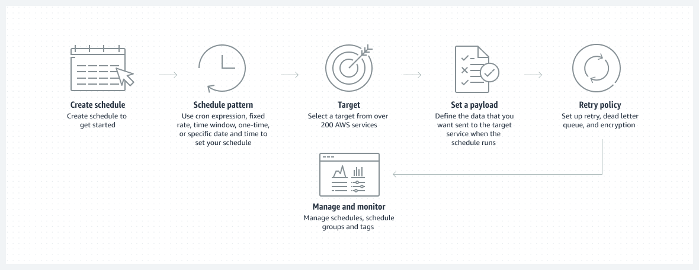
via - https://aws.amazon.com/eventbridge/
AWS Lambda - AWS Lambda lets you run code without provisioning or managing servers. You pay only for the compute time you consume. The lambda has a maximum execution time of 15 minutes, so it can be used to run this log backup process.
To build the solution for the given use-case, you can leverage the Amazon EventBridge Scheduler to trigger on a schedule. You can then set the Lambda as the target for this rule.
Incorrect options:
AWS Systems Manager - AWS Systems Manager gives you visibility and control of your infrastructure on AWS. Systems Manager provides a unified user interface so you can view operational data from multiple AWS services and allows you to automate operational tasks across your AWS resources. With Systems Manager, you can group resources, like Amazon EC2 instances, Amazon S3 buckets, or Amazon RDS instances, by application, view operational data for monitoring and troubleshooting, and take action on your groups of resources. Secrets Manager cannot be used to run a process on a schedule.
Amazon Elastic Compute Cloud (Amazon EC2) - Amazon Elastic Compute Cloud (Amazon EC2) is a web service that provides secure, resizable compute capacity in the cloud with support for per-second billing. It is the easiest way to provision servers on AWS Cloud and access the underlying OS. As the company wants a serverless solution, so this option is ruled out.
AWS Step Function - AWS Step Function lets you coordinate multiple AWS services into serverless workflows. You can design and run workflows that stitch together services such as AWS Lambda, AWS Glue and Amazon SageMaker. Step Function cannot be used to run a process on a schedule.
Reference:
https://aws.amazon.com/eventbridge/
7. A startup wants to provision an EC2 instance for the lowest possible cost for a long-term duration but needs to make sure that the instance would never be interrupted. As a Cloud Practitioner, which of the following options would you recommend?
EC2 On-Demand Instance
Your answer is incorrect
EC2 Dedicated Host
EC2 Spot Instance
Correct answer
EC2 Reserved Instance (RI)
Overall explanation
Correct option:
EC2 Reserved Instance (RI)
An EC2 Reserved Instance (RI) provides you with significant savings (up to 75%) on your Amazon EC2 costs compared to On-Demand Instance pricing. A Reserved Instance (RI) is not a physical instance, but rather a billing discount applied to the use of On-Demand Instances in your account. You can purchase a Reserved Instance (RI) for a one-year or three-year commitment, with the three-year commitment offering a bigger discount. A reserved instance (RI) cannot be interrupted. So this is the correct option.
EC2 Pricing Options Overview:
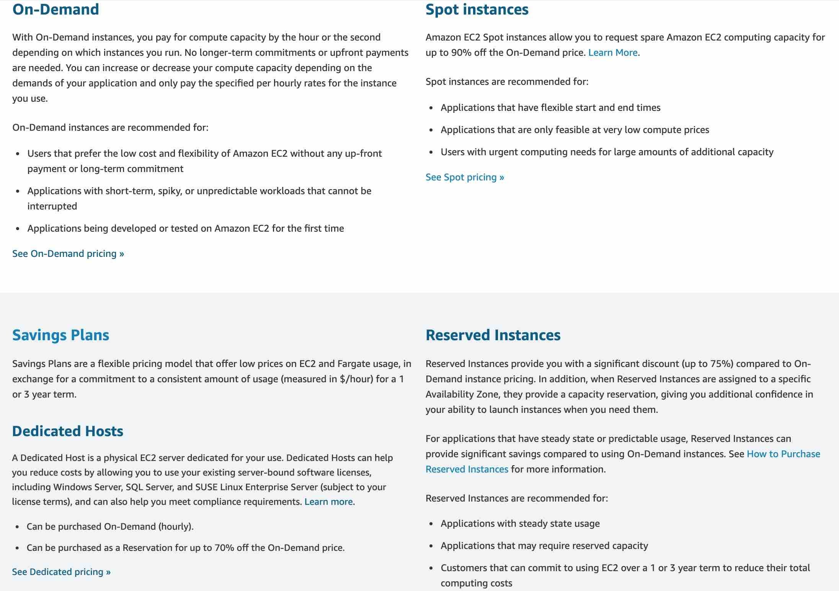
via - https://aws.amazon.com/ec2/pricing/
Incorrect options:
EC2 On-Demand Instance - An EC2 On-Demand Instance is an instance that you use on-demand. You have full control over its lifecycle — you decide when to launch, stop, hibernate, start, reboot, or terminate it. There is no long-term commitment required when you purchase On-Demand Instances. There is no upfront payment and you pay only for the seconds that your On-Demand Instances are running. The price per second for running an On-Demand Instance is fixed. On-demand instances cannot be interrupted. However, On-demand instances are not as cost-effective as Reserved instances, so this option is not correct.
EC2 Spot Instance - An EC2 Spot Instance is an unused EC2 instance that is available for less than the On-Demand price. Because Spot Instances enable you to request unused EC2 instances at steep discounts (up to 90%), you can lower your Amazon EC2 costs significantly. Spot Instances are well-suited for data analysis, batch jobs, background processing, and optional tasks. These can be terminated at short notice, so these are not suitable for critical workloads that need to run at a specific point in time. So this option is not correct for the given use-case.
EC2 Dedicated Host - An Amazon EC2 Dedicated Host allows you to use your eligible software licenses from vendors such as Microsoft and Oracle on Amazon EC2 so that you get the flexibility and cost-effectiveness of using your licenses, but with the resiliency, simplicity, and elasticity of AWS. An Amazon EC2 Dedicated Host is a physical server fully dedicated for your use, so you can help address corporate compliance requirement. It is not cost-efficient compared to an On-Demand instance. So this option is not correct.
Reference:
https://aws.amazon.com/ec2/pricing/
8. An IT company is on a cost-optimization spree and wants to identify all Amazon Elastic Compute Cloud (Amazon EC2) instances that are under-utilized. Which AWS services can be used off-the-shelf to address this use-case without needing any manual configurations? (Select two)
Your selection is correct
AWS Cost Explorer
AWS Cost & Usage Report (AWS CUR)
AWS Budgets
Amazon CloudWatch
Correct selection
AWS Trusted Advisor
Overall explanation
Correct option:
AWS Trusted Advisor
AWS Trusted Advisor is an online tool that provides real-time guidance to help provision your resources following AWS best practices. Whether establishing new workflows, developing applications, or as part of ongoing improvement, recommendations provided by Trusted Advisor regularly help keep your solutions provisioned optimally. AWS Trusted Advisor analyzes your AWS environment and provides best practice recommendations in five categories: Cost Optimization, Performance, Security, Fault Tolerance, Service Limits.
AWS Trusted Advisor checks the Amazon Elastic Compute Cloud (Amazon EC2) instances that were running at any time during the last 14 days and alerts you if the daily CPU utilization was 10% or less and network I/O was 5 MB or less on 4 or more days.
How AWS Trusted Advisor Works:
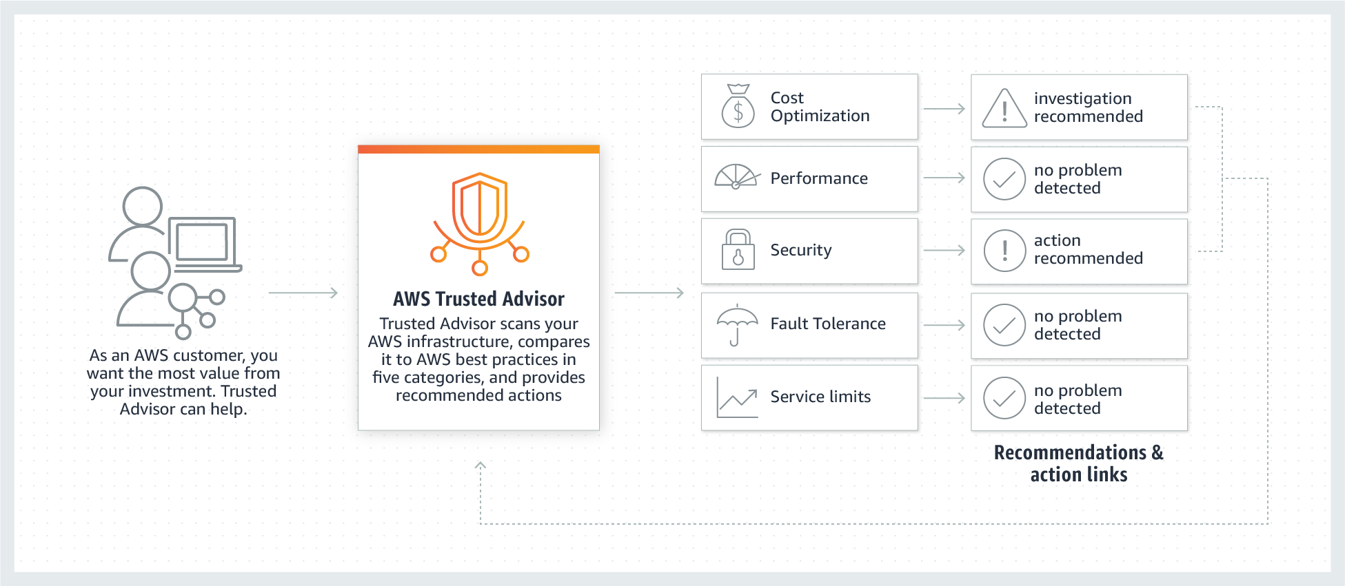
via - https://aws.amazon.com/premiumsupport/technology/trusted-advisor/
How AWS Trusted Advisor identifies low utilization Amazon EC2 instances:
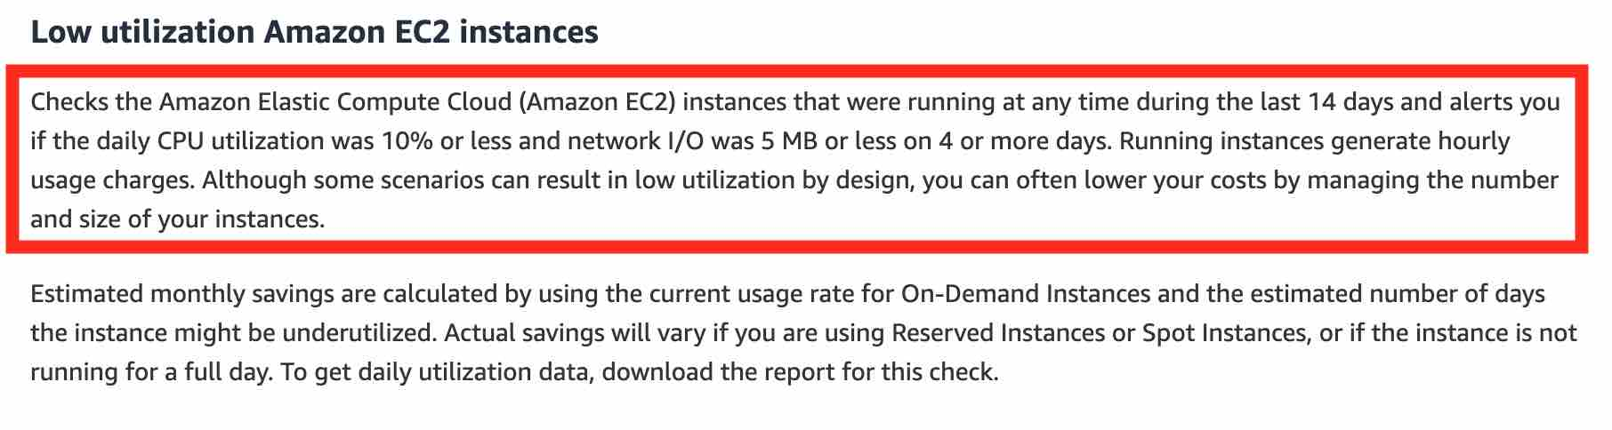
via - https://aws.amazon.com/premiumsupport/technology/trusted-advisor/best-practice-checklist/#Cost_Optimization
AWS Cost Explorer
AWS Cost Explorer has an easy-to-use interface that lets you visualize, understand, and manage your AWS costs and usage over time. AWS Cost Explorer includes a default report that helps you visualize the costs and usage associated with your top five cost-accruing AWS services, and gives you a detailed breakdown of all services in the table view. The reports let you adjust the time range to view historical data going back up to twelve months to gain an understanding of your cost trends.
The rightsizing recommendations feature in AWS Cost Explorer helps you identify cost-saving opportunities by downsizing or terminating Amazon EC2 instances. You can see all of your underutilized Amazon EC2 instances across member accounts in a single view to immediately identify how much you can save.
Incorrect options:
AWS Cost & Usage Report (AWS CUR) - The AWS Cost & Usage Report (AWS CUR) contains the most comprehensive set of cost and usage data available. You can use AWS Cost & Usage Report (AWS CUR) to publish your AWS billing reports to an Amazon Simple Storage Service (Amazon S3) bucket that you own. You can receive reports that break down your costs by the hour or month, by product or product resource, or by tags that you define yourself. AWS Cost & Usage Report (AWS CUR) cannot be used to identify under-utilized Amazon EC2 instances.
Amazon CloudWatch - Amazon CloudWatch can be used to create alarm to monitor your estimated charges. When you enable the monitoring of estimated charges for your AWS account, the estimated charges are calculated and sent several times daily to CloudWatch as metric data. You can choose to receive alerts by email when charges have exceeded a certain threshold. Think resource performance monitoring, events, and alerts; think CloudWatch. Amazon CloudWatch cannot be used to identify under-utilized Amazon EC2 instances without manually configuring an alarm with the appropriate threshold to track the Amazon EC2 utilization, so this option is incorrect.
AWS Budgets - AWS Budgets gives the ability to set custom budgets that alert you when your costs or usage exceed (or are forecasted to exceed) your budgeted amount. You can also use AWS Budgets to set reservation utilization or coverage targets and receive alerts when your utilization drops below the threshold you define. AWS Budgets can be created at the monthly, quarterly, or yearly level, and you can customize the start and end dates. You can further refine your budget to track costs associated with multiple dimensions, such as AWS service, linked account, tag, and others. AWS Budgets cannot be used to identify under-utilized EC2 instances without manually configuring coverage targets, so this option is incorrect.
References:
https://aws.amazon.com/premiumsupport/technology/trusted-advisor/best-practice-checklist/#Cost_Optimization
https://docs.aws.amazon.com/awsaccountbilling/latest/aboutv2/ce-rightsizing.html
9. An AWS user is trying to launch an Amazon Elastic Compute Cloud (Amazon EC2) instance in a given region. What is the region-specific constraint that the Amazon Machine Image (AMI) must meet so that it can be used for this Amazon Elastic Compute Cloud (Amazon EC2) instance?
An Amazon Machine Image (AMI) is a global entity, so the region is not applicable
You should use an Amazon Machine Image (AMI) from the same region, as it improves the performance of the Amazon EC2 instance
You can use an Amazon Machine Image (AMI) from a different region, but it degrades the performance of the Amazon EC2 instance
Your answer is correct
You must use an Amazon Machine Image (AMI) from the same region as that of the Amazon EC2 instance. The region of the Amazon Machine Image (AMI) has no bearing on the performance of the Amazon EC2 instance
Overall explanation
Correct option:
You must use an Amazon Machine Image (AMI) from the same region as that of the Amazon EC2 instance. The region of the Amazon Machine Image (AMI) has no bearing on the performance of the Amazon EC2 instance
An Amazon Machine Image (AMI) provides the information required to launch an instance. You must specify an Amazon Machine Image (AMI) when you launch an instance. You can launch multiple instances from a single AMI when you need multiple instances with the same configuration.
The Amazon Machine Image (AMI) must be in the same region as that of the Amazon EC2 instance to be launched. If the Amazon Machine Image (AMI) exists in a different region, you can copy that Amazon Machine Image (AMI) to the region where you want to launch the EC2 instance. The region of Amazon Machine Image (AMI) has no bearing on the performance of the Amazon EC2 instance.
Amazon Machine Images (AMI) Overview:
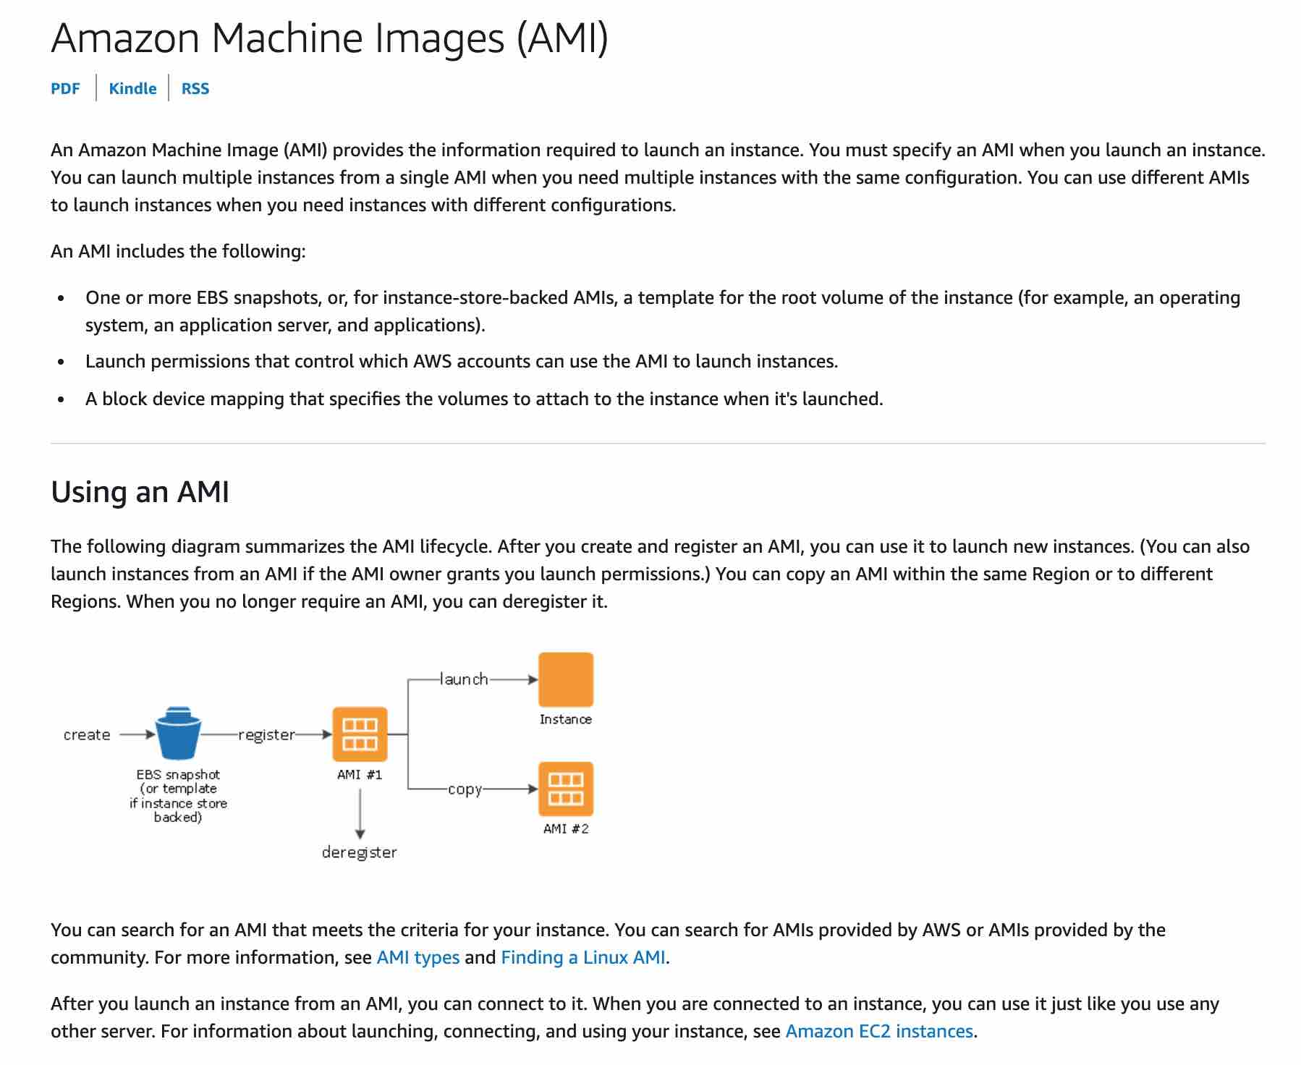
via - https://docs.aws.amazon.com/AWSEC2/latest/UserGuide/AMIs.html
Incorrect options:
You can use an Amazon Machine Image (AMI) from a different region, but it degrades the performance of the Amazon EC2 instance
You should use an Amazon Machine Image (AMI) from the same region, as it improves the performance of the Amazon EC2 instance
An Amazon Machine Image (AMI) is a global entity, so the region is not applicable
These three options contradict the details provided earlier in the explanation, so these options are incorrect.
Reference:
https://docs.aws.amazon.com/AWSEC2/latest/UserGuide/using-regions-availability-zones.html
10. A financial services company wants to ensure that its AWS account activity meets the governance, compliance and auditing norms. As a Cloud Practitioner, which AWS service would you recommend for this use-case?
Amazon CloudWatch
Your answer is incorrect
AWS Trusted Advisor
AWS Config
Correct answer
AWS CloudTrail
Overall explanation
Correct option:
AWS CloudTrail
You can use CloudTrail to log, monitor and retain account activity related to actions across your AWS infrastructure. CloudTrail provides an event history of your AWS account activity, including actions taken through the AWS Management Console, AWS SDKs, command-line tools, and other AWS services.
How CloudTrail Works:
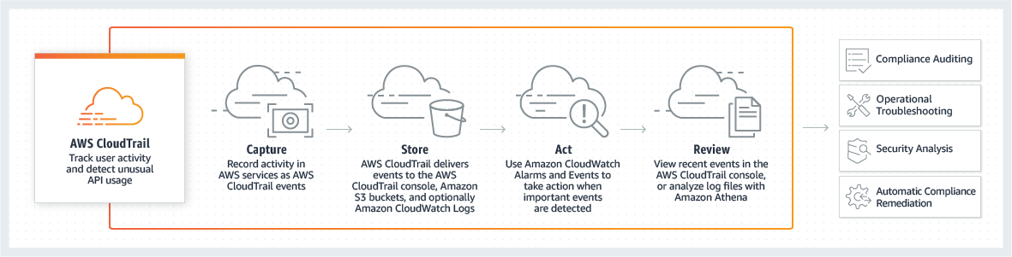
via - https://aws.amazon.com/cloudtrail/
Incorrect options:
AWS Config - AWS Config is a service that enables you to assess, audit, and evaluate the configurations of your AWS resources. Config continuously monitors and records your AWS resource configurations and allows you to automate the evaluation of recorded configurations against desired configurations.
Amazon CloudWatch - Amazon CloudWatch is a monitoring and observability service built for DevOps engineers, developers, site reliability engineers (SREs), and IT managers. CloudWatch provides data and actionable insights to monitor applications, respond to system-wide performance changes, optimize resource utilization, and get a unified view of operational health. This is an excellent service for building Resilient systems.
AWS Trusted Advisor - AWS Trusted Advisor is an online tool that provides you real-time guidance to help you provision your resources following AWS best practices on cost optimization, security, fault tolerance, service limits and performance improvement.
Exam Alert:
You may see use-cases asking you to select one of CloudWatch vs CloudTrail vs Config. Just remember this thumb rule -
Think resource performance monitoring, events, and alerts; think CloudWatch.
Think account-specific activity and audit; think CloudTrail.
Think resource-specific change history, audit, and compliance; think Config.
Reference:
https://aws.amazon.com/cloudtrail/

