Matrix-Weighted Graph Operators: Static Loewner Order, Dynamic Response, and Optimization Rates
Abstract
We study matrix-weighted graph Laplacian operators of the form
A = L\otimes I_d + M \in \mathbb{R}^{nd\times nd},
where L is the Laplacian of a connected graph on n nodes and M is a block-diagonal matrix of symmetric positive definite node-wise penalties on \mathbb{R}^d-valued signals.
Our first result is a static Loewner-order monotonicity principle: if the node matrices increase in the Loewner order (M_i'\succeq M_i), then the corresponding inverses satisfy A'^{-1}\preceq A^{-1}, with consequences for Gaussian fields, Green’s operators, and quadratic regularization. We then show that the same Loewner ordering governs the forced second-order dynamics \ddot x + A x = \xi(t), simultaneously controlling time-domain input–output gains (e.g., L^1\!\to L^\infty bounds) and frequency-domain resolvents. On the spectral side, we derive graph-structured lower bounds on \lambda_{\min}(A) for standard graph families (regular graphs, paths, cycles, stars, and Cartesian grids), and obtain sharpened mode-wise response bounds in the commuting case M_i = mI_d, where A diagonalizes in the Laplacian eigenbasis. Finally, we translate these spectral bounds into explicit convergence rates for gradient and proximal-gradient methods for strongly convex quadratic objectives defined on graphs. Together, these results connect the algebraic structure of matrix-weighted graph Laplacians to dynamic response and first-order optimization performance, with closed-form constants on standard graph families.
⸻
1. Introduction
Many networked systems can be modeled by attaching a vector state x_i\in\mathbb{R}^d to each node i of a graph and penalizing both edge-wise differences and deviations from preferred local states. Examples include Gaussian Markov random fields, network-structured regularization in machine learning, multi-agent dynamics, and discrete analogues of elliptic operators with "mass" or "pinning" terms. This unified perspective allows one to translate a simple, local design choice—such as increasing node-wise "stiffness"—directly into a predictable, global improvement in dynamic stability or optimization convergence speed. In these settings, local symmetric positive definite matrices encode node-wise “stiffness,” and a central question is how making some nodes stiffer—in the sense of the Loewner order—changes global quantities such as covariance structure, dynamic response, and the convergence rates of optimization algorithms defined on the graph.
Let G=(V,E) be a connected, undirected graph with |V|=n, and suppose each node i\in V carries a vector x_i\in\mathbb{R}^d. Stacking the node states as x=(x_1,\dots,x_n)\in\mathbb{R}^{nd}, a natural quadratic energy on such vector-valued node signals is
\mathcal{E}(x)
= \frac12\sum_{\{i,j\}\in E}\|x_i - x_j\|^2
\;+\;
\frac12\sum_{i=1}^n \langle M_i(x_i - y_i),\, x_i - y_i\rangle,
where M_i\in\mathbb{R}^{d\times d} are symmetric positive definite (SPD) node-wise matrices and y_i are target vectors. In matrix form,
\mathcal{E}(x)
= \frac12 (x-y)^\top A (x-y),\qquad
A := L\otimes I_d + M,
with L the graph Laplacian and M = \mathrm{diag}(M_1,\dots,M_n) block-diagonal.
Matrix-weighted graph Laplacians and related operators therefore appear in a range of stochastic and deterministic network models; the perspective taken here emphasizes Loewner-order comparison principles and explicit, graph-structured spectral bounds for these operators.
The central structural fact is that A is SPD and becomes “stiffer” as the node matrices M_i increase in the Loewner order. This stiffness manifests (i) statically, in the inverse A^{-1} and associated covariance or Green’s operators, and (ii) dynamically, in the response of the second-order system
\ddot x(t) + A x(t) = \xi(t)
to external forcing \xi. Understanding how changes in the node-wise penalties M_i propagate through these static and dynamic quantities, and how they translate into optimization rates, is the main goal of this paper.
Within this framework, our contributions are fivefold. First, we establish a static Loewner-order monotonicity result: node-wise increases M_i'\succeq M_i yield A'\succeq A and A'^{-1}\preceq A^{-1}, with interpretations in terms of Gaussian fields and regularized energies. Second, we show that the same Loewner ordering governs dynamic input–output gains (e.g., L^1\!\to L^\infty bounds) and frequency-domain resolvents for the forced system \ddot x + Ax = \xi, providing comparison principles for the responses of second-order networks. Third, we derive graph-structured lower bounds for \lambda_{\min}(A) in terms of \lambda_2(L) for standard graph families, leading to explicit constants for condition numbers and dynamic gains. Fourth, in the commuting case M_i = mI_d, we obtain mode-wise bounds by diagonalizing A in the Laplacian eigenbasis. Finally, we translate these spectral results into explicit convergence rates for gradient and proximal-gradient methods on graphs.
Sections 2–3 present preliminaries and the static Loewner-order inequalities and Gaussian field interpretations. Section 4 develops the dynamic comparison results for forced second-order systems. Section 5 develops graph-structured eigenvalue bounds. Section 6 treats the commuting case with mode-wise analysis. Section 7 applies these results to optimization, and Section 8 concludes.
⸻
2. Preliminaries
2.1 Graph Laplacian and Kronecker structure
Let G=(V,E) be a connected, undirected graph with |V|=n. The (combinatorial) Laplacian L\in\mathbb{R}^{n\times n} is
L_{ij} =
\begin{cases}
\deg(i), & i=j,\\
-1, & \{i,j\}\in E,\\
0, & \text{otherwise.}
\end{cases}
Then L is symmetric positive semidefinite (PSD) with eigenvalues
0=\lambda_1(L) \le \lambda_2(L)\le \dots \le \lambda_n(L),
and \lambda_2(L)>0 because G is connected.
We consider signals x_i\in\mathbb{R}^d at each node, stacked into x\in\mathbb{R}^{nd}. The operator L\otimes I_d encodes graph coupling:
x^\top (L\otimes I_d)x = \sum_{\{i,j\}\in E}\|x_i - x_j\|^2.
2.2 Node-wise matrix penalties and Loewner order
Each node i is equipped with a symmetric positive definite matrix M_i\in\mathbb{R}^{d\times d}. Let
M := \mathrm{diag}(M_1,\dots,M_n)\in\mathbb{R}^{nd\times nd}.
Our central operator is
A := L\otimes I_d + M.
We use the Loewner order on symmetric matrices: for symmetric X,Y, we write X\preceq Y if Y-X\succeq 0 (i.e., Y-X is PSD). For SPD matrices 0 \prec X\preceq Y, inversion reverses the order:
X \preceq Y \quad\Rightarrow\quad Y^{-1} \preceq X^{-1}.
⸻
3. Static operator inequalities and Gaussian fields
Theorem 3.1 (SPD structure and unique minimizer)
Let G be connected, L its Laplacian, and M_i\succ 0 for all i. Then:
1. A = L\otimes I_d + M is SPD.
2. The quadratic functional
f(x) = \frac12 x^\top A x - b^\top x
is strictly convex for any b\in\mathbb{R}^{nd} and has a unique minimizer
x^\star = A^{-1}b.
Proof.
L\otimes I_d is symmetric PSD. The block-diagonal M is SPD because each block M_i\succ 0. Thus for any nonzero z\in\mathbb{R}^{nd},
z^\top A z = z^\top (L\otimes I_d)z + z^\top M z > 0.
Hence A\succ 0 and f is strictly convex, with unique minimizer obtained by solving \nabla f(x)=Ax-b=0. ∎
Theorem 3.2 (Loewner monotonicity and Gaussian fields)
Let
A = L\otimes I_d + M,\quad
A' = L\otimes I_d + M',
with M=\mathrm{diag}(M_i), M'=\mathrm{diag}(M'_i), and M'_i\succeq M_i for all i. Then:
1. A'\succeq A and both are SPD.
2. A'^{-1}\preceq A^{-1}. Equivalently,
b^\top A'^{-1} b \le b^\top A^{-1} b
\quad \forall\,b\in\mathbb{R}^{nd}.
3. If X\sim\mathcal{N}(0,\sigma^2 A^{-1}) and X'\sim\mathcal{N}(0,\sigma^2 A'^{-1}), then
\operatorname{Var}(u^\top X') \le \operatorname{Var}(u^\top X)
\quad \forall\,u\in\mathbb{R}^{nd}.
Proof.
Node-wise M'_i\succeq M_i implies M'-M\succeq 0, hence
A'-A = M'-M\succeq 0.
Thus A'\succeq A. Since M\succ 0, both A and A' are SPD.
For SPD matrices, inversion reverses Loewner order: if 0\prec B\preceq C, write C=B^{1/2}(I+S)B^{1/2} with S\succeq 0, so (I+S)^{-1}\preceq I, hence
C^{-1} = B^{-1/2}(I+S)^{-1}B^{-1/2}\preceq B^{-1}.
Apply this with B=A, C=A' to obtain A'^{-1}\preceq A^{-1}.
For the Gaussian fields, \operatorname{Cov}(X) = \sigma^2 A^{-1} and \operatorname{Cov}(X') = \sigma^2 A'^{-1}, so for any u,
\operatorname{Var}(u^\top X) = \sigma^2 u^\top A^{-1}u,\quad
\operatorname{Var}(u^\top X') = \sigma^2 u^\top A'^{-1}u.
Using A'^{-1}\preceq A^{-1} yields the variance inequality. ∎
These results formalize the intuition that increasing node-wise stiffness reduces global flexibility, both in static Green’s functions and in Gaussian field variances.
⸻
4. Second-order dynamics and dynamic gain
Consider the forced second-order system
\ddot x(t) + A x(t) = \xi(t),\qquad x(0)=\dot x(0)=0.
4.1 Green’s operator and operator norm bound
By spectral calculus, since A\succ 0, we can define A^{1/2} and A^{-1/2}. The solution with zero initial data is
x_A(t) = \int_0^t S_A(t-s)\,\xi(s)\,ds,
\quad
S_A(\tau) := A^{-1/2}\sin(\tau A^{1/2}),\ \tau\ge 0.
Diagonalizing A=U\Lambda U^\top with \Lambda=\mathrm{diag}(\lambda_1,\dots,\lambda_{nd}), \lambda_i>0, the eigenvalues of \sin(\tau A^{1/2}) are \sin(\tau\sqrt{\lambda_i}), hence \|\sin(\tau A^{1/2})\|\le 1. Thus
\|S_A(\tau)\|
\le \|A^{-1/2}\| \cdot \|\sin(\tau A^{1/2})\|
\le \|A^{-1/2}\| = \frac{1}{\sqrt{\lambda_{\min}(A)}}.
Consequently, for any T>0 and \xi\in L^1([0,T];\mathbb{R}^{nd}),
\|x_A(t)\|
\le \frac{1}{\sqrt{\lambda_{\min}(A)}} \int_0^t \|\xi(s)\|\,ds,\quad t\in[0,T],
so the induced operator norm
\|T_A\|_{L^1\to L^\infty([0,T])}
:= \sup_{\xi\neq 0} \frac{\sup_{t\in[0,T]}\|x_A(t)\|}{\int_0^T \|\xi(s)\|\,ds}
is bounded by
\|T_A\|_{L^1\to L^\infty([0,T])}
\le \frac{1}{\sqrt{\lambda_{\min}(A)}}.
Theorem 4.1 (Dynamic gain monotonicity)
Let A\preceq A' as in Theorem 3.2. Then
\lambda_{\min}(A)\le \lambda_{\min}(A'),\quad
\|T_{A'}\|_{L^1\to L^\infty([0,T])}
\le \|T_A\|_{L^1\to L^\infty([0,T])}
\quad\forall T>0.
Proof.
Loewner order between SPD matrices implies \lambda_{\min}(A)\le\lambda_{\min}(A'). Then
\|A'^{-1/2}\| = \frac{1}{\sqrt{\lambda_{\min}(A')}} \le \frac{1}{\sqrt{\lambda_{\min}(A)}} = \|A^{-1/2}\|.
From the kernel bounds,
\|T_A\|_{L^1\to L^\infty}\le \|A^{-1/2}\|,\quad
\|T_{A'}\|_{L^1\to L^\infty}\le \|A'^{-1/2}\|,
so \|T_{A'}\|\le \|T_A\|. ∎
4.2 Frequency-domain resolvents
For suitable \xi (say, \xi\in L^2(\mathbb{R}) and zero initial data in the distant past), Fourier transform in time yields
(-\omega^2 I + A)\widehat{x}_A(\omega) = \widehat{\xi}(\omega),
\quad
\widehat{x}_A(\omega) = R_A(\omega)\widehat{\xi}(\omega),
with resolvent
R_A(\omega) := (A - \omega^2 I)^{-1},
defined for |\omega| < \sqrt{\lambda_{\min}(A)}. Similarly for A'.
Theorem 4.2 (Frequency-wise resolvent ordering)
If A\preceq A', then for every |\omega|<\sqrt{\lambda_{\min}(A)},
R_{A'}(\omega) = (A' - \omega^2 I)^{-1}
\;\preceq\;
(A - \omega^2 I)^{-1} = R_A(\omega).
Proof.
For such \omega, both A - \omega^2 I and A'-\omega^2 I are SPD. Subtracting \omega^2I preserves Loewner order, so
A - \omega^2 I \preceq A' - \omega^2 I.
Inverting reverses the order, yielding the desired inequality. ∎
⸻
5. Graph-structured lower bounds for \lambda_{\min}(A)
The dynamic and optimization results depend on \lambda_{\min}(A). We now derive explicit lower bounds in terms of graph spectra and node-wise penalties.
5.1 General bounds
Let
m_{\min} := \min_{1\le i\le n}\lambda_{\min}(M_i).
Proposition 5.1 (Global bound)
For all M_i\succ 0,
\lambda_{\min}(A) \;\ge\; m_{\min}.
Proof.
For any unit vector x,
x^\top A x = x^\top (L\otimes I_d)x + x^\top M x
\ge x^\top M x
\ge m_{\min}\|x\|^2 = m_{\min}.
Taking the infimum over unit vectors gives the result. ∎
This lower bound is independent of the graph structure; it is tight when x lies in the constant subspace (for scalar d=1, that subspace corresponds to \lambda_1(L)=0).
Let \mathbf{1}\in\mathbb{R}^n be the all-ones vector, and let \mathcal{C} = \{\mathbf{1}\}\otimes\mathbb{R}^d\subset\mathbb{R}^{nd} be the “constant” subspace. Let \mathcal{C}^\perp be its orthogonal complement. On \mathcal{C}^\perp, the smallest eigenvalue of the operator L\otimes I_d is \lambda_2(L).
Proposition 5.2 (Subspace bound)
On \mathcal{C}^\perp,
\lambda_{\min}\big(A|_{\mathcal{C}^\perp}\big)
\;\ge\; m_{\min} + \lambda_2(L).
Proof.
On \mathcal{C}^\perp, L\otimes I_d has eigenvalues at least \lambda_2(L) (each eigenvalue of L is replicated d times). For x\in\mathcal{C}^\perp with \|x\|=1,
x^\top A x = x^\top (L\otimes I_d)x + x^\top M x
\ge \lambda_2(L)\|x\|^2 + m_{\min}\|x\|^2
= \lambda_2(L) + m_{\min}.
Taking the infimum over unit vectors in \mathcal{C}^\perp gives the bound. ∎
This bound is relevant when working with mean-zero forcings or observables orthogonal to the constant mode.
5.2 Explicit \lambda_2(L) for standard graph families
We now recall the Laplacian spectra of certain standard connected graphs G=(V,E) with n=|V|, and combine them with Proposition 5.2.
5.2.1 k-regular graphs
For a k-regular graph, each node has degree k. The Laplacian satisfies
0 = \lambda_1(L) \le \lambda_2(L) \le \dots\le \lambda_n(L) \le 2k.
The explicit value of \lambda_2(L) depends on the graph, but the upper bound \lambda_{\max}(L)\le 2k is universal.
5.2.2 Path and cycle graphs
Let P_n be the path graph on n nodes, and C_n the cycle graph.
• For P_n,
the Laplacian eigenvalues are
\lambda_k(L(P_n)) = 2\Big(1 - \cos\frac{k\pi}{n}\Big), \quad k = 0,1,\dots,n-1.
The smallest is \lambda_0 = 0, and the second-smallest is
\lambda_2(L(P_n)) = 2\Big(1 - \cos\frac{\pi}{n}\Big).
• For C_n,
\lambda_k(L(C_n)) = 2\Big(1 - \cos\frac{2\pi k}{n}\Big),\quad k=0,\dots,n-1,
and the second-smallest eigenvalue is
\lambda_2(L(C_n)) = 2\Big(1 - \cos\frac{2\pi}{n}\Big).
Combining with Proposition 5.2, for M_i\succeq m_{\min} I_d and forcing orthogonal to constants,
\lambda_{\min}\big(A|_{\mathcal{C}^\perp}\big) \ge m_{\min} + 2\Big(1 - \cos\frac{\pi}{n}\Big)
\quad\text{on } P_n,
\lambda_{\min}\big(A|_{\mathcal{C}^\perp}\big) \ge m_{\min} + 2\Big(1 - \cos\frac{2\pi}{n}\Big)
\quad\text{on } C_n.
For large n, these behave like
\lambda_2(L(P_n)) \approx \frac{\pi^2}{n^2},\quad
\lambda_2(L(C_n)) \approx \frac{4\pi^2}{n^2}.
5.2.3 Star graph
Let S_n be the star graph on n nodes: one center connected to n-1 leaves. Its Laplacian eigenvalues are
0,\ 1,\dots,1,\ n.
Thus \lambda_2(L(S_n)) = 1, and for M_i\succeq m_{\min}I_d,
\lambda_{\min}\big(A|_{\mathcal{C}^\perp}\big) \ge m_{\min} + 1.
5.2.4 Cartesian grids
Let G be the Cartesian product of paths:
G = P_{n_1}\square P_{n_2}\square \dots\square P_{n_D},
a D-dimensional grid with n_1\cdots n_D nodes. The Laplacian eigenvalues are
\lambda_{k_1,\dots,k_D}(L(G)) = \sum_{r=1}^D 2\Big(1 - \cos\frac{k_r\pi}{n_r}\Big), \quad k_r = 0,1,\dots,n_r-1.
The smallest nonzero eigenvalue is achieved by taking one k_r = 1 and all others k_s = 0, so
\lambda_2(L(G)) = \min_{1\le r\le D} 2\Big(1 - \cos\frac{\pi}{n_r}\Big).
Thus, for M_i\succeq m_{\min}I_d,
\lambda_{\min}\big(A|_{\mathcal{C}^\perp}\big)
\;\ge\;
m_{\min} + \min_{1\le r\le D} 2\Big(1 - \cos\frac{\pi}{n_r}\Big).
As shown in Figure 1, numerical computations for paths, cycles, and grids confirm that \lambda_{\min}(A) approaches m as the graph size increases, consistent with our bounds on \lambda_{\min}(A) and \lambda_2(L).
5.3 Consequences for dynamic gain and condition numbers
Combining these bounds with Theorem 4.1, we obtain explicit gain estimates \|T_A\|_{L^1\to L^\infty}\le 1/\sqrt{\lambda_{\min}(A)} in terms of graph size and m_{\min}, and for uniform M_i=mI_d we recover exact spectra:
\lambda_{\min}(A)=m,\quad
\lambda_{\max}(A) = \lambda_{\max}(L) + m,
with \lambda_{\max}(L)\le 2k for k-regular graphs and explicit formulas for paths, cycles, stars, and grids.
These constants will be used in Section 7 to bound condition numbers and convergence rates of optimization algorithms.
⸻
6. Commuting case and mode-wise analysis
We now consider the special case where all node matrices are equal and scalar, M_i = mI_d with m>0. Then
M = mI_{nd},\quad
A = L\otimes I_d + mI_{nd}.
6.1 Simultaneous diagonalization
Let L = U\Lambda U^\top with \Lambda=\mathrm{diag}(\lambda_1(L),\dots,\lambda_n(L)). Then
A = (U\otimes I_d)(\Lambda\otimes I_d + mI_{nd})(U^\top\otimes I_d).
Thus eigenvectors of A are of the form \phi_k\otimes e_\ell with \phi_k an eigenvector of L and e_\ell a standard basis vector in \mathbb{R}^d, and eigenvalues are
\lambda_k(A) = \lambda_k(L) + m,\quad k=1,\dots,n,
each with multiplicity d.
This yields the exact spectrum:
\lambda_{\min}(A) = m,\quad
\lambda_{\max}(A) = \lambda_{\max}(L) + m.
6.2 Mode-wise static bounds
For a given mode k, let P_k = (\phi_k\phi_k^\top)\otimes I_d be the projector onto the k-th eigenmode subspace. The restriction of A to that subspace is (\lambda_k(L)+m)I_d, so
A^{-1}|_{\mathrm{im}\,P_k} = (\lambda_k(L)+m)^{-1} I_d.
Thus, for any z\in\mathbb{R}^{nd},
z^\top A^{-1} z
= \sum_{k=1}^n \frac{1}{\lambda_k(L)+m} \|P_k z\|^2.
If we increase m to m'>m, the new operator A' = L\otimes I_d + m'I_{nd} satisfies
(A')^{-1}|_{\mathrm{im}\,P_k} = (\lambda_k(L)+m')^{-1} I_d
\le (\lambda_k(L)+m)^{-1} I_d
for every k, and the Loewner inequality A'^{-1}\preceq A^{-1} holds mode-wise with strict improvement in each mode.
6.3 Mode-wise dynamic bounds
In the commuting case, the second-order system \ddot x + A x = \xi decouples into scalar oscillators in the eigenbasis of L. Let x_k(t)\in\mathbb{R}^d denote the component of x(t) in \mathrm{im}\,P_k, and let \xi_k(t) be the corresponding forcing component. Then
\ddot x_k(t) + (\lambda_k(L)+m)x_k(t) = \xi_k(t),
and the Green’s operator in this mode is
S_{A,k}(\tau) = (\lambda_k(L)+m)^{-1/2}\sin\big(\tau\sqrt{\lambda_k(L)+m}\big)I_d.
The operator norm bound becomes mode-wise:
\|S_{A,k}(\tau)\| \le \frac{1}{\sqrt{\lambda_k(L)+m}}.
If we increase m to m'>m, then for every k,
\frac{1}{\sqrt{\lambda_k(L)+m'}} \le \frac{1}{\sqrt{\lambda_k(L)+m}},
so each mode’s dynamic gain strictly decreases. The global inequality of Theorem 4.1 then follows by combining these mode-wise bounds.
In the frequency domain, the resolvent in mode k is
R_{A,k}(\omega) = \big(\lambda_k(L)+m - \omega^2\big)^{-1} I_d
for |\omega|<\sqrt{\lambda_k(L)+m}. Increasing m to m' yields
\big(\lambda_k(L)+m' - \omega^2\big)^{-1} \le \big(\lambda_k(L)+m - \omega^2\big)^{-1}
for each mode individually, whenever both resolvents are defined.
⸻
7. Applications to optimization and convergence rates
We now connect these operator bounds to convergence rates of gradient and proximal-gradient methods applied to quadratic objectives on graphs.
7.1 Gradient descent on a quadratic
Consider
f(x) = \frac12 x^\top A x - b^\top x,
with A\succ 0. Gradient descent with step size \alpha>0 iterates
x^{k+1} = x^k - \alpha \nabla f(x^k)
= x^k - \alpha (A x^k - b).
Let x^\star = A^{-1}b be the unique minimizer. Then the error e^k = x^k - x^\star evolves as
e^{k+1} = (I - \alpha A)e^k.
The spectral radius of I-\alpha A governs convergence. Its eigenvalues are 1-\alpha\lambda_i(A), so
\rho(I-\alpha A) = \max_i |1-\alpha\lambda_i(A)|.
Taking 0<\alpha<2/\lambda_{\max}(A) ensures \rho(I-\alpha A)<1. The optimal step size \alpha_* = 2/(\lambda_{\max}(A)+\lambda_{\min}(A)) yields
\rho(I-\alpha_* A) = \frac{\kappa(A)-1}{\kappa(A)+1},
\quad
\kappa(A) := \frac{\lambda_{\max}(A)}{\lambda_{\min}(A)}.
Our graph-structured bounds yield explicit condition numbers on standard families.
Example: k-regular graph, uniform penalty
Let G be k-regular and M_i=mI_d for all i. Then
\lambda_{\min}(A) = m,\quad
\lambda_{\max}(A) = \lambda_{\max}(L)+m \le 2k + m.
Thus
\kappa(A) \le \frac{2k+m}{m},\quad
\rho(I-\alpha_* A) \le \frac{\frac{2k+m}{m}-1}{\frac{2k+m}{m}+1}
= \frac{2k}{2m+2k}.
So with optimal step size,
\|e^k\| \le \rho^k \|e^0\|,\qquad
\rho \le \frac{2k}{2m+2k},
yielding an explicit linear convergence rate.
Analogous expressions can be obtained for paths, cycles, stars, and grids by substituting the appropriate \lambda_{\max}(L) into \lambda_{\max}(A).
We now verify these spectral predictions numerically on a grid graph. Consider a 5\times 10 Cartesian grid with uniform stiffness M_i = I (m = 1). Using the numerically computed spectrum of A = L + I on this 50-node grid, we obtain \lambda_{\min}(A) \approx 1.00 and \lambda_{\max}(A) \approx 8.52, so the condition number satisfies \kappa(A) \approx 8.52 and the corresponding rate parameter is \rho = (\kappa(A)-1)/(\kappa(A)+1) \approx 0.79 for gradient descent with optimal step size \alpha_* = 2/(\lambda_{\max}(A)+\lambda_{\min}(A)).
Figure 2 compares this predicted rate to the observed behavior of gradient descent on the same 50-node grid. We initialize from the zero vector and run the iteration with step size \alpha_* computed directly from the extreme eigenvalues of A. When we plot \|e^k\| on a logarithmic scale against k, the trajectory aligns closely with the geometric envelope \rho^k, with small discrepancies in the initial iterations ($k \lesssim 50$) attributable to non-asymptotic transients. The long-run slope of the observed curve agrees with the spectral prediction, confirming that the graph-structured bounds from Section 5 give sharp constants for convergence in this setting.
Figure 2: Gradient descent convergence on a 50-node grid (5\times 10) with M_i = I (m = 1) and step size \alpha_* = 2/(\lambda_{\max}(A)+\lambda_{\min}(A)). The solid curve shows the observed error, plotted as $\log \|e^k\|$ versus iteration $k$; the dashed curve shows the predicted rate $\rho^k$ with $\rho \approx 0.79$ computed from the condition number $\kappa(A)\approx 8.52$. After an initial transient ($k \lesssim 50$) the observed and predicted rates nearly coincide, empirically validating the spectral convergence rate.
7.2 Proximal-gradient methods
Consider a composite objective
F(x) = f(x) + R(x),
\quad
f(x) = \frac12 x^\top A x - b^\top x,
where R:\mathbb{R}^{nd}\to(-\infty,+\infty] is a proper, closed, convex function with computable proximal operator
\mathrm{prox}_{\alpha R}(z)
:= \arg\min_x\left\{R(x) + \frac{1}{2\alpha}\|x-z\|^2\right\}.
Proximal-gradient (forward–backward splitting) iterates
x^{k+1}
= \mathrm{prox}_{\alpha R}\big(x^k - \alpha \nabla f(x^k)\big)
= \mathrm{prox}_{\alpha R}\big(x^k - \alpha(Ax^k - b)\big).
Because f is \mu-strongly convex with \mu=\lambda_{\min}(A) and has L_f-Lipschitz gradient with L_f=\lambda_{\max}(A), standard theory yields linear convergence for \alpha \in (0, 2/L_f). A simple bound is
\|x^{k+1} - x^\star\| \le (1-\alpha\mu)\|x^{k} - x^\star\|
for \alpha\le 1/L_f, giving a rate (1-\alpha\lambda_{\min}(A))^k.
Substituting our graph-structured eigenvalue bounds:
• For k-regular graphs with uniform M_i=mI_d, we can take L_f \le 2k+m and \mu=m, yielding a rate parameter 1-\alpha m.
• On \mathcal{C}^\perp, if the regularizer R enforces zero-mean structure (e.g., by penalizing the constant mode), Proposition 5.2 gives \mu \ge m_{\min} + \lambda_2(L), providing strictly better rates:
1-\alpha(m_{\min} + \lambda_2(L)) < 1-\alpha m_{\min}.
For paths and cycles, explicit \lambda_2(L) can be inserted, leading to convergence rates that degrade as O(1/n^2) in the worst case, with improvement controlled by m_{\min}. For grids, rates can be expressed in terms of the largest side length n_r via \lambda_2(L) in Section 5.2.4.
7.3 Relation to continuous-time dynamics
The gradient flow
\dot x(t) = -\nabla f(x(t)) = -A(x(t)-x^\star)
has solution x(t)-x^\star = e^{-At}(x(0)-x^\star) with decay rate \|e^{-At}\|\le e^{-\lambda_{\min}(A)t}. Thus the same \lambda_{\min}(A) controlling dynamic gain and proximal-gradient convergence governs exponential decay in the continuous-time limit. Our graph-structured bounds yield explicit decay constants in terms of graph size and node penalties.
In the commuting case M_i = mI_d, the gradient flow decouples into scalar modes in the Laplacian eigenbasis. Writing z_k(t) for the component of x(t)-x^\star along the k-th eigenmode, we obtain
\dot z_k(t) = -\lambda_k(A) z_k(t),
with solution
z_k(t) = e^{-\lambda_k(A)t} z_k(0),\qquad \lambda_k(A) = \lambda_k(L)+m.
Low-frequency modes (small \lambda_k(L)) decay slowly and dominate the long-time behavior, while high-frequency modes with larger \lambda_k(L) are strongly damped.
Figure 3 illustrates this modal structure on a 20-node cycle graph with M_i = I (m = 1). For each of several Laplacian eigenmodes, we initialize the gradient flow \dot x = -A(x-x^\star) along that eigenmode and track the amplitude of the corresponding mode |z_k(t)| on a logarithmic scale. Each mode decays exponentially at its predicted rate e^{-\lambda_k(A)t}, with higher-frequency modes decaying more quickly. The slowest mode is governed by \lambda_{\min}(A)=m, consistent with the global bounds in Section 7.3 and the mode-wise analysis of Section 6.
Figure 3: Mode-wise decay for the gradient flow \dot x = -A(x-x^\star) on a 20-node cycle graph with M_i = I (m = 1). For each Laplacian eigenmode k, we initialize x(0) along that mode and plot the amplitude |z_k(t)| of the corresponding component of x(t)-x^\star (solid) together with the predicted exponential envelope e^{-\lambda_k(A)t} (dashed). Modes with larger \lambda_k(L) (higher spatial frequencies) decay faster, matching the explicit eigenvalues \lambda_k(A) = \lambda_k(L)+1 and illustrating the modal structure underlying the global decay rate governed by \lambda_{\min}(A).
7.4 Numerical implementation
All figures were generated in Python using NumPy and Matplotlib. Graph Laplacians for paths, cycles, and grids were constructed using simple helper routines (laplacian_path, laplacian_cycle, laplacian_grid), and eigenvalues were computed with dense symmetric eigensolvers from NumPy. Gradient-descent trajectories for Figure 2 used the exact eigenvalues of A to select the optimal step size \alpha_*, and the error norms \|e^k\| were recorded at each iteration. For Figure 3, the gradient flow \dot x = -A(x-x^\star) was integrated using an explicit forward Euler method with a step size chosen to satisfy dt \cdot \lambda_{\max}(A) < 2 for stability. Code and data to reproduce all figures will be made publicly available in a version-controlled repository.
⸻
8. Conclusion and directions
We have presented a unified algebraic framework for matrix-weighted graph Laplacians of the form A=L\otimes I_d + M, establishing:
• static Loewner-order monotonicity M'\succeq M\Rightarrow A'^{-1}\preceq A^{-1} with Gaussian field interpretations;
• dynamic input–output gain and resolvent inequalities for \ddot x + Ax = \xi;
• explicit \lambda_{\min}(A) bounds on standard graph families via \lambda_2(L);
• sharpened mode-wise bounds in the commuting case M_i=mI_d;
• and applications to concrete convergence rates for gradient and proximal-gradient methods.
Several directions appear natural:
1. Non-scalar node matrices.
For M_i non-scalar but structured (e.g., sharing a common eigenbasis), can one obtain finer eigenvalue bounds for A beyond m_{\min} and m_{\min}+\lambda_2(L)?
2. Random and weighted graphs.
Extending the explicit spectral bounds to random or weighted graphs, while retaining closed-form constants for \lambda_{\min}(A), would further connect graph geometry, regularization, and optimization rates.
3. Damping and first-order systems.
Incorporating damping (\ddot x + C\dot x + Ax = \xi) or focusing on first-order dynamics (\dot x + Ax = \xi) may yield refined comparisons between continuous-time and discrete optimization schemes.
4. Nonlinear and time-varying extensions.
Investigating whether similar Loewner-order comparison principles persist under controlled nonlinearities or time-varying graph topologies could broaden applicability in networked systems and time-evolving data.
Taken together, these results form a pipeline from Loewner-order comparisons to explicit convergence rates, illustrating how the matrix-weighted Laplacian structure provides a convenient bridge between linear algebra, spectral graph theory, stochastic processes, and optimization, with explicit constants computable for many graphs of practical interest.

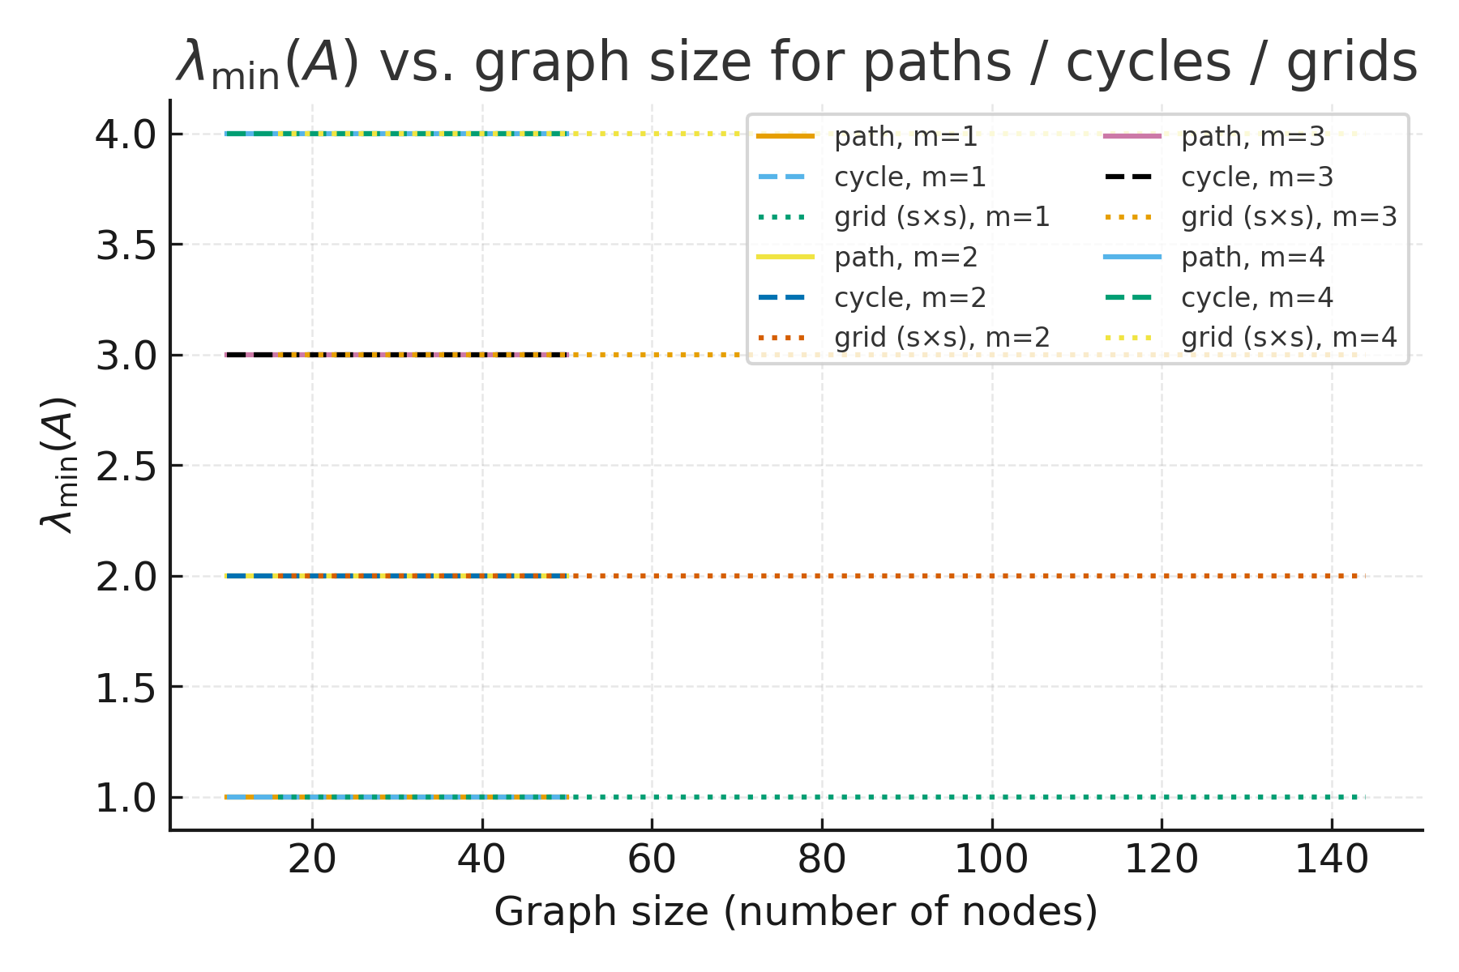
Figure 1: Numerically computed values of \lambda_{\min}(A) for paths, cycles, and 2D grids as a function of graph size, for several values of the uniform node stiffness m \in \{1,2,3,4\}. Solid lines correspond to paths, dashed lines to cycles, and dotted lines to square grids. In each case \lambda_{\min}(A) approaches m as the graph grows, consistent with the bounds \lambda_{\min}(A) \ge m and \lambda_{\min}\big(A|_{\mathcal{C}^\perp}\big) \ge m + \lambda_2(L).
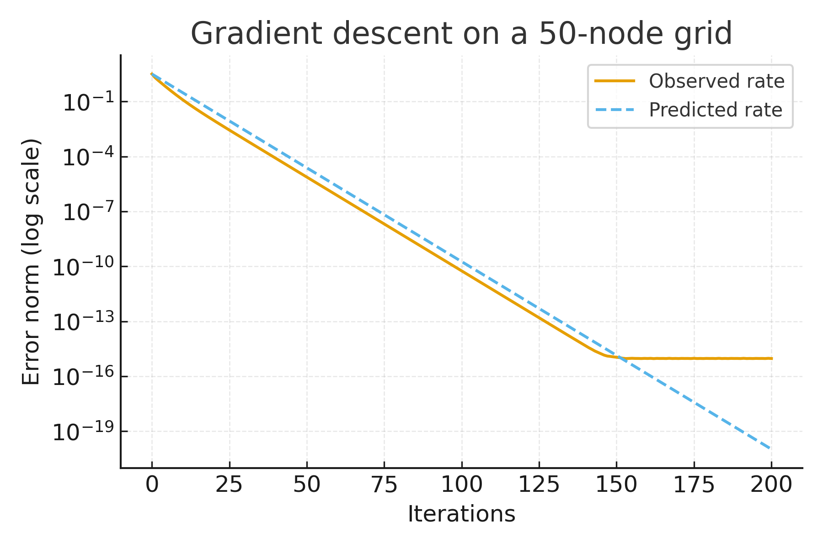
Figure 2: Gradient descent convergence on a 50-node grid (5\times 10) with M_i = I (m = 1) and step size \alpha_* = 2/(\lambda_{\max}(A)+\lambda_{\min}(A)). The solid curve shows the observed error, plotted as $\log \|e^k\|$ versus iteration $k$; the dashed curve shows the predicted rate $\rho^k$ with $\rho \approx 0.79$ computed from the condition number $\kappa(A)\approx 8.52$. After an initial transient ($k \lesssim 50$) the observed and predicted rates nearly coincide, empirically validating the spectral convergence rate.
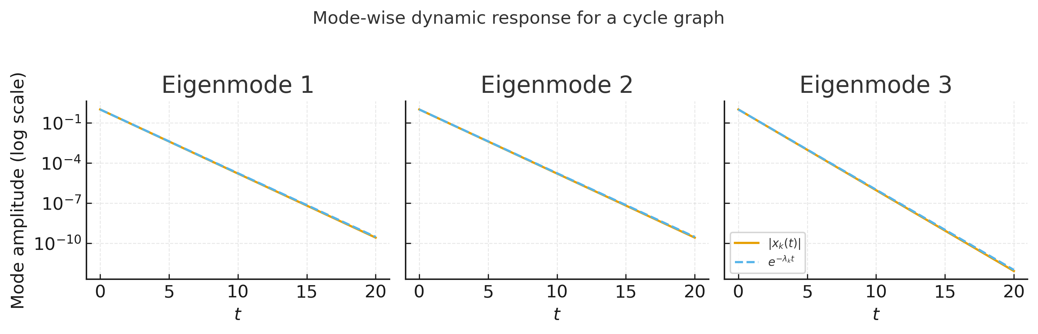
Figure 3: Mode-wise decay for the gradient flow \dot x = -A(x-x^\star) on a 20-node cycle graph with M_i = I (m = 1). For each Laplacian eigenmode k, we initialize x(0) along that mode and plot the amplitude |z_k(t)| of the corresponding component of x(t)-x^\star (solid) together with the predicted exponential envelope e^{-\lambda_k(A)t} (dashed). Modes with larger \lambda_k(L) (higher spatial frequencies) decay faster, matching the explicit eigenvalues \lambda_k(A) = \lambda_k(L)+1 and illustrating the modal structure underlying the global decay rate governed by \lambda_{\min}(A).

