1 数据库表创建及导入数据 1
2 idea创建maven+spring+mybatis项目 2
3使用mybatis-generator生成实体类和Mapper映射文件以及接口 11
3.1 pom文件引入所需插件 11
3.2 添加generatorConfig.xml 12
3.2 通过插件生成Mapper.java、Mapper.xml、POJO 13
4 实现分页 14
4.1 postman返回结果 17
5 扩展（联表查询如何分页） 17
5.1 建表插入数据 17
5.2 定义实体类、Mapper文件及Mapper接口 19
5.3查询结果 22

1 数据库表创建及导入数据
drop table if exists Payment_Info;
/*==============================================================*/
/* Table: PaymentInfo */
/*==============================================================*/
create table Payment_Info
(
Id int not null auto_increment,
AcceptId varchar(32) not null,
TransNo varchar(32) not null,
Status int not null,
CreatTime varchar(8) not null,
Extend varchar(32),
primary key (Id)
);

insert into Payment_Info (AcceptId,TransNo,Status,CreatTime,Extend) values ("A000001", "T000001", 0, "20190323","72334");
insert into Payment_Info (AcceptId,TransNo,Status,CreatTime,Extend) values ("A000002", "T000002", 0, "20190323","723se34");
insert into Payment_Info (AcceptId,TransNo,Status,CreatTime,Extend) values ("A000003", "T000003", 0, "20190323","72fsds334");
insert into Payment_Info (AcceptId,TransNo,Status,CreatTime,Extend) values ("A000004", "T000004", 0, "20190323","72fff334");
insert into Payment_Info (AcceptId,TransNo,Status,CreatTime,Extend) values ("A000005", "T000005", 0, "20190324","72334err");
insert into Payment_Info (AcceptId,TransNo,Status,CreatTime,Extend) values ("A000006", "T000006", 0, "20190324","723eee34");
insert into Payment_Info (AcceptId,TransNo,Status,CreatTime,Extend) values ("A000007", "T000007", 0, "20190323","72334");
insert into Payment_Info (AcceptId,TransNo,Status,CreatTime,Extend) values ("A000008", "T000008", 0, "20190323","723se34");
insert into Payment_Info (AcceptId,TransNo,Status,CreatTime,Extend) values ("A000009", "T000009", 0, "20190323","72fsds334");
insert into Payment_Info (AcceptId,TransNo,Status,CreatTime,Extend) values ("A000010", "T000010", 1, "20190323","72fff334");
insert into Payment_Info (AcceptId,TransNo,Status,CreatTime,Extend) values ("A000011", "T000011", 1, "20190324","72334err");
insert into Payment_Info (AcceptId,TransNo,Status,CreatTime,Extend) values ("A000012", "T000012", 1, "20190324","723eee34");
commit;

2 idea创建maven+spring+mybatis项目
jdk1.8，目录结构如下所示：
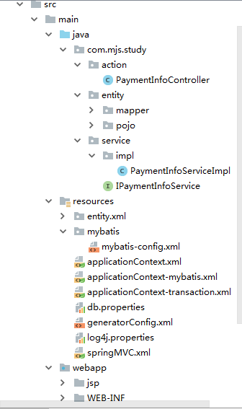
\sty\src\main\resources\mybatis\mybatis-config.xml,如下所示
<?xml version="1.0" encoding="UTF-8"?>
<!DOCTYPE configuration PUBLIC "-//mybatis.org//DTD Config 3.0//EN" "http://mybatis.org/dtd/mybatis-3-config.dtd">
<configuration>
<!-- 全局参数 -->
<settings>
<!-- 使全局的映射器启用或禁用缓存。 -->
<setting name="cacheEnabled" value="true"/>
<!-- 全局启用或禁用延迟加载。当禁用时，所有关联对象都会即时加载。 -->
<setting name="lazyLoadingEnabled" value="true"/>
<!-- 当启用时，有延迟加载属性的对象在被调用时将会完全加载任意属性。否则，每种属性将会按需要加载。 -->
<setting name="aggressiveLazyLoading" value="false"/>
<!-- 是否允许单条sql 返回多个数据集 (取决于驱动的兼容性) default:true -->
<setting name="multipleResultSetsEnabled" value="true"/>
<!-- 是否可以使用列的别名 (取决于驱动的兼容性) default:true -->
<setting name="useColumnLabel" value="true"/>
<!-- 允许JDBC 生成主键。需要驱动器支持。如果设为了true，这个设置将强制使用被生成的主键，有一些驱动器不兼容不过仍然可以执行。 default:false -->
<setting name="useGeneratedKeys" value="false"/>
<!-- 指定 MyBatis 如何自动映射 数据基表的列 NONE：不隐射 PARTIAL:部分 FULL:全部 -->
<setting name="autoMappingBehavior" value="PARTIAL"/>
<!-- 这是默认的执行类型 （SIMPLE: 简单； REUSE: 执行器可能重复使用prepared statements语句；BATCH: 执行器可以重复执行语句和批量更新） -->
<setting name="defaultExecutorType" value="SIMPLE"/>
<!-- 使用驼峰命名法转换字段。 -->
<!-- <setting name="mapUnderscoreToCamelCase" value="true"/> -->
<!-- 设置本地缓存范围 session:就会有数据的共享 statement:语句范围 (这样就不会有数据的共享 ) defalut:session -->
<setting name="localCacheScope" value="SESSION"/>
<!-- 设置但JDBC类型为空时,某些驱动程序 要指定值,default:OTHER，插入空值时不需要指定类型 -->
<setting name="jdbcTypeForNull" value="NULL"/>
</settings>
</configuration>

\src\main\resources\applicationContext.xml，如下所示：
<?xml version="1.0" encoding="UTF-8"?>
<beans xmlns="http://www.springframework.org/schema/beans"
xmlns:xsi="http://www.w3.org/2001/XMLSchema-instance" xmlns:p="http://www.springframework.org/schema/p"
xmlns:context="http://www.springframework.org/schema/context"
xsi:schemaLocation="http://www.springframework.org/schema/beans http://www.springframework.org/schema/beans/spring-beans.xsd
http://www.springframework.org/schema/context http://www.springframework.org/schema/context/spring-context.xsd">
<!-- 扫描到有@Component @Controller@Service等这些注解的类 ,则把这些类注册为bean -->
<!-- spring不要扫MVC的controller,否则引起事务失效 -->
<context:component-scan base-package="com">
<context:exclude-filter type="annotation"
expression="org.springframework.stereotype.Controller" />
</context:component-scan>
<context:property-placeholder location="classpath:db.properties" />
<!-- 数据库连接池 :dataSource -->
<bean id="dataSource" class="com.mchange.v2.c3p0.ComboPooledDataSource"
destroy-method="close">
<property name="driverClass" value="${driverClass}" />
<property name="jdbcUrl"
value="${jdbcUrl}" />
<property name="user" value="${user}" />
<property name="password" value="${password}" />
<property name="minPoolSize" value="5" />
<property name="maxPoolSize" value="100" />
<property name="maxIdleTime" value="60" />
<property name="acquireIncrement" value="3" />
<property name="maxStatements" value="100" />
<property name="initialPoolSize" value="3" />
<property name="idleConnectionTestPeriod" value="60" />
<property name="acquireRetryAttempts" value="30" />
<property name="breakAfterAcquireFailure" value="true" />
<property name="testConnectionOnCheckout" value="false" />
</bean>
</beans>

\src\main\resources\applicationContext-mybatis.xml，如下所示：
<?xml version="1.0" encoding="UTF-8"?>
<beans xmlns="http://www.springframework.org/schema/beans"
xmlns:xsi="http://www.w3.org/2001/XMLSchema-instance" xmlns:p="http://www.springframework.org/schema/p"
xmlns:context="http://www.springframework.org/schema/context"
xmlns:mvc="http://www.springframework.org/schema/mvc"
xsi:schemaLocation="http://www.springframework.org/schema/beans http://www.springframework.org/schema/beans/spring-beans.xsd
http://www.springframework.org/schema/mvc http://www.springframework.org/schema/mvc/spring-mvc-4.0.xsd
http://www.springframework.org/schema/context http://www.springframework.org/schema/context/spring-context.xsd">
<!-- 定义Mybatis的SqlSessionFactory -->
<bean id="sqlSessionFactory" class="org.mybatis.spring.SqlSessionFactoryBean">
<!-- 定义数据源 -->
<property name="dataSource" ref="dataSource" />
<!-- 指定mybatis全局配置文件 -->
<property name="configLocation" value="classpath:mybatis/mybatis-config.xml"/>
<property name="mapperLocations" value="classpath:entity/xml/*.xml" />
<!-- 别名扫描包 -->
<property name="typeAliasesPackage" value="com.mjs.study.entity"/>
<property name="plugins">
<array>
<bean class="com.github.pagehelper.PageInterceptor">
<property name="properties">
<value>
params=value1
</value>
</property>
</bean>
</array>
</property>
</bean>
<!-- 配置自动生成接口的实现类
配置 转换器，对于在basePackage设置的包（包括子包）下的接口类，如果在Mapper.xml文件中定义过，
将被转换成spring的BEAN，在调用 的地方通过@Autowired方式将可以注入接口实例-->
<bean class="org.mybatis.spring.mapper.MapperScannerConfigurer">
<property name="basePackage" value="com.mjs.study.entity.mapper" />
<property name="sqlSessionFactoryBeanName" value="sqlSessionFactory"></property>
</bean>
</beans>

\src\main\resources\applicationContext-transaction.xml,如下所示：
<beans xmlns="http://www.springframework.org/schema/beans"
xmlns:context="http://www.springframework.org/schema/context" xmlns:p="http://www.springframework.org/schema/p"
xmlns:aop="http://www.springframework.org/schema/aop" xmlns:tx="http://www.springframework.org/schema/tx"
xmlns:xsi="http://www.w3.org/2001/XMLSchema-instance"
xsi:schemaLocation="http://www.springframework.org/schema/beans http://www.springframework.org/schema/beans/spring-beans-4.0.xsd
http://www.springframework.org/schema/context http://www.springframework.org/schema/context/spring-context-4.0.xsd
http://www.springframework.org/schema/aop http://www.springframework.org/schema/aop/spring-aop-4.0.xsd http://www.springframework.org/schema/tx http://www.springframework.org/schema/tx/spring-tx-4.0.xsd
http://www.springframework.org/schema/util http://www.springframework.org/schema/util/spring-util-4.0.xsd">
<!-- 定义事务管理器 -->
<bean id="transactionManager"
class="org.springframework.jdbc.datasource.DataSourceTransactionManager">
<property name="dataSource" ref="dataSource"/>
</bean>
<!-- 定义事务策略 -->
<tx:advice id="txAdvice" transaction-manager="transactionManager">
<tx:attributes>
<!--所有以query开头的方法都是只读的 -->
<tx:method name="query*" read-only="true"/>
<!--其他方法使用默认事务策略 -->
<tx:method name="*"/>
</tx:attributes>
</tx:advice>
<!--<aop:config>
&lt;!&ndash;pointcut元素定义一个切入点，execution中的第一个星号 用以匹配方法的返回类型，
这里星号表明匹配所有返回类型。 com.abc.dao.*.*(..)表明匹配com.service包下的所有类的所有
方法 &ndash;&gt;
<aop:pointcut id="myPointcut" expression="execution(* com.mjs.study.service.*.*(..))"/>
&lt;!&ndash;将定义好的事务处理策略应用到上述的切入点 &ndash;&gt;
<aop:advisor advice-ref="txAdvice" pointcut-ref="myPointcut"/>
</aop:config>-->
</beans>

\src\main\resources\db.properties，如下所示：
user=root
password=
driverClass=com.mysql.jdbc.Driver
jdbcUrl=jdbc:mysql://127.0.0.1/mjs

\src\main\resources\springMVC.xml，如下图所示：
<?xml version="1.0" encoding="UTF-8"?>
<beans xmlns="http://www.springframework.org/schema/beans"
xmlns:xsi="http://www.w3.org/2001/XMLSchema-instance" xmlns:p="http://www.springframework.org/schema/p"
xmlns:context="http://www.springframework.org/schema/context"
xmlns:mvc="http://www.springframework.org/schema/mvc"
xsi:schemaLocation="http://www.springframework.org/schema/beans http://www.springframework.org/schema/beans/spring-beans.xsd
http://www.springframework.org/schema/mvc http://www.springframework.org/schema/mvc/spring-mvc-4.0.xsd
http://www.springframework.org/schema/context http://www.springframework.org/schema/context/spring-context.xsd">
<!-- 同时开启json格式的支持 -->
<mvc:annotation-driven></mvc:annotation-driven>
<!-- spring mvc 扫描所有的controller 但是不扫描service -->
<context:component-scan base-package="com.mjs.study.action">
<context:include-filter type="annotation"
expression="org.springframework.stereotype.Controller"/>
</context:component-scan>
<!-- 对模型视图名称的解析，即在模型视图名称添加前后缀 -->
<bean class="org.springframework.web.servlet.view.InternalResourceViewResolver">
<property name="prefix" value="/jsp/"/>
<property name="suffix" value=".jsp"/><!--可为空,方便实现自已的依据扩展名来选择视图解释类的逻辑 -->
</bean>
</beans>

web.xml,如下图所示：
<?xml version="1.0" encoding="UTF-8"?>
<web-app xmlns:xsi="http://www.w3.org/2001/XMLSchema-instance"
xmlns="http://java.sun.com/xml/ns/javaee"
xsi:schemaLocation="http://java.sun.com/xml/ns/javaee http://java.sun.com/xml/ns/javaee/web-app_2_5.xsd"
id="MyWebApp" version="2.5">
<display-name>my</display-name>
<!-- 加载(spring自身的,事务,mybatis)配置文件-->
<context-param>
<param-name>contextConfigLocation</param-name>
<param-value>classpath*:applicationContext.xml,
classpath*:applicationContext-mybatis.xml,
classpath*:applicationContext-transaction.xml
</param-value>
</context-param>
<!-- 防止spring内存溢出监听器 -->
<listener>
<listener-class>org.springframework.web.util.IntrospectorCleanupListener</listener-class>
</listener>
<!--Spring的ApplicationContext 载入：Spring的监听器 -->
<listener>
<listener-class>org.springframework.web.context.ContextLoaderListener</listener-class>
</listener>
<!-- 加载SpringMVC的配置文件-->
<servlet>
<servlet-name>SpringMVC</servlet-name>
<servlet-class>org.springframework.web.servlet.DispatcherServlet</servlet-class>
<init-param>
<param-name>contextConfigLocation</param-name>
<param-value>classpath*:springMVC.xml</param-value>
</init-param>
<load-on-startup>1</load-on-startup>
</servlet>
<servlet-mapping>
<servlet-name>SpringMVC</servlet-name>
<url-pattern>/</url-pattern>
</servlet-mapping>
<filter>
<description>字符集过滤器</description>
<filter-name>encodingFilter</filter-name>
<filter-class>org.springframework.web.filter.CharacterEncodingFilter</filter-class>
<init-param>
<description>字符集编码</description>
<param-name>encoding</param-name>
<param-value>UTF-8</param-value>
</init-param>
</filter>
<filter-mapping>
<filter-name>encodingFilter</filter-name>
<url-pattern>/*</url-pattern>
</filter-mapping>
<!-- 配置session超时时间，单位分钟 -->
<session-config>
<session-timeout>60</session-timeout>
</session-config>
<!-- DEFAULT PAGE -->
<welcome-file-list>
<welcome-file>index.jsp</welcome-file>
</welcome-file-list>
</web-app>

3使用mybatis-generator生成实体类和Mapper映射文件以及接口
MyBatis官方提供了逆向工程 mybatis-generator，可以针对数据库表自动生成MyBatis执行所需要的代码（如Mapper.java、Mapper.xml、POJO）。主要有命令行及插件方式，本次使用maven插件方式生成。

3.1 pom文件引入所需插件
<!-- 与pluginManagement 同一级，否则在idea右侧Plugins无法显示 -->
<plugins>
<plugin>
<groupId>org.mybatis.generator</groupId>
<artifactId>mybatis-generator-maven-plugin</artifactId>
<version>1.3.2</version>
<configuration>
<!--配置文件的位置-->
<configurationFile>src/main/resources/generatorConfig.xml</configurationFile>
<verbose>true</verbose>
<overwrite>true</overwrite>
</configuration>
<executions>
<execution>
<id>Generate MyBatis Artifacts</id>
<goals>
<goal>generate</goal>
</goals>
</execution>
</executions>
<dependencies>
<dependency>
<groupId>org.mybatis.generator</groupId>
<artifactId>mybatis-generator-core</artifactId>
<version>1.3.2</version>
</dependency>
</dependencies>
</plugin>
</plugins>

3.2 添加generatorConfig.xml
在resources目录添加generatorConfig.xml文件，内容如下所示：
<?xml version="1.0" encoding="UTF-8"?>
<!DOCTYPE generatorConfiguration
PUBLIC "-//mybatis.org//DTD MyBatis Generator Configuration 1.0//EN"
"http://mybatis.org/dtd/mybatis-generator-config_1_0.dtd">
<generatorConfiguration>
<!--mysql 连接数据库jar 这里选择自己本地位置-->
<classPathEntry location="D:\Repositories\Maven\mysql\mysql-connector-java\5.1.38\mysql-connector-java-5.1.38.jar" />
<context id="testTables" targetRuntime="MyBatis3">
<commentGenerator>
<!-- 是否去除自动生成的注释 true：是 ： false:否 -->
<property name="suppressAllComments" value="true" />
</commentGenerator>
<!--数据库连接的信息：驱动类、连接地址、用户名、密码 -->
<jdbcConnection driverClass="com.mysql.jdbc.Driver"
connectionURL="jdbc:mysql://127.0.0.1/mjs" userId="root"
password="">
</jdbcConnection>
<!-- 默认false，把JDBC DECIMAL 和 NUMERIC 类型解析为 Integer，为 true时把JDBC DECIMAL 和
NUMERIC 类型解析为java.math.BigDecimal -->
<javaTypeResolver>
<property name="forceBigDecimals" value="false" />
</javaTypeResolver>
<!-- targetProject:生成PO类的位置 -->
<javaModelGenerator targetPackage="com.mjs.study.entity.pojo"
targetProject="src/main/java">
<!-- enableSubPackages:是否让schema作为包的后缀 -->
<property name="enableSubPackages" value="false" />
<!-- 从数据库返回的值被清理前后的空格 -->
<property name="trimStrings" value="true" />
</javaModelGenerator>
<!-- targetProject:mapper映射文件生成的位置
如果maven工程只是单独的一个工程，targetProject="src/main/java"
若果maven工程是分模块的工程，targetProject="所属模块的名称"，例如：
targetProject="ecps-manager-mapper"，下同-->
<sqlMapGenerator targetPackage="entity.xml"
targetProject="src/main/resources">
<!-- enableSubPackages:是否让schema作为包的后缀 -->
<property name="enableSubPackages" value="false" />
</sqlMapGenerator>
<!-- targetPackage：mapper接口生成的位置 -->
<javaClientGenerator type="XMLMAPPER"
targetPackage="com.mjs.study.entity.mapper"
targetProject="src/main/java">
<!-- enableSubPackages:是否让schema作为包的后缀 -->
<property name="enableSubPackages" value="false" />
</javaClientGenerator>
<!-- 指定数据库表 -->
<table schema="" tableName="Payment_Info">
<!--<property name="useActualColumnNames" value="true" />-->
</table>
</context>
</generatorConfiguration>

3.2 通过插件生成Mapper.java、Mapper.xml、POJO
右键选择运行即可。
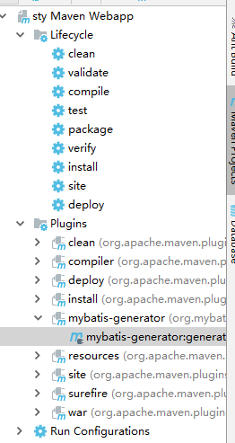

4 实现分页
pagehelper的实现方式，详细参考https://github.com/pagehelper/Mybatis-PageHelper/blob/master/wikis/zh/HowToUse.md。
//第一种，RowBounds方式的调用
List<Country> list = sqlSession.selectList("x.y.selectIf", null, new RowBounds(0, 10));

//第二种，Mapper接口方式的调用，推荐这种使用方式。
PageHelper.startPage(1, 10);
List<Country> list = countryMapper.selectIf(1);

//第三种，Mapper接口方式的调用，推荐这种使用方式。
PageHelper.offsetPage(1, 10);
List<Country> list = countryMapper.selectIf(1);

//第四种，参数方法调用
//存在以下 Mapper 接口方法，你不需要在 xml 处理后两个参数
public interface CountryMapper {
List<Country> selectByPageNumSize(
@Param("user") User user,
@Param("pageNum") int pageNum,
@Param("pageSize") int pageSize);
}
//配置supportMethodsArguments=true
//在代码中直接调用：
List<Country> list = countryMapper.selectByPageNumSize(user, 1, 10);
……

项目使用第二种方式进行调用，具体代码如下所示：
Controller层
package com.mjs.study.action;
import com.github.pagehelper.PageInfo;
import com.mjs.study.service.IPaymentInfoService;
import org.slf4j.Logger;
import org.slf4j.LoggerFactory;
import org.springframework.beans.factory.annotation.Autowired;
import org.springframework.stereotype.Controller;
import org.springframework.web.bind.annotation.*;
/**
* @Description 订单信息控制层
* @ClassName PaymentInfoController
* @Author Administrator
* @Data 2019/9/18 2:44
* @Version 1.0
*/
@Controller
@RequestMapping("/paymentInfo")
public class PaymentInfoController {
private static final Logger logger = LoggerFactory.getLogger(PaymentInfoController.class);
@Autowired
private IPaymentInfoService paymentInfoService;
@RequestMapping(value = "/search", method = RequestMethod.GET)
@ResponseBody
public PageInfo getPaymentInfos(@RequestParam(required = false) String status,
@RequestParam(required = false, defaultValue = "0") Integer pageNum,
@RequestParam(required = false, defaultValue = "5") Integer pageSize){
logger.debug("订单信息控制层");
return paymentInfoService.getPaymentInfos(status, pageNum, pageSize);
}
}

service实现层(忽略接口层代码)
package com.mjs.study.service.impl;
import com.github.pagehelper.PageHelper;
import com.github.pagehelper.PageInfo;
import com.mjs.study.entity.mapper.PaymentInfoMapper;
import com.mjs.study.entity.pojo.PaymentInfo;
import com.mjs.study.entity.pojo.PaymentInfoExample;
import com.mjs.study.service.IPaymentInfoService;
import org.springframework.beans.factory.annotation.Autowired;
import org.springframework.stereotype.Service;
import java.util.List;
/**
* @Description 订单信息实现层
* @ClassName PaymentInfoServiceImpl
* @Author Administrator
* @Data 2019/9/18 18:33
* @Version 1.0
*/
@Service
public class PaymentInfoServiceImpl implements IPaymentInfoService{
@Autowired
private PaymentInfoMapper paymentInfoMapper;
/**
* 查询订单信息
* @param status 订单状态
* @param pageNum
* @param pageSize
* @return
*/
@Override
public PageInfo getPaymentInfos(String status, Integer pageNum, Integer pageSize) {
pageNum = pageNum == null ? 1 : pageNum;
pageSize = pageSize == null ? 10 : pageSize;
PageHelper.startPage(pageNum, pageSize);
PaymentInfoExample example = new PaymentInfoExample();
example.createCriteria().andStatusEqualTo(Integer.valueOf(status));
List<PaymentInfo> list = paymentInfoMapper.selectByExample(example);
return new PageInfo(list);
}
}

4.1 postman返回结果
http://localhost:8080/sty/paymentInfo/search.action?status=0&pageNum=2&pageSize=5
返回结果如下所示：
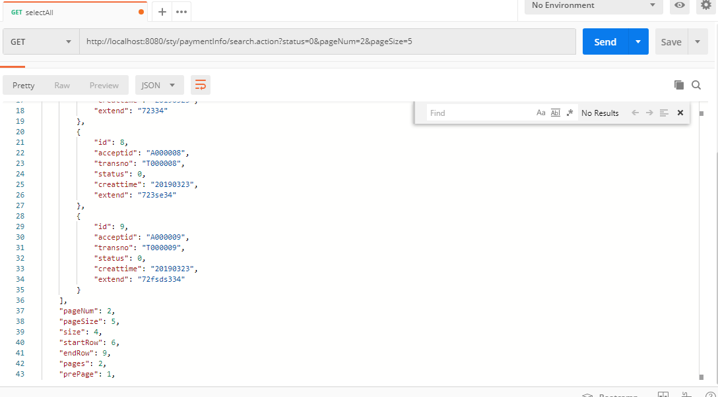

5 扩展（联表查询如何分页）

5.1 建表插入数据
首先建立退款表，脚本如下所示：
drop table if exists Refund_Info;
/*==============================================================*/
/* Table: PaymentInfo */
/*==============================================================*/
create table Refund_Info
(
Id int not null auto_increment,
TransNo varchar(32) not null,
Amt decimal(10,2) not null,
Status int not null,
CreatTime varchar(8) not null,
Extend varchar(32),
primary key (Id)
);

insert into Refund_Info (TransNo,Amt,Status,CreatTime,Extend) values ("T000001", 10.1, 1, "20190324","723eee34");
insert into Refund_Info (TransNo,Amt,Status,CreatTime,Extend) values ("T000002", 10.1, 1, "20190324","723eee34");
insert into Refund_Info (TransNo,Amt,Status,CreatTime,Extend) values ("T000003", 10.1, 1, "20190324","723eee34");
insert into Refund_Info (TransNo,Amt,Status,CreatTime,Extend) values ("T000012", 10.1, 1, "20190324","723eee34");
insert into Refund_Info (TransNo,Amt,Status,CreatTime,Extend) values ("T000012", 10.2, 1, "20190324","723eee34");
insert into Refund_Info (TransNo,Amt,Status,CreatTime,Extend) values ("T000012", 10.3, 1, "20190324","723eee34");
insert into Refund_Info (TransNo,Amt,Status,CreatTime,Extend) values ("T000012", 10.4, 1, "20190324","723eee34");
insert into Refund_Info (TransNo,Amt,Status,CreatTime,Extend) values ("T000012", 10.5, 1, "20190324","723eee34");
insert into Refund_Info (TransNo,Amt,Status,CreatTime,Extend) values ("T000012", 10.6, 1, "20190324","723eee34");
insert into Refund_Info (TransNo,Amt,Status,CreatTime,Extend) values ("T000012", 10.7, 1, "20190324","723eee34");
insert into Refund_Info (TransNo,Amt,Status,CreatTime,Extend) values ("T000012", 10.8, 1, "20190324","723eee34");
insert into Refund_Info (TransNo,Amt,Status,CreatTime,Extend) values ("T000012", 10.9, 1, "20190324","723eee34");
insert into Refund_Info (TransNo,Amt,Status,CreatTime,Extend) values ("T000012", 10.8, 2, "20190324","723eee34");
insert into Refund_Info (TransNo,Amt,Status,CreatTime,Extend) values ("T000012", 10.9, 3, "20190324","723eee34");
insert into Refund_Info (TransNo,Amt,Status,CreatTime,Extend) values ("T000012", 10.8, 4, "20190324","723eee34");
insert into Refund_Info (TransNo,Amt,Status,CreatTime,Extend) values ("T000012", 10.9, 5, "20190324","723eee34");
commit;

需要实现以下功能
select distinct
p.id as PId,
p.AcceptId,
p.TransNo,
p.status AS PStatus,
p.creatTime AS PCreatTime,
p.extend AS PExtend,
r.id AS RID,
r.Amt,
r.status AS RStatus,
r.creatTime AS RCreatTime,
r.extend AS RExtend
from
Payment_Info p, Refund_Info r
where p.TransNo=r.TransNo
查询结果：
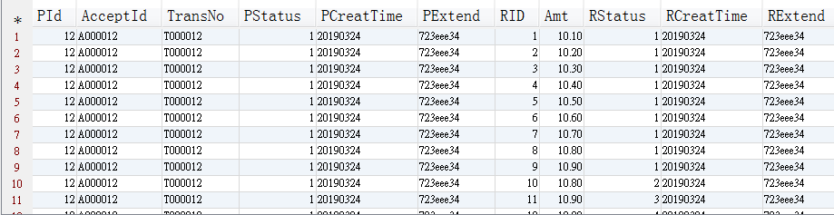

5.2 定义实体类、Mapper文件及Mapper接口

RefundInfo使用mybatis generator生成器生成。
关联表实体类：
package com.mjs.study.entity.pojo;
import java.util.List;
/**
* @Description 订单对应的退款记录
* @ClassName PaymentRefundInfo
* @Author Administrator
* @Data 2019/9/19 8:59
* @Version 1.0
*/
public class PaymentRefundInfo extends PaymentInfo{
private List<RefundInfo> lists;
public List<RefundInfo> getLists() {
return lists;
}
public void setLists(List<RefundInfo> lists) {
this.lists = lists;
}
}

mapper xml文件
<?xml version="1.0" encoding="UTF-8" ?>
<!DOCTYPE mapper PUBLIC "-//mybatis.org//DTD Mapper 3.0//EN" "http://mybatis.org/dtd/mybatis-3-mapper.dtd" >
<mapper namespace="com.mjs.study.entity.mapper.PaymentRefundInfoMapper" >
<resultMap id="paymentRefundMap" type="com.mjs.study.entity.pojo.PaymentRefundInfo">
<id column="PId" property="id" jdbcType="INTEGER" />
<result column="AcceptId" property="acceptid" jdbcType="VARCHAR" />
<result column="TransNo" property="transno" jdbcType="VARCHAR" />
<result column="PStatus" property="status" jdbcType="INTEGER" />
<result column="PCreatTime" property="creattime" jdbcType="VARCHAR" />
<result column="PExtend" property="extend" jdbcType="VARCHAR" />
<collection property="lists" ofType="com.mjs.study.entity.pojo.RefundInfo">
<id column="RID" property="id" jdbcType="INTEGER" />
<result column="TransNo" property="transno" jdbcType="VARCHAR" />
<result column="Amt" property="amt" jdbcType="DECIMAL" />
<result column="RStatus" property="status" jdbcType="INTEGER" />
<result column="RCreatTime" property="creattime" jdbcType="VARCHAR" />
<result column="RExtend" property="extend" jdbcType="VARCHAR" />
</collection>
</resultMap>
<select id="findPaymentRefundList" resultMap="paymentRefundMap">
select distinct
p.id as PId,
p.AcceptId,
p.TransNo,
p.status AS PStatus,
p.creatTime AS PCreatTime,
p.extend AS PExtend,
r.id AS RID,
r.Amt,
r.status AS RStatus,
r.creatTime AS RCreatTime,
r.extend AS RExtend
from
Payment_Info p, Refund_Info r
where p.TransNo=r.TransNo
</select>
</mapper>

关联表Mapper接口：
package com.mjs.study.entity.mapper;
import com.mjs.study.entity.pojo.PaymentRefundInfo;
import java.util.List;
/**
* @Description 订单退款信息关联查询
* @ClassName PaymentRefundInfoMapper
* @Author Administrator
* @Data 2019/9/19 9:29
* @Version 1.0
*/
public interface PaymentRefundInfoMapper {
List<PaymentRefundInfo> findPaymentRefundList();
}

service层代码：
@Override
public PageInfo findPaymentRefundList(String status, Integer pageNum, Integer pageSize){
pageNum = pageNum == null ? 1 : pageNum;
pageSize = pageSize == null ? 10 : pageSize;
PageHelper.startPage(pageNum, pageSize);
List<PaymentRefundInfo> list = paymentRefundInfoMapper.findPaymentRefundList();
return new PageInfo(list);
}

5.3查询结果
注意：该种方式total是有问题的，需要重新处理一下total
