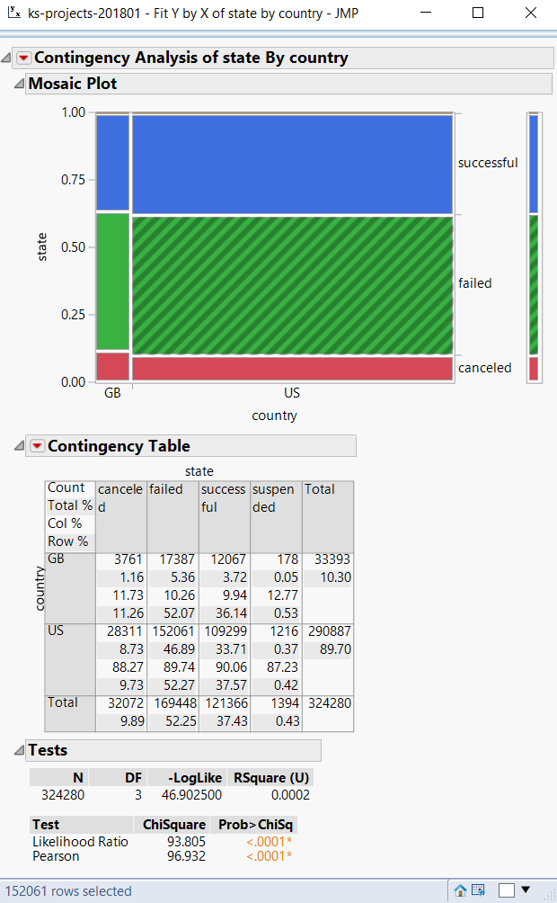

As you can see here, American Kickstarter campaigns were more likely to succeed and more likely to fail, but were less likely to be canceled. The difference in success was greater than the difference in failure. Due to the large numbers involved, the difference of roughly one percent rendered the possibility of no difference between the countries at less than one ten-thousandth of one percent on both the Likelihood Ratio and the Pearson test. Possible reasons include America ranking higher on the world giving index, and thus more inclined to support these projects. The multiple times higher percentage of suspended campaigns could be a result of American culture’s emphasis on business success, leading to people trying ethically or legally dubious plots to raise Kickstarter money.

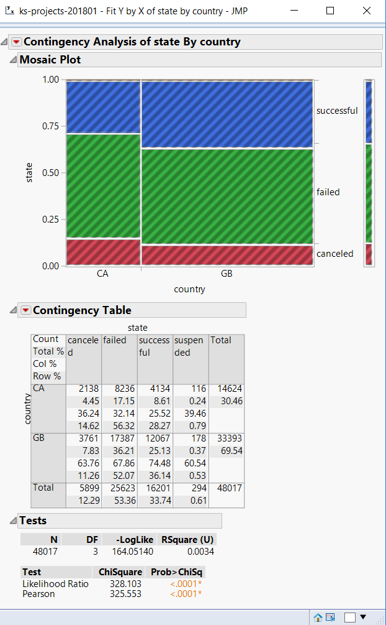

Analyzing the difference between Great Britain and Canada, the second and third largest countries in terms of Kickstarter projects, we can see that Great Britain has a higher percentage of successes, and a lower percentage of failed or suspended campaigns. This does not square well with earlier assumptions related to the world giving index. Canada has consistently been higher than Great Britain, but nonetheless has less successful campaigns. More research is needed to understand this. It is possible that the United States, Great Britain, and Canada have different types of kick starters, and these campaigns simply have different success rates.

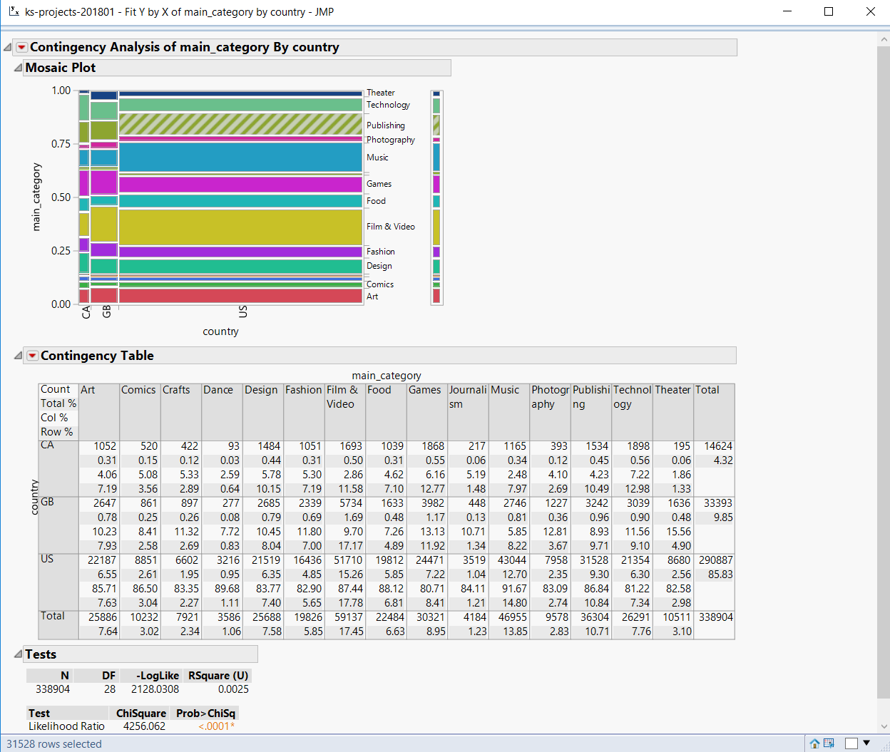

This table demonstrates that the top three countries for Kickstarter campaigns, the US, Canada, and Great Britain. All categories had some skew towards one country or another, with some stronger than others. Categories with disproportionate American interest included Dance and Music. Categories with disproportionate British interest included Art, Photography, and Theater. Areas with disproportionate Canadian interest included Comics, Crafts, Design, Food, Games, and Technology. Clearly, different countries have different interests in terms of produced Kickstarter projects. However, this may not be the full picture. This graph demonstrates all Kickstarter projects, but completed ones could be a different story.

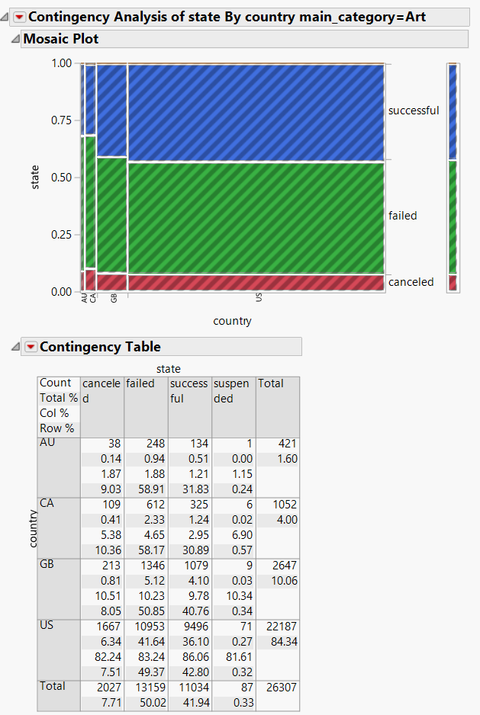

This table shows the success rates of campaigns with the ART category. As we can see, they were more successful in the United States and Great Britain than in Australia and Canada the different success rates overall could be to blame. Tests in other categories are necessary. 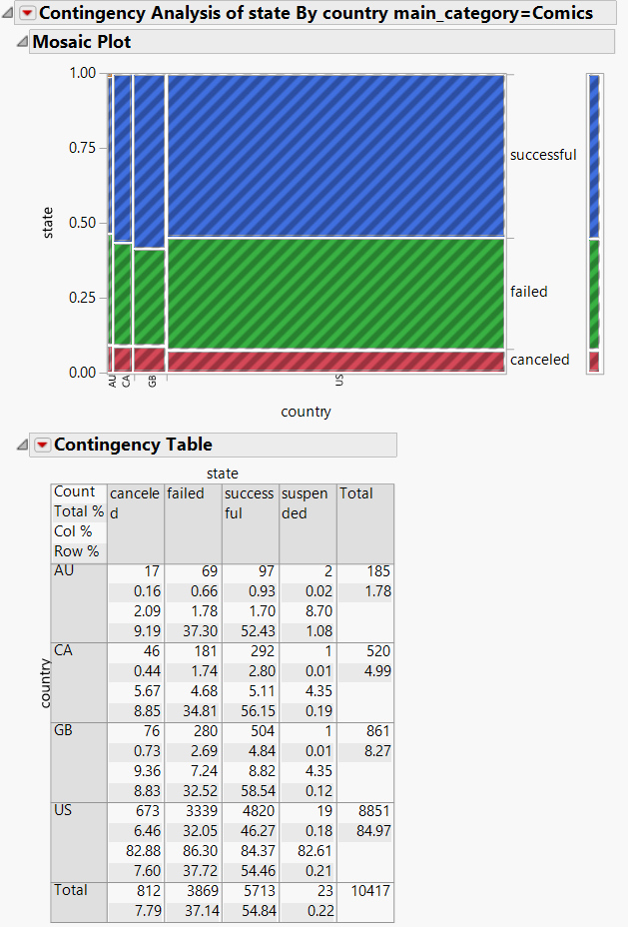

Here, we can see that the Comics category was in fact less likely to succeed than other categories in the United States despite the higher overall rate of success amongst Kickstarter campaigns in the United States.

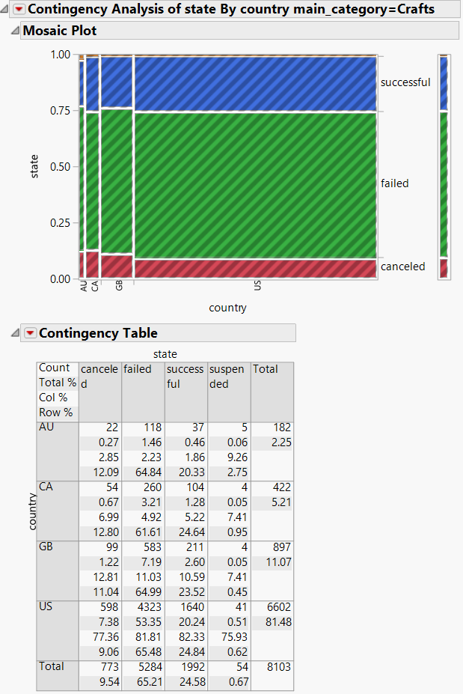

Crafts is closer to equal, but not quite. Overall, it is lower than others. A future test must be to determine which types are more successful irrespective of country. 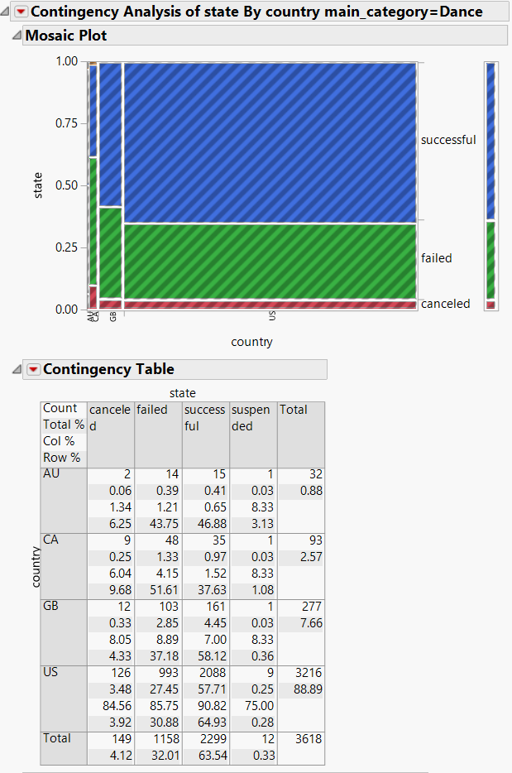

Dance Kickstarter projects were wildly varied, ranging from highly successful campaigns in the United States and Great Britain, to less effective campaigns in Canada and Australia.

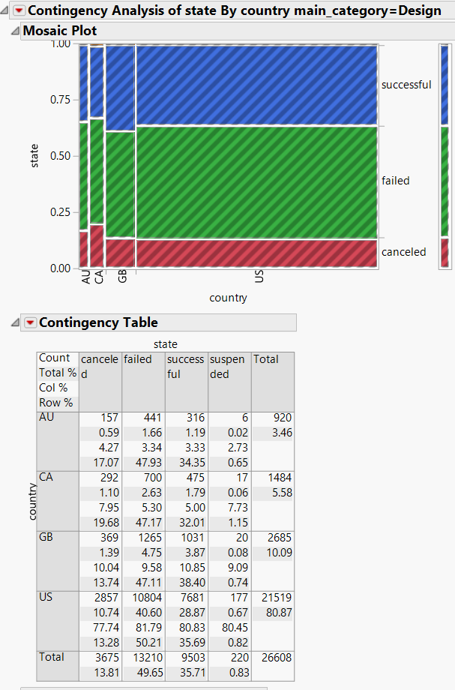

Design found disproportionate success in Greet Britain, and less in other countries. 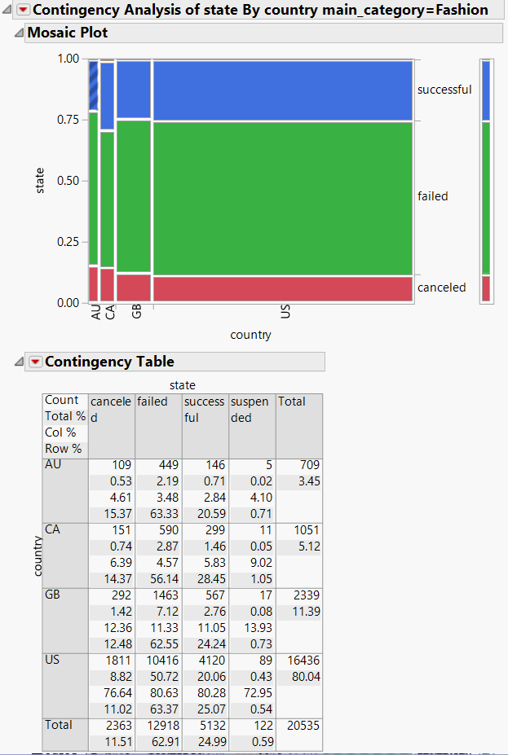

Fashion found more success in Canada than in other countries. It was not particularly disproportionate however. 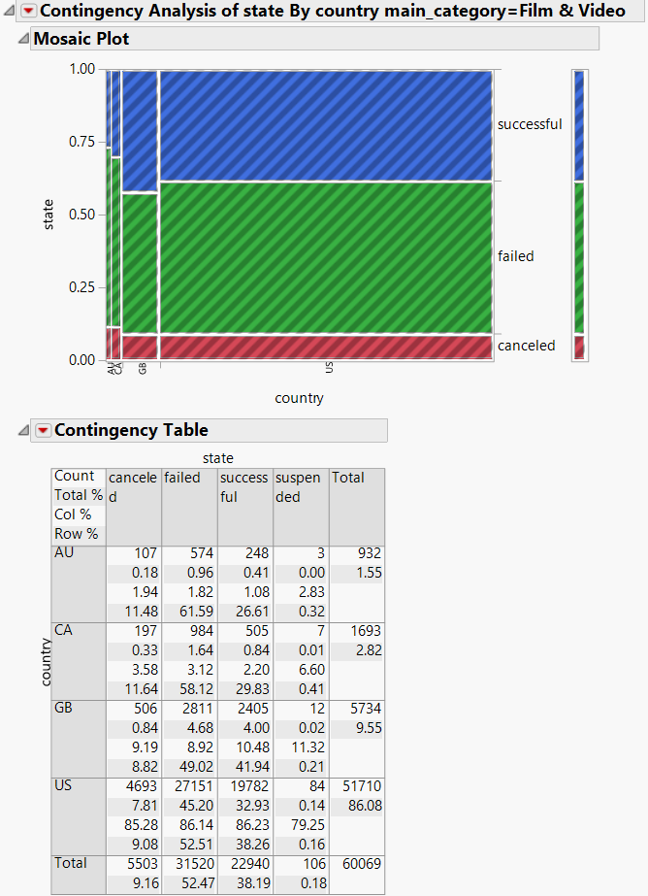

Film and Video was disproportionately successful in Great Britain, and particularly unsuccessful in Australia and Canada. Notably, the UK had a higher average rate of Film and Video Kickstarter campaigns than Canada, equal to the United States. This may partially explain the abnormal success rate.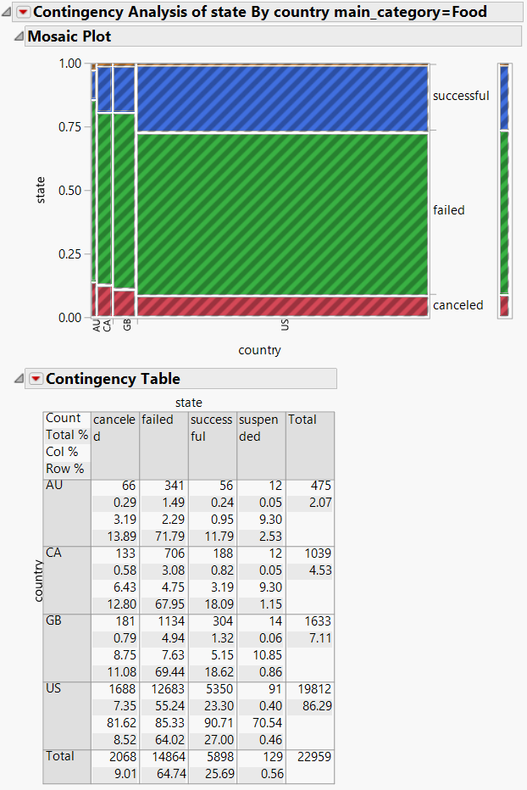

Food campaign’s had more success in the United States than in other countries. Canada had more interest relatively speaking, and the United States less. Canada caught up to the UK, but the UK did not catch up to the United States. This suggests that overall interest is not a major factor in overall success rates of Kickstarter campaigns.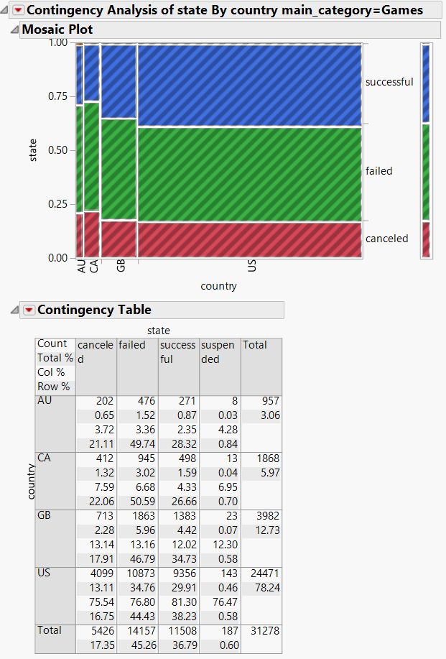

Games campaigns had particular success in the United States, and to a lesser extend Great Britain. As with Food, the Games Kickstarter campaign’s suggest that the much higher interest outside of the United States was not a major factor in .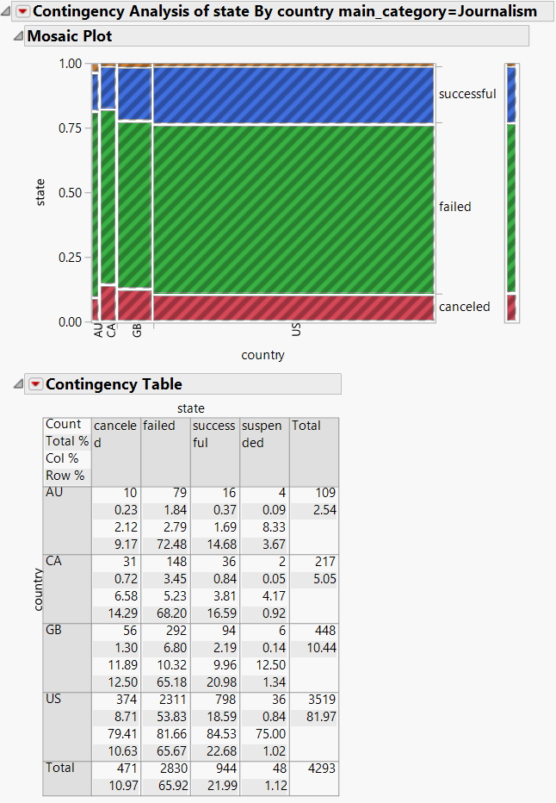Journalism Kickstarter campaigns were not particularly different among countries, or particularly successful. They were average. This is despite somewhat higher interest in Canada and Great Britain relative to the United States.

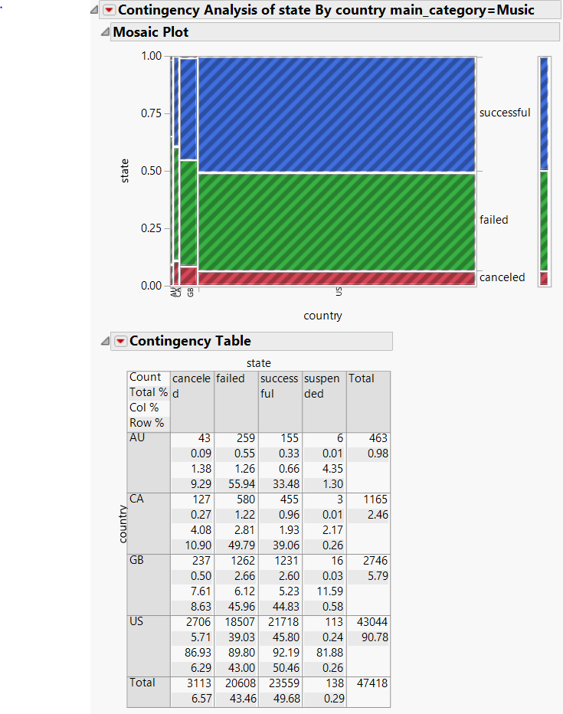The Music campaigns were particularly successful, and as usual an edge was present with the United States. There was not a great difference in the United States, despite much higher interest, about 8% in the UK and Canada, but 14% in the United States.

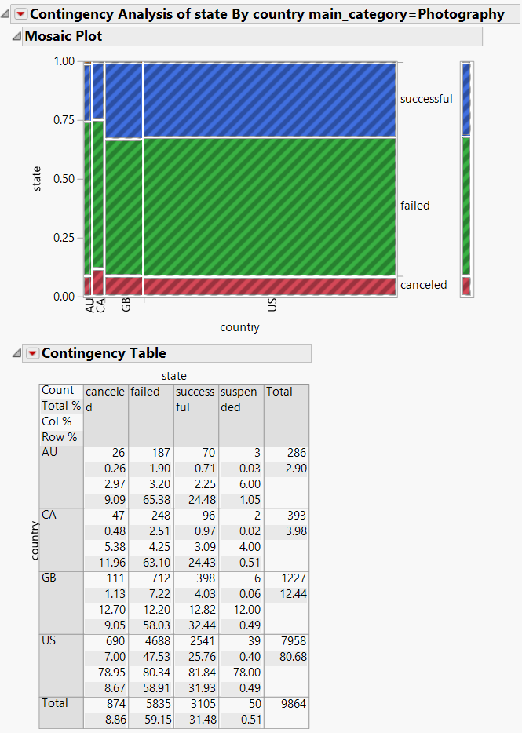

Photography followed the pattern of being marginally more successful in the US and UK than in Canada and Australia. The UK did have a higher percentage of interest in photography, but previous elements have suggested that this is not in fact the reason for the higher levels of success in the UK.

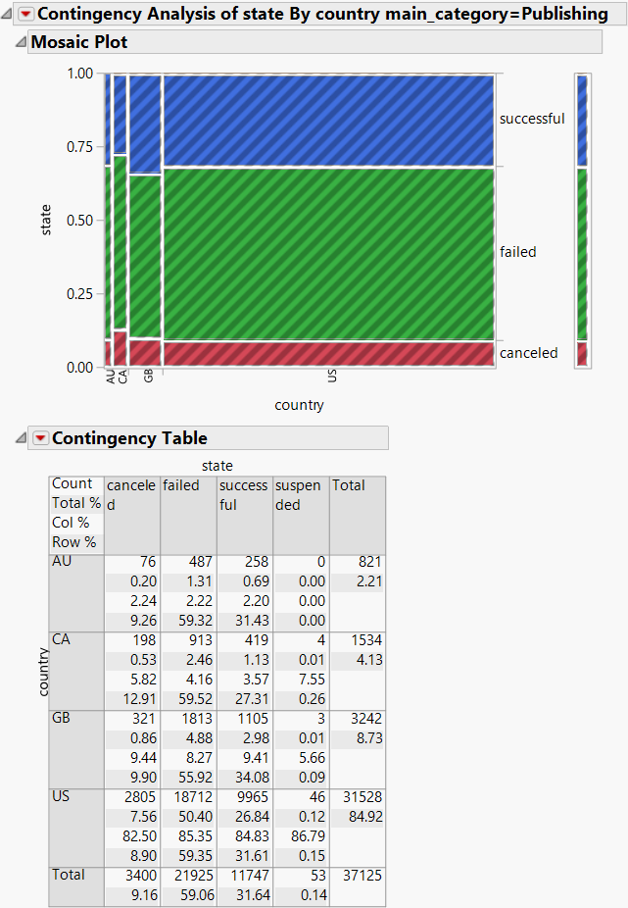Publishing was more successful in the UK, and less successful in Canada. The UK had a higher success rate, but a lower overall number of Campaigns. Here, we have another example where higher prevalence of one type of campaign does not mean tit will be more successful.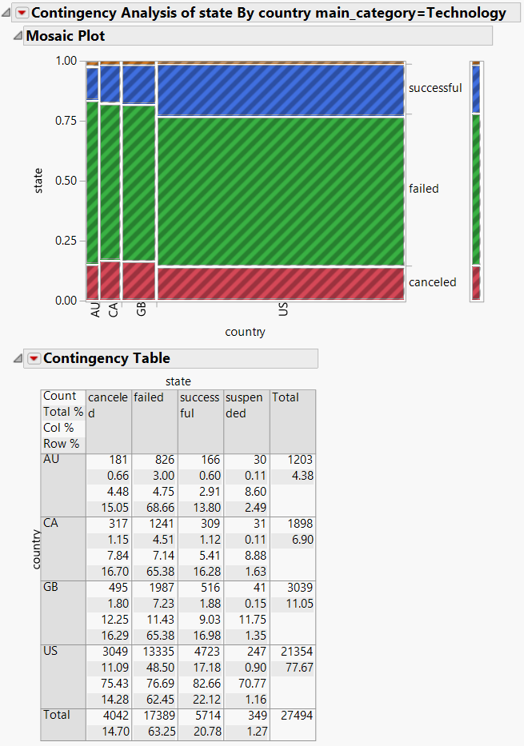

Technology was more successful in the Unites States, and less so in descending order from the UK, Canada, and Australia. It was in line with the average overall. Percentagewise, there was less interest from Americans, but still there was a higher percentage of success. More evidence that high percentage of interest does not mean higher success.

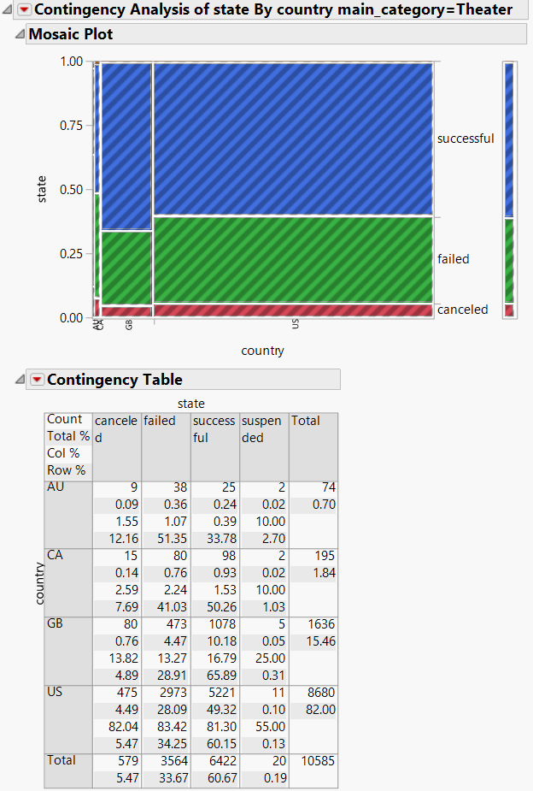

Theater was most successful in the UK, second place in the United States, third in Canada, and Fourth in Australia. After this, it is necessary to get an overall view of success rates in the four countries, as well as success rates of each of the categories. 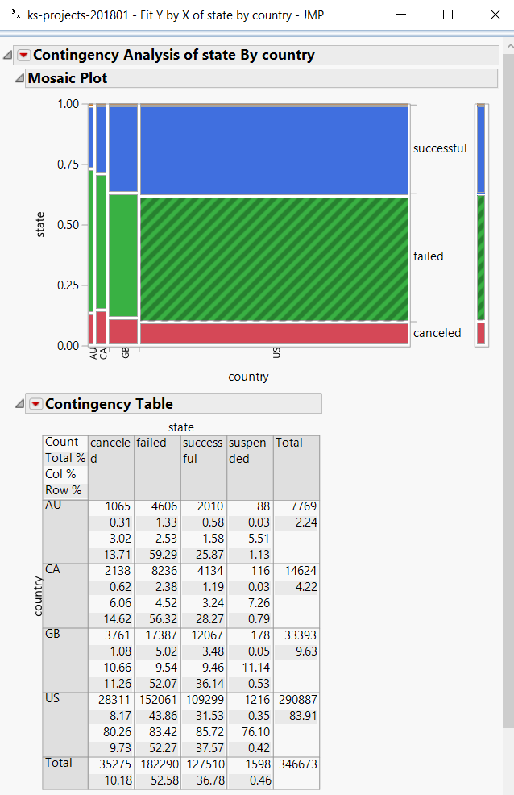

As has been seen before, America slighyly edges out Great Britian for overal suces, follwed by Canada and Australia.

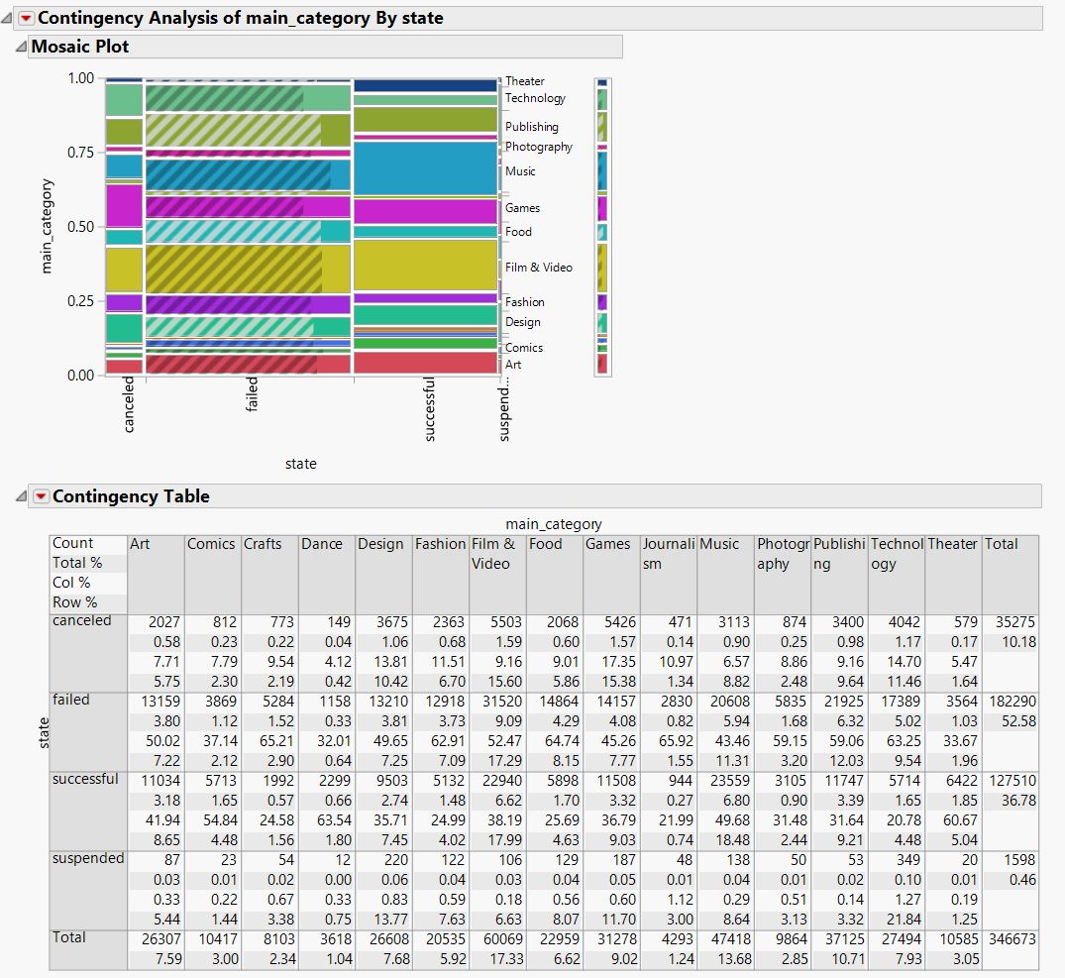

Here, we can observe that there are simply different success rates for different projects. While different countries have different levels of success for individual projects, the overall trend is clear from looking back at the projects. The United States has the overall highest success rate, followed by the United Kingdom, Canada, and Australia.

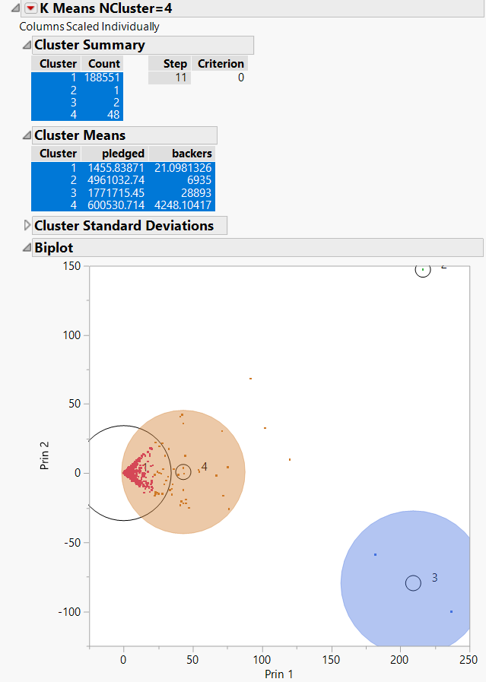

Analyzing the relationship between the number of backers and the money taken in in United States Dollars revealed a great many outliers. Excluding projects that received zero donations and astronomical amounts, there nonetheless was a real presence of outliers. The majority of Kickstarter were much less than a thousand dollars.

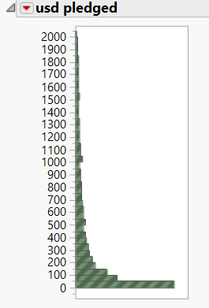

Here, we can observe even the difference amongst Kickstarters making less than two thousand dollars. There are an even smaller number as the value taken in goes up.

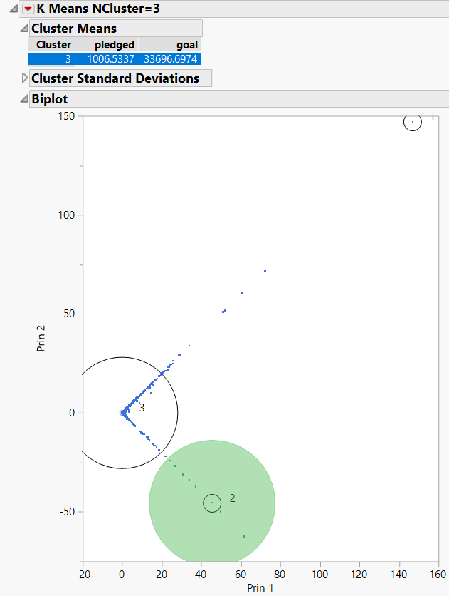

It would appear, given this chart, that there is no real clustering of backers and money raised, just a straight line. Average money per backer may be different, but in all likelihood is not.

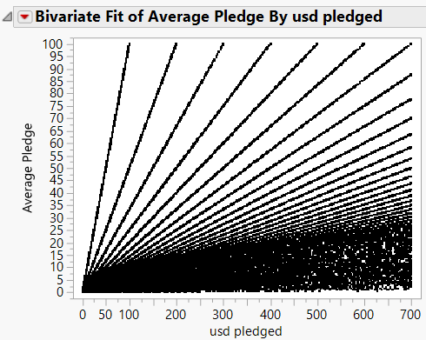

This is an unexpected result. It would appear that there is a correlation between the average pledge and the overall pledge, with several different groups. These were not immediately apparent in clustering, but here are quite clear.

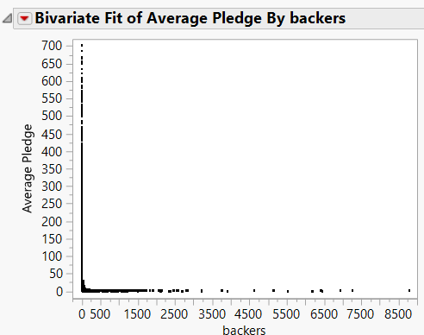

Another interesting note is that there seems to generally be less bakers if there is a high average pledge, ultimately this makes sense. Projects with mega donors usually would be expected to have a few wealthy individuals covering the entire cost. A closer look ought to be undertaken to see if there is anything interesting up close to the majority of them.

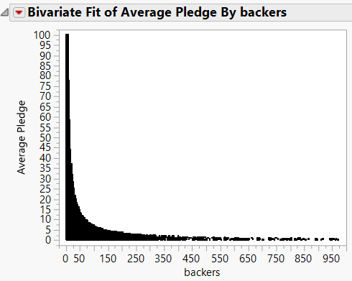

A closer look at the Kickstarters demonstrates that there is an inverse relationship between the number of backers and the average pledge per backer. This is a big deal for understanding how Kickstarter projects work. Aparently, the different lines of the average pledged vs the total pledged are from different parts of the above graph.

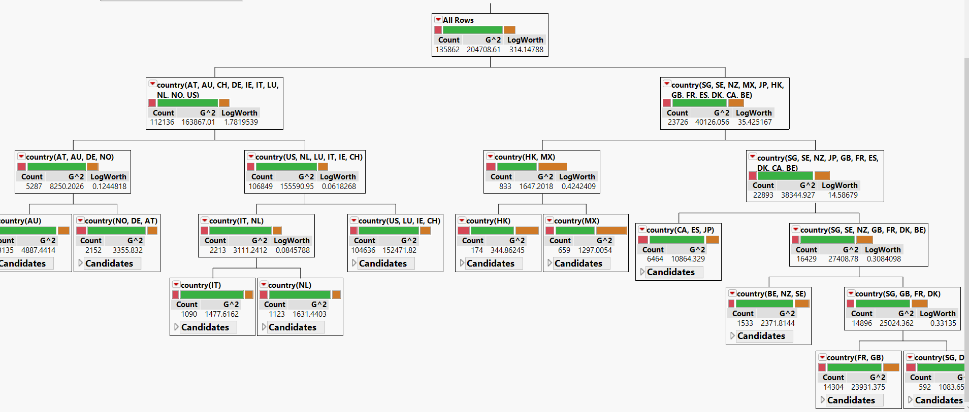

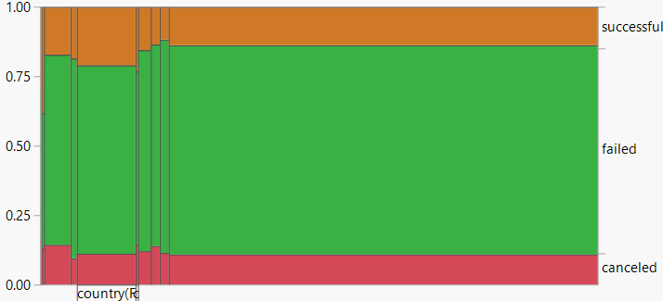

A partition analysis shows different success rates in many countries, visualized. Hong Kong and Mexico appeared to have particularly high success rates.

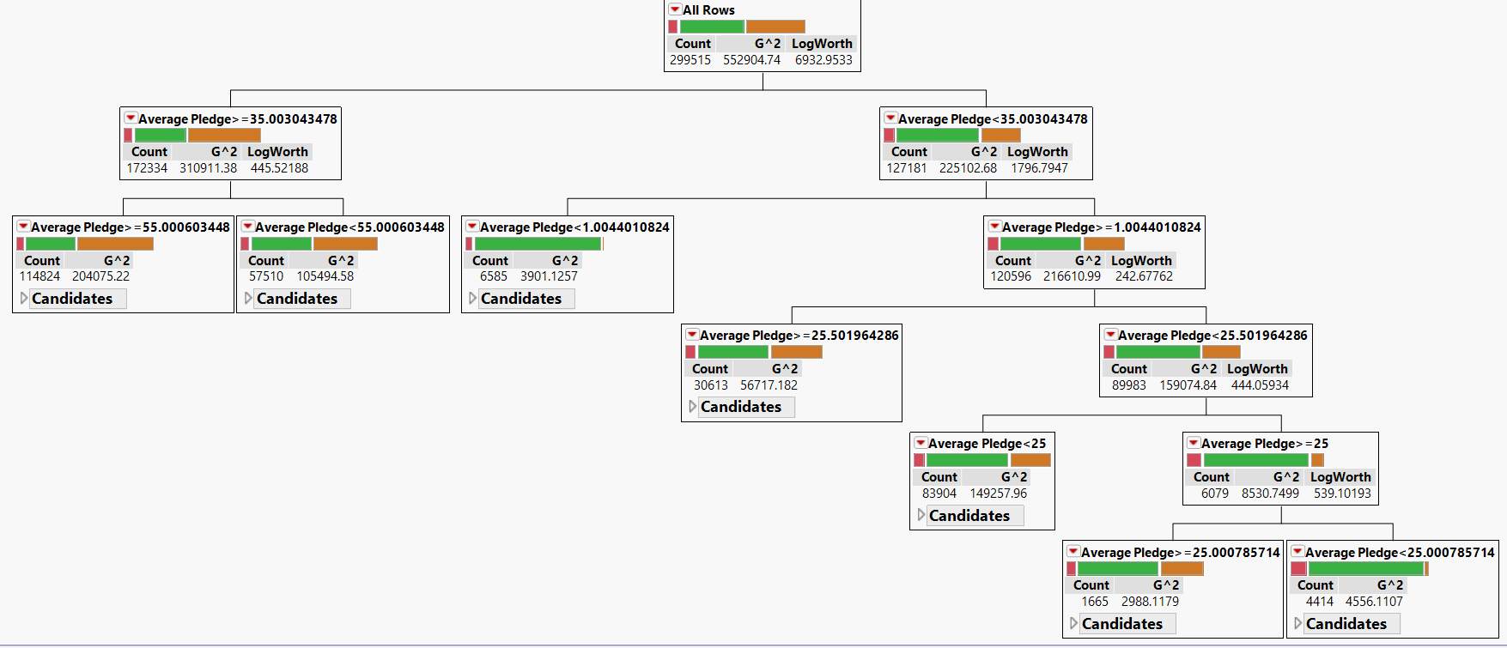

Here it would appear that the higher average pledges are correlated with a higher success rate. The effect is quite prominent. Even at smaller levels, the difference is notable. It is even greater at higher levels.

I have a theory to explain the data that has been observed. Countries with larger numbers of projects have larger Kickstarter communities, which mean that that they are more likely to connect people with Kickstarter projects in which they are interested. I would further note that this effect is far form linear, seeing as the United States has a stupendous difference in the number of projects, but a comparatively small difference in success rate. In addition, I would argue that overall national wealth is NOT an explanation, considering the fact that the United Kingdom has a higher success rate, but a smaller GDP per capita. As for the nature of the individual Kickstarters, those that are spread to more wealthy individuals who are willing to grant more money are more likely to succeed, as the higher success rate came from higher average donations. After careful analysis of the data, these are my conclusions.