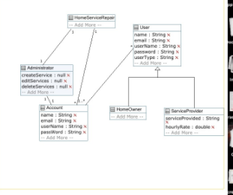

ASSUMPTIONS

* An admin can belong to just 1 homeRepairService
* A HomeRepareService can have 0 accounts
* A user has to have at least 1 account and a user can have multiple accounts