FORECASTING NEXT-DAY HOURLY
ELECTRICITY DEMAND IN ERCOT
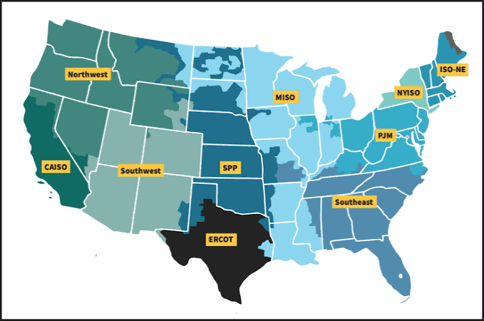
Matthew Scarpello | Andrea Barfield | Sarah Parsons
October 25, 2026
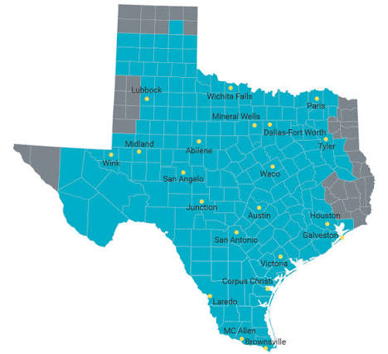
Cover image credits
Cover images: ERCOT logo (Electric Reliability Council of Texas, n.d.-a), ERCOT region map (Electric Reliability Council of Texas, n.d.-b), and U.S. electric grid operator map (Federal Energy Regulatory Commission, as reproduced in Larson, 2023).

TABLE OF CONTENTS
Introduction 3
Business Problem / Hypothesis 3
Research Question 3
Methods / Analysis 4
Modeling Approaches 5
Results 5
Forecast Behavior 6
Conclusion 7
References 8
Appendix A: Documentation and 10 Questions 9
INTRODUCTION
Accurate short-term electricity demand forecasts are integral to grid operations because generation schedules, energy purchases, and reserve decisions must be established before consumption occurs. Overestimating demand can result in unnecessary commitments, while underestimating it may increase reliance on short-notice market adjustments. The February 2021 Texas electricity crisis illustrates the broader consequences of system vulnerability, although shortages and outages cannot be attributed to demand forecasts alone; generation availability, fuel infrastructure, and operational conditions must also be considered (Busby et al., 2021; Federal Energy Regulatory Commission [FERC] & North American Electric Reliability Corporation [NERC], 2021).
BUSINESS PROBLEM / HYPOTHESIS
Building on the Milestone 1 proposal, this study examines whether models developed from publicly available historical electricity demand and calendar variables can approximate the accuracy of the Electric Reliability Council of Texas (ERCOT) published day-ahead forecast. The investigation subsequently expanded to test whether temperature-derived predictors provide additional forecasting value. ERCOT is an appropriate case because the Energy Information Administration (EIA) reports both realized hourly demand and ERCOT's corresponding forecast, permitting evaluation against an independent operational benchmark rather than only a simplified baseline (U.S. Energy Information Administration [EIA], n.d.; Electric Reliability Council of Texas [ERCOT], n.d.-c).
RESEARCH QUESTION
This study asks whether historical demand, calendar patterns, and selected weather variables can forecast ERCOT's next-day hourly electricity consumption with accuracy approaching the operator's published forecast. The target is demand in megawatthours (MWh). Mean absolute error (MAE) measures typical hourly deviation; root mean squared error (RMSE) gives greater weight to large misses; and mean absolute percentage error (MAPE) expresses relative error. The hypothesis is that models capturing recurrent temporal patterns will outperform a same-hour-last-week baseline. Supporting analyses examine seasonality, the incremental value of weather, and prediction errors during high-load conditions (Hong & Fan, 2016).
METHODS / ANALYSIS
The data-wrangling stage assembled 41,616 consecutive hourly records from EIA Form 930, covering January 1, 2022, through September 30, 2026. Validation found no missing demand observations, duplicate timestamps, or nonpositive demand values. Unusual but plausible observations were retained to avoid removing legitimate variation. ERCOT's benchmark forecast was unavailable for 120 hours in the test period, while generation and interchange contained smaller gaps; those records were not artificially reconstructed. Timestamps were maintained in Coordinated Universal Time (UTC) to avoid daylight-saving ambiguities, while local calendar features used Central time to reflect electricity-consumption behavior.
Predictors were constructed to represent recurrent behavior: hour, weekday, season, holiday status, 24- and 168-hour demand lags, and a historical moving average. Supplementary weather data include observed temperatures from Houston, Dallas–Fort Worth, San Antonio, and Austin, summarized through weighted regional temperature and heating/cooling indicators (Zippenfenig, 2023). These variables reflect plausible relationships between time, temperature, and consumption. However, observed temperatures are not interchangeable with information available before issuing a future forecast.
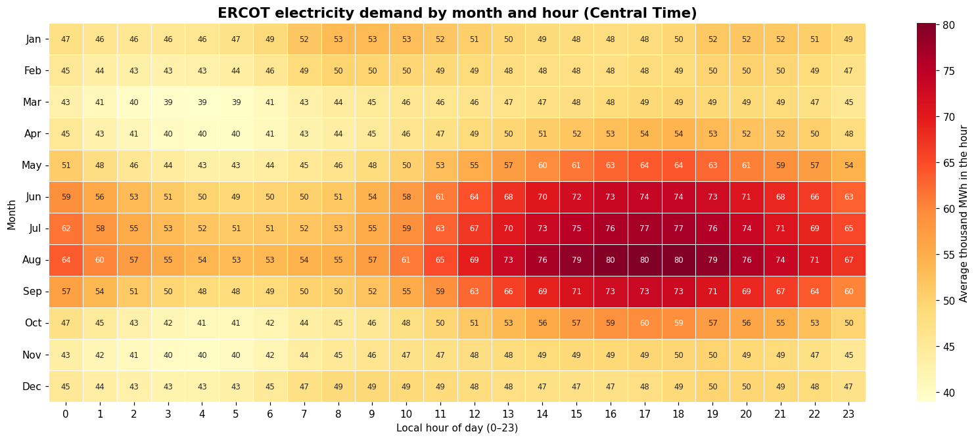F
Figure 1. Average hourly ERCOT electricity demand by month and hour of day (Central Time).
Note. Values represent historical average demand in thousands of MWh, not model predictions.
Figure 1 reveals distinct hourly and seasonal consumption patterns. Electricity demand peaks during summer afternoons, particularly in July and August, while cooler months exhibit lower and more consistent consumption. These patterns support the importance of hourly and seasonal predictors in the forecasting models, visualizing how historical patterns appear consistently as hotspots each year and hour.
MODELING APPROACHES
The models were evaluated on a chronological holdout from October 2025 through September 2026, following training primarily on October 2022 through September 2025. A seasonal naive baseline repeated demand from the same hour one week earlier. An initial full-year SARIMA projection drifted implausibly, prompting a shift to rolling 24-hour forecasts updated with observed demand between prediction blocks (Hyndman & Athanasopoulos, 2021; statsmodels developers, n.d.).
Prophet represented daily, weekly, and annual seasonality, with limited tuning but a static holdout forecast (Taylor & Letham, 2018). XGBoost used boosted trees to learn nonlinear calendar and historical-demand relationships (Chen & Guestrin, 2016). Weather-enhanced XGBoost added lagged temperatures and heating/cooling summaries, while weather-enhanced rolling SARIMAX incorporated external weather predictors. Finally, a 50/50 hybrid model averaged the original rolling SARIMA predictions and weather-enhanced XGBoost predictions to test whether combining the two approaches improved overall accuracy.
RESULTS
Using 8,640 shared test hours, Figure 2 ranks the models by mean absolute error (MAE). ERCOT led at 1,135 MWh (2.00% MAPE). Among the team models, the 50/50 hybrid rolling SARIMA and weather-enhanced XGBoost performed best, with an MAE of approximately 2,006 MWh (3.54% MAPE). Weather-enhanced XGBoost followed at 2,477 MWh (4.18% MAPE), followed by original XGBoost (2,647 MWh) and rolling SARIMA (2,662 MWh). The seasonal naive baseline reached approximately 4,205 MWh. The hybrid reduced MAE by approximately 52% relative to the seasonal naïve baseline, while weather-enhanced XGBoost reduced it by approximately 41%. However, no team model matched ERCOT’s overall accuracy. Matched timestamps establish a common evaluation sample, not equivalent forecast-issuance conditions.
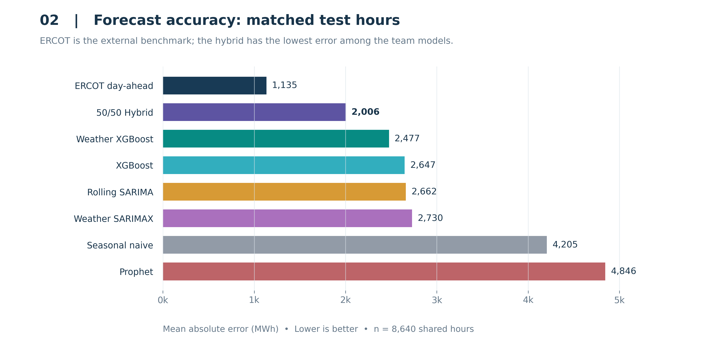
Figure 2. Matched-sample mean absolute error across eight forecasting approaches.

FORECAST BEHAVIOR
The foundational visualization notebook first established the context for prediction by examining long-term demand, recurring hourly cycles, seasonality, and atypical conditions. The subsequent model-prediction export enabled a more diagnostic comparison: actual demand could be plotted against several competing forecasts at identical timestamps. Figure 3 adds the 50/50 hybrid alongside rolling SARIMA, weather-enhanced XGBoost, and ERCOT during one summer week to illustrate how models may reproduce the timing of daily increases while differing substantially in the magnitude of the peaks. This distinction matters because accurately anticipating when demand rises is not equivalent to estimating the quantity of energy that must be supplied.
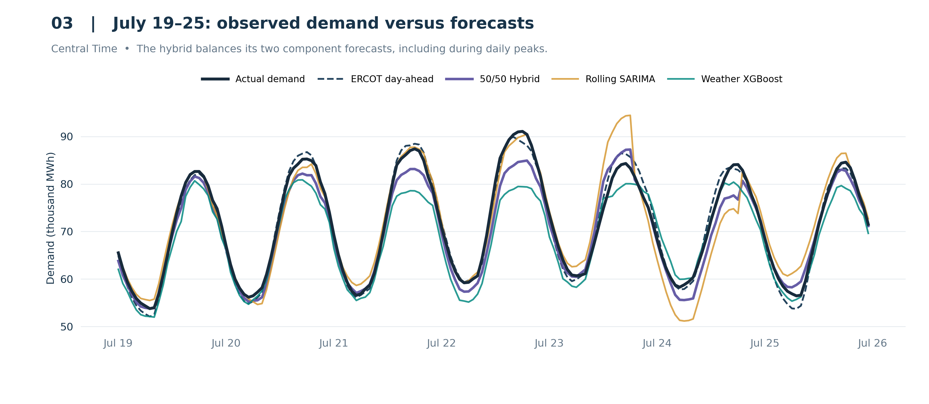
Figure 3. Observed demand and competing model forecasts, July 19–25, 2026.
During the selected July week, the models generally capture the daily rhythm but differ visibly at several high-demand intervals. The hybrid generally sits between its component forecasts, showing how averaging moderates their individual predictions. This case study helps explain model behavior, but the full-year metrics determine overall ranking. Accordingly, the advanced visualization analysis examined errors by month, actual demand level, and direction of forecast bias. These supplementary diagnostics address an important weakness of aggregate metrics: two models can have similar overall MAE while making very different errors during periods when operational planning may be most sensitive.
PEAK-DEMAND PERFORMANCE
Overall accuracy did not predict performance under extreme demand. In the 88 hours that formed the highest 1% of observed test-year load (87,966 MWh or more), rolling SARIMA recorded 1,242 MWh MAE and weather SARIMAX 1,176 MWh, close to ERCOT’s 1,158 MWh. The 50/50 hybrid recorded a MAE of 3,189 MWh, performing better than weather-enhanced XGBoost at 6,421 MWh and original XGBoost at 8,019 MWh. Both XGBoost models under-forecast every one of these hours and the hybrid under-forecast on average. A likely cause is that tree-based models cannot predict values beyond the range seen in training, while test-year peaks exceeded most training-year demand as Texas load grew. SARIMA updates with observed demand each day, which may help it track changing demand. Figure 4 places this contrast within errors across demand categories. These hours were identified after the fact; the results diagnose historical weaknesses rather than predict which future hours will be extreme.
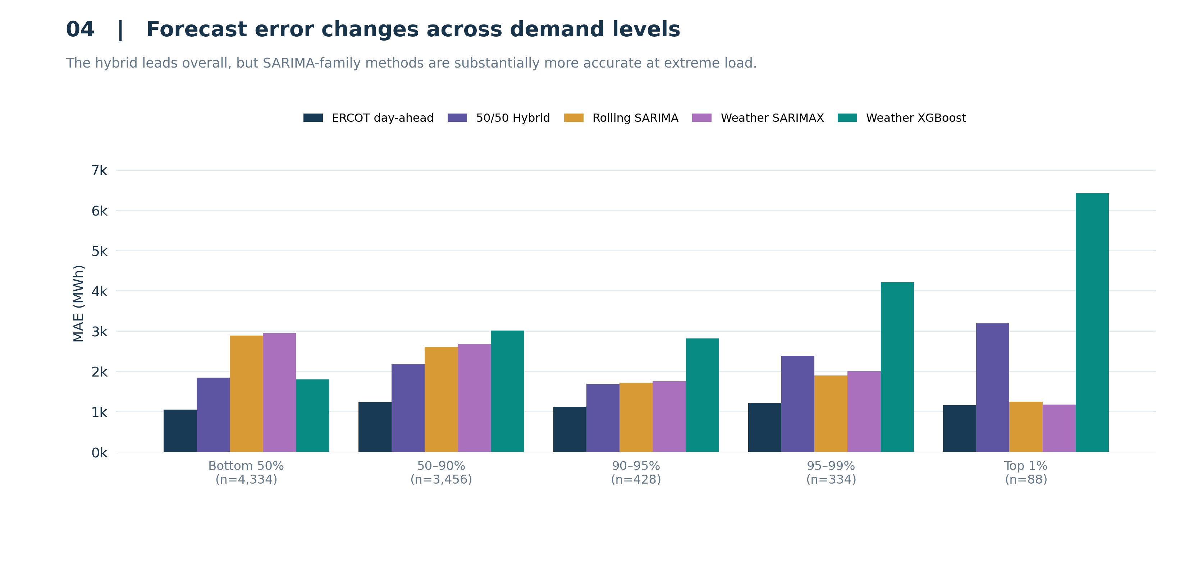
Figure 4. Forecasting MAE across observed-demand categories, including the hybrid.
Note. Demand cutoffs use the full 8,760-hour test year; MAE uses the 8,640 shared hours. The top 1% contains 88 matched hours. Categories are retrospective.
CONCLUSION
The evidence supports the hypothesis that historical demand and calendar information can outperform a naive weekly-repeat forecast: The 50/50 hybrid of rolling SARIMA and weather-enhanced XGBoost reduced MAE by approximately 52% relative to the seasonal naïve baseline, making it the strongest overall model among the team’s approaches. Weather-enhanced XGBoost alone reduced error by roughly 41% relative to the same baseline. ERCOT’s forecast remained substantially more accurate, which likely reflects its access to weather forecasts and operational information that public historical data does not contain. The most important finding is that average accuracy concealed peak-hour weakness. Despite its leading overall accuracy, the hybrid was substantially less accurate than rolling SARIMA and weather SARIMAX during the highest-demand hours, when both SARIMA-family models performed much closer to ERCOT.
An important limitation is forecast comparability. SARIMA and SARIMAX generate rolling 24-hour UTC predictions, XGBoost uses target-relative historical lags, and Prophet produced a static holdout forecast. Evaluation on the same timestamps does not establish identical issuance times or predictor availability, and observed weather is not a substitute for advance weather predictions. Future evaluation should standardize forecast-issuance times, use only advance-available inputs, and compare equal 24-hour horizons. Any model should support, rather than replace, operator judgment (Hong & Fan, 2016).

RECOMMENDATIONS / ETHICAL CONSIDERATIONS
The results support three recommendations. First, model choice should depend on both overall accuracy and demand conditions: the 50/50 hybrid achieved the greatest overall error reduction among the team’s models, while SARIMA-family models were far more reliable during peak load. Second, peak-hour error and forecast bias should be reported alongside average error, because a single average hid the weakness that matters most operationally. Third, future versions should use weather forecasts rather than observed temperatures and issue predictions at a fixed time, so results reflect information available in practice.

REFERENCES
Busby, J. W., Baker, K., Bazilian, M. D., Gilbert, A. Q., Grubert, E., Rai, V., Rhodes, J. D., Shidore, S., Smith, C. A., & Webber, M. E. (2021). Cascading risks: Understanding the 2021 winter blackout in Texas. Energy Research & Social Science, 77, Article 102106. https://doi.org/10.1016/j.erss.2021.102106
Chen, T., & Guestrin, C. (2016). XGBoost: A scalable tree boosting system. Proceedings of the 22nd ACM SIGKDD International Conference on Knowledge Discovery and Data Mining, 785–794. https://doi.org/10.1145/2939672.2939785
Electric Reliability Council of Texas. (n.d.-a). ERCOT logo [Logo]. BKV Energy. https://bkvenergy.com/wp-content/uploads/2023/08/ERCOT-logo-1.webp
Electric Reliability Council of Texas. (n.d.-b). ERCOT region map [Map]. https://www.ercot.com/news/mediakit/maps
Electric Reliability Council of Texas. (n.d.-c). Load forecast. https://www.ercot.com/gridinfo/load/forecast
Federal Energy Regulatory Commission & North American Electric Reliability Corporation. (2021). The February 2021 cold weather outages in Texas and the South Central United States (FERC-NERC-Regional Entity Staff Report). https://www.nerc.com/pa/rrm/ea/Documents/February_2021_Cold_Weather_Report.pdf
Hong, T., & Fan, S. (2016). Probabilistic electric load forecasting: A tutorial review. International Journal of Forecasting, 32(3), 914–938. https://doi.org/10.1016/j.ijforecast.2015.11.011
Hyndman, R. J., & Athanasopoulos, G. (2021). Forecasting: Principles and practice (3rd ed.). OTexts. https://otexts.com/fpp3/
Larson, A. (2023, December 29). What is ERCOT and what does it do? POWER. https://www.powermag.com/what-is-ercot-and-what-does-it-do/
statsmodels developers. (n.d.). statsmodels.tsa.statespace.sarimax.SARIMAX. https://www.statsmodels.org/stable/generated/statsmodels.tsa.statespace.sarimax.SARIMAX.html
Taylor, S. J., & Letham, B. (2018). Forecasting at scale. The American Statistician, 72(1), 37–45. https://doi.org/10.1080/00031305.2017.1380080
U.S. Energy Information Administration. (n.d.). About the EIA-930 data. Hourly Electric Grid Monitor. Retrieved October 11, 2026, from https://www.eia.gov/electricity/gridmonitor/about
Zippenfenig, P. (2023). Open-Meteo.com Weather API [Computer software]. Zenodo. https://doi.org/10.5281/ZENODO.7970649

APPENDIX A

Research Documentation and Reproducibility
Item | Project Detail
Target variable | ERCOT observed hourly electricity demand (demand_mwh), MWh
Historical data | EIA-930, 41,616 hourly observations, Jan 2022–Sep 2026
Test period | October 2025–September 2026, 8,760 hours
Shared benchmark sample | 8,640 test hours; 120 unavailable ERCOT forecasts excluded
Predictive inputs | Calendar, historical demand lags and moving averages; weather features for enhanced models
Models | Seasonal naive; rolling SARIMA; Prophet; XGBoost; weather XGBoost; weather SARIMAX; ERCOT benchmark; 50/50 hybrid rolling SARIMA and weather XGBoost
Evaluation | MAE, RMSE, MAPE; shared-hour comparison and peak-demand diagnostics
Responsibility | Data wrangling and features; forecasting models; visualization and interpretation

Data Validation and Fair Comparison
- Target and unit. The dependent variable, demand_mwh, represents observed energy consumption during each one-hour interval. MAE and RMSE retain MWh units; MAPE expresses absolute error as a percentage of observed demand.
- Predictor construction. The original models use calendar features, 24- and 168-hour demand lags, and a historical rolling mean. Weather-enhanced models additionally use a lagged regional temperature and trailing heating/cooling measures; predictor timing must be checked against each forecast origin.
- External comparison. ERCOT's reported day-ahead values serve as the operational benchmark. During the 8,760-hour holdout, 120 benchmark forecasts were missing. Those hours were excluded, leaving 8,640 common observations for comparisons that include ERCOT; no missing forecast was imputed.
- Research workflow. Data wrangling established a validated EIA-930 dataset and historical predictors; predictive modeling produced seven forecast series including the operator benchmark; foundational and advanced visualization converted the shared predictions into interpretable performance analyses and report figures.
- Evaluation boundary. A common test sample controls for differences in evaluated hours but does not itself ensure equivalent issuance times, future-information restrictions, retraining schedules, or forecast horizons. Those checks remain necessary before claiming an operational day-ahead comparison.

Questions from considerations and ethical concerns
Who could be impacted, and how? Grid operators and utilities could benefit from an independent check on demand forecasts. Households and businesses are affected indirectly: under-forecasting peak demand can contribute to shortages and price spikes, which fall hardest on vulnerable residents, such as those relying on medical equipment or air conditioning during heat waves.
What assumptions could introduce bias or risk? The models assume past demand patterns continue and that reported demand is accurate. Rapid load growth breaks the first assumption, which is why XGBoost under-forecast record peaks. Observed temperatures also assume perfect weather knowledge, which overstates the accuracy any real forecast could achieve.
How was the data sourced, and were privacy, consent, and ownership addressed? EIA-930 data is published by a federal agency and is in the public domain. It is aggregated to the whole ERCOT grid, so no individual customer can be identified and no consent is required. Weather data comes from the openly licensed Open-Meteo archive.
How might results be misinterpreted or misused? A single accuracy figure could be read as evidence that a model is ready for operational use, when it performed worst during the hours that matter most. Results from ERCOT should not be generalized to other grids without retraining, and retrospective accuracy should not be presented as real-time performance.
What responsibility does the team have for harmful outcomes? The team is responsible for stating limitations plainly, reporting peak-hour weaknesses alongside averages, documenting methods so others can verify them, and recommending that these models support rather than replace operator judgment.

Ten Questions and Answers

- What business decision does the project inform?
Day-ahead load projections can inform generation scheduling, reserve planning, and electricity purchases. This study evaluates forecast accuracy rather than estimating financial losses, dispatch feasibility, or the operational consequences of a particular prediction error.
- What exactly are we predicting?
The prediction target is realized electricity consumption in ERCOT during each hourly interval, recorded as demand_mwh in MWh. The forecasting objective is to estimate those values in advance using historical and calendar information, with supplementary weather features examined in selected models.
- Why use ERCOT’s published forecast?
ERCOT's reported day-ahead forecast supplies an independently produced reference using the same underlying demand outcome. It places the team's results in an operational context, although a valid performance comparison also requires consistent prediction horizons and information availability.
- Does adding weather always help?
No. Weather-enhanced XGBoost improved relative to the model without weather, whereas the tested rolling SARIMAX specification performed slightly worse than rolling SARIMA. The result demonstrates model-specific value, not a causal guarantee that adding weather will improve forecasting accuracy.
- Which team model performed best?
The 50/50 hybrid of rolling SARIMA and weather-enhanced XGBoost performed the best overall among the team models, reducing MAE by approximately 52% relative to the seasonal naïve baseline. However, it was not the strongest during peak demand, where rolling SARIMA and weather SARIMAX were far more accurate.
- Why didn’t any model beat ERCOT?
ERCOT forecasts with weather predictions, detailed regional load data, and operational information unavailable in public historical records. Our models used only past demand, calendar patterns, and observed temperatures.
- How do the models perform on the highest-demand hours?
In the top 1% of demand hours, rolling SARIMA (1,242 MWh MAE) and weather SARIMAX (1,176 MWh) came close to ERCOT (1,158 MWh). The 50/50 hybrid had an MAE of approximately 3,189 MWh, performing better than XGBoost models which under-forecast every peak hour by over 6,000 MWh on average, likely because tree models cannot predict beyond the demand levels seen in training.
- Is the comparison with ERCOT fair?
Partly. All models were scored on the same 8,640 hours, but they did not forecast under identical conditions. ERCOT issues forecasts in advance with weather predictions and operational information, while some of our models used observed historical temperatures, which gives them an advantage ERCOT does not have. Therefore, the comparison does not establish equivalent predictor availability or forecast-issuance conditions.
- Could this model be used operationally today?
No. It is a retrospective study. Operational use would require fixed forecast-issuance times, weather forecasts instead of observations, regular retraining, and better peak-hour performance.
- What would most improve the forecasts?
The current 50/50 hybrid improves average forecast error, but its weaker peak-hour accuracy shows why a single fixed blend may not suit every demand condition. Future work should use advance-available weather forecasts, account for demand growth, and test model weights that adapt to conditions known at forecast issuance, without relying on actual demand to choose the model.

