Forecasting Next-Day Hourly Electricity Demand in ERCOT
Milestone 2: Final Project Draft | October 20, 2026
Hali Sarah Parsons · Andrea Barfield · Matthew Scarpello
Business Problem, Purpose, and Hypothesis
Grid operators need advance estimates of hourly electricity demand because generation and purchases must be planned before customers use the power. Forecasts that run high may encourage unnecessary commitments; forecasts that run low can leave planners making expensive adjustments. The 2021 Texas winter crisis illustrates how serious electric-system failures can be, but demand alone cannot explain those failures or predict an outage (Busby et al., 2021; Federal Energy Regulatory Commission [FERC] & North American Electric Reliability Corporation [NERC], 2021).
Our question from Milestone 1 was whether a model using recent demand and calendar patterns could forecast next-day hourly demand in the Electric Reliability Council of Texas (ERCOT) region as accurately as the operator’s own published forecast. We kept that measurable comparison but broadened the experiment to investigate whether weather features improve prediction. ERCOT is especially suitable because EIA-930 supplies both actual demand and the operator’s reported day-ahead forecast, providing an external standard rather than an invented classroom benchmark (U.S. Energy Information Administration [EIA], n.d.; Electric Reliability Council of Texas [ERCOT], n.d.).
Research Questions and Evaluation Strategy
The target is the energy consumed during each hour, measured in megawatthours (MWh). Our primary outcome is mean absolute error (MAE), the average size of an hourly miss, measured in MWh. Root mean squared error (RMSE) places more weight on large misses, while mean absolute percentage error (MAPE) communicates relative error. Our hypothesis was that methods learning daily and weekly patterns would outperform a simple repeat-last-week baseline. We did not assume our models would surpass ERCOT. Three supporting questions structured the work: What demand patterns are predictable? Does adding weather help? When do errors become more important, particularly during extreme load (Hong & Fan, 2016)?
Data, Preparation, and Foundational Analysis
Sarah retrieved and cleaned EIA-930 observations from January 1, 2022, to September 30, 2026: 41,616 consecutive hours. The actual-demand series has no missing hours, duplicate timestamps, or nonpositive values. We retained real observations, including unusual lows, instead of smoothing them away. The operator forecast has 120 missing values during the test year; generation and interchange also have small gaps. These were left missing rather than replaced with artificial measurements. Hourly records are aligned in UTC to avoid daylight-saving ambiguities, while calendar features use Central time to represent daily behavior.
Sarah then created weekday, month, season, holiday, 24-hour and 168-hour demand lags, and a historical moving average. The weather-enriched file adds observed temperatures for Houston, Dallas–Fort Worth, San Antonio, and Austin, together with a weighted Texas temperature and derived indicators. Open-Meteo is the documented weather source (Zippenfenig, 2023). Our descriptive notebook tested whether these candidate inputs correspond to meaningful demand patterns, rather than including features merely because they were available.
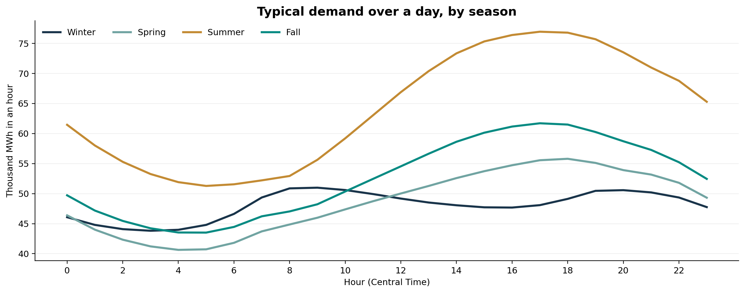
Figure 1. Average hourly ERCOT electricity demand by season and Central-time hour.
Note. Historical descriptive averages, not fitted model forecasts; chart exported from the foundational visualization notebook.
Figure 1 shows pronounced recurring structure. Summer demand climbs through the afternoon and peaks around early evening, while winter has a much flatter and partly different daily profile. These differences supported Sarah’s seasonal features and Andrea’s decision to test models designed for time dependence. The pattern suggests predictability; it does not prove that season or temperature caused a particular model’s performance.
Modeling Methods and Decisions
Andrea held out October 2025–September 2026 for testing; most fitted models trained on October 2022–September 2025. A repeat-last-week baseline established a minimum standard. Her first, static full-year SARIMA forecast drifted implausibly, prompting a more defensible sequence of rolling 24-hour forecasts (Hyndman & Athanasopoulos, 2021; statsmodels developers, n.d.).
She tested Prophet for longer-cycle trends and holidays, including a limited parameter search, and XGBoost for nonlinear calendar and historical-demand relationships (Taylor & Letham, 2018; Chen & Guestrin, 2016). Finally, Andrea introduced weather-enhanced XGBoost and rolling SARIMAX. The weather results were mixed: XGBoost improved, but the tested SARIMAX configuration did not. These are valuable model-selection findings because adding features does not guarantee better forecasts.
Head-to-Head Results
Using Andrea’s exported predictions, we recalculated seven forecasts on 8,640 identical test hours, excluding missing ERCOT forecasts. ERCOT scored 1,135 MWh MAE (2.00% MAPE); weather XGBoost led the project-built series with 2,477 MWh MAE (4.18% MAPE). Original XGBoost scored 2,647 MWh, rolling SARIMA 2,662 MWh, and seasonal naive 4,205 MWh. Weather XGBoost beat the naive baseline by approximately 41%, but none matched ERCOT.
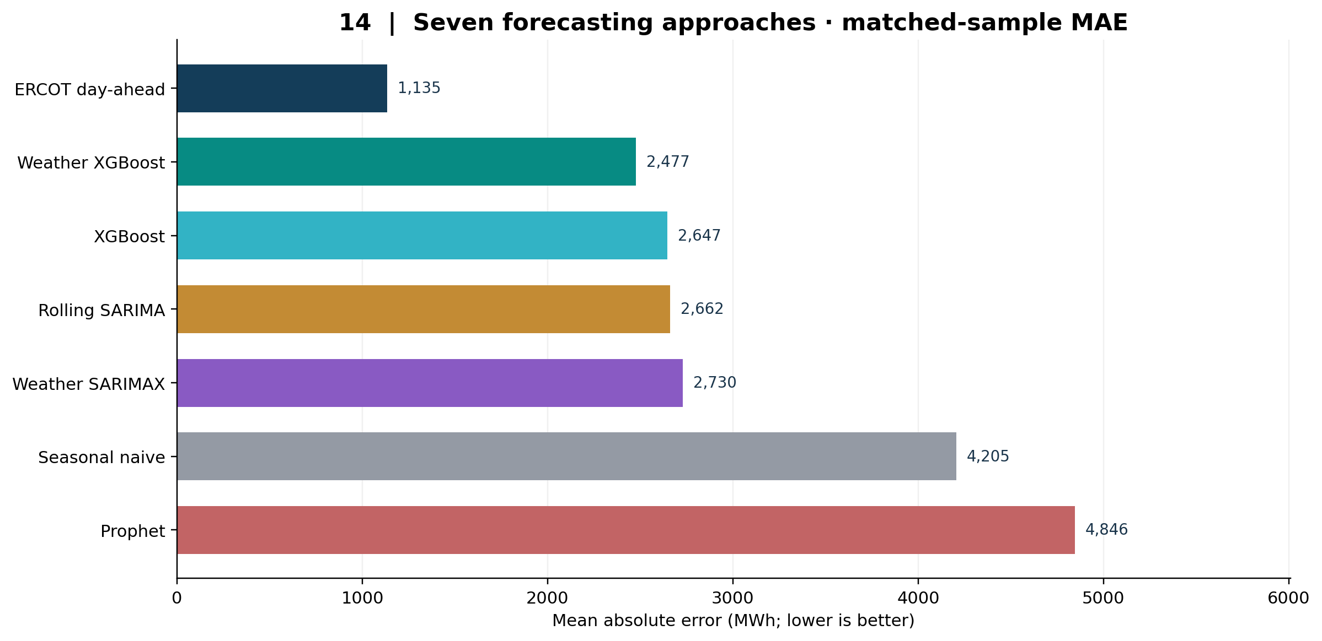
Figure 2. Seven forecast series ranked by matched-hour MAE.
Note. All series evaluated on the same 8,640 hours; lower values are better. ERCOT is an external operator benchmark.
A Forecast Is More Than Its Average Error
Matthew’s foundational visual analysis first mapped seasonal cycles, daily peaks, and extreme-demand episodes. With Andrea’s complete prediction export available, we moved from separately examining ERCOT’s forecast to comparing individual model traces on the same test-year hours. This helped us explain to a nontechnical audience that forecasting a daily pattern is not identical to estimating the magnitude of a peak.
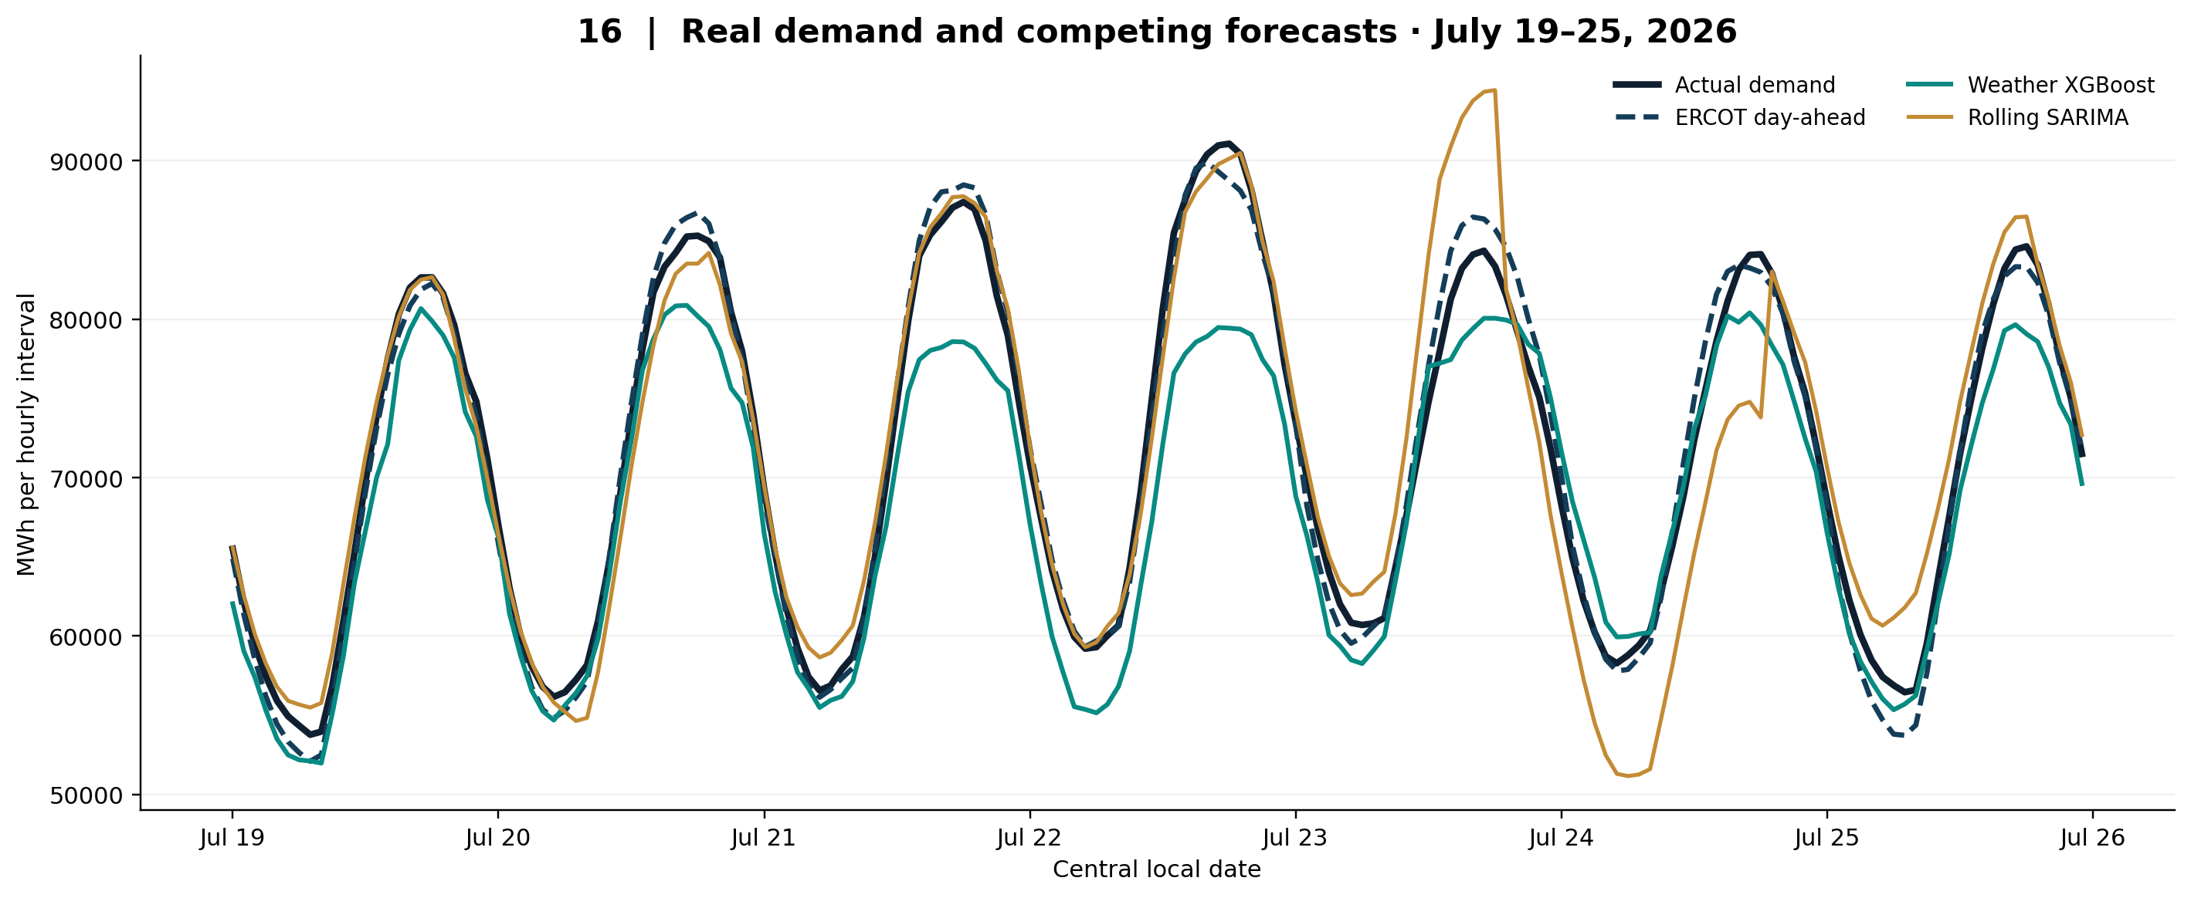
Figure 3. Observed load and three competing forecasts during July 19–25, 2026.
Note. One selected historical test week with high demand; lines are retrospective predictions, not a demonstration of real-time deployment.
In this summer example, the methods generally follow the daily rise and fall but diverge noticeably at some peaks. A model that tracks timing while consistently missing peak magnitude may still create planning difficulties. We therefore used the advanced visualization notebook to examine monthly error, forecast bias, and performance across observed demand levels. The case week illustrates the behavior; only the year-long evaluation supports overall rankings.
Peak Demand, Limitations, and Conclusions
The error analysis complicated the simple leaderboard story: the lowest overall error did not imply the best peak-demand accuracy. In the top 1% of realized demand (88 test hours), weather XGBoost averaged about 6,421 MWh absolute error versus about 1,242 MWh for rolling SARIMA. This small retrospective subset is informative, not a guarantee about future peaks.
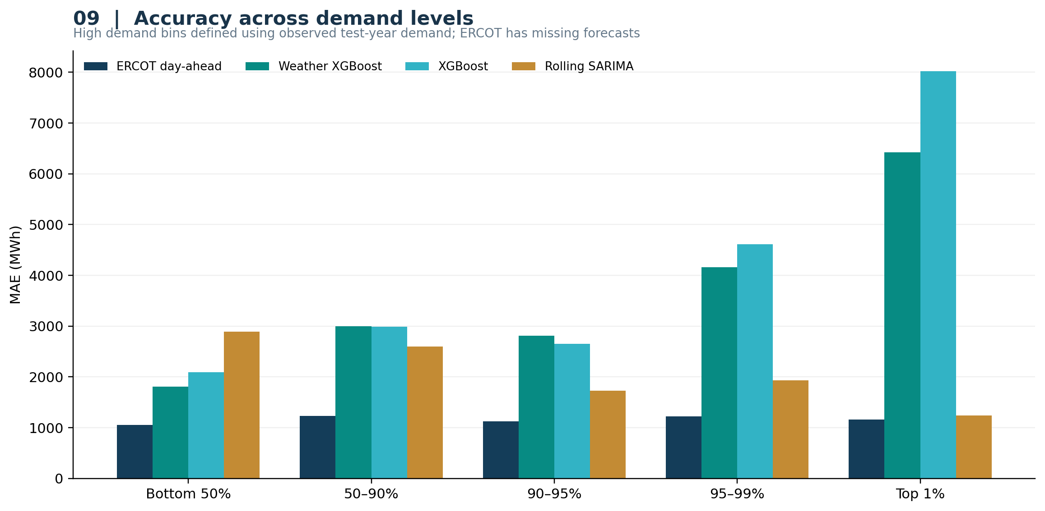
Figure 4. Error magnitude across categories of observed demand.
Note. Demand bands use realized test-year load; the ERCOT benchmark excludes hours without a published forecast.
The main limitation is the “day-ahead” definition. SARIMA/SARIMAX roll in 24-hour UTC blocks, XGBoost uses target-relative lag features, and Prophet produced a longer static forecast. Each must be checked against a shared issuance time. Some SARIMAX temperature summaries may include observations unavailable when tomorrow’s forecast is issued. Observed weather is not a future forecast. Thus, the present comparison is retrospective, not yet a common operational day-ahead test.
Public demand history supported useful forecasts that beat a naive baseline, though not ERCOT’s accuracy. Next, align forecast issue times, restrict weather to advance-available inputs, rerun matched comparisons, and monitor peak errors. Models should support, not replace, grid judgment (Hong & Fan, 2016).
References
Busby, J. W., Baker, K., Bazilian, M. D., Gilbert, A. Q., Grubert, E., Rai, V., Rhodes, J. D., Shidore, S., Smith, C. A., & Webber, M. E. (2021). Cascading risks: Understanding the 2021 winter blackout in Texas. Energy Research & Social Science, 77, Article 102106. https://doi.org/10.1016/j.erss.2021.102106
Chen, T., & Guestrin, C. (2016). XGBoost: A scalable tree boosting system. Proceedings of the 22nd ACM SIGKDD International Conference on Knowledge Discovery and Data Mining, 785–794. https://doi.org/10.1145/2939672.2939785
Electric Reliability Council of Texas. (n.d.). Load forecast. https://www.ercot.com/gridinfo/load/forecast
Federal Energy Regulatory Commission & North American Electric Reliability Corporation. (2021). The February 2021 cold weather outages in Texas and the South Central United States (FERC-NERC-Regional Entity Staff Report). https://www.nerc.com/pa/rrm/ea/Documents/February_2021_Cold_Weather_Report.pdf
Hong, T., & Fan, S. (2016). Probabilistic electric load forecasting: A tutorial review. International Journal of Forecasting, 32(3), 914–938. https://doi.org/10.1016/j.ijforecast.2015.11.011
Hyndman, R. J., & Athanasopoulos, G. (2021). Forecasting: Principles and practice (3rd ed.). OTexts. https://otexts.com/fpp3/
statsmodels developers. (n.d.). statsmodels.tsa.statespace.sarimax.SARIMAX. https://www.statsmodels.org/stable/generated/statsmodels.tsa.statespace.sarimax.SARIMAX.html
Taylor, S. J., & Letham, B. (2018). Forecasting at scale. The American Statistician, 72(1), 37–45. https://doi.org/10.1080/00031305.2017.1380080
U.S. Energy Information Administration. (n.d.). About the EIA-930 data. Hourly Electric Grid Monitor. Retrieved October 11, 2026, from https://www.eia.gov/electricity/gridmonitor/about
Zippenfenig, P. (2023). Open-Meteo.com Weather API [Computer software]. Zenodo. https://doi.org/10.5281/ZENODO.7970649
Appendix: Research Documentation and Ten Stakeholder Questions
Data definitions and reproducibility notes
• Target and unit. demand_mwh is observed energy for each one-hour interval. MAE and RMSE use MWh, while MAPE uses percent.
• External comparison. demand_forecast_mwh is the reported ERCOT day-ahead figure. Its 120 missing holdout values were omitted, not imputed; n = 8,640 common hours.
• Forecast inputs. Calendar, lag-24, lag-168, moving-average demand, and selected temperature/degree-day features are documented in team data and modeling notebooks.
• Workflow. Sarah’s cleaning/feature preparation → Andrea’s seven prediction series → Matthew’s foundational and advanced visual notebooks → recalculated model metrics and Milestone 2 figures.
• Validation boundary. Equal test hours do not yet imply equal forecast origin, known-in-advance predictors, or training cadence. Confirm these before any operational day-ahead claim.
Ten questions a utility stakeholder might ask (with evidence-based responses)
1. What business decision does the project inform?
Next-day load estimates could inform planning and purchasing; the study does not calculate dispatch costs.
2. What exactly are we predicting?
Recorded ERCOT electricity demand, in MWh for each hour of the next-day forecasting task.
3. Why use ERCOT’s published forecast?
It provides an external professional reference on the same recorded demand observations.
4. How do we know the underlying data are reliable?
The cleaned file has a continuous demand series with no imputed demand or duplicate timestamps; secondary gaps remain documented.
5. Which model was most accurate?
ERCOT: 1,135 MWh MAE; among student models, weather XGBoost: 2,477 MWh MAE, on 8,640 common hours.
6. Does adding weather always help?
No. The tested weather XGBoost improved relative to original XGBoost, while weather SARIMAX scored worse than rolling SARIMA.
7. What did the team learn from unsuccessful experiments?
A full-year static SARIMA forecast drifted implausibly, prompting 24-hour rolling updates; Prophet’s long static forecast also underperformed.
8. Where does model performance change most?
The top 1% of realized load hours showed much larger weather XGBoost error than rolling SARIMA, despite XGBoost’s lower overall MAE.
9. Can these scores be called true day-ahead operational performance?
Not fully yet; the group must verify common forecast issuance times and feature/weather availability.
10. What would improve the next version?
A uniform forecast horizon, issue-time weather forecasts, repeated validation across more years, and explicit peak-load stress tests.

