Professor,

Your comments are in red.

However,  I see that in your table, the range of grain sizes allows one to have  
a large range of conductivity ratios.

I just want to remind you that I am still thinking about the meaning of grain size and I am not completely sure what it means yet.

The various models certainly have different dependencies on the grain size and by varying the grain size you indeed can explain a wide range of thermal conductivity ratios:

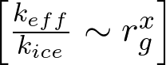 OR 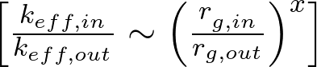

I think it would be interesting to make plots of the various dependencies for each model and compare them over the measured grain sizes (i.e. keff/kice vs rg(x)). I think that the porosity will change with large changes in the grain size, but for distributions 20μ m ≤ rg ≤ 200μ m we should probably be safe assuming porosity is constant.

There will also be differences due to monodispersity, but I think at least one of the models discusses this and I think I can easily make some estimates of this effect.

It is also clear that the irradiation  
will cause both changes in grain size and changes in contact area.

Now the JKR  
theory with The Fjkr appears to be contact just due to the binding forces  
between that molecules in two grains–is that right?

 The sintering models incorporate the change in shape of the grains, assuming spherical grains initially. This should be sufficient to account for the change in grain size/shape.

It is true that Fjkr is only the contact due to binding forces. However, some of the models allow the contact to be calculated explicitly and in general the JKR contact area is GREATER than the contact derived through the models. It appears I left out some of the calculations which show this (ahh, the tables got pushed to the end of the pdf! I will make sure I fix in the next draft).

But I think what the energy deposited does at the boundaries is to cement the  
grains.  
In Eq 15. keff ~ c kice (R/rg)2  
This says that the increase in contact area increases the conductivity–but is  
it true that if the grains are larger for the same contact area the  
conductivity decreases?  
I ask because the eqs on page 5 suggest what that larger grains enhance  
conductivity.

This is exactly my point with the grain size dependence. As far as I can tell it is treated somewhat differently in each of the models. It should be easy to discriminate between the models by comparison to experimental data. If I remember correctly Wood 2013 did this so I will go back and double check those results.

I agree that what we are interested in is the contribution of energy deposited at boundaries to the cementation of grains, but the effective contact area calculated from model application to measured values is LESS than that calculated for adhesion alone, so I think we need to be careful with our models.

thought about it more

yes the contact area stays the same size but the grain is large then getting  
all he heat in one grain to the next takes longer for a larger grain.

So the models that predict that the conductivity increases with grain size  
(Like the JKR) are assuming the contact area increases with increasing grain  
radius-which is of course what you say  
  
so both the models are right  
  
The percolation theory form ~(R/rg)2 would require that the contact radius  
grows faster than the grain radius in order to increase the conductivity

I thought that heat transfer through the grain should be efficient compared to the heat transfer at the point of contact so that larger grains would actually conduct heat more rapidly. Also, I think the effective contact area (for non-cemented grains) should increase with increasing grain size. The JKR theory certainly predicts that thermal conductivity increases with increasing grain size. However, we need to be sure this corresponds to the real world by comparison with experimental data, especially considering the contact area estimates mentioned above.

**A short review of what has been considered in the literature:**

Piqueux and Christensen (1999) calculated/measured thermal conductivity of uncemented glass beads in a CO2 atmosphere and saw that larger grain sizes corresponded to greater thermal conductivity. However, the results appear to converge at low pressures.

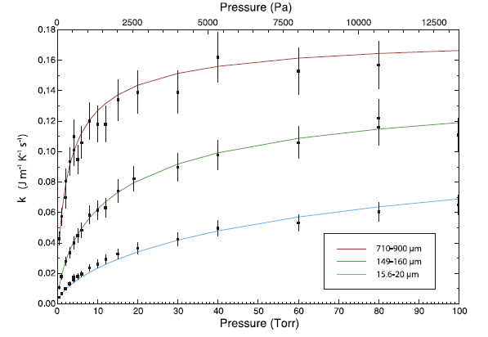

Alternately, Presely and Christensen (1997) gave data for lower pressures and a larger variety of materials (see also data for glass beads in Wood 2013 plot below). This plot shows that in general the thermal conductivity increases with larger particle size. Unfortunately, Presley and Christensen never considered low pressures in their measurements.

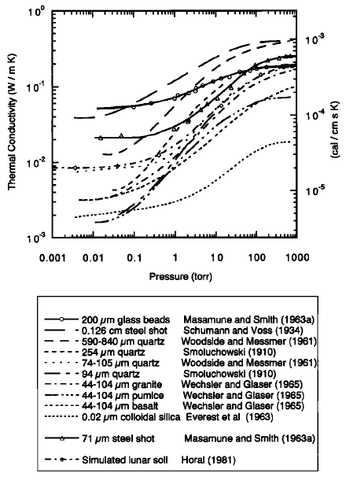

In a more direct comparison, Wechsler and Glaser (1965) they also show the measured themral conductivity for three size distributions of pumice powder [ $k_{pumice, bulk} \sim 0.4269 MKS]. Here, at low pressures the smallest grain size has the largest thermal conductivity while the other two are about equal (largest grain size slightly greater). This could be explained by the finest fraction in the smallest grain size distribution reducing the porosity of the bed, but the low conductivities might also be at the limit of the sensitivity of the measurements (data were taken in 1965, although most of the data in the above graph were as well...).

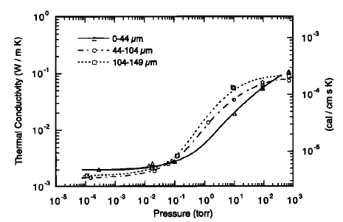.

Finally, Wood 2013 gave a nice plot of thermal conductivity for a large number of glass sphere size distributions. Here it is definitely evident that at low pressures the thermal conductivity increases with increasing grain size. From this I conclude that any model which predicts decreasing thermal conductivity with increasing grain size should be considered non-applicable to the environment in which we are applying it.

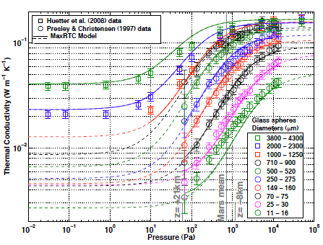[](https://mail.google.com/mail/u/0/?ui=2&ik=f)

It would be interesting to find low pressure thermal conductivity data so that the dependence on grain size could be compared with the theoretical models