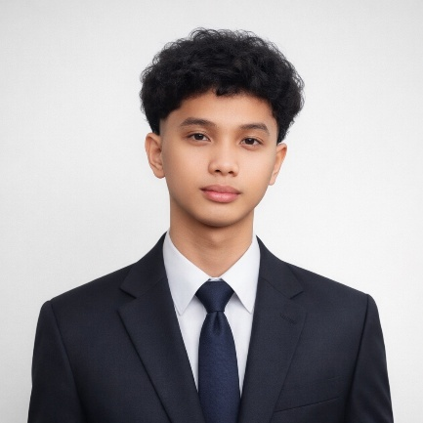
Mark John B. Matining
BS Information Technology

PERSONAL INFORMATION
CONTACT INFORMATION:
Contact Number: 09482058702
Email Address: matiningmj850@gmail.com
Physical Address: Pili, Boac, Marinduque
EDUCATIONAL BACKGROUND:
Elementary: Pili – Balogo Elementary School
Secondary: Marinduque National High School
Senior High School: Marinduque State College
College: Marinduque State University
Degree: Bachelor of Science in Information Technology major in Software Development
RELEVANT EXPERIENCE:
ACADEMIC PROJECT
HAPAG: High speed, Accesible Platforms, for Appetizing Goods in Marinduque – Leader, full stack developer
WORK EXPERIENCE:
Freelance Web & Mobile App Developer (WPDG, June 01, 2026 - Present)
On-the-Job Training - 486 hrs (DOST-PSTO Marinduque, 2026)
CERTIFICATIONS:
2025 MIMAROPA HackforGov Competition (2025) - Participant
DICT – The Dynamic of Cloud Computing (2024)
DOST - Marinduque – On-the-Job Training (486 hrs) (2026)
DOST - Marinduque – Code Master Award (2026)
DOST – LODIXR – On-the-Job Training (486 hrs) (2026)
DICT – Artificial Intelligence: Decoding Its Essence (2024)
DICT - Programming for Intermediate Users Using Python (2024)
DICT – Cybersecurity Proficiency Upskilling: Ethical Hacking Training Program (2024)

RELEVANT SKILLS:
Agentic Development AI Integration AI Automation Figma/FlutterFlow UI/UX Design
Prompt Engineering Networking Skills Cybersecurity Hardware Repairs
CHARACTER REFERENCES:
Keith Paolo A. Buenaventura, Engr. Trishia Marie Tabas, ECT
Supervising Science Research Specialist Project Technical Specialist III
DOST - Marinduque DOST – Central Office keithpaolo.buenaventura@gmail.com trishia.marie.tabag@outlook.com
09457059747 09564728418

