PlaceMate: Placement Management Portal
Project Report and System Documentation
A Unified Web-Based Campus Placement Automation Platform
Academic Project Documentation
Index
Sr. No. | Topic Name | Page No.
1 | Introduction | 2
2 | Project Purpose and Objectives | 2
3 | Technological Stack | 3
4 | Database Architecture | 4
5 | Application Workflow and Screenshots | 5
 | 5.1 Authentication and Account Setup | 5
 | 5.2 Student Portal | 8
 | 5.3 Company Portal | 13
 | 5.4 Placement Officer (Admin) Portal | 19
 | 5.5 Automated Email Notification System | 23
6 | Conclusion | 26

1. Introduction
Campus recruitment is one of the most critical events in any college or university. Every year, hundreds of students participate in placement drives organized by visiting companies. However, in most institutions, the process is still handled manually using disconnected tools—such as Google Forms, Excel sheets, email notices, and WhatsApp groups.
This traditional approach creates serious challenges: students often miss drive notices, placement officers spend days verifying eligibility criteria like CGPA and backlogs by hand, and recruiters face difficulty shortlisting candidates efficiently.
PlaceMate is a comprehensive web application built to solve these exact problems. It automates the entire placement lifecycle by providing three tailored portals: one for Students, one for Companies, and one for College Placement Officers (Admin). The platform centralizes student profiles, automates eligibility checks, manages drive applications, delivers branded email alerts, and provides visual recruitment analytics.
2. Project Purpose and Objectives
Project Purpose
The primary purpose of PlaceMate is to replace chaotic, manual placement operations with a modern, transparent, and automated digital system. By providing a single source of truth, PlaceMate ensures that students only see drives they are actually eligible for, companies can post requirements and manage applicants seamlessly, and placement officers have real-time visibility into hiring outcomes.
Core Objectives
- Role-Based Portals: To provide secure, distinct dashboards for Students, Company HRs, and Placement Officers with granular role-based permissions.
- OTP-Verified Authentication: To verify email addresses during registration using a time-limited 6-digit OTP sent via SMTP, preventing fake user registrations.
- Automated Eligibility Filtering: To automatically validate student criteria (CGPA, active backlogs, passing year, and department) against company drive criteria before an application can be submitted.
- Real-Time Application Tracking: To give students a transparent view of their job applications (Applied, Shortlisted, Interview Scheduled, Selected, Rejected) with instant status updates.
- Automated Email Notification System: To automatically send professional, responsive HTML email notifications whenever a student registers, applies for a drive, or gets shortlisted/selected.
- Interactive Analytics: To display visual charts (department hiring rates, package distribution, application ratios) using Chart.js for both students and company recruiters.
- Modern UI and Theming: To deliver a responsive, accessible interface with zero-flicker light and dark mode toggles integrated across every screen.

3. Technological Stack
PlaceMate is developed using a robust, production-ready stack chosen for performance, security, and developer productivity:
Component | Technology | Role in Project
Backend Framework | Python 3.13 & Django | Handles application routing, business logic, ORM data queries, user authentication, and security protections (CSRF, XSS, password hashing).
Database | PostgreSQL (Supabase) | Stores all relational data including user accounts, profiles, drives, applications, and master records with strict foreign keys.
Frontend & Styling | HTML5 & Vanilla CSS | Built with custom CSS variables, responsive flexbox and grid layouts, clean cards, and unified light/dark color themes without heavy dependencies.
Client Scripting | Vanilla JavaScript | Controls client-side OTP timers, instant form validation, dynamic theme toggling, and modal interactions.
Data Visualization | Chart.js | Generates interactive doughnut and bar charts for student placement analytics and company recruitment metrics.
Email Service | Django SMTP & Gmail | Delivers responsive HTML emails for OTP codes, application confirmations, status updates, and password resets.
Static Assets | WhiteNoise | Handles efficient serving and caching of static stylesheets, scripts, and logos in production.

4. Database Architecture
PlaceMate relies on a relational database schema designed to maintain clean separation of concerns while enforcing referential integrity. The database is organized into distinct entities mapped through Django's Object-Relational Mapping (ORM).
Core Entities
- User (Custom User Model): Extends Django's AbstractUser. Uses email as the unique username identifier and includes a role field ('student', 'company', 'officer') along with an email_verified boolean flag.
- StudentProfile: Linked 1-to-1 with User. Stores student academic details including full name, roll number, university, department (Foreign Key), semester, CGPA, passing year, active backlogs, verified status, resume file, and skills (Many-to-Many).
- CompanyProfile: Linked 1-to-1 with User. Stores corporate profile details including company name, logo image, industry type, website URL, headquarter location, description, and admin verification status.
- OfficerProfile: Linked 1-to-1 with User. Represents college placement coordinators who verify drives and oversee campus hiring activities.
- Department and Skill: Master lookup tables storing academic departments (e.g., Computer Engineering, Information Technology) and technical skills (e.g., Python, React, SQL).
- PlacementDrive: Created by CompanyProfile. Specifies job title, description, package (CTC in LPA), job location, eligible departments (Many-to-Many), required skills (Many-to-Many), minimum CGPA cutoff, maximum allowed backlogs, eligible passing year, deadlines, and drive status ('draft', 'published', 'closed').
- Application: Bridges StudentProfile and PlacementDrive (Many-to-Many junction). Tracks candidate application status ('applied', 'shortlisted', 'interview_scheduled', 'selected', 'rejected') and maintains application timestamps.
Entity Relationship Overview
Source Entity | Relationship | Target Entity | Description
User | One-to-One | StudentProfile | Each student account maps to exactly one student profile.
User | One-to-One | CompanyProfile | Each recruiter account maps to exactly one company profile.
User | One-to-One | OfficerProfile | Each staff account maps to a placement officer profile.
StudentProfile | Many-to-One | Department | Every student belongs to an academic department.
StudentProfile | Many-to-Many | Skill | Students can add multiple skills to their profile.
CompanyProfile | One-to-Many | PlacementDrive | A company can publish multiple placement drives.
PlacementDrive | Many-to-Many | Department | A drive can be open to multiple eligible departments.
StudentProfile | One-to-Many | Application | A student can apply to multiple eligible drives.
PlacementDrive | One-to-Many | Application | A drive receives applications from multiple students.

5. Application Workflow and Screenshots
This section presents the step-by-step visual workflow of PlaceMate, walking through Authentication, the Student Portal, the Company Portal, the Placement Officer Portal, and the Automated Email System.
5.1 Authentication and Account Setup
PlaceMate provides a secure, role-specific onboarding experience. Users select their appropriate role, verify their official email address using a one-time password (OTP), and log in securely.
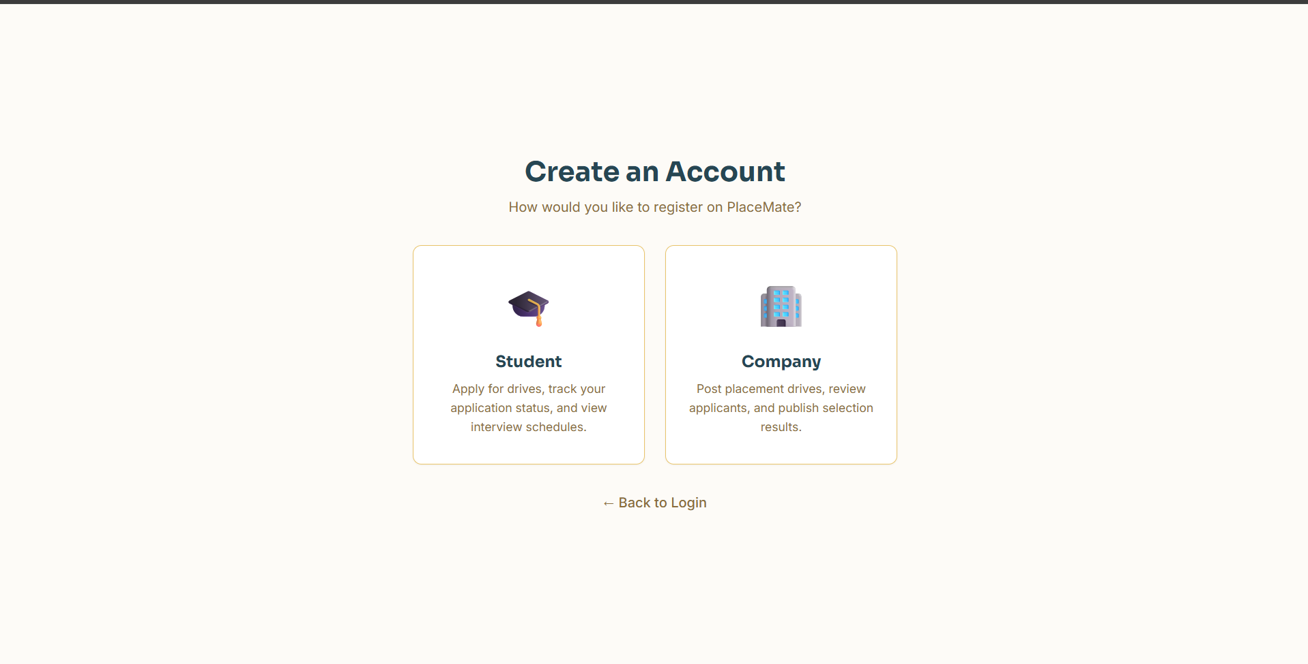
Figure 1: Registration Role Selection Screen
The starting onboarding screen where visitors select whether they want to register as a Student seeking job opportunities or as a Company looking to hire fresh talent.
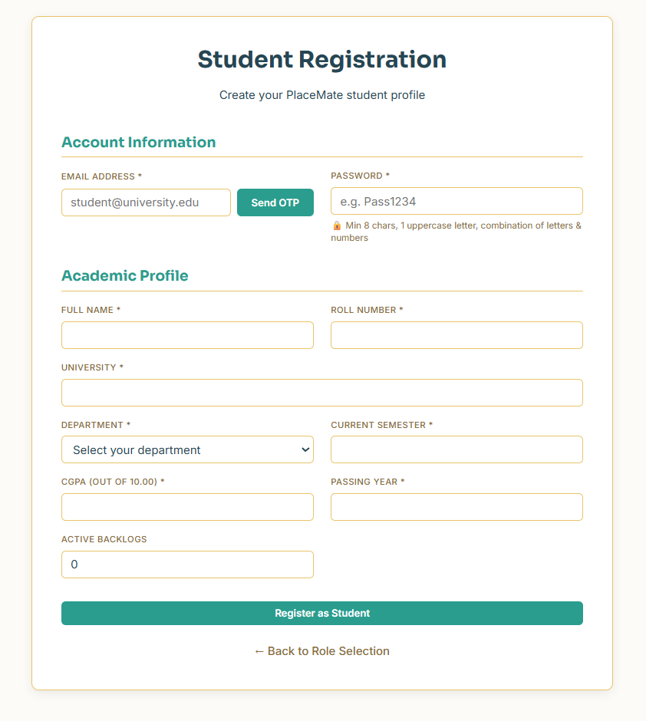
Figure 2: Student Registration Form
The student signup screen where candidates enter their email, create a secure password, and fill in academic credentials including roll number, department, CGPA, and passing year.

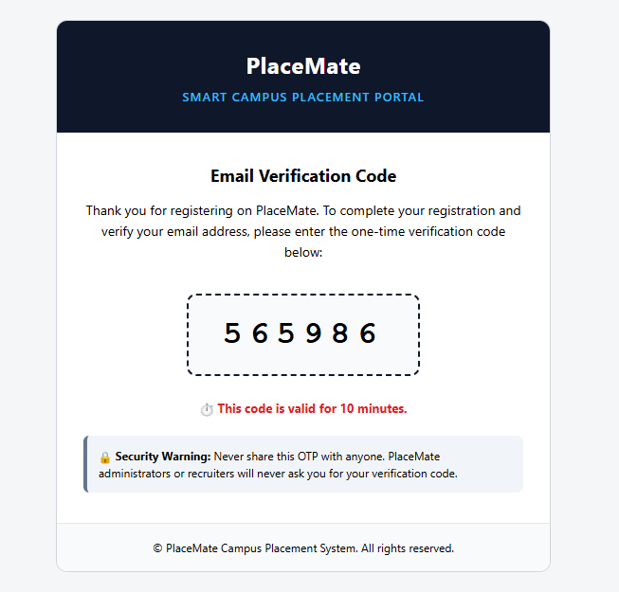
Figure 3: Real-Time Email OTP Verification
The integrated OTP verification box that activates upon clicking 'Send OTP'. It prevents fraudulent registrations by ensuring students possess access to their registered email inbox.
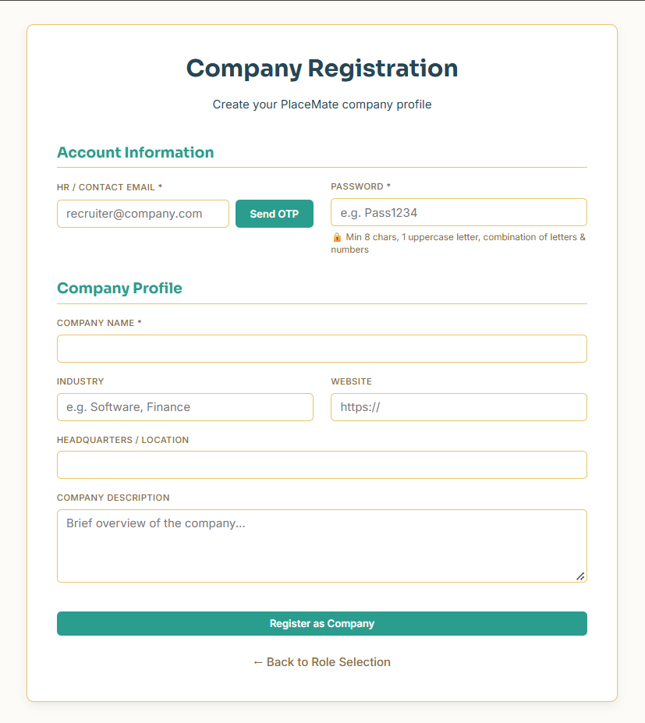
Figure 4: Company Registration Form
The recruiter registration screen allowing HR representatives to register their corporate profile with email verification, company name, industry, website, and headquarters location.

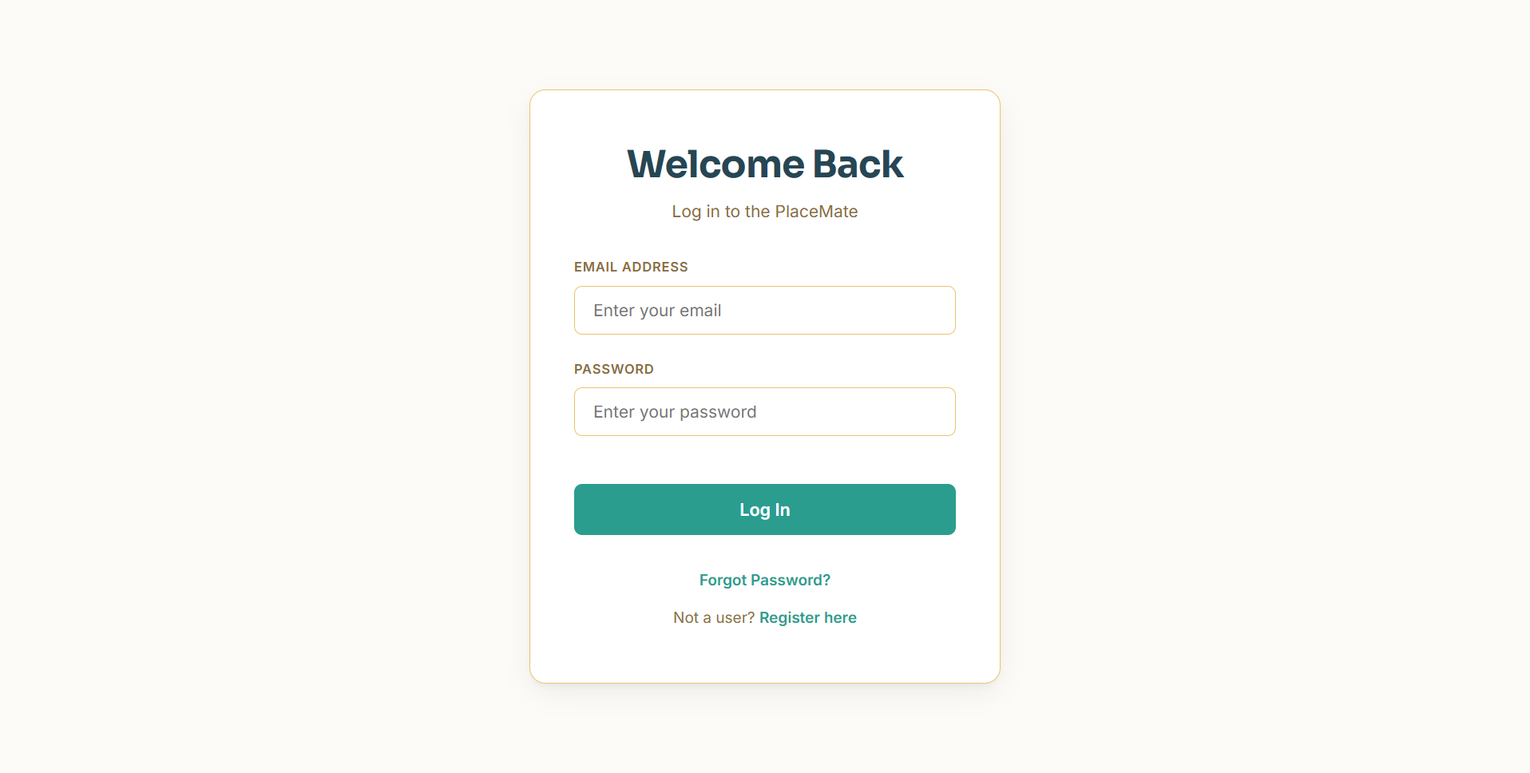
Figure 5: PlaceMate Central Login Screen
The unified login screen featuring an integrated dark/light mode toggle in the top bar. Users enter their credentials and are automatically routed to their respective role-based portal.
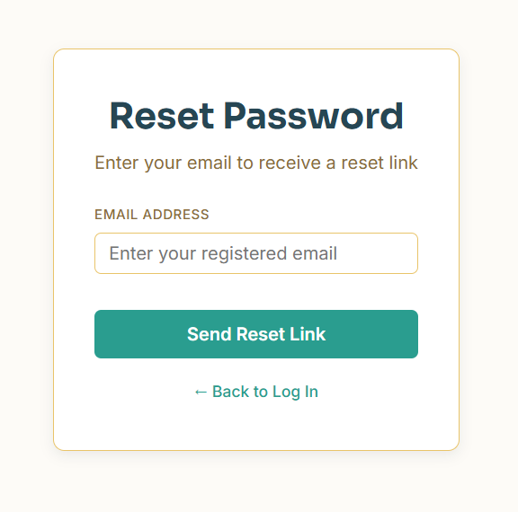
Figure 6: Password Reset Request Screen
Self-service password recovery screen where users enter their registered email address to receive a secure, time-limited password reset link.
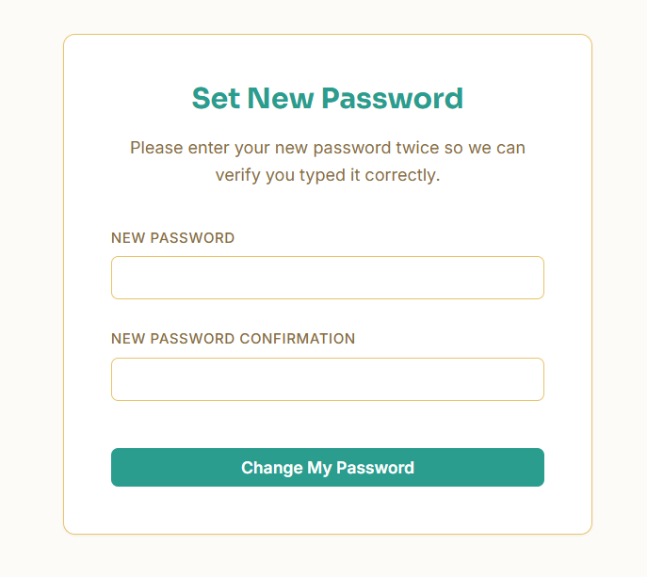
Figure 7: Set New Password Screen
Secure token-authenticated page allowing the user to create a new password adhering to complexity requirements.

5.2 Student Portal
The Student Portal serves as a personalized career hub where candidates can maintain their academic profile, discover placement drives, check eligibility criteria in real time, submit job applications, and analyze campus placement trends.
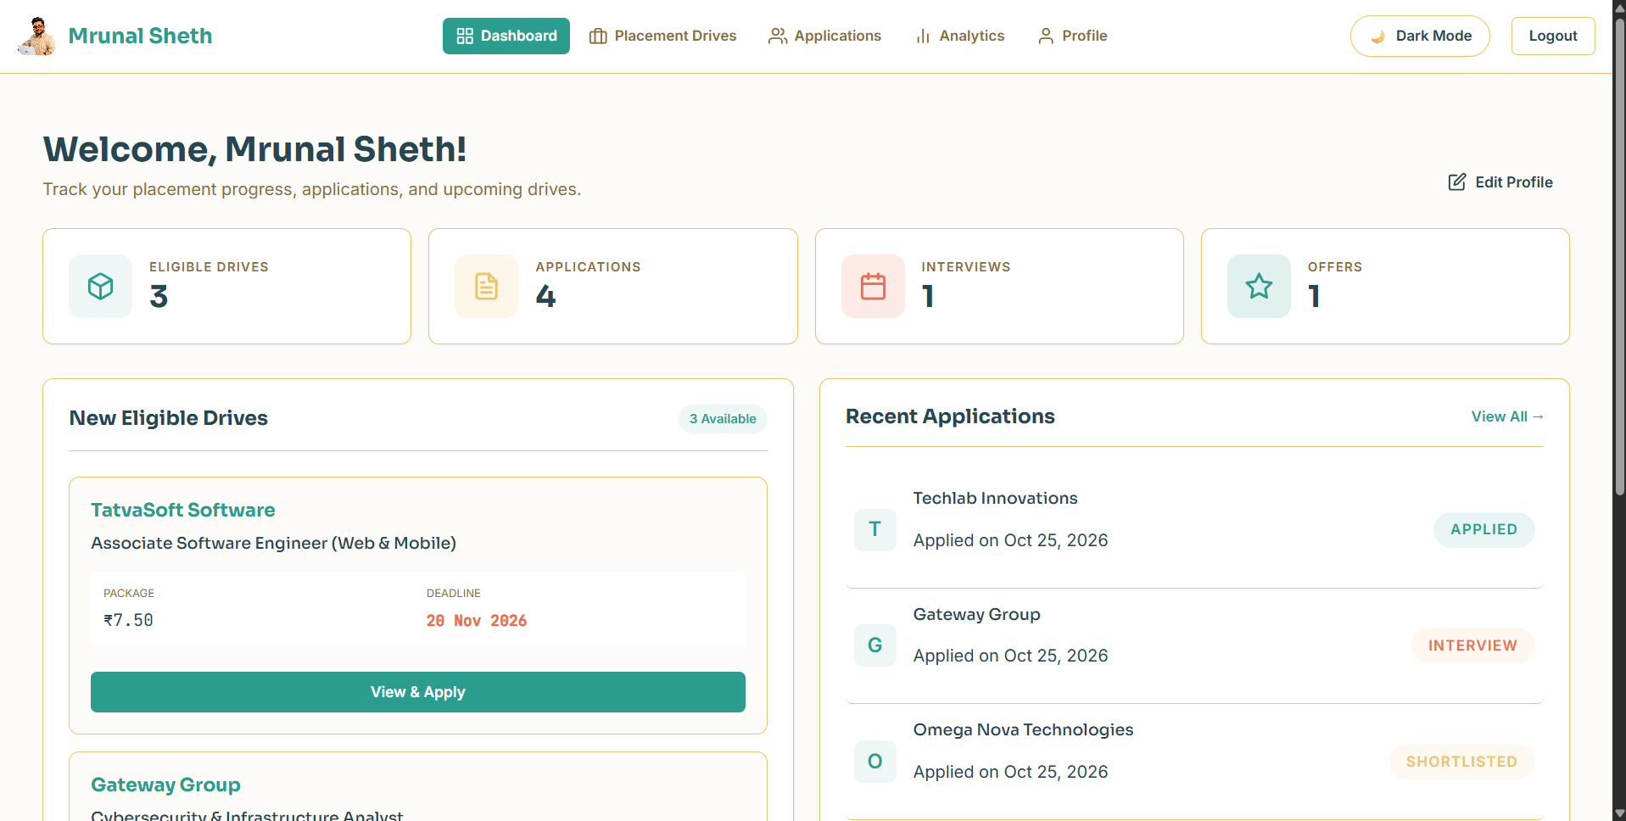
Figure 8: Student Dashboard
The main student dashboard displaying quick summary cards (eligible drives, active applications, shortlisted status) and a feed of newly announced placement drives.
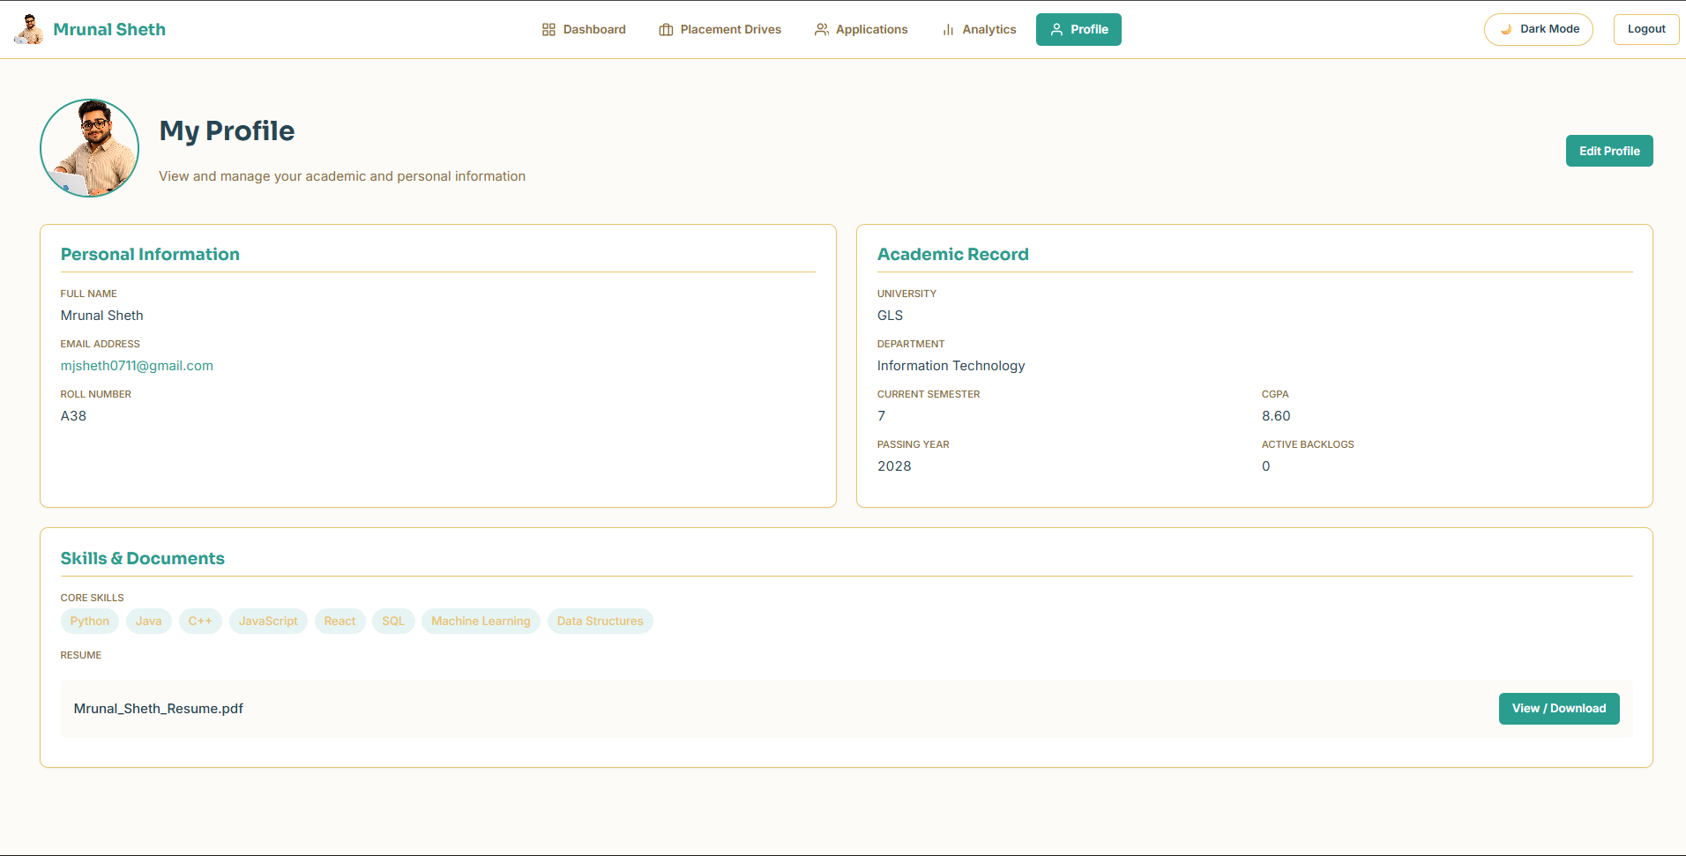
Figure 9: Student Profile Overview
Detailed view of the student's academic profile showing roll number, department, CGPA, active backlogs, verified status badge, tagged technical skills, and uploaded resume link.

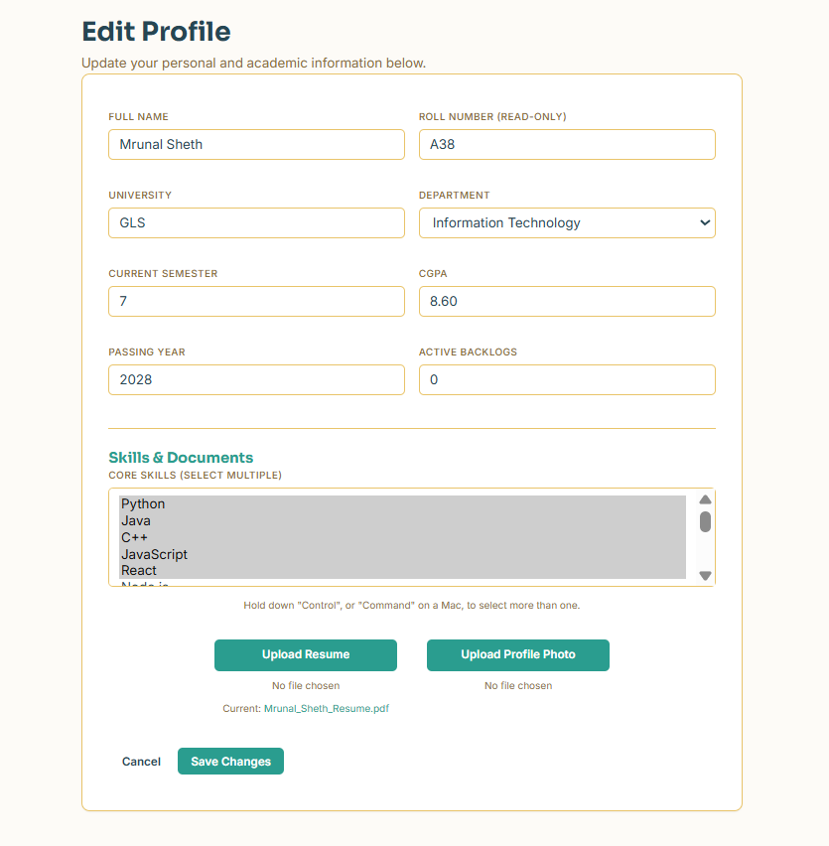
Figure 10: Edit Student Profile
Profile editing interface where students can update their skills, upload new resumes, and refresh academic details.
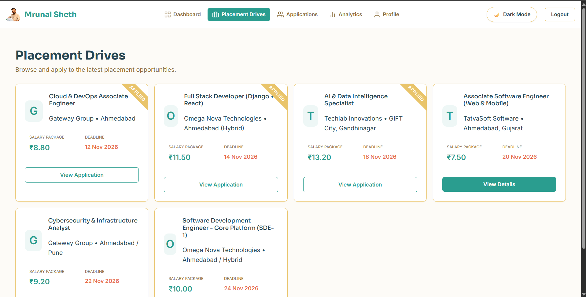
Figure 11: Placement Drives Listing
List of all published recruitment drives on campus with search filters, salary tags, deadline alerts, and quick eligibility badges.

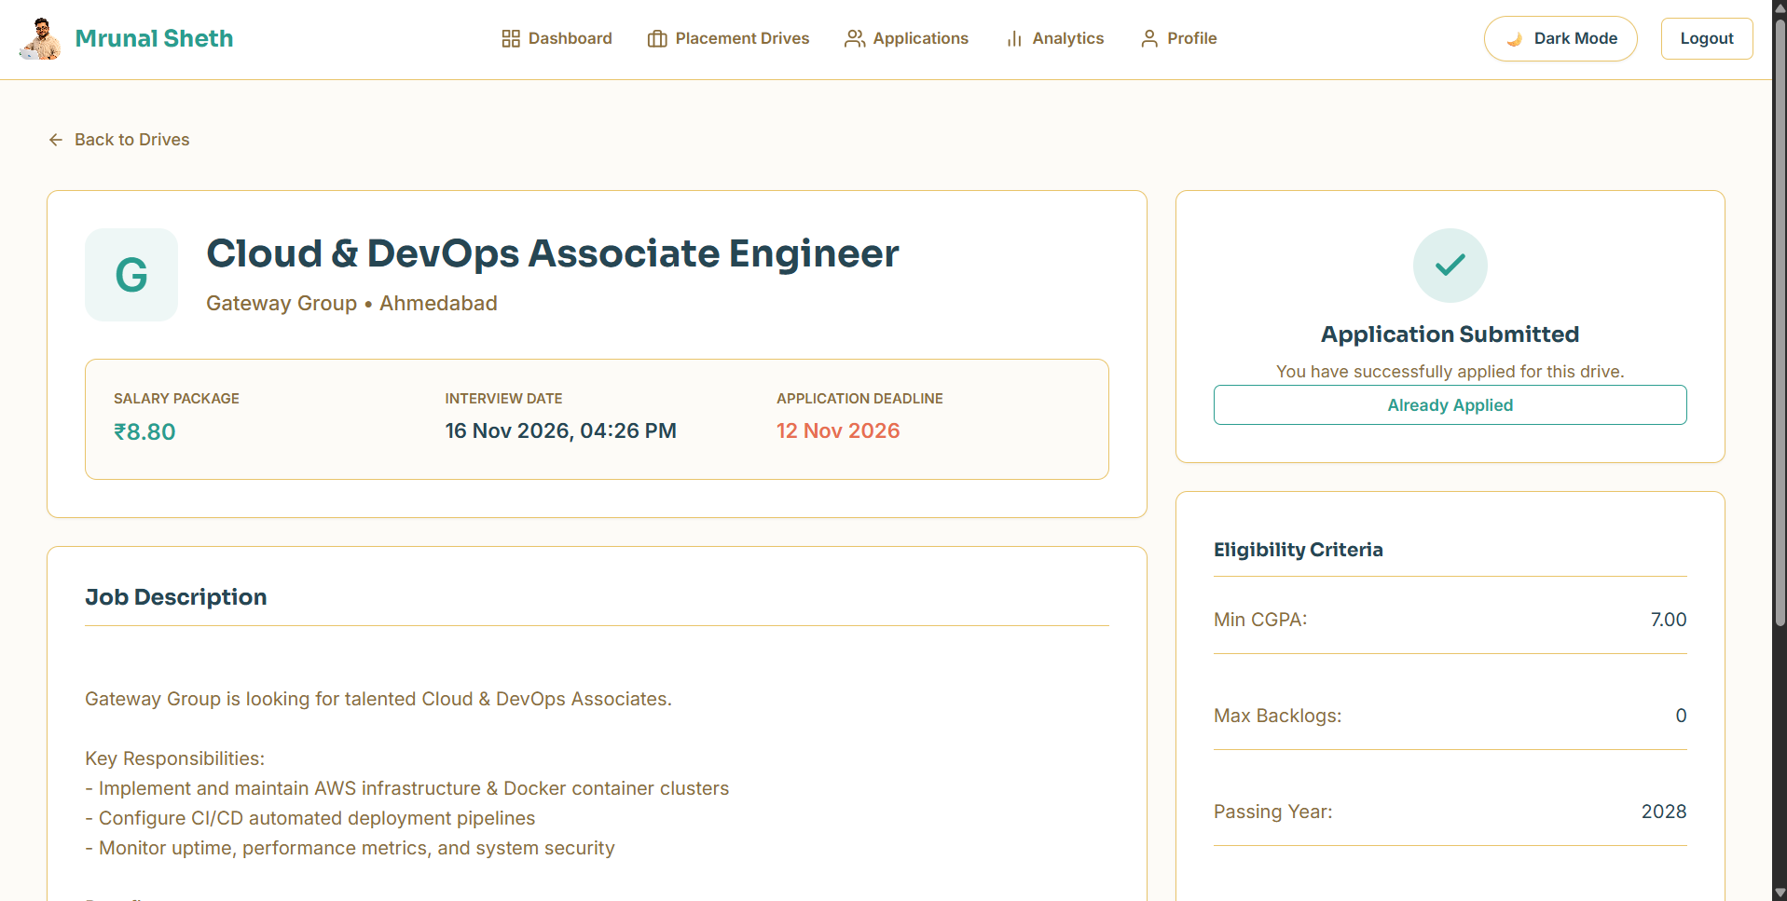
Figure 12: Placement Drive Details & Eligibility Breakdown
In-depth view of a specific placement drive outlining job role, CTC, location, required skill tags, application deadline, and automated eligibility criteria checks.
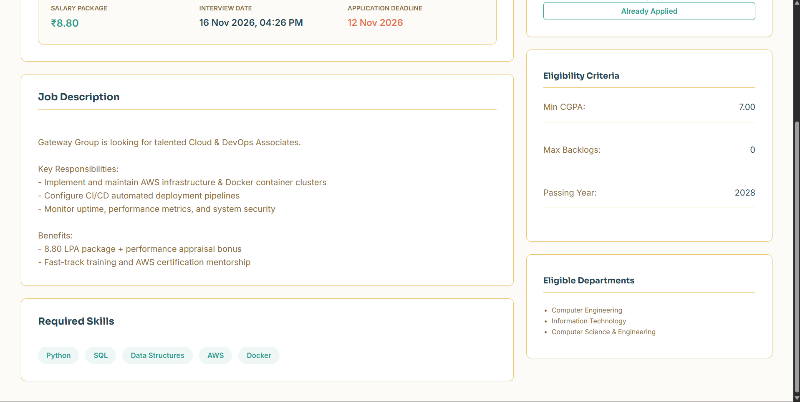
Figure 13: Drive Application Submission
Drive application confirmation modal that allows students who meet all criteria to submit their resume and application with a single click.

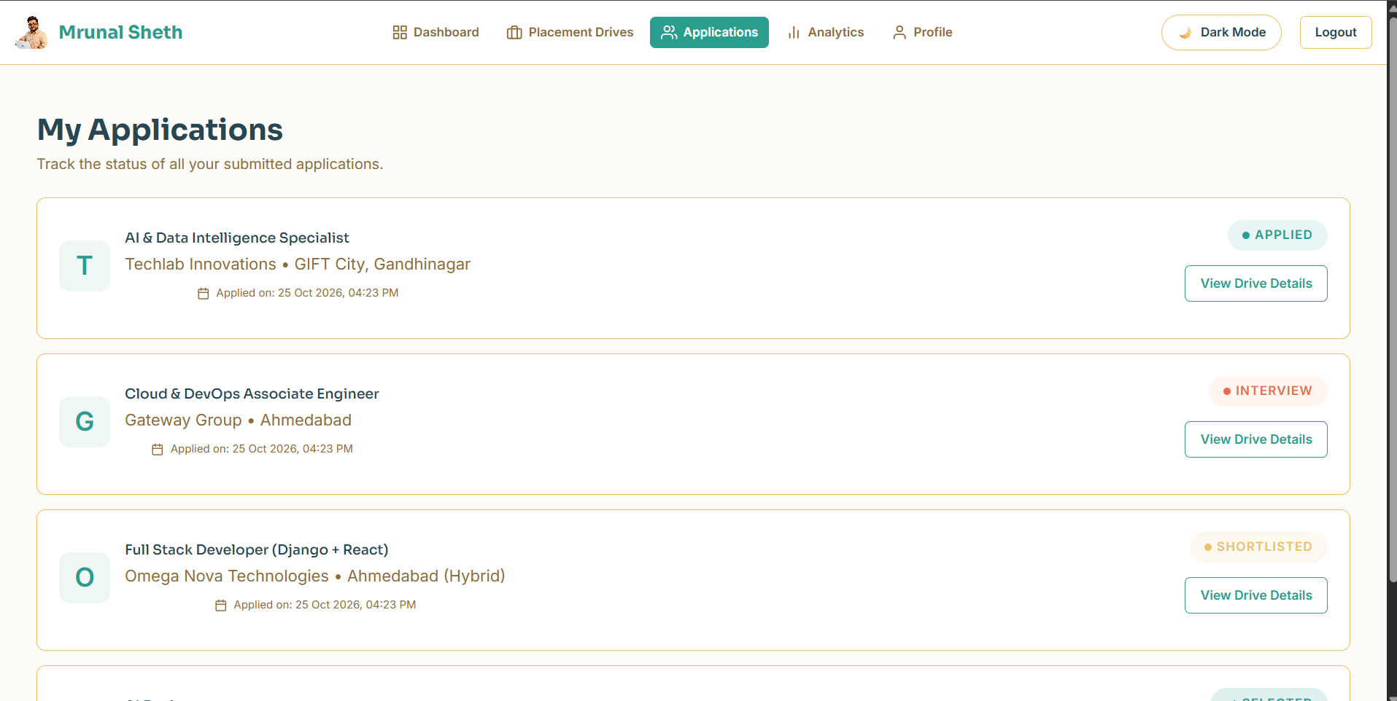
Figure 14: My Applications Tracking Screen
Dedicated status board where students track every submitted application in real time, complete with color-coded status badges (Applied, Shortlisted, Selected).
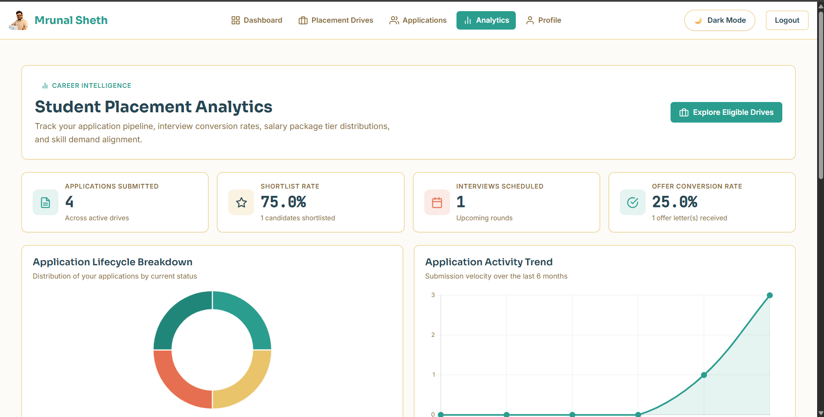
Figure 15: Student Placement Analytics - Key Performance Indicators
Analytics dashboard providing students with clear insights on total companies visited, placement percentage, and overall drive participation.

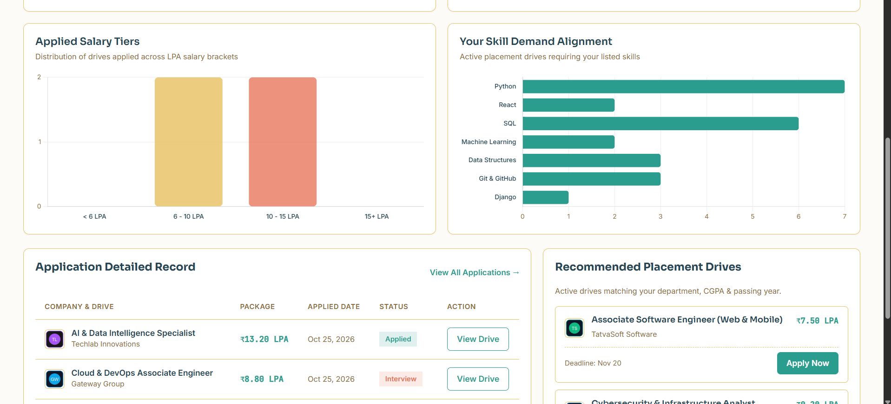
Figure 16: Student Analytics - Department Hiring Trends
Interactive Chart.js chart illustrating placement counts and selection rates broken down across engineering departments.
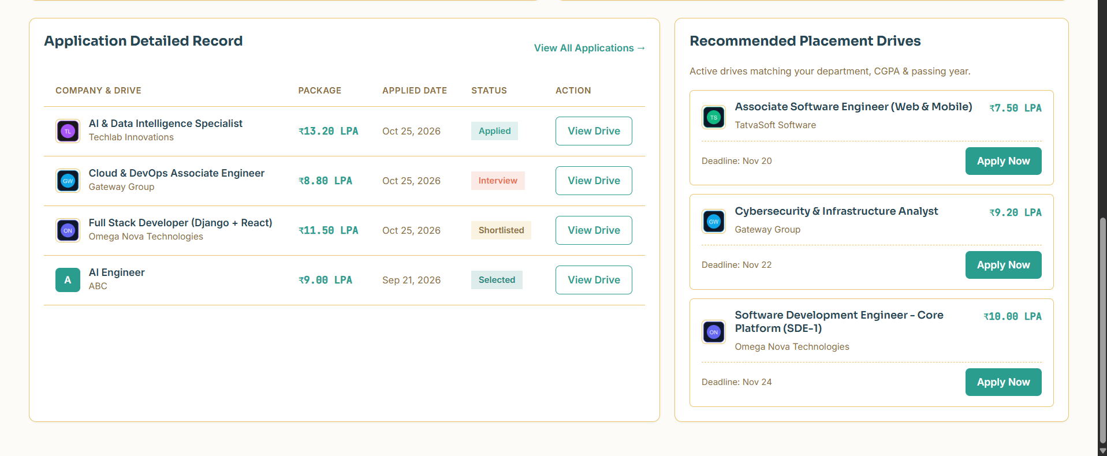
Figure 17: Student Analytics - Salary Package Distribution
Visualization showing the distribution of salary packages (CTC in LPA) across campus placement drives.

5.3 Company Portal
The Company Portal empowers corporate recruiters to manage their company profile, create customized placement drives with specific academic cutoffs, review student applicants, and manage candidate selection stages.
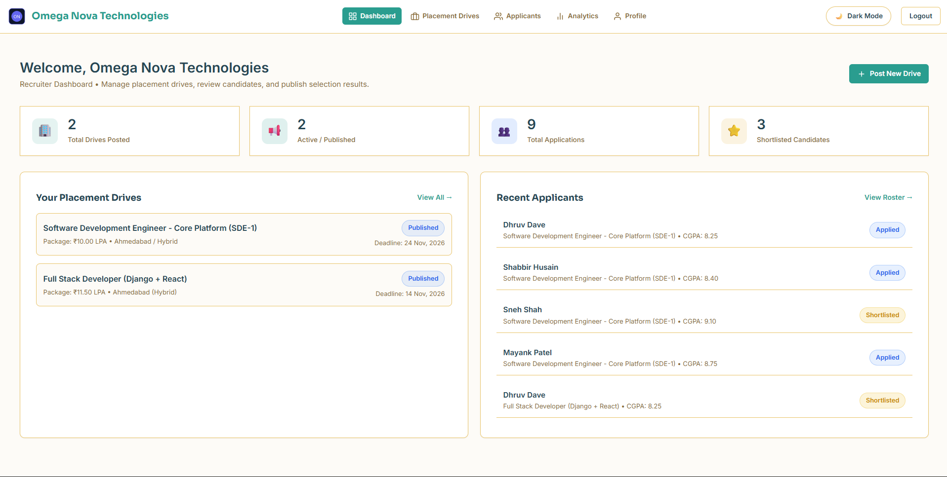
Figure 18: Company Recruiter Dashboard
The recruiter dashboard showing high-level recruitment metrics, including total drives posted, total applicants received, and shortlisted candidates.
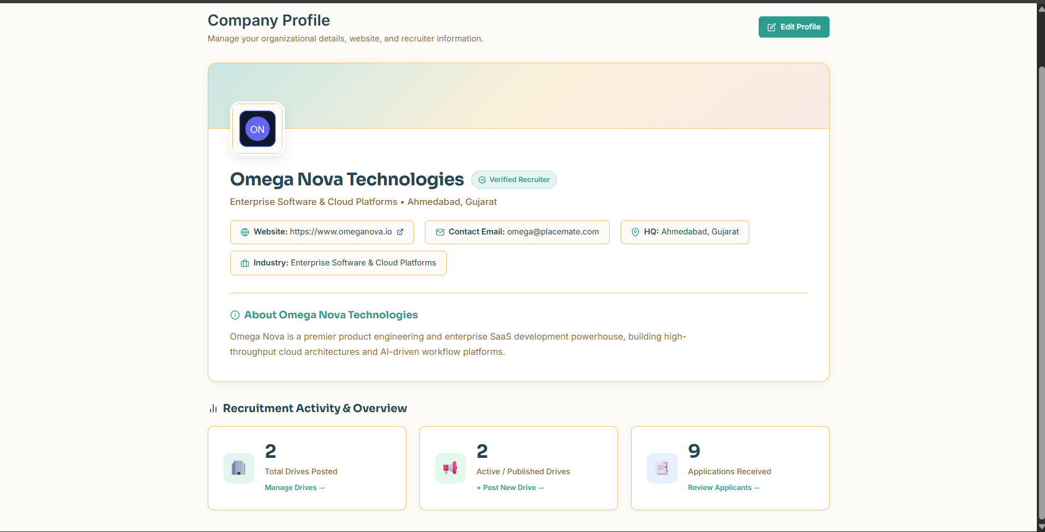
Figure 19: Company Profile Overview
Corporate profile page displaying company branding, logo, industry sector, website, office location, and verification status.

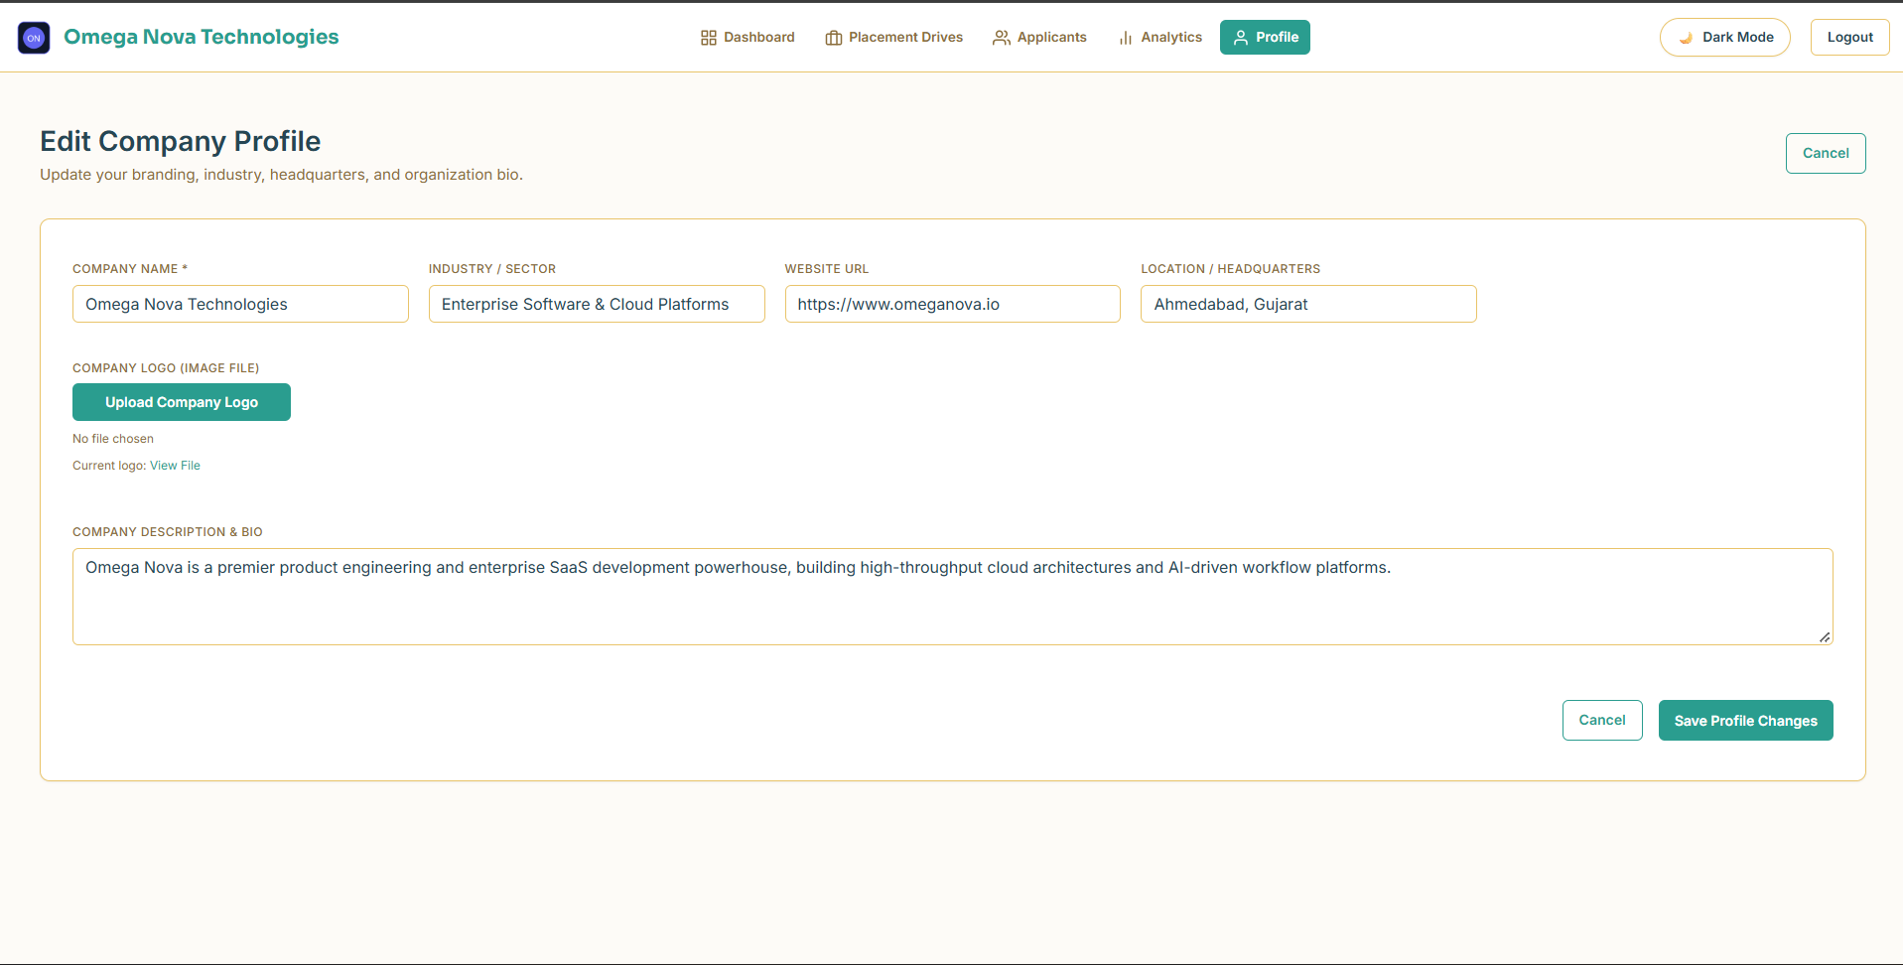
Figure 20: Edit Company Profile
Form allowing HR personnel to update recruiter contact information, company bio, and recruitment preferences.
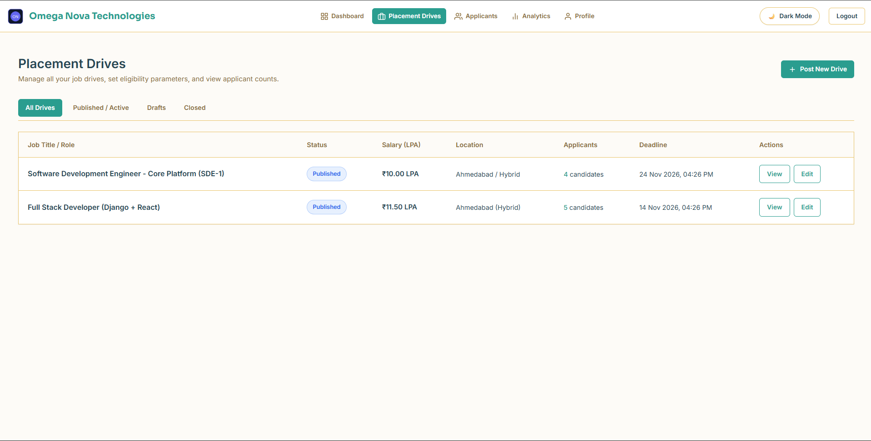
Figure 21: Company Placement Drives Management
Overview table of all placement drives published by the company, showing application deadlines, applicant counts, and drive statuses.

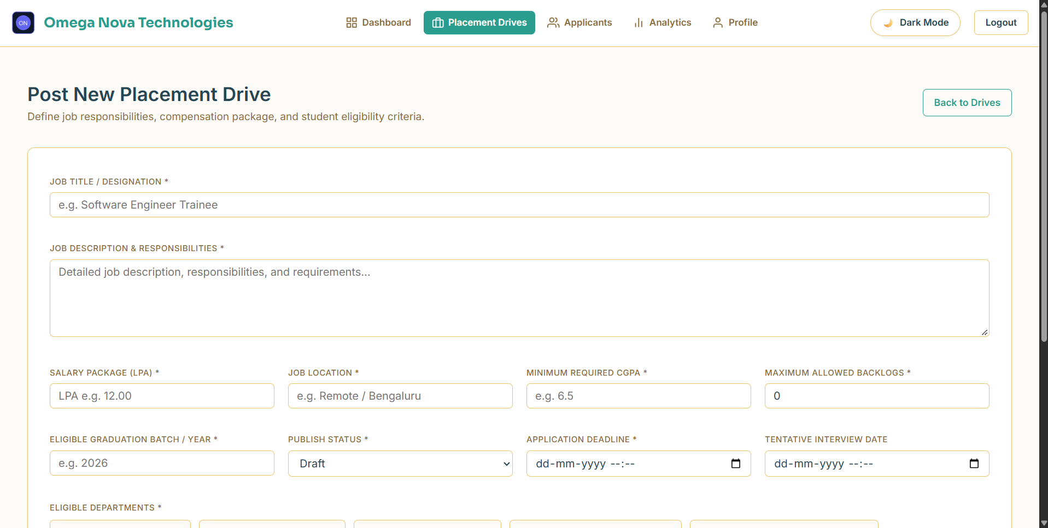
Figure 22: Create Placement Drive - Job Role and Details
Step 1 of drive creation where recruiters enter the job title, job description, annual CTC package, job location, and application deadline.
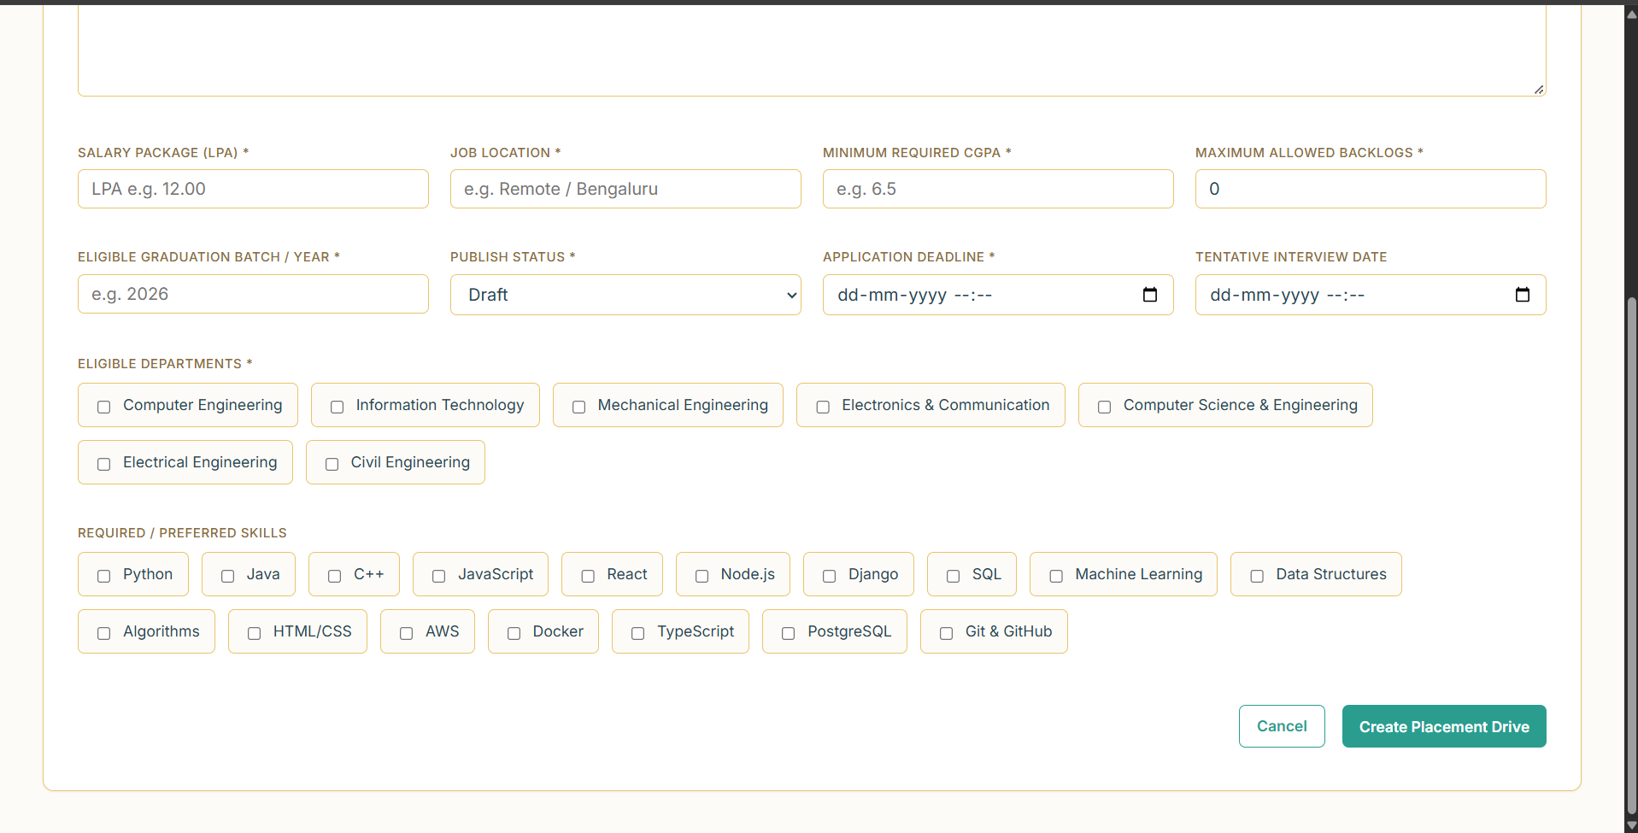
Figure 23: Create Placement Drive - Eligibility Criteria
Step 2 of drive creation where recruiters configure strict eligibility rules: minimum CGPA cutoff, maximum backlogs, eligible passing year, and required technical skills.

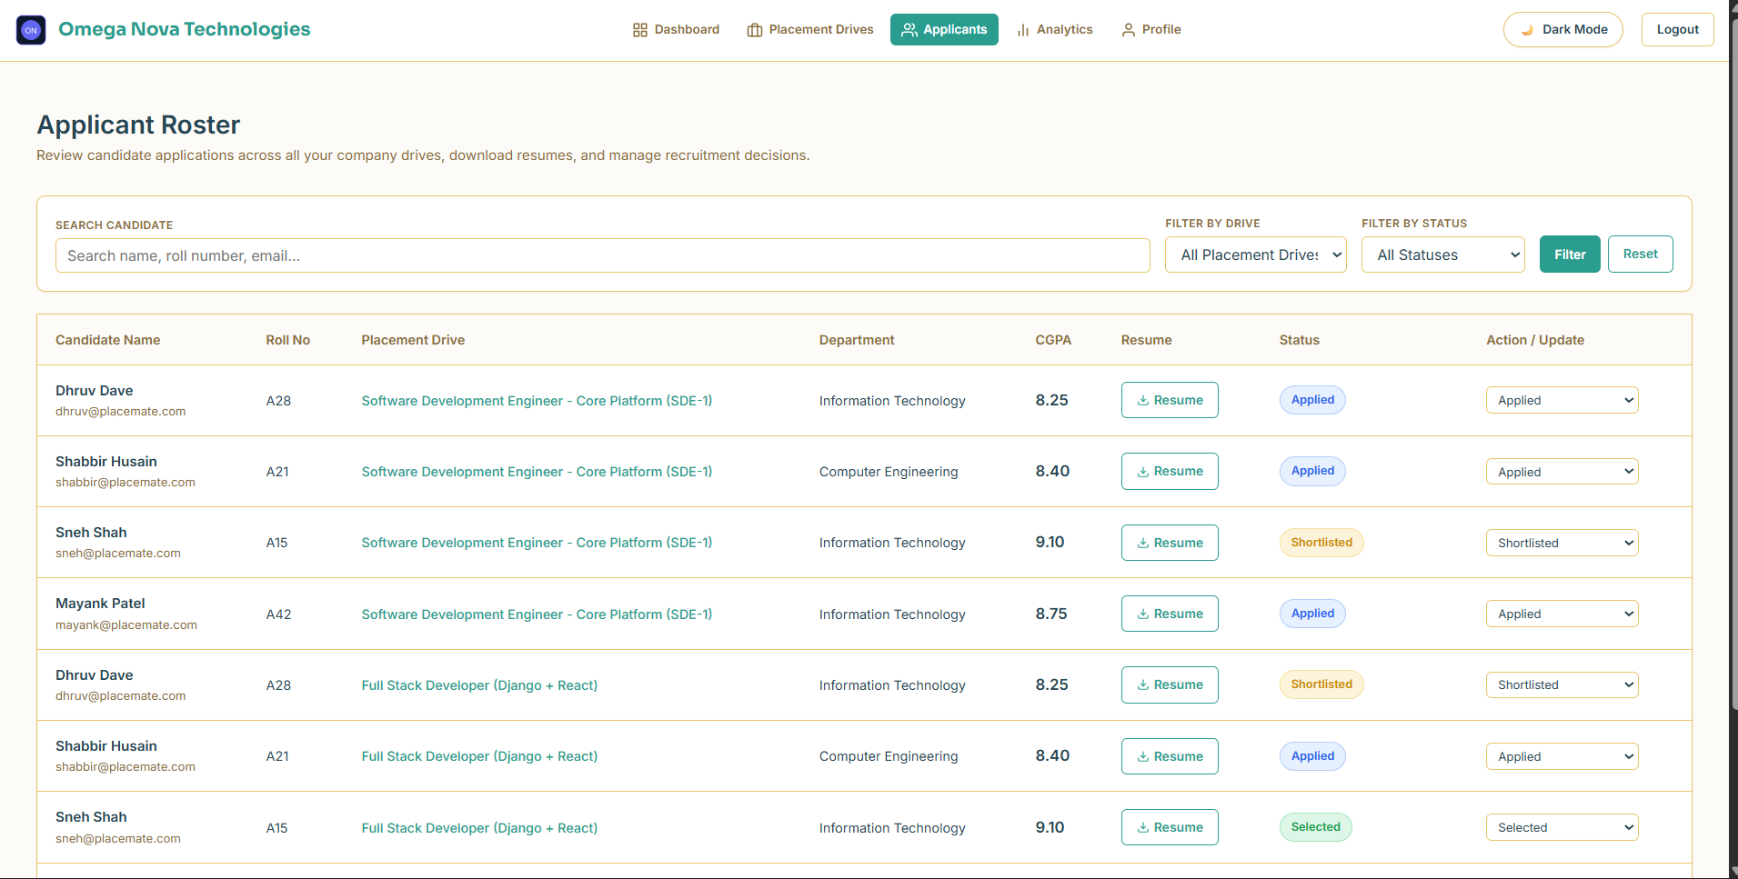
Figure 24: Drive Applicants Management Screen
Applicant review table listing all students who applied to the drive, complete with roll number, department, CGPA, resume download link, and current stage.
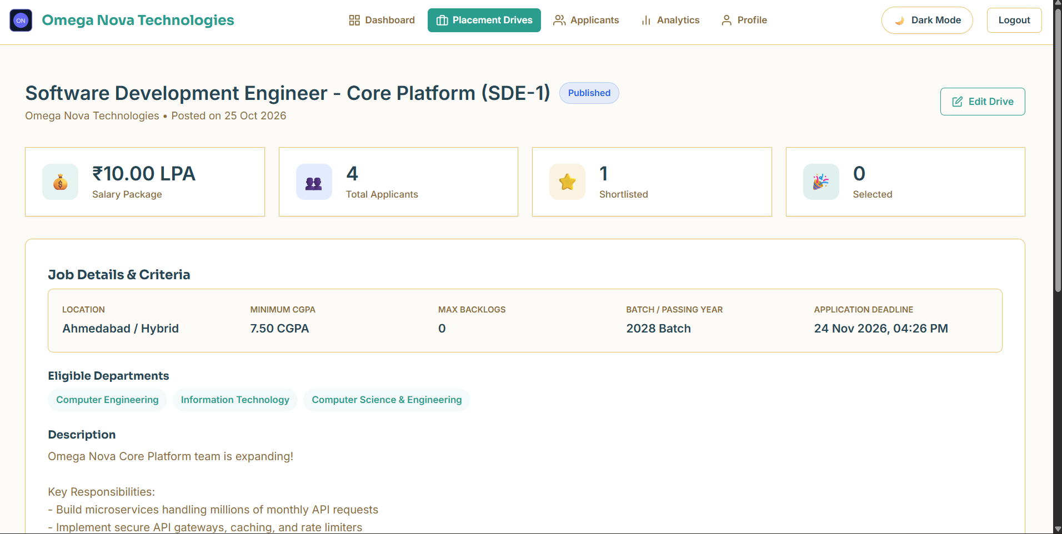
Figure 25: Applicant Status Review and Updating
Interface allowing company HR to review candidate qualifications and update their application status to Shortlisted, Interview Scheduled, or Rejected.

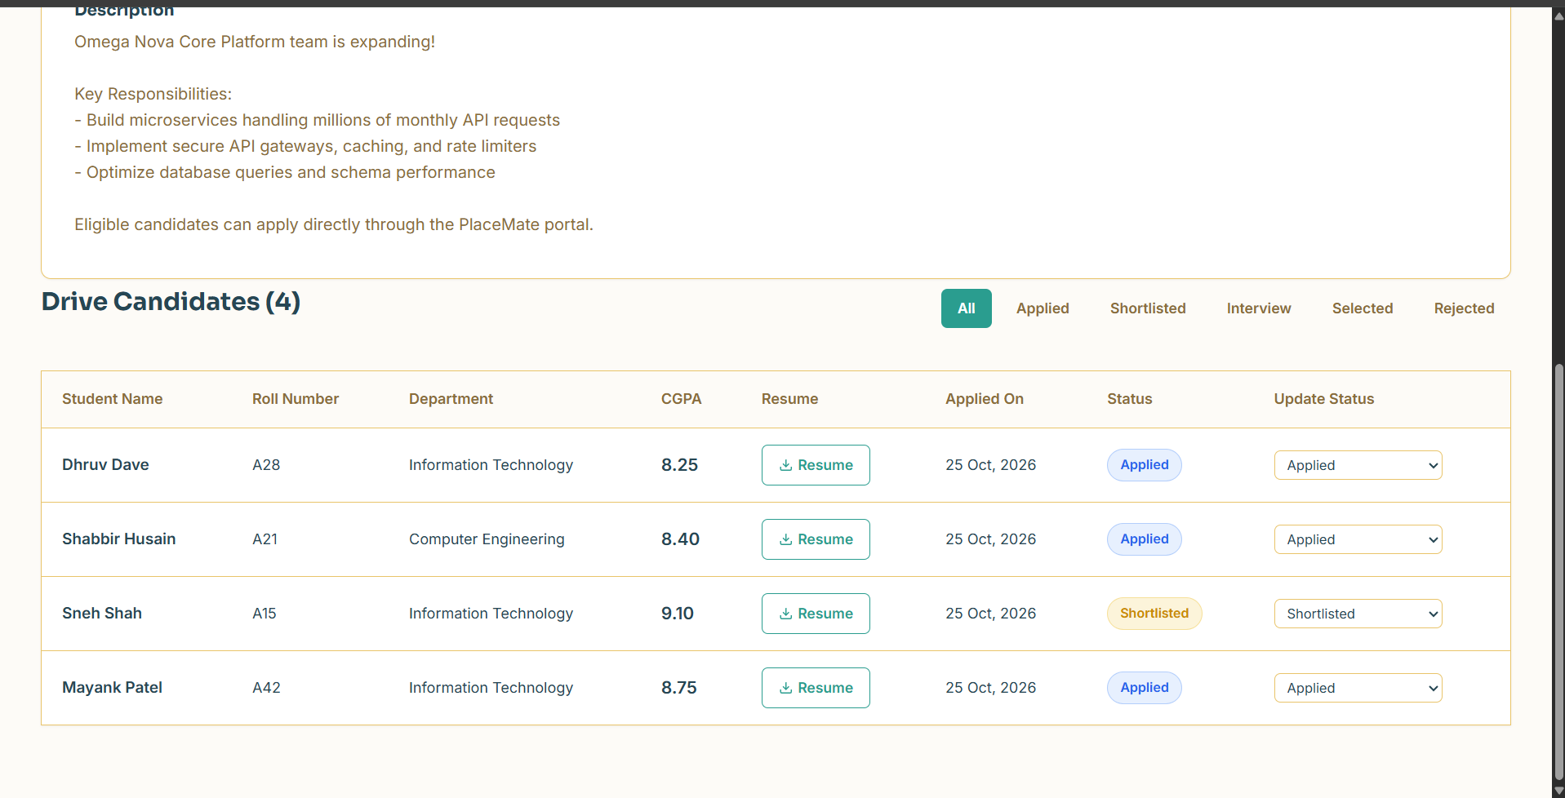
Figure 26: Final Selection and Offer Confirmation
Candidate management view confirming final student selections and triggering automated congratulatory emails.
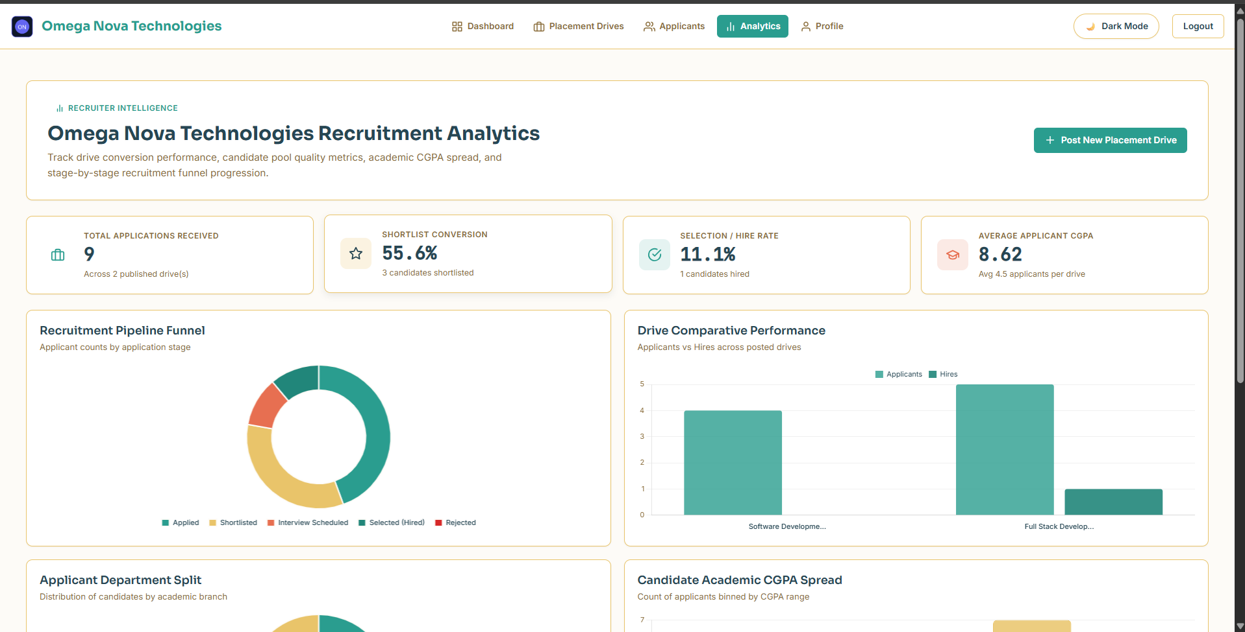
Figure 27: Company Analytics - Hiring Funnel
Recruitment analytics screen presenting the company's application-to-selection funnel and average applicant CGPA.

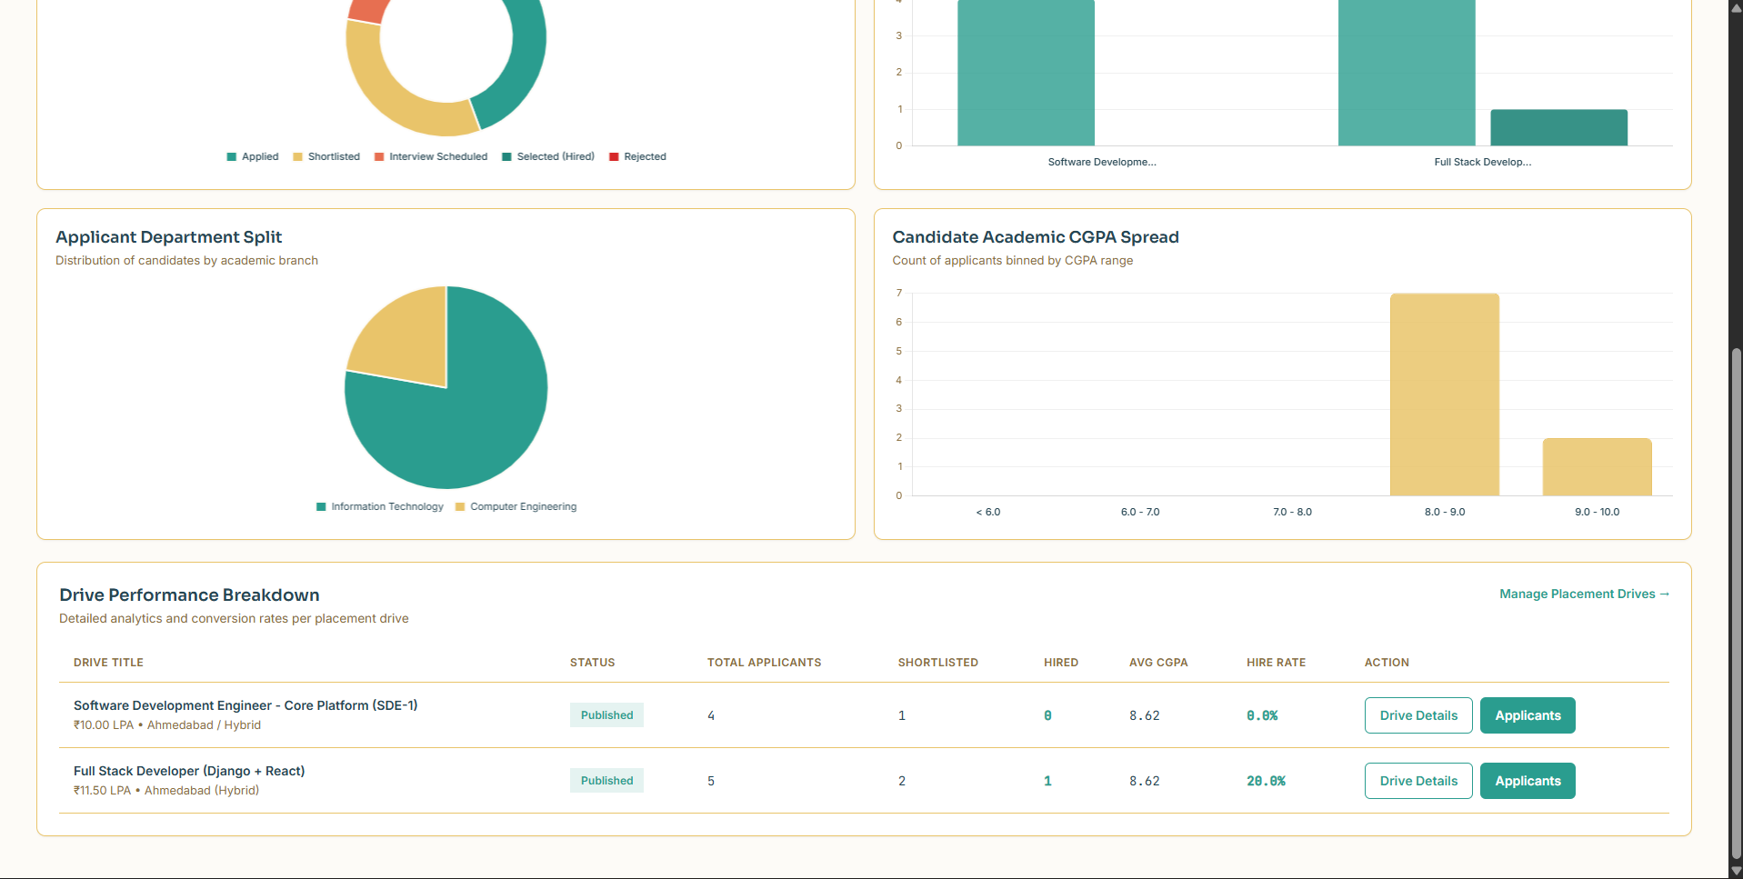
Figure 28: Company Analytics - Department-wise Candidate Breakdown
Visual chart detailing applicant distribution by academic branch to help recruiters evaluate candidate pool diversity.

5.4 Placement Officer (Admin) Portal
The Placement Officer Portal provides college administrators with centralized control over users, verification requests, master academic records, drives, and institutional hiring statistics.
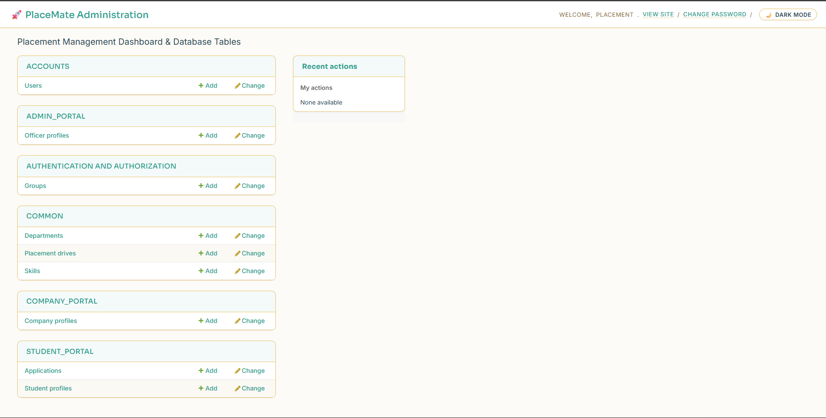
Figure 29: Placement Officer Admin Dashboard
Central administration dashboard showing university-wide recruitment metrics, pending company verifications, and active campus drives.
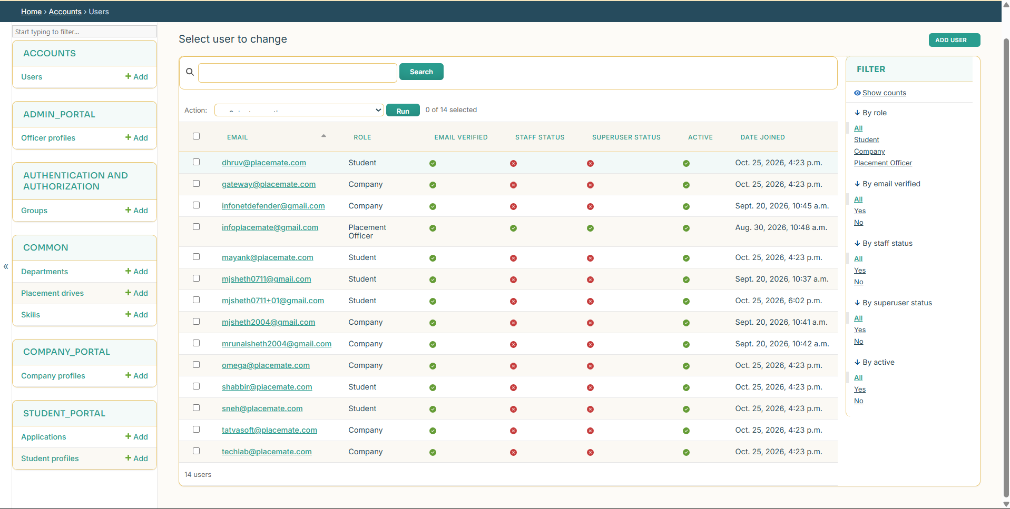
Figure 30: User Management and Verification
User administration screen where placement officers verify student and company accounts, assign roles, and manage system access.

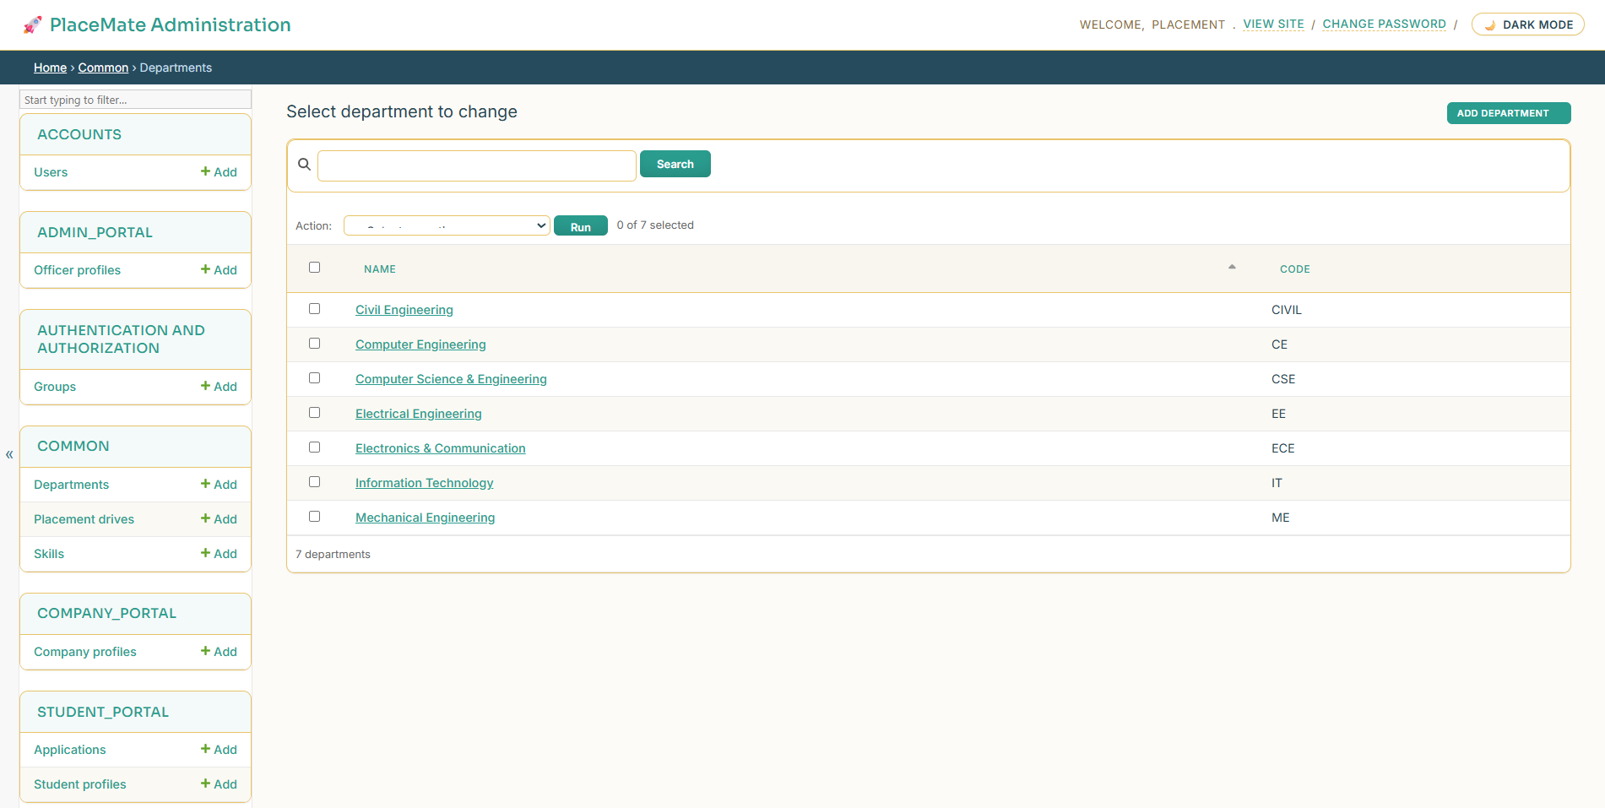
Figure 31: Academic Department Master Management
Master data screen allowing administrators to configure college departments, degree codes, and eligible streams.
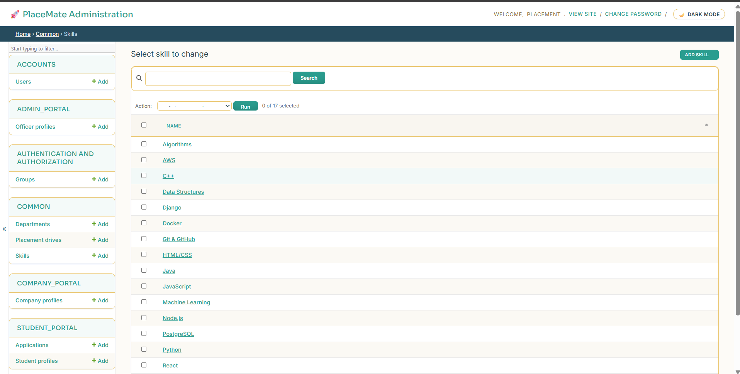
Figure 32: Technical Skills Master Management
Master catalogue of technical skills and competencies used for student tagging and drive matching.

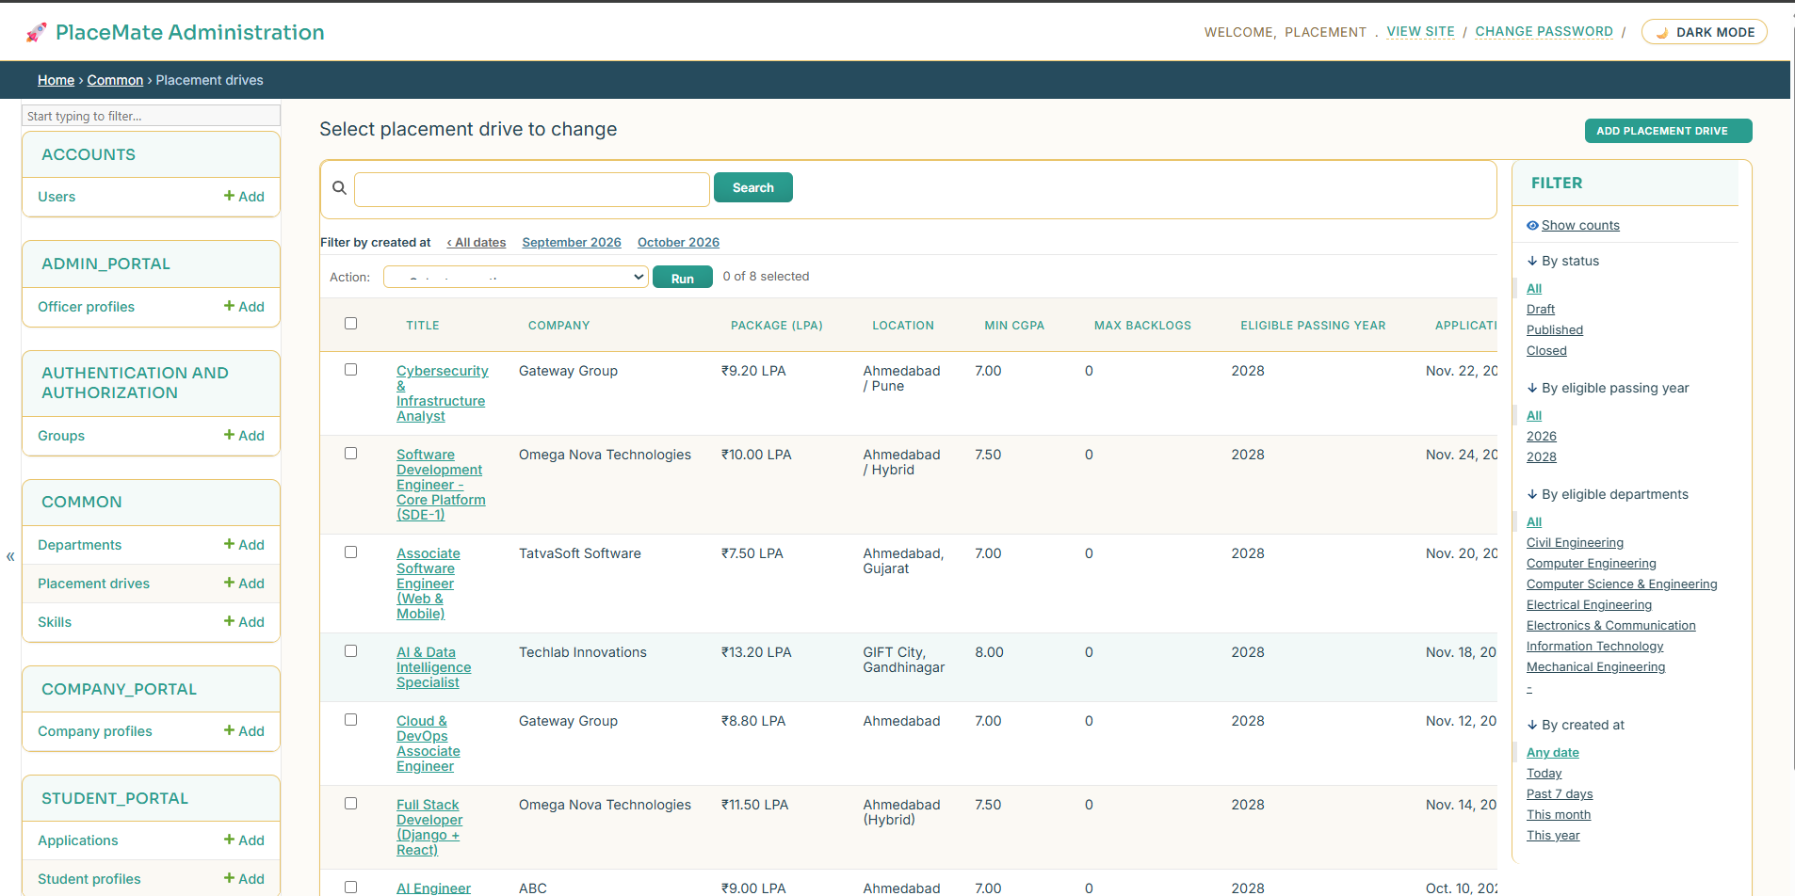
Figure 33: Placement Drives Oversight and Approval
Administration screen for reviewing drives submitted by visiting companies, confirming eligibility criteria, and approving them for publishing.
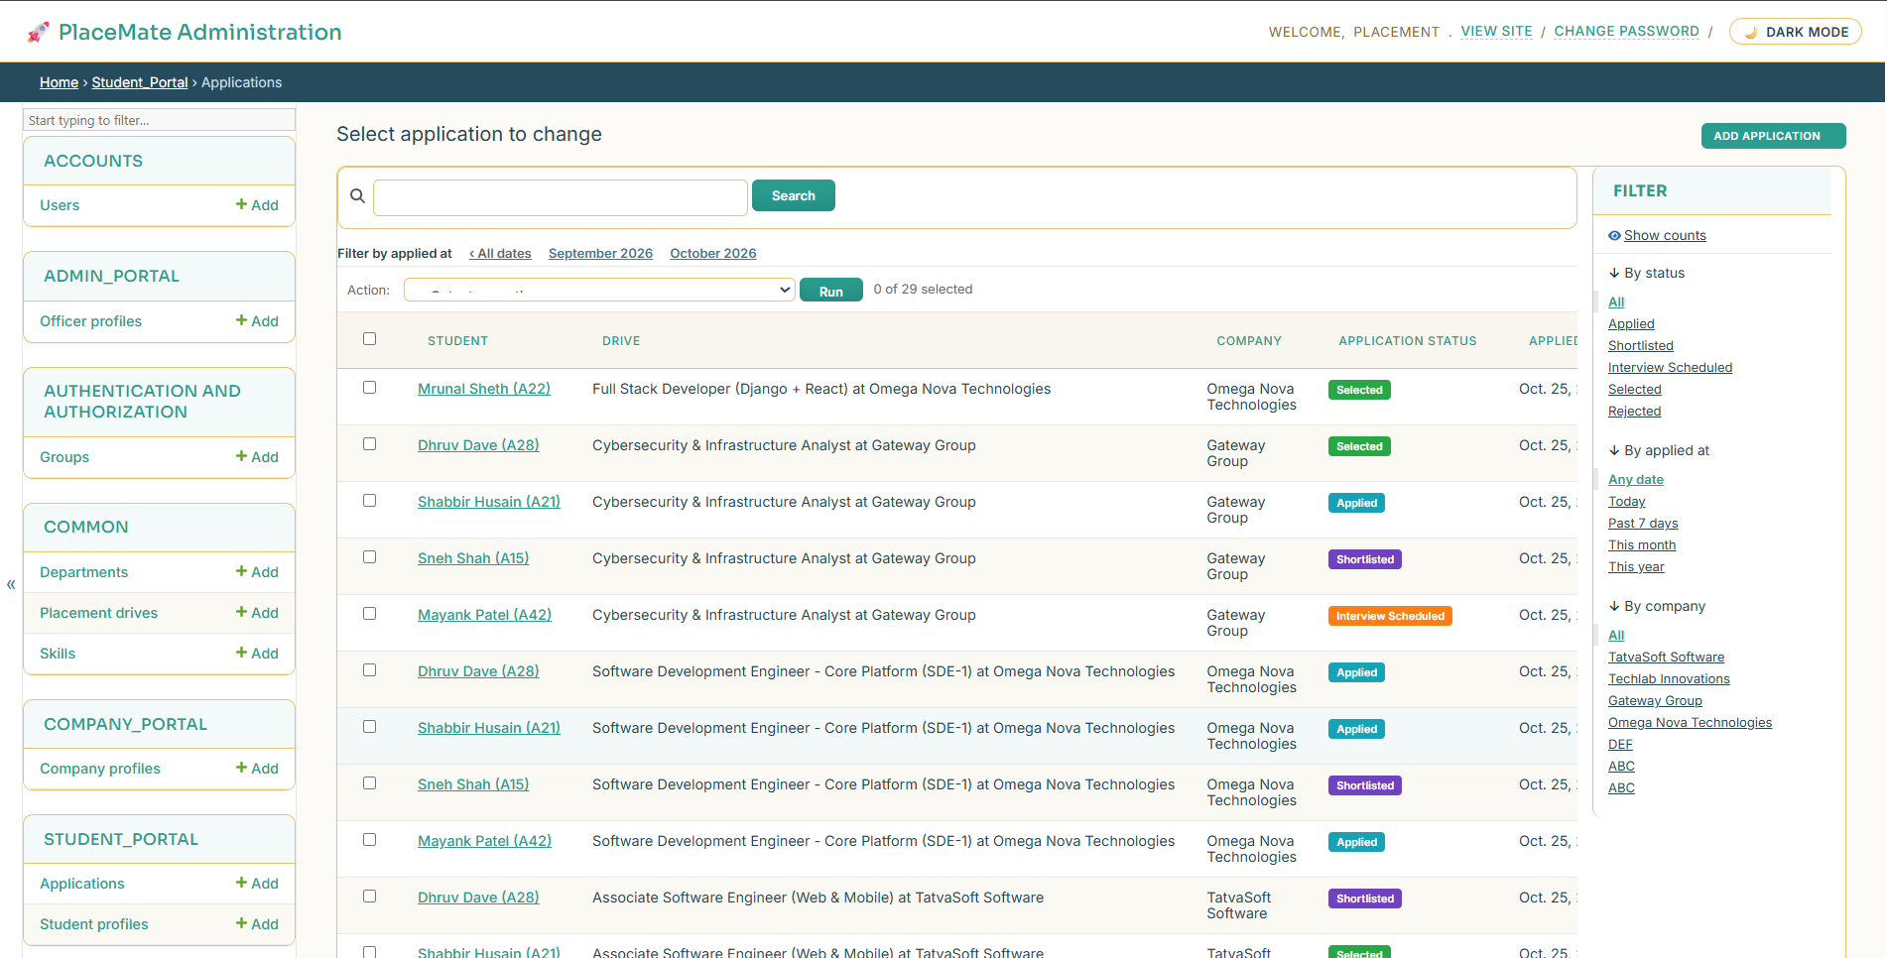
Figure 34: Global Application Records Oversight
Comprehensive database log of all student applications across all active and completed campus placement drives.

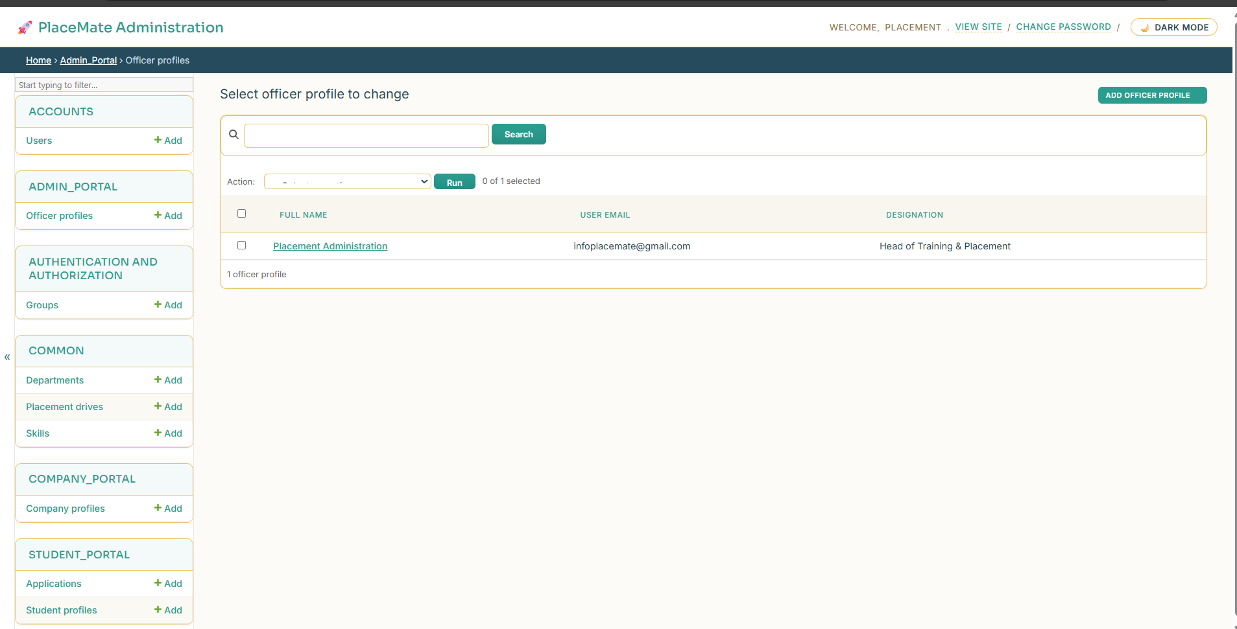
Figure 35: Placement Officer Staff Profiles
Management interface for placement cell faculty members and administrative staff coordinators.

5.5 Automated Email Notification System
PlaceMate incorporates an automated email notification system built with custom, responsive HTML templates. Whenever significant actions take place, the server dispatches instant, branded notifications directly to the user's inbox.
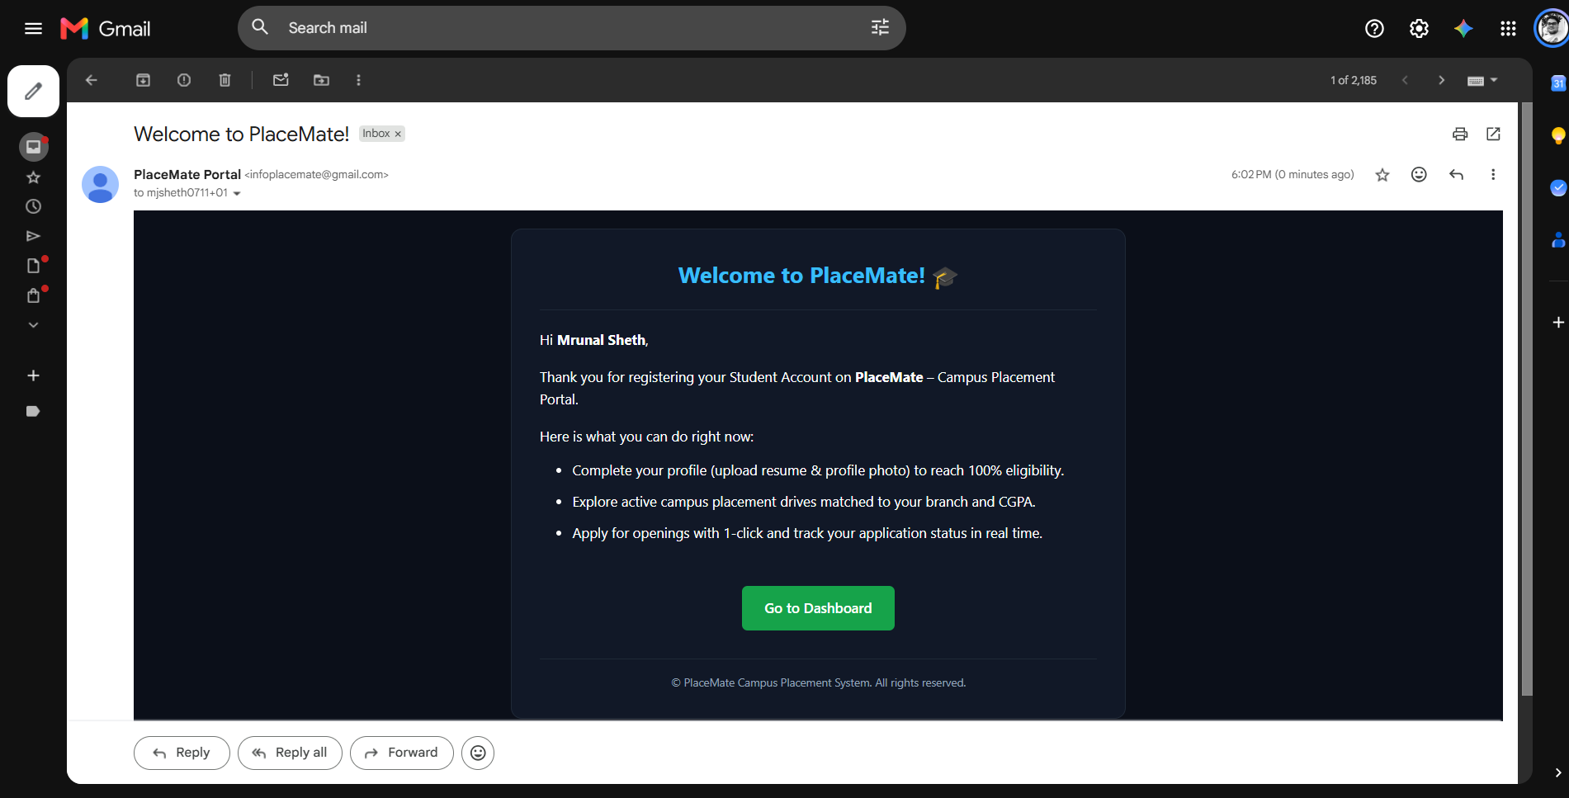
Figure 36: Welcome & Account Verification Email
Automated welcome email dispatched upon successful registration, welcoming the user to PlaceMate and confirming their verified credentials.
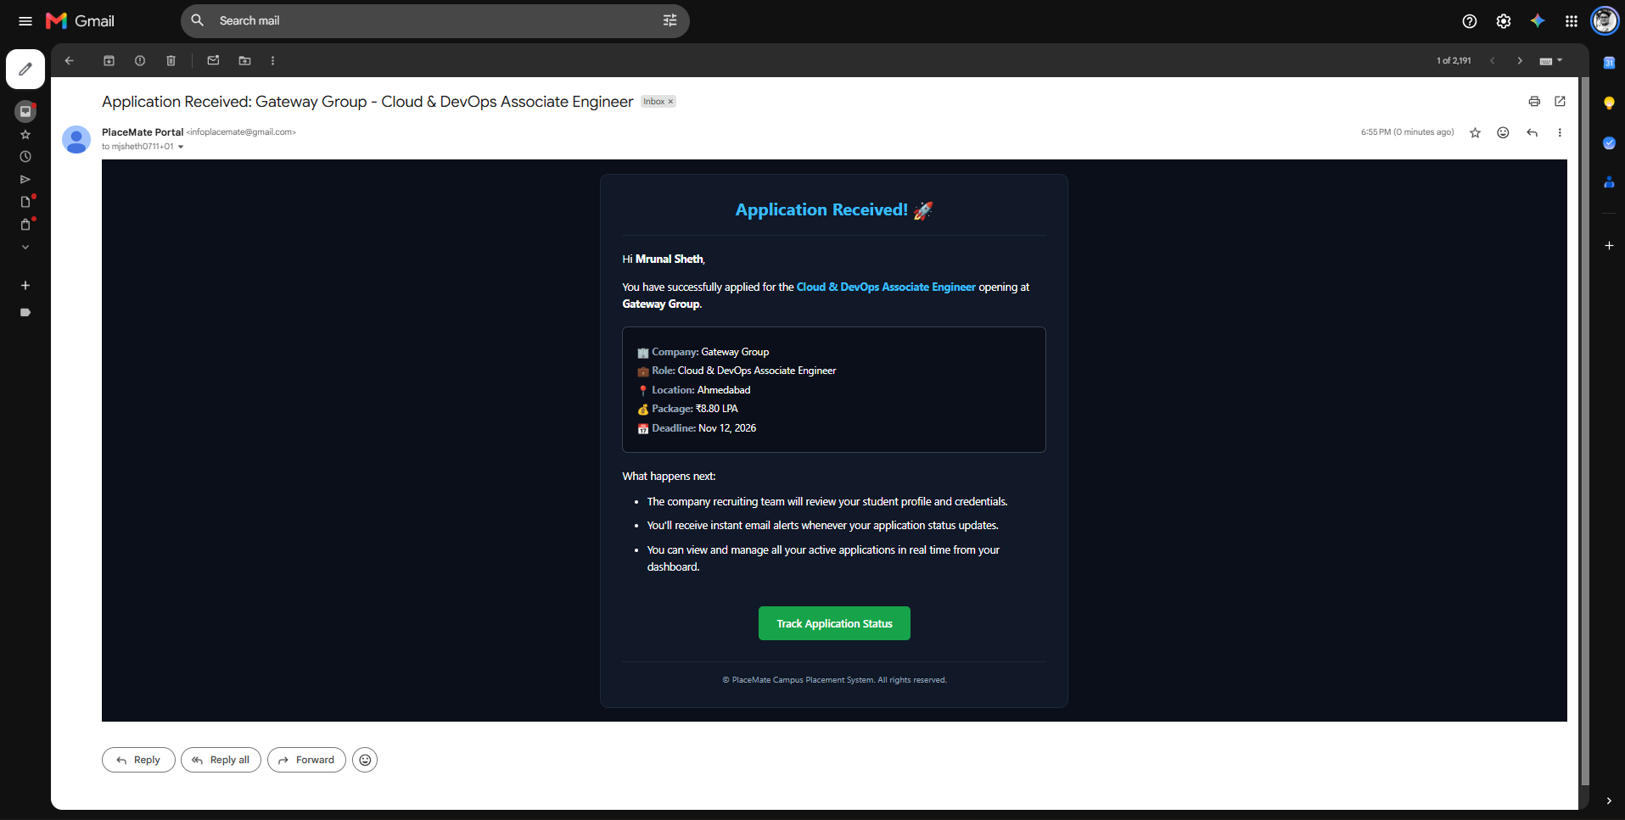
Figure 37: Drive Application Confirmation Email
Confirmation email received by students immediately upon applying for a drive, summarizing the job title, company name, and application reference.

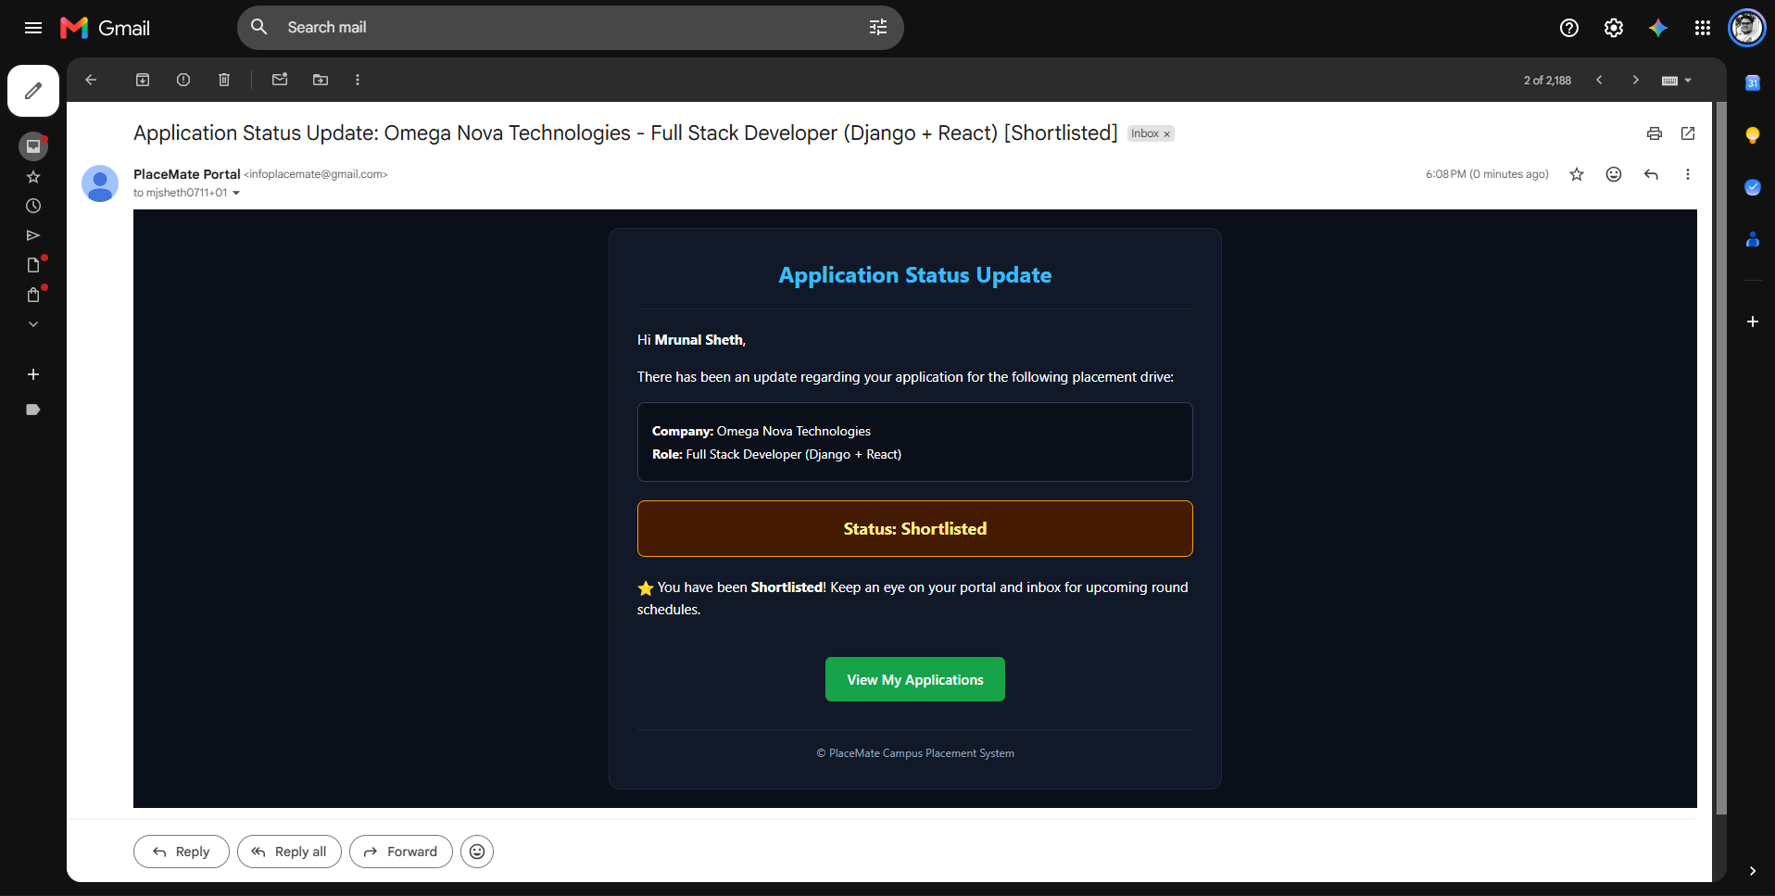
Figure 38: Candidate Shortlisted Notification Email
Real-time alert sent to candidates whose applications have been reviewed and shortlisted for the upcoming interview round.
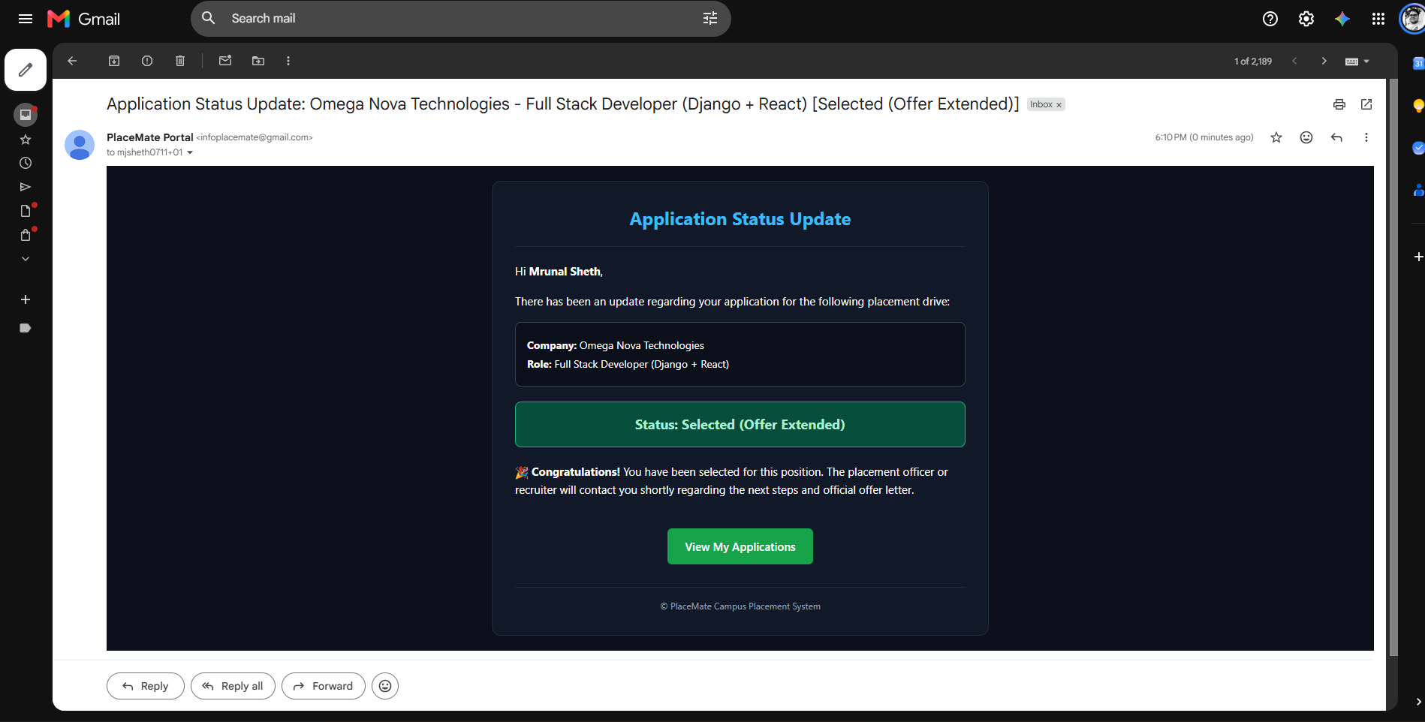
Figure 39: Final Selection & Job Offer Congratulatory Email
Official congratulatory email sent when a company marks a candidate as Selected, providing job confirmation and package details.

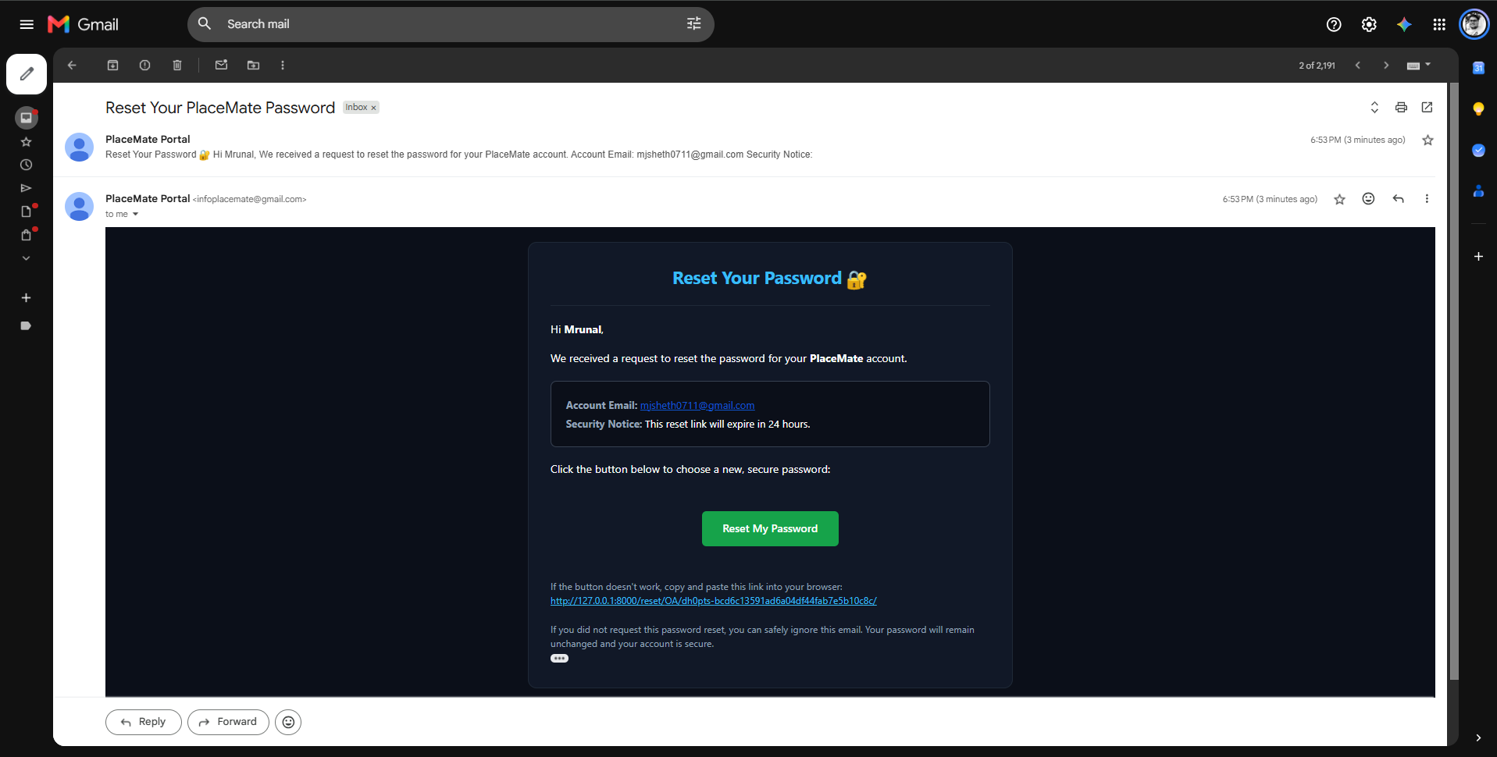
Figure 40: Secure Password Reset Email
Password recovery email containing a secure, single-use reset link with clear security advice.

6. Conclusion
PlaceMate successfully transforms the traditional, fragmented campus placement process into a cohesive, automated digital platform. By uniting Students, Recruiters, and College Placement Officers within a single system, it eliminates manual data verification, prevents human errors in eligibility checking, and ensures transparent communication through real-time application tracking and automated emails.
The application's responsive design, integrated dark and light mode system, and interactive analytics dashboards provide an intuitive and efficient experience for all users. PlaceMate delivers a scalable, production-ready solution that modernizes institutional recruitment and helps colleges run smooth, organized, and data-driven placement seasons.

