Matt Smith
Michael Haderman
CS355
6 April 2015
Project 1 Report
1)
My application allows for a centralized player statistics tracking system for the video game Quake III Arena. In the world of online gaming, trash talk and bragging are the norm. Therefore, the only way to settle the age old question of who really is the best player is to back it up with hard statistics. My web-based application, which utilizes automatically generated match statistics from the Quake III competition mod CPMA, allows for tracking each and every match a player has played. It features an Elo rating system that automatically updates after each match allowing for precise rankings. In addition to ranking, the application allows for long term tracking of player statistics, particularly weapon usage and accuracies. This allows for players to identify areas where they need improvement.
The application is designed with the intention of expanding to other gametypes beyond just one versus one. This can be seen by the separation between Matches and DuelMatchStats in the database implementation as well as the inclusion of items that are not normally found in one versus one play (e.x. FlagGrabs).
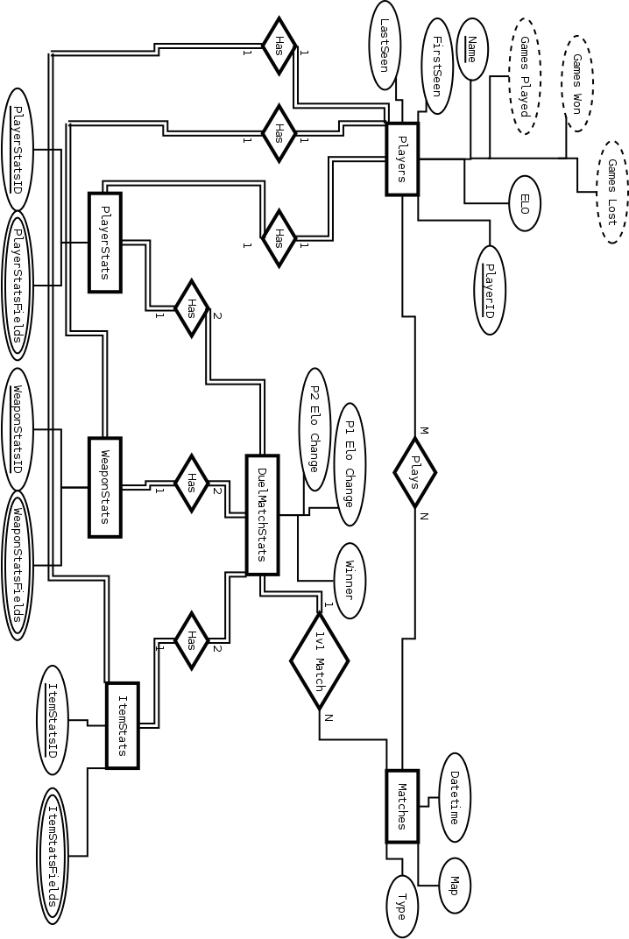
3)
Players Table
The Players table holds information about each player. Due to limitations in the mod's statistics generation they are currently uniquely identified by their in-game alias which is given an auto incrementing PlayerID. A future revision would use a different unique source such as a Punkbuster GUID or custom account system. The Players table also contains DATETIME fields for FirstSeen and LastSeen, the player's current ELO ranking value, as well as foreign key references for their global player, weapon, and item statistics.
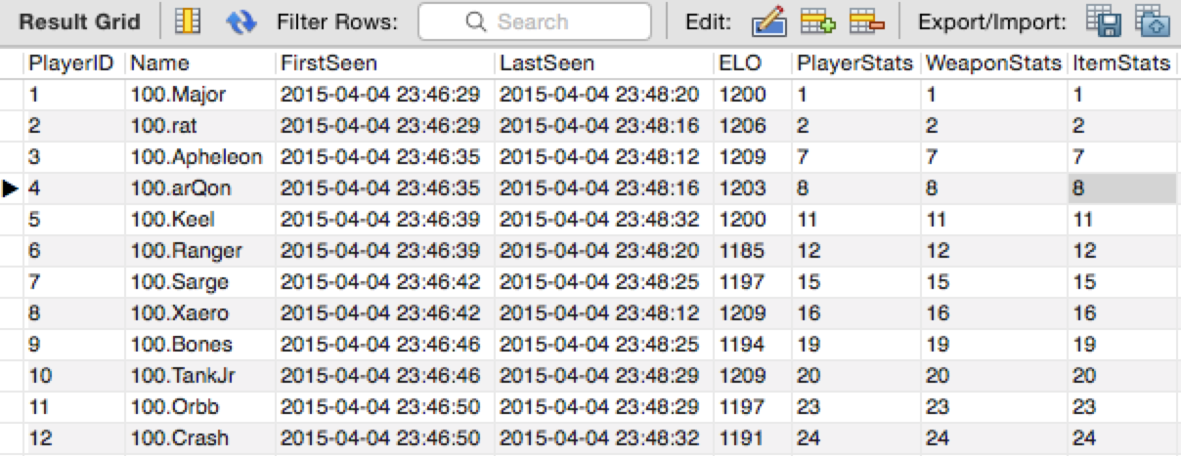

Matches Table
The Matches table stores every match entered into the system. It is uniquely identified by a Datetime field and each match is given an auto incrementing MatchID. Additionally the type of match played (1v1, Capture the Flag, etc.) is stored. Other modes have not yet been implemented. The table also stores which map the match was played on.
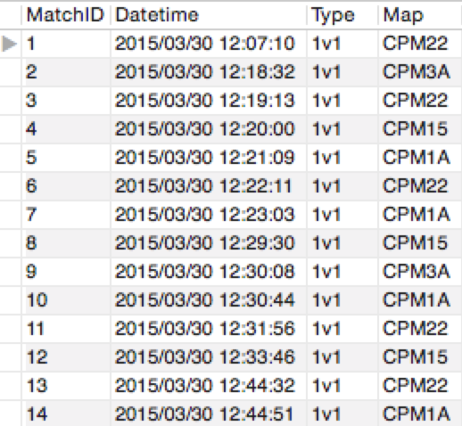

PlayersMatches Table
PlayersMatches is a lookup table that associates players with matches that they have played in.
It consists of a PlayerID foreign key and a MatchID foreign key. Together they make a combined Unique key for the table.
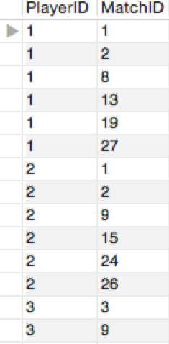

DuelMatchStats Table
DuelMatchStats is a table specifically for one versus one matches and is effectively a hybrid lookup table. The primary unique key for the table is a foreign key reference MatchID. The table contains a field called Winner which contains the PlayerID of whoever won the match. P1ELOChange and P2ELOChange hold the Elo rating adjustment for each player from the duel match. The table also includes foreign key references for both players, PlayerStats foreign keys for both players, WeaponStats foreign keys for both players, and ItemStats foreign keys for both players.
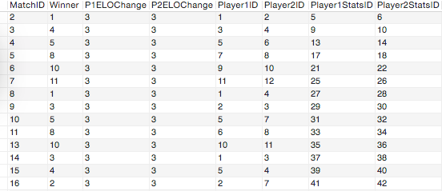
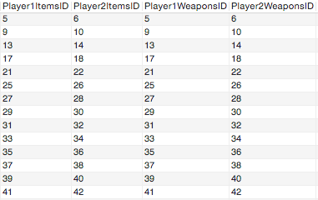
PlayerStats Table
PlayerStats contains various player statistics. It is used on a per match basis as well as a global statistics table for each Player. The table contains a PlayerStatsID which is the auto incrementing primary key. It also contains a foreign key reference PlayerID to the player it belongs to. The rest of the table contains various player related statistics all stored as integers which default to 0. Score, Kills, Deaths, Suicides, Net, DamageGiven, DamageTaken, Captures, Assists, Defense, Returns, HealthTotal, ArmorTotal.
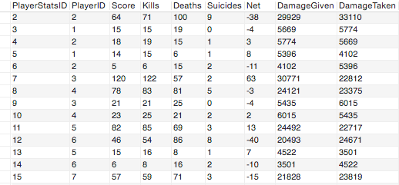
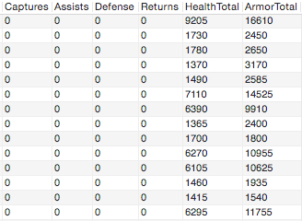
ItemStats Table
The ItemStats table contains all the item data for a given player for a given match (or globally). It consists of an auto incrementing primary key called ItemStatsID as well as a foreign key reference to a PlayerID which owns it. The rest of the fields are all integers which default to 0: MHPickups, RAPickups, YAPickups, GAPickups, QuadPickups, BSPickups, InvisPickups, FlightPickups, RegenPickups, FlagGrabs, QuadTime, BSTime, InvisTime, FlightTime, RegenTime, FlagTime.
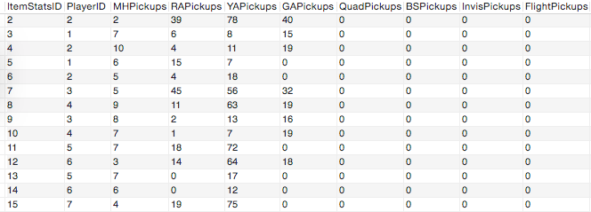
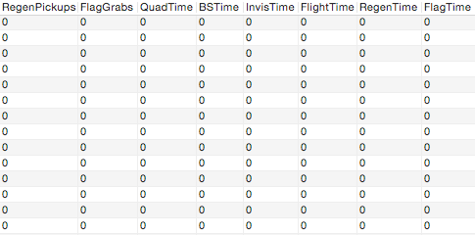
WeaponStats Table
The WeaponStats table contains all of a player's weapon statistics for a given match or globally. Like PlayerStats and ItemStats it contains a primary auto incrementing key called WeaponStatsID, as well as a foreign key reference PlayerID to the player that owns the statistics. The integer fields in the table all default to 0 and are weapons referenced by their shorthand alias: G – Gauntlet, MG – Machinegun, SG – Shotgun, PG – Plasma Gun, - RL – Rocket Launcher, LG – Lightning Gun, RG – Railgun, BFG – Big Freaking Gun, GL – Grenade Launcher, TF – Telefrags. With the exception of the Gauntlet and Telefrags (only containing Kills), each weapon contains a Kills, Shots, and Hits field.
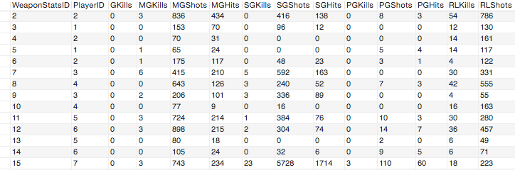
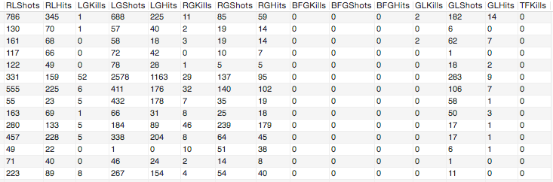

4)
Main Page ('/')
The main page allows a player to quickly view who the top 10 best players are as well as the latest matches that have been processed. Each player in the top 10 has a link to their player page. The recent matches section also links to both competitors' player pages as well as links to the specific match page for that match. The navigation bar on the top links to the top 100 players page, latest matches page, and project 1 requirements page.

Top 100 Page ('/top100)
The top 100 page displays the top 100 players ordered by their Elo rating. It is an extension of the top 10 section of the main page. The page also shows their games played, games won, games lost, and winning percentage. It also links to each respective competitors' player page.

Latest Matches Page ('/latestmatches')
The latest matches page displays the 100 latest matches as ordered by their date. It is an extension of the recent matches section of the main page. It displays both opponent's names, links to their player pages, their scores, the date of the match, and the map it was played on.

Player Page ('/player')
The player page displays a given player and all of their statistics. This includes their games played, games won, games lost, first seen date, last seen date, match history with links to match pages, as well as their globally tracked statistics such as total kills, weapon statistics and item pickups.

Match Page ('/match')
The match page displays a given match and all the statistics from it. This includes both players (with links to their pages), who won and lost, each player's current Elo rating as well as their Elo rating change from the match and their final scores. It also shows both players' weapon statistics, and item pickups for the given match.

Project Requirements Page ('/projectrequirements')
This page is a landing page to access administrative functions for the website. It allows for uploading xml files containing match data, manually creating, updating and deleting players, as well as manually creating, updating and deleting matches.

Add Match XML Page ('/api/addmatch')
This page allows for the selection and uploading of a valid CPMA Maxstats xml file which is then processed and loaded into the database as a new match. If a player is not currently in the database it is automatically created.

Create Player Page ('/api/createplayer')
This page allows for the manual creation of a player with a given handle. The player's global statistics tables are also created but they will not appear in the top 10 listings or top 100 listings until they have played a match.

Update Player Selection Page ('/api/updateplayer')
This page allows for selecting a player to edit information for. After selecting a player, the user is then forwarded to the update player page.

Update Player Page ('/api/updateplayer/edit')
This page allows for the editing of a single player and their associated global statistics tables. This includes their name, first seen and last seen fields, and Elo rating, as well as all of their global player statistics, item statistics and weapon statistics.

Delete Player Page ('/api/deleteplayer')
This page allows for the selection of a player from a dropdown list for deletion. Upon submission the player and all associated information, including matches they participated in, are permanently removed from the database.

Create Match Page ('/api/creatematch')
This page allows for the manual creation of a match. It provides a dropdown selection of valid players as well as tables for each player's match statistics. Upon submission the match will attempt to be inserted into the database and success or failure will be returned;

Update Match Selection Page ('/api/updatematch')
This page provides a dropdown to select from a list of matches in the database. Upon submission the user is then redirected to the update match edit page.

Update Match Edit Page ('/api/updatematch/edit')
This page allows for manually editing all the various statistics for both players in a given match. It also allows for the changing of the date of the match and the map it was played on.
Delete Match Page ('/api/deletematch')
This page provides a dropdown to select a match from the database for deletion. Upon submission the match is permanently removed, including all associated statistics tables included with it.
5) The project can be found here: https://github.com/mjsmith707/CS355_Project1
Special Note: My port on cwolf (8041) does not work. The project will only bind to localhost for IPv6. Additionally, it is recommended you either use my database on cwolf with pre-populated data or go to '/api/addmatch' and manually add some the xml files from the included example_stats folder.

