Identifying prestige objects in graves

Mikkel Nørtoft2,✉

26 marts, 2021

This paper identifies prestige objects by number of represented object types

1 University of Copenhagen  
2 UCPH

✉ Correspondence: [Mikkel Nørtoft <[jsv399@hum.ku.dk](mailto:jsv399@hum.ku.dk)>](mailto:jsv399@hum.ku.dk)

Keywords: keyword 1; keyword 2; keyword 3

Highlights: These are the highlights.

# 1 Introduction

Identifying prestige objects can be tricky.

# 2 Background

Corded Ware graves from Moravia.

# 3 Methods

Changing counted grave goods in each grave dividied into 15 grave good types, and converitng into binary data, which is then counted for each grave gives a Total Object Type (TOT) result for each grave. These were then grouped by grave good type, which were plotted in a multiple boxplot, ordered by TOT count and colored by material.

# 4 Results

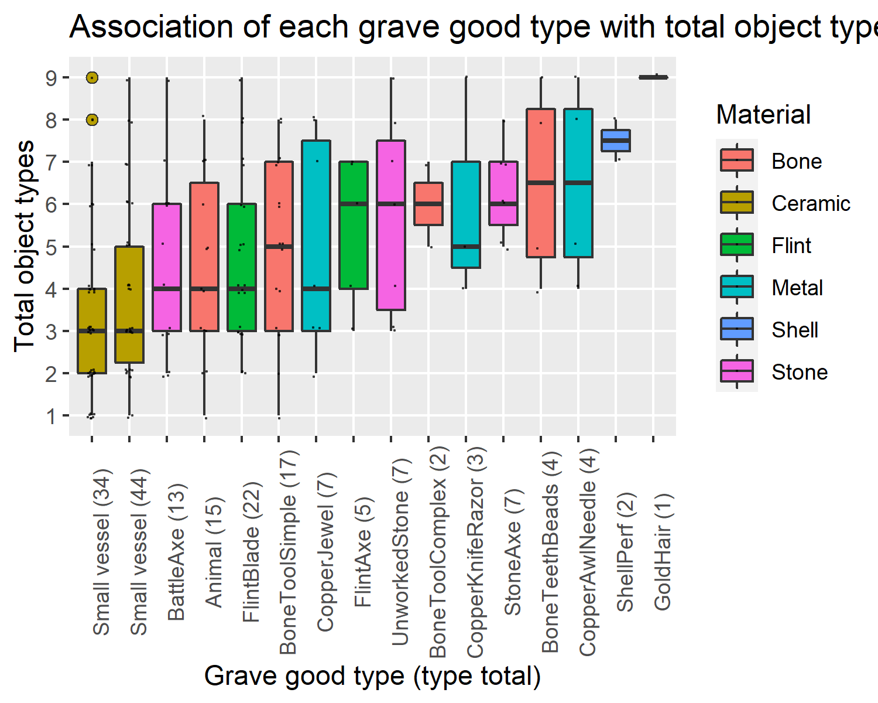

Figure 4.1: Association of each grave good type with Total Object Types

Figure 4.1 shows the different ranges in Total Object Types for each grave good type assuming a spectrum of 0-9 represented grave good types (TOT). It indicates that some object types are exclusive to the richest graves (gold hair decoration, perforated shells), some are confined to the upper half of the spectrum (perforated tooth beads, stone axes, copper awls/needles and copper knives/razors), and some are more widely distributed from top to bottom, e.g. ceramics. While some perforated shells may have been locally available, the fact that they are only found in shellGraves of the richest graves in this sample of graves, is mirrored in a larger study of Corded Ware graves (Kyselý et al., 2019).

# 5 Discussion

# 6 Conclusion

# 7 Acknowledgements

# 8 References

Kyselý, R., Dobeš, M., Svoboda, K., 2019. Drilled teeth and shell artefacts from a grave at Prague-Březiněves and a review of decorative artefacts made from animal material from Corded Ware culture in the Czech Republic. Archaeological and Anthropological Sciences 11, 87–131. <https://doi.org/10.1007/s12520-017-0514-5>

### 8.0.1 Colophon

This report was generated on 2021-03-26 15:41:43 using the following computational environment and dependencies:

The current Git commit details are: