Art gallery kiosk app documentation

# Requirements

* Implementation must use HTML/CSS with JavaScript
* Google Chrome compatibility at a minimum
* The app must feature a drawing canvas for patrons at the art gallery
* Users should be able to create artwork in the style of the artist
* Users should be able to select a brush size
* Users should be able to select a colour from the palette which is suitable to the artist’s style
* The canvas should be able to be cleared both manually by a button and automatically after a period of inactivity
* The app must be interactable with a touch screen, thus incorporate elements suitable to this type of screen
* The app must work in a responsive screen size, including 1920x1080 and 1280x720
* The app must consistently implement the artistic style and branding
* Additional drawing tools should be incorporated (eg. Stencils, stamps, patterned brush)

# TARGET DEMOGRAPHIC

The expected demographic of this art gallery are people aged 8 upwards who have an interest in art by Jasper Johns. The most common users of the website are likely to be towards the younger segment of the age bracket, between 8 and 20. Therefore this will be the target demographic of the website. This target does not intend for the website to be exclusive to this audience, rather the design will be created with the intention to appeal primarily to this audience.

## SAMPLE PERSONA:

|  |  |  |
| --- | --- | --- |
| **Persona** | School student |  |
| **Fictional name** | Hayley Johnson |
| **Job title/responsibilities** | Student at John Monash Science School |
| **Demographics** | 14 years old  Favourite subjects are art and biology  Attends painting and sculpting classes |
| **Goals and tasks** | Likes attending various art galleries  Plays volleyball and golf  Favourite art styles include abstract and pop art  Likes sketching digitally and physically |
| **Environment** | Has a Windows tablet for sketching and writing documents, is comfortable using web interfaces | |

# Inspiration

## Jasper Johns: Target with four faces

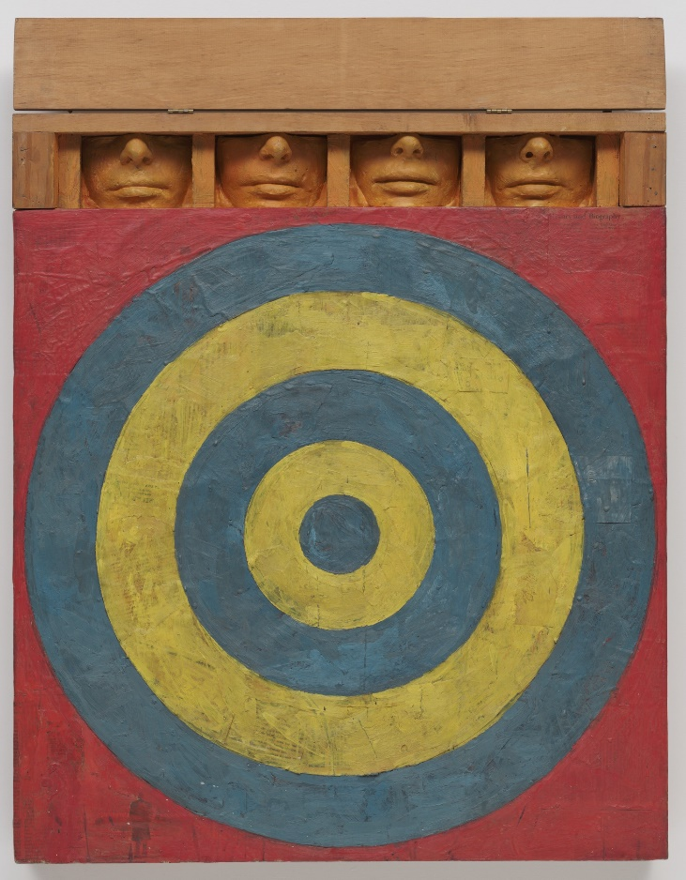

## Jasper Johns: Map

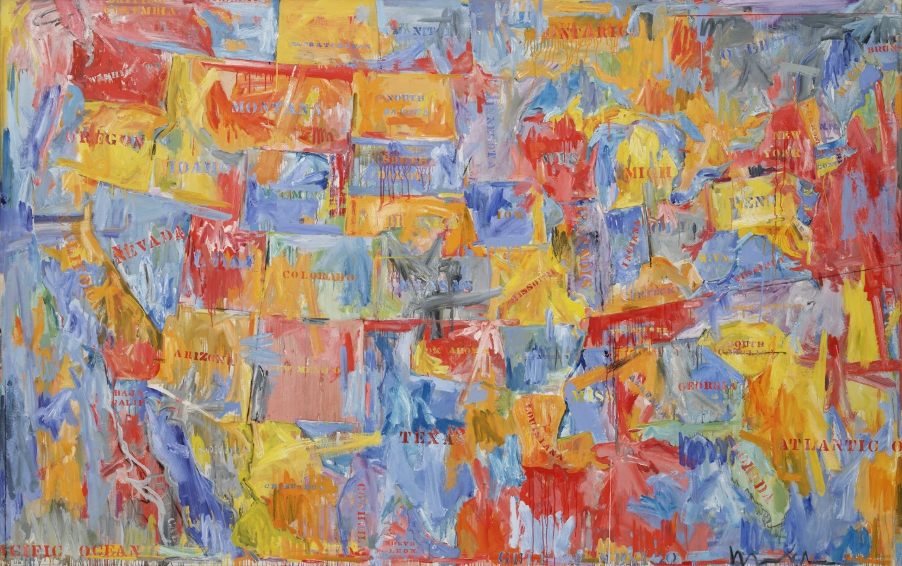

## Jasper Johns: corpse and mirror ii

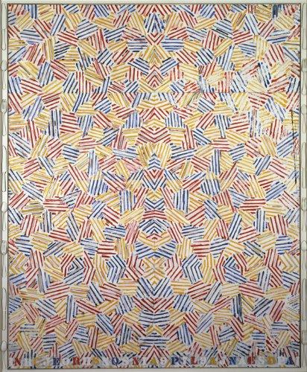

## Jasper Johns: Land’s end

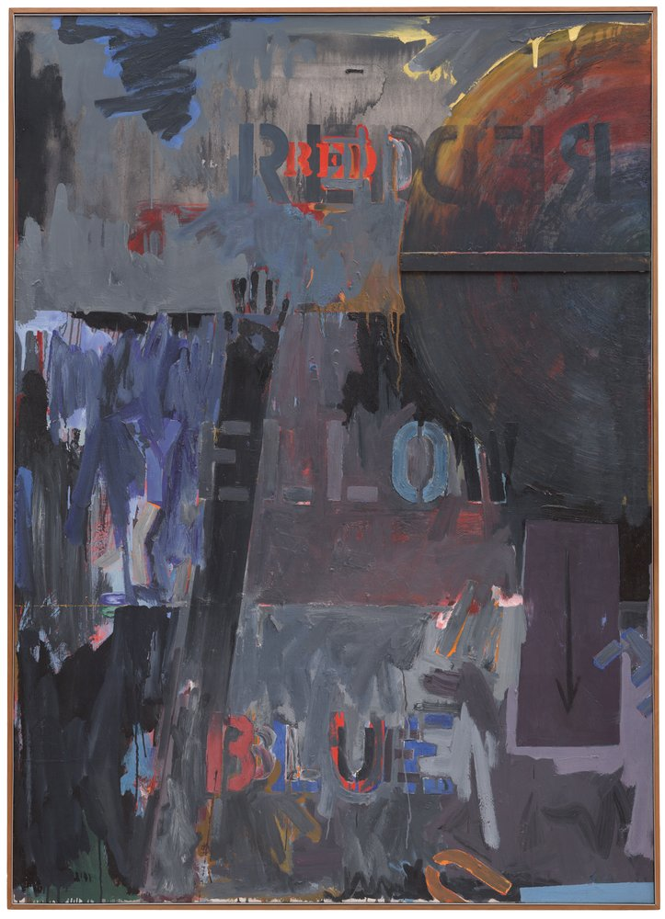

## Jasper Johns: 0 through 9

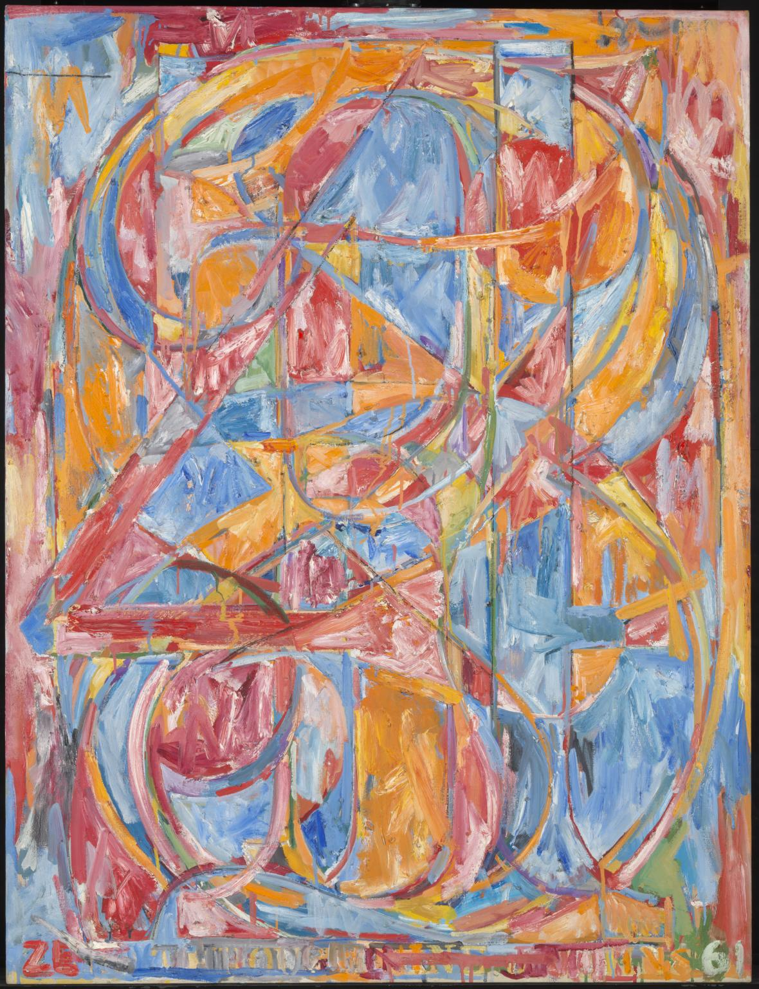

## sketch.io sketchpad

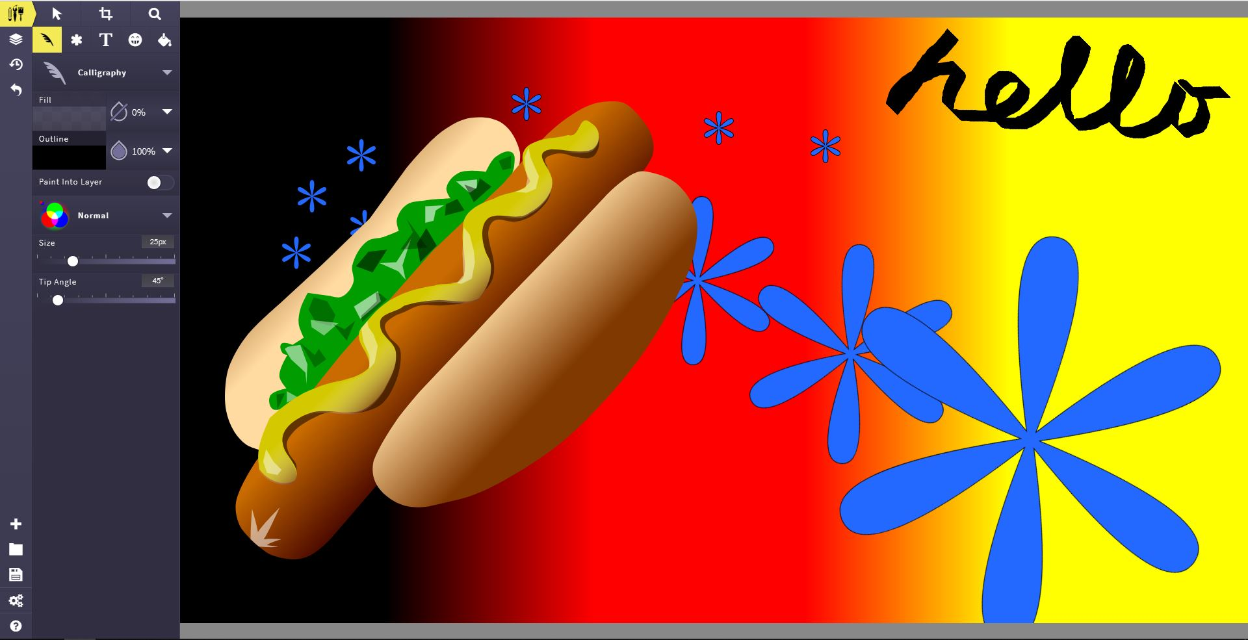

## kleki.com sketchpad

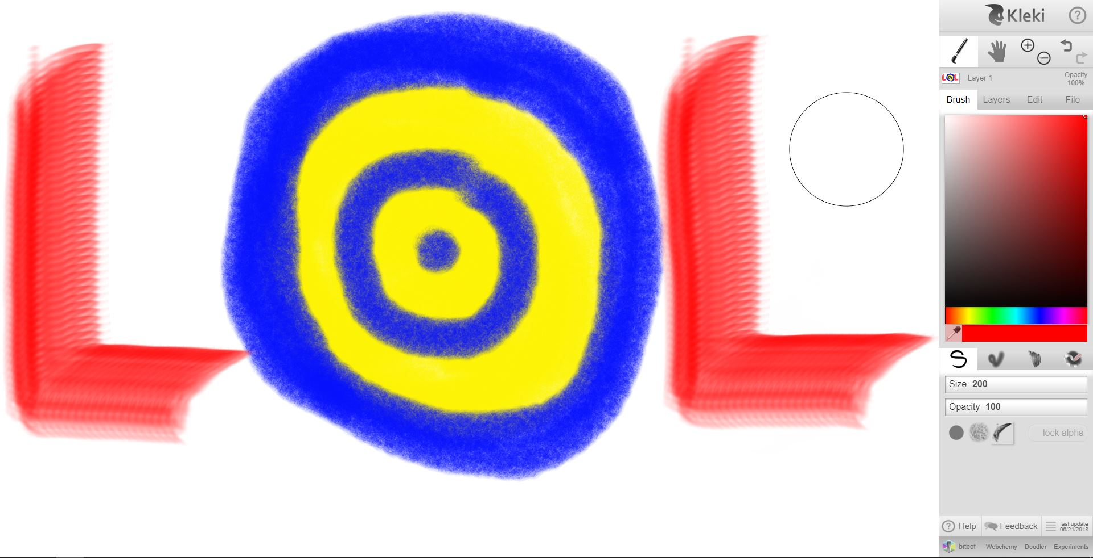

## galactic.ink sketchpad

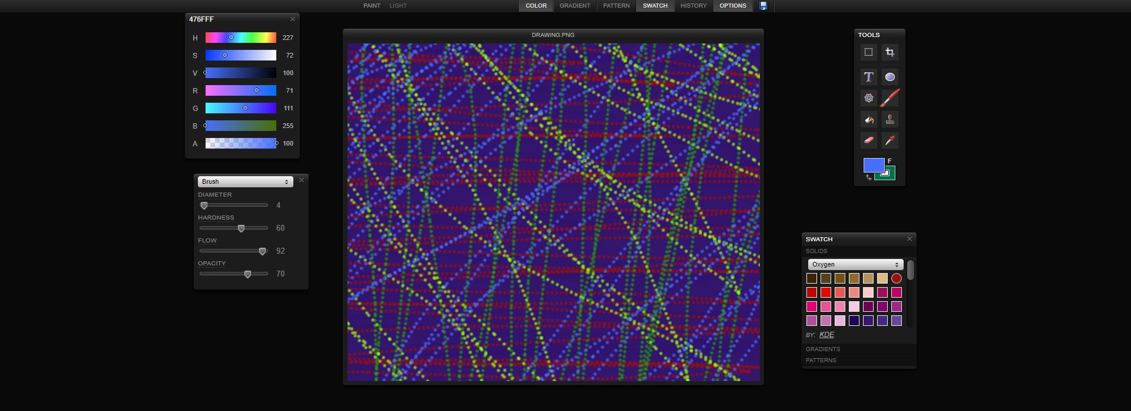

## ms paint sketchpad

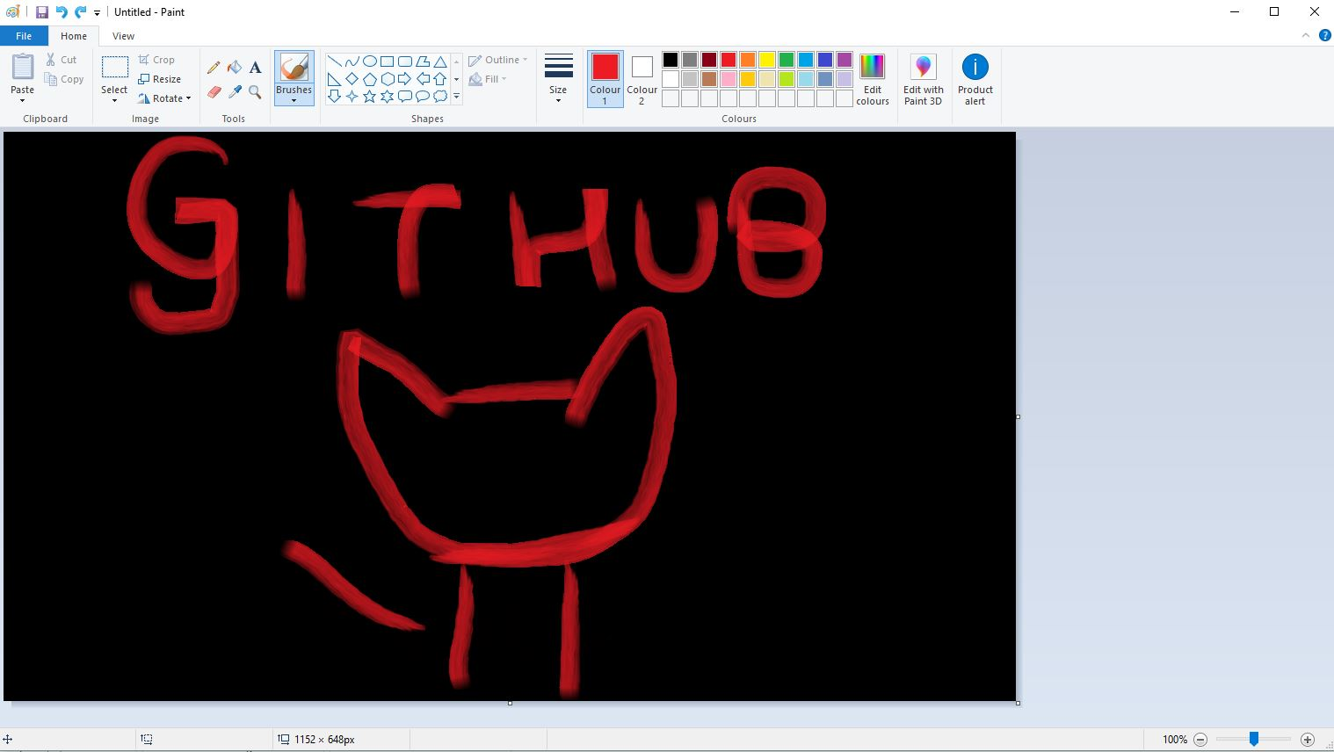

# References – DOCUMENTATION

### Images

<https://www.pexels.com/photo/woman-wearing-pink-floral-sleeveless-romper-sitting-on-gray-concrete-holding-earth-globe-638696/>

<https://www.tate.org.uk/art/artists/jasper-johns-1365>

<https://www.moma.org/collection/works/78393>

<https://www.moma.org/collection/works/79372>

<https://www.abebooks.co.uk/9780947564285/Cage-John-Cunningham-Merce-Johns-0947564284/plp>

<https://www.sfmoma.org/read/discussion-questions-jasper-johns-lands-end/>

<https://sketch.io/sketchpad/>

<http://kleki.com/>

<https://galactic.ink/sketchpad/>