Contiguity Manual

Requirements
Python – Contiguity has been tested using python 2.7, use earlier versions at your own risk.
Tkinter – Included in most installations of python.
NCBI-BLAST – If you would like contiguity to automatically generate comparison files for you, please have BLAST installed and in your path. Contiguity also accepts user generated comparison files in BLAST's tabbed output format with no headers (-outfmt 6). BLAST is required for generating CSAG files.
Bowtie 2 – Bowtie 2 is required for generating CSAG files with paired-end data.

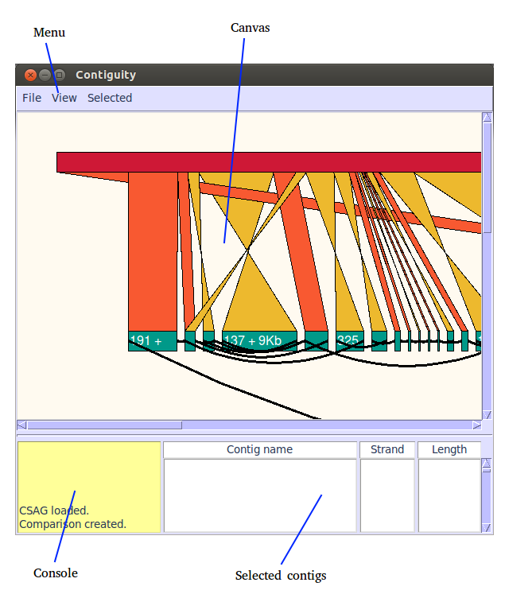
Overview
Menu – Dropdown menu
Canvas – Area where Contig, mapping and graph information is shown.
Console – Progress of processes running in the background is reported here.
Selected contigs – List of selected contigs

Overview – Comparison to reference with adjacency graph
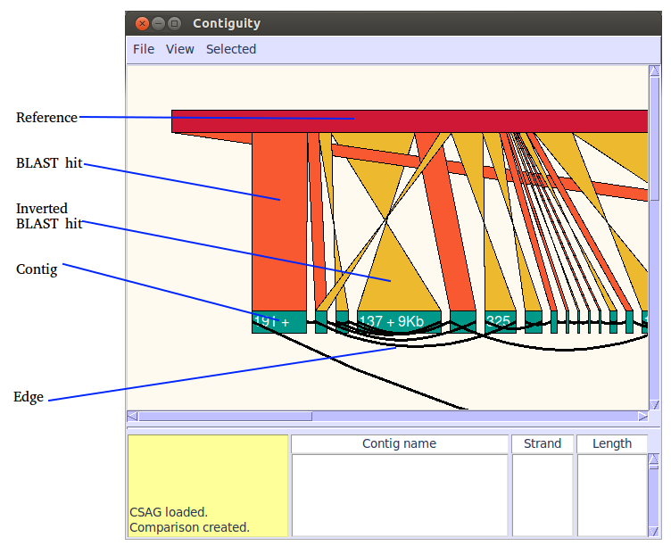
ABOVE: Comparison of an Illmunia assembly of E. coli to a virulence plasmid.
The Plasmid reference is shown in red. BLAST hits and inverted BLAST hits are shown in orange and yellow respectively. Contigs are displayed in teal, a shortened version of the contig name on the contig when room allows. It's orientation and length is also shown where possible. If read information suggests that these contigs may be adjacent to each other, they are joined by a curved black line.

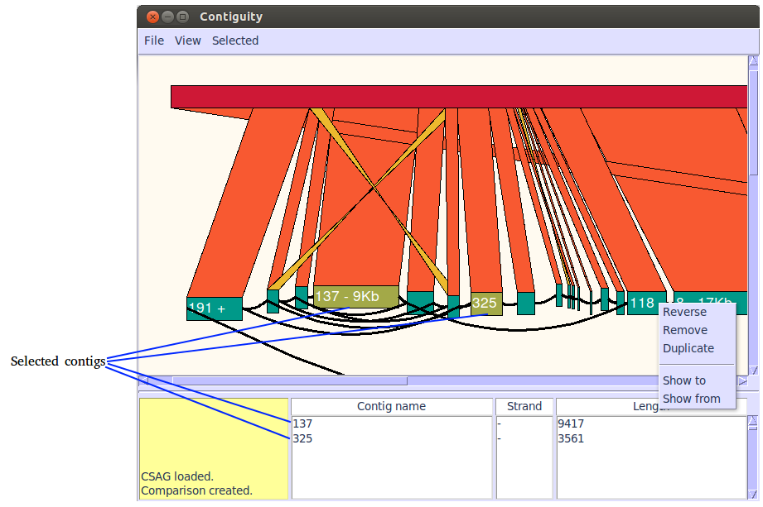

ABOVE: Comparison of the Illumina assembly to a plasmid reference. Two contigs have been selected, information about these contigs is displayed in the window. Several contigs have been reversed and repeat region that was assembled into a single contig duplicated.
The contigs and the reference may be moved individually by dragging them with the left mouse button.
Contigs can be selected by double clicking on them. Once selected contigs can be written into a single scaffolded fasta file, a multifasta file or paths can be between selected contigs.
Right clicking on contigs allows them to be reversed, removed or duplicated. Right clicking also allows adjacent contigs to be displayed.
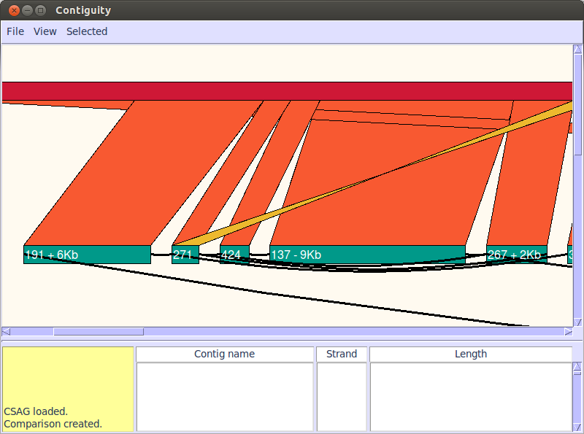
ABOVE: Comparison where contigs have been stretched.
Contigs can be streched or shrunk in the x dimension using the “A” and “D” keys, or from the View menu. Widening contigs allows more contig information to be displayed in the canvas.

Overview – Self comparison

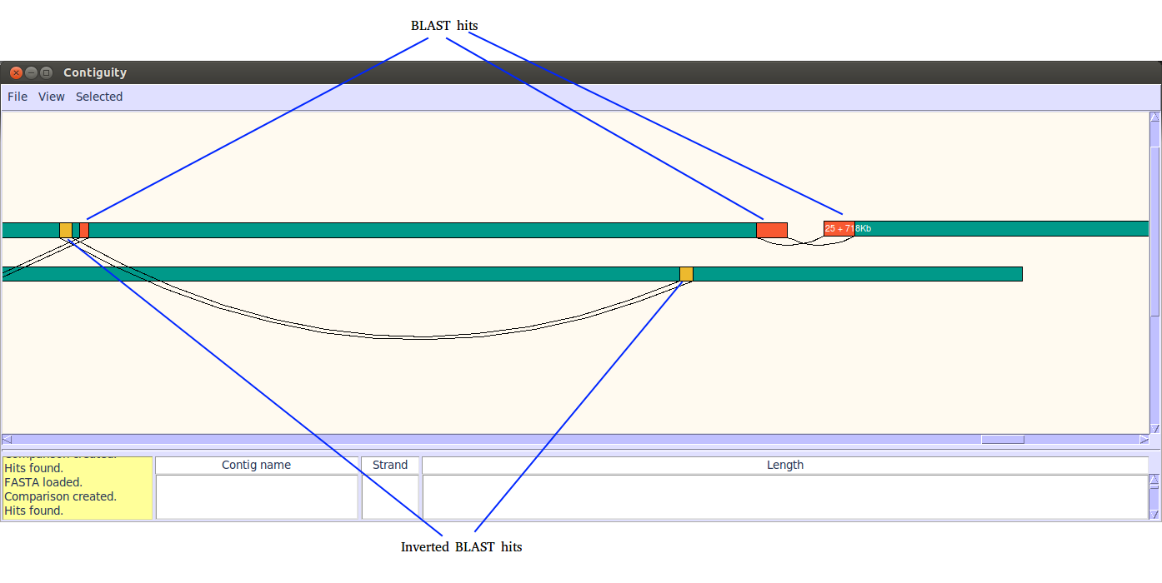
ABOVE: Self comparison of a PACBIO assembly
Self against self comparisons can be performed using contiguity by either loading a comparison file or generated automatically if BLAST is installed. Hits and inverted hits are displayed in orange and yellow respectively.

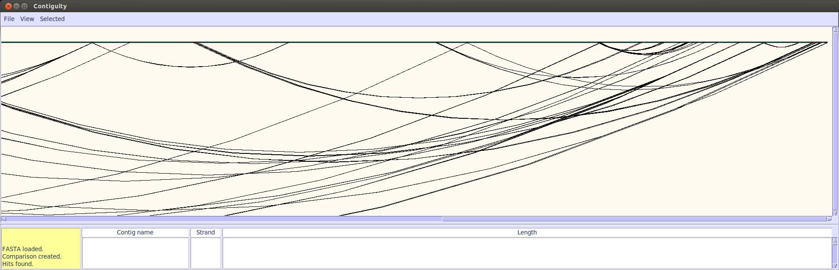
ABOVE: Zoomed out comparison of the same PACBIO assembly
Contiguity allows you to zoom using the mouse wheel, the “W” and “S” keys or from the menu.

Menu options

File
Create CSAG File
Create a CSAG file from a fasta file of an assembly and a read file (fasta or fastq). If you wish to using paired information please have BOWTIE 2 installed to your path. Reads must be interleaved and orientated like so →←.
Create Comparison
Will create a comparison between your assembly and a reference file (fasta)
Load assembly
Load your assembly, accepts a multifasta or CSAG file.
Exit

View
View assembly
Draw your assembly on the canvas.
Contigs to view: Which contigs to view.
BLAST – only view contigs with a hit to the reference.
All – view all contigs.
List – Display only contigs found in the list file.
List of contigs: if list is chosen from the Contigs to view menu select the file with selected contigs here. Must be a plain text file with each contig name as it's own line i.e.
NODE_321
NODE_342
NODE_421
…
View reference and BLAST hits: If a comparison has been performed selecting this option will show the reference and BLAST hits.
Shorten long contigs: Change the length of contigs on the canvas.
No – Width of contigs on the canvas is directly proportional to their length in base pairs.
Max – Width of contigs on the canvas is directly proportional to their length in base pairs up to 100 pixels. All larger contigs will be shown at width 100 pixelds
Min – Contigs will be at least 100 pixels wide, widths greater than 100 pixels are directely proportional to the length in base pairs.
Log – Width is calculated at Log(length/x)*x where x is the scale.
Scale: 1 pixel = this many base pairs.

Self comparison
Perform a self versus self BLAST comparison of all contigs currently on the canvas and display results.
Add contig
Add contig to canvas with selected contig name.
Find contig
Goto contig on canvas.
Zoom in
Zoom out
Shrink
Shrink the contig on the x axis only.
Stretch
Enlarge the contig on the x axis only.

Selected
Find paths
Find possible paths between selected contigs.
Write fasta
Write a scaffolded fasta file of selected contigs.
Write multifasta
Write a multifasta with each selected contig as it's own entry.

