**CSC 3020 – Java Programming**

**Homework 1 – Mike Torchia**

**25 points – Due January 18, 10am**

**Late deadline is September 17, 11:59pm, but 20% off**

**a)** Save this document with your name and the homework number somewhere in the file name.

**b)** Type/paste your answers into the document.

**c)** Submit this document to the Blackboard item where you downloaded this document.

**1) [4 points]** Using information from the Internet or the textbook, list any four facts about the Java programming language (history of, developers of, owners of, supported hardware, supported operating systems, etc.). Include your sources.

|  |  |  |
| --- | --- | --- |
| # | Fact | Source |
| 1 | [James Gosling](https://en.wikipedia.org/wiki/James_Gosling), Mike Sheridan, and [Patrick Naughton](https://en.wikipedia.org/wiki/Patrick_Naughton) initiated the Java language project in June 1991 | https://en.wikipedia.org/wiki/Java_(programming_language) |
| 2 | [Oracle Corporation](https://en.wikipedia.org/wiki/Oracle_Corporation) is the current owner of the official implementation of the Java SE platform | https://en.wikipedia.org/wiki/Java_(programming_language) |
| 3 | The Oracle implementation is available for [Microsoft Windows](https://en.wikipedia.org/wiki/Microsoft_Windows) (still works for XP, while only later versions currently officially supported), [Mac OS X](https://en.wikipedia.org/wiki/MacOS), [Linux](https://en.wikipedia.org/wiki/Linux) and [Solaris](https://en.wikipedia.org/wiki/Solaris_%28operating_system%29) | https://en.wikipedia.org/wiki/Java_(programming_language) |
| 4 | The use of Java-related technology in Android led to a legal dispute between Oracle and Google | https://en.wikipedia.org/wiki/Java_(programming_language) |

**2) [10 points]** You've been hired by *Lyric Lovers* to write a Java console application that displays lyrics from the song *Somewhere Over the Rainbow* from The Wizard of Oz. Here are the lyrics:

Somewhere over the rainbow way up high,

There's a land that I heard of once in a lullaby.

Somewhere over the rainbow skies are blue,

And the dreams that you dare to dream really do come true.

Someday I'll wish upon a star

And wake up where the clouds are far behind me.

Where troubles melt like lemon drops away above the chimney tops

That's where you'll find me.

Somewhere over the rainbow bluebirds fly.

Birds fly over the rainbow. Why then, oh why can't I?

Display the lyrics as shown here. For blank lines between paragraphs, you may use Java statement *System.out.println();*

**//===============================================**

**//**

**//Title: Homework1**

**//**

**//Description:**

**// Display lyrics of a song to the screen and**

**// modify the args array to print args to the**

**// screen then show the sum**

**//**

**//**

**//===============================================**

**package csc3020_homework1;**

**public class Homework1 {**

**public static void main(String[] args) {**

**// TODO Auto-generated method stub**

**System.*out*.println("Welcome to Homework 1");**

**System.*out*.println("-----------------------");**

**//Start of Question 2**

**System.*out*.println("Question 2");**

**//Lyrics to be printed out per Question 2**

**System.*out*.println("Somewhere over the rainbow way up high,");**

**System.*out*.println("There's a land that I heard of once in a lullaby.");**

**System.*out*.println("Somewhere over the rainbow skies are blue,");**

**System.*out*.println("And the dreams that you dare to dream really do come true.");**

**System.*out*.println();**

**System.*out*.println("Someday I'll wish upon a star");**

**System.*out*.println("And wake up where the clouds are far behind me.");**

**System.*out*.println("Where troubles melt like lemon drops away above the chimney tops");**

**System.*out*.println("That's where you'll find me.");**

**System.*out*.println();**

**System.*out*.println("Somewhere over the rainbow bluebirds fly.");**

**System.*out*.println("Birds fly over the rainbow. Why then, oh why can't I?");**

**//End of Question 2**

**//Add to blank lines. Easier to read output**

**System.*out*.println();**

**System.*out*.println();**

**//Start of Question 3**

**int argSum = 0;**

**System.*out*.println("Question 3");**

**for(int i=0;i<args.length;i++)**

**{**

**System.*out*.print(args[i]);**

**System.*out*.print("\t");**

**}**

**System.*out*.println();**

**System.*out*.print("Sum of all the args is ");**

**for(int i=0;i<args.length;i++)**

**{**

**//Converts the string arg to an int and then adds it to argSum**

**argSum+=Integer.*parseInt*(args[i]);**

**}**

**System.*out*.println(argSum);**

**//End of Question 3**

**System.*out*.println();**

**System.*out*.println("End of Homework1");**

**}**

**}**

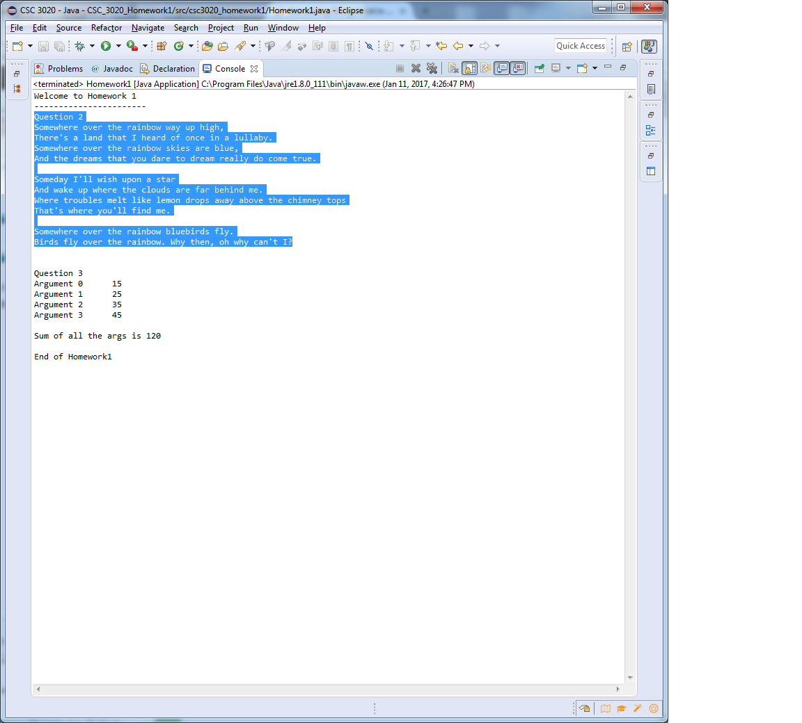

**3) [11 points]** You've been hired by *Argument Adders* to write a Java console application that add program arguments. Specify the following program arguments to the program: 15, 25, 35, 45. Access the args array to echo the arguments. Add the arguments and show the sum. Format the five rows of output in two columns with a label in the first column and a value in the second column. Separate the columns using the tab escape sequence.

**//===============================================**

**//**

**//Title: Homework1**

**//**

**//Description:**

**// Display lyrics of a song to the screen and**

**// modify the args array to print args to the**

**// screen then show the sum**

**//**

**//**

**//===============================================**

**package csc3020_homework1;**

**public class Homework1 {**

**public static void main(String[] args) {**

**// TODO Auto-generated method stub**

**System.*out*.println("Welcome to Homework 1");**

**System.*out*.println("-----------------------");**

**//Start of Question 2**

**System.*out*.println("Question 2");**

**//Lyrics to be printed out per Question 2**

**System.*out*.println("Somewhere over the rainbow way up high,");**

**System.*out*.println("There's a land that I heard of once in a lullaby.");**

**System.*out*.println("Somewhere over the rainbow skies are blue,");**

**System.*out*.println("And the dreams that you dare to dream really do come true.");**

**System.*out*.println();**

**System.*out*.println("Someday I'll wish upon a star");**

**System.*out*.println("And wake up where the clouds are far behind me.");**

**System.*out*.println("Where troubles melt like lemon drops away above the chimney tops");**

**System.*out*.println("That's where you'll find me.");**

**System.*out*.println();**

**System.*out*.println("Somewhere over the rainbow bluebirds fly.");**

**System.*out*.println("Birds fly over the rainbow. Why then, oh why can't I?");**

**//End of Question 2**

**//Add to blank lines. Easier to read output**

**System.*out*.println();**

**System.*out*.println();**

**//Start of Question 3**

**int argSum = 0;**

**System.*out*.println("Question 3");**

**for(int i=0;i<args.length;i++)**

**{**

**System.*out*.print("Argument "+i);**

**System.*out*.print("\t");**

***System.out.print(args[i]);***

***System.out.println();***

***}***

***System.out.println();***

***System.out.print("Sum of all the args is ");***

***for(int i=0;i<args.length;i++)***

***{***

***//Converts the string arg to an int and then adds it to argSum***

***argSum+=Integer*.*parseInt*(args[i]);**

**}**

**System.*out*.println(argSum);**

**//End of Question 3**

**System.*out*.println();**

**System.*out*.println("End of Homework1");**

**}**

**}**

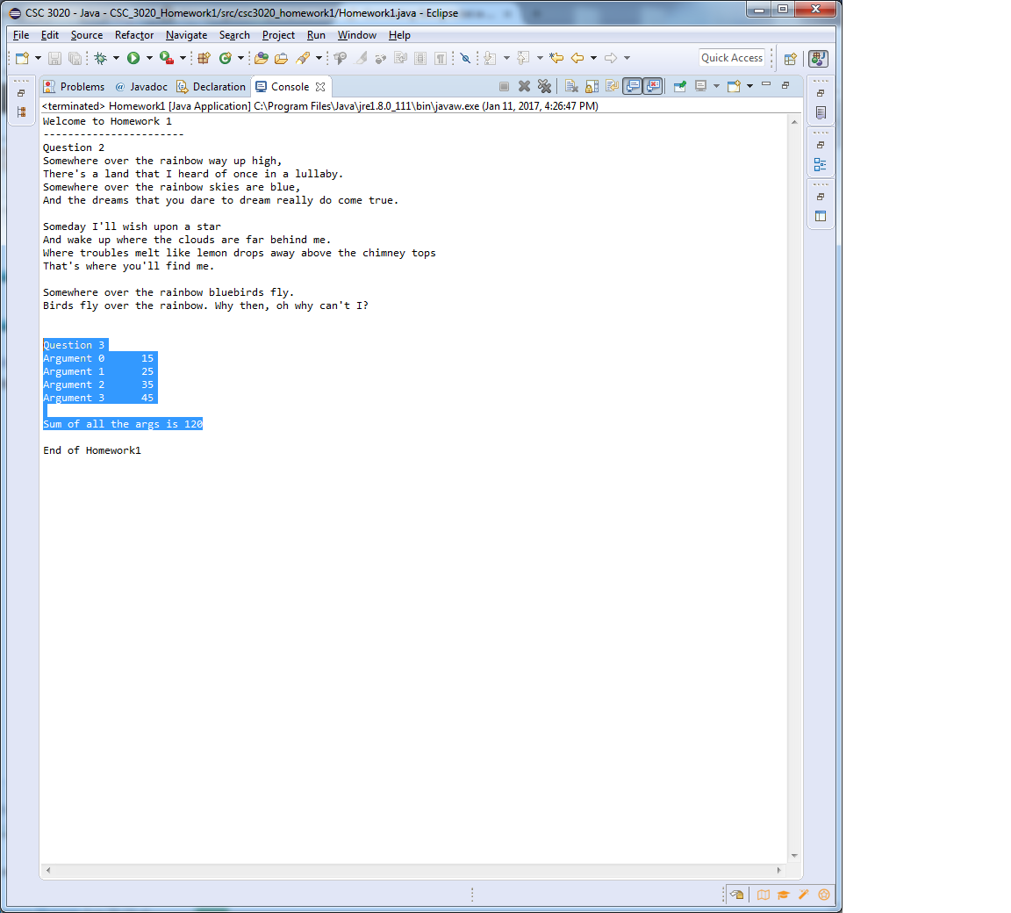

* **Copying-and-pasting application code to a Word document**

1) From the program editor window, press **CTRL-A** and press **CTRL-C**.

2) From within the Word document, press **CTRL-V**.

** **Copying-and-pasting application output to a Word document**

1) From the Eclipse main screen, maximize the Console window.

2) From the Console window, press **ALT-PrintScreen**.

3) From within the Word document, press **CTRL-V**.