**CSC 3020 – Java Programming**

**Homework 2 – Mike Torchia**

**25 points – Due February 1, 10am**

**Late deadline is February 3, 11:59pm, but 20% off**

**1) [8 points]** Write regular expressions after the ► to validate the following inputs:

**a)** Product codes that have one or more letters followed by one or more digits.

► [D]+[d]+

**b)** Nonnegative integers between 1,000 and 9,999, including the comma.

► \d[^0]\p{,}\d{3}

**c)** Canadian zip code containing upper case characters only.

► \p{Lu}\d\p{Lu}\s\p{Lu}\d\p{Lu}

**d)** License plate numbers that have the form:

Letter

Digit

Letter

Hypen (-)

Digit

Letter

Digit

► [a-zA-Z]\d[a-zA-Z]\p{-}\d[a-zA-Z]\d

**2) [8 points]** You've been hired by *Temperature Tempests* to write a Java console application that converts between Celsius, Kelvin, and Newton temperature units. Prompt the user for a conversion code:

| Code | Conversion | Last run input |
| --- | --- | --- |
| a | Celsius → Kelvin | 32 |
| b | Celsius → Newton | 64 |
| c | Kelvin → Celsius | 200 |
| d | Kelvin → Newton | 300 |
| e | Newton → Celsius | 24 |
| f | Newton → Kelvin | 28 |

Then prompt the user for a temperature value, calculate the conversion, and show the two values. Use printf to format the output in two columns with the first column containing a label and the second column containing a value. Format the values to three decimal places. You may use **(char) 176** to include the degree symbol after a value. Use the inputs shown in the table for the last six runs.

*[your program code here]\**

**//=====================================**

**//**

**//Title: Homework 2**

**//**

**//Description:**

**// Prompt the user for a conversion code**

**// then convert their input and format**

**// the output using printf.**

**//**

**// Parse an input showing what each**

**// character is and also tokenize the**

**// input. Format using printf**

**//=====================================**

**package homework_2;**

**import java.util.Scanner;**

**import java.util.StringTokenizer;**

**public class Homework2**

**{**

**public static void main (String[] args){**

**//Declare variables**

**Scanner keyboard=new Scanner(System.in);**

**String inputLine;**

**String temp;**

**int sentinel=0;**

**System.out.println("Start of Homework 2");**

**System.out.println("Question 2");**

**System.out.println();**

**//Format the table to show conversion codes**

**System.out.printf("%-10s %s %20s","Code","Conversion","Last Run Input\n");**

**System.out.printf("%-10s %s %10s","A","Celsius->Kelvin","32\n");**

**System.out.printf("%-10s %s %10s","B","Celcius->Newton","64\n");**

**System.out.printf("%-10s %s %10s","C","Kelvin->Celsius","200\n");**

**System.out.printf("%-10s %s %11s","D","Kelvin->Newton","300\n");**

**System.out.printf("%-10s %s %10s","E","Newton->Celsius","24\n");**

**System.out.printf("%-10s %s %11s","F","Newton->Kelvin","28\n");**

**System.out.println("Enter A Conversion Code: ");**

**inputLine=keyboard.nextLine();**

**//while loop used to validate the user input. controlled**

**//by a sentinel value.**

**while(sentinel==0){**

**//if the input is incorrect**

**if(!(inputLine.equals("A")||inputLine.equals("a")||**

**inputLine.equals("B")||inputLine.equals("b")||**

**inputLine.equals("C")||inputLine.equals("c")||**

**inputLine.equals("D")||inputLine.equals("d")||**

**inputLine.equals("E")||inputLine.equals("e")||**

**inputLine.equals("F")||inputLine.equals("f")))**

**{ //end of if**

**System.out.println("Your input is incorrect. "**

**+ "Please enter one of the"**

**+ "Converstion Codes");**

**System.out.println("Enter A Conversion Code: ");**

**inputLine=keyboard.nextLine();**

**//if the input is correct**

**if((inputLine.equals("A")||inputLine.equals("a")||**

**inputLine.equals("B")||inputLine.equals("b")||**

**inputLine.equals("C")||inputLine.equals("c")||**

**inputLine.equals("D")||inputLine.equals("d")||**

**inputLine.equals("E")||inputLine.equals("e")||**

**inputLine.equals("F")||inputLine.equals("f")))**

**{**

**sentinel=1; /*Change to break out of the**

**validation while loop*/**

**}**

**}**

**//if the user enters the correct input on the first time**

**if((inputLine.equals("A")||inputLine.equals("a")||**

**inputLine.equals("B")||inputLine.equals("b")||**

**inputLine.equals("C")||inputLine.equals("c")||**

**inputLine.equals("D")||inputLine.equals("d")||**

**inputLine.equals("E")||inputLine.equals("e")||**

**inputLine.equals("F")||inputLine.equals("f")))**

**{**

**sentinel=1;/*Change to break out of the**

**validation while loop*/**

**}**

**}//end of while**

**System.out.println("Enter a Temperature: ");**

**temp=keyboard.nextLine();**

**/*Series of If statements to check the conversion code**

**then convert the temp and print using printf*/**

**if(inputLine.equals("A")||inputLine.equals("a"))**

**{**

**double convertedTemp=Integer.parseInt(temp);**

**convertedTemp=convertedTemp+273.15;**

**System.out.printf("%-10s %20s","Original Temp","Converted Temp\n");**

**System.out.printf("%-10s %14s",temp,convertedTemp,"\n");**

**}**

**if(inputLine.equals("B")||inputLine.equals("b"))**

**{**

**double convertedTemp=Integer.parseInt(temp);**

**convertedTemp=(convertedTemp*33)/100;**

**System.out.printf("%-10s %20s","Original Temp","Converted Temp\n");**

**System.out.printf("%-10s %14s",temp,convertedTemp,"\n");**

**}**

**if(inputLine.equals("C")||inputLine.equals("c"))**

**{**

**double convertedTemp=Integer.parseInt(temp);**

**convertedTemp=convertedTemp-273.15;**

**System.out.printf("%-10s %20s","Original Temp","Converted Temp\n");**

**System.out.printf("%-10s %14s",temp,convertedTemp,"\n");**

**}**

**if(inputLine.equals("D")||inputLine.equals("d"))**

**{**

**double convertedTemp=Integer.parseInt(temp);**

**convertedTemp=convertedTemp*(100/33);**

**System.out.printf("%-10s %20s","Original Temp","Converted Temp\n");**

**System.out.printf("%-10s %14s",temp,convertedTemp,"\n");**

**}**

**if(inputLine.equals("E")||inputLine.equals("e"))**

**{**

**double convertedTemp=Integer.parseInt(temp);**

**convertedTemp=convertedTemp*(100/33);**

**System.out.printf("%-10s %20s","Original Temp","Converted Temp\n");**

**System.out.printf("%-10s %14s",temp,convertedTemp,"\n");**

**}**

**if(inputLine.equals("F")||inputLine.equals("f"))**

**{**

**double convertedTemp=Integer.parseInt(temp);**

**convertedTemp=(convertedTemp*33)/100;**

**System.out.printf("%-10s %20s","Original Temp","Converted Temp\n");**

**System.out.printf("%-10s %14s",temp,convertedTemp,"\n");**

**}**

**System.out.println();**

**System.out.println("End of Question2 ");**

**keyboard.close();**

**//End of Question 2**

*[your program output here]\*\**

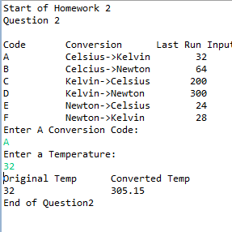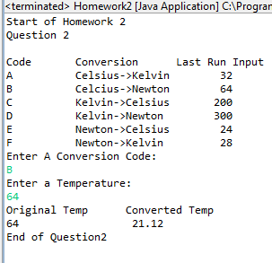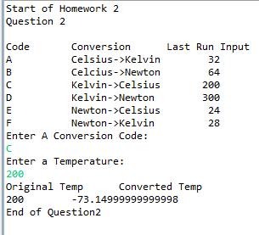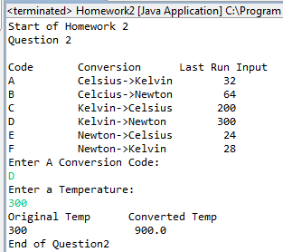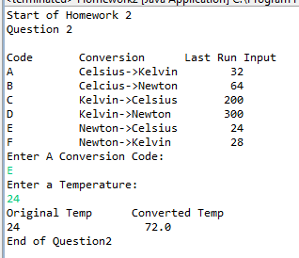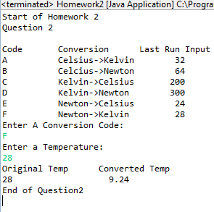

**3) [9 points]** You've been hired by *Character Counts* to write a Java console application that analyzes a sentence. Prompt the user for a sentence and show the numbers of letters, digits, whitespace characters, and other characters in the sentence. Also, tokenize the sentence and show the number of tokens using these delimiters:

space character ( )

comma (,)

digit 7 (7)

Use printf to format the output in two columns with the first column containing a label and the second column containing a value. Use this sentence as the last input:

The last mission to the moon was Apollo 17 in December 1972.

*[your program code here]\**

//Question 3

//Referenced Sample Code from Blackboard

**final** String delimiters = ", \t\n\r\f";

StringTokenizer tokens;

**int** tokenCount;

System.***out***.println("Question 3");

System.***out***.println();

System.***out***.println("Enter A Sentence: ");

inputLine=keyboard.nextLine();

System.***out***.printf("%-10s %-12s %-13s %-6s %14s %12s %16s %n", "Character","At","Letter", "Lower Case", "Upper Case", "Number", "White Space");

/*loop for however big the input is and at every character

* (tempchar=inputLine.charAt(i)) print true or fales if the

* character is upper,lower, ect*/

**for**(**int** i=0;i<inputLine.length();i++)

{

**char** tempChar=inputLine.charAt(i);

System.***out***.printf("%-10s %-12s %-13s %-6s %14s %15s %16s %n",tempChar,i,Character.*isLetter*(tempChar),Character.*isLowerCase*(tempChar),

Character.*isUpperCase*(tempChar),Character.*isDigit*(tempChar),Character.*isWhitespace*(tempChar));

}

tokens= **new** StringTokenizer(inputLine,delimiters);

tokenCount=tokens.countTokens();

System.***out***.printf("%-10s %4s \n", "Sentence:",inputLine,"\n");

System.***out***.printf("%-10s %2s \n", "Number of Tokens:",tokenCount,"\n");

//loop for however number of tokens there are

//and print each token

**for** (**int** i=1;i<=tokenCount;i++){

System.***out***.printf("%-10s %d %s %s \n","Token #",i,": ",tokens.nextToken(),"\n");

}

System.***out***.println("End of Question 3");

keyboard.close();

//End of Question 3

}

}

*[your program output here]\*\**

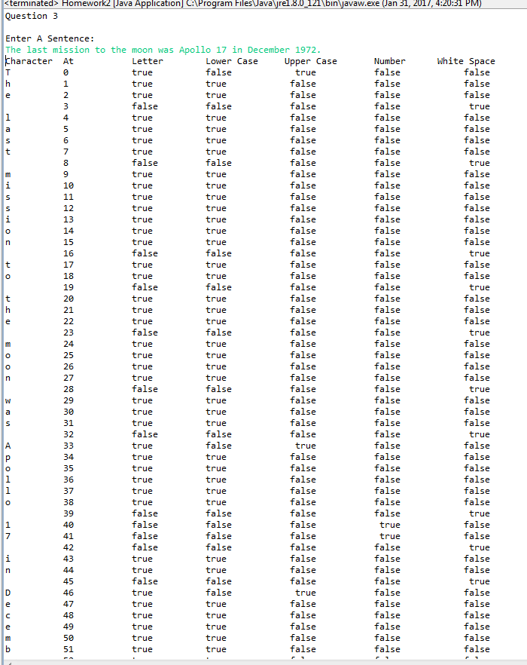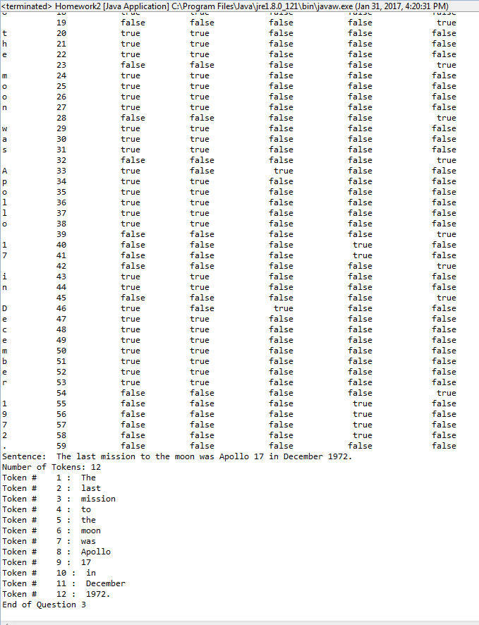

* **Copying-and-pasting application code to a Word document**

1) From the program editor window, press **CTRL-A** and press **CTRL-C**.

2) From within the Word document, press **CTRL-V**.

** **Copying-and-pasting application output to a Word document**

1) From the Eclipse main screen, maximize the Console window.

2) From the Console window, press **ALT-PrintScreen**.

3) From within the Word document, press **CTRL-V**.