**CSC 3020 – Java Programming**

**Homework 3 – Mike Torchia**

**25 points – Due February 8, 10am**

**Late deadline is February 10, 11:59pm, but 20% off**

**a)** Save this document with your name and the homework number somewhere in the file name.

**b)** Type/paste your answers into the document.

**c)** Submit this document to the Blackboard item where you downloaded this document.

**1) [10 points]** You've been hired by *Tax Tempests* to write a Java console application that determines the pays and taxes on a paycheck. Use a validation loop to prompt and get from the user an hourly rate in the range $10-30 per hour. Then use a validation loop to prompt and get from the user a number of hours worked in the range 15-45 hours per week. Calculate the gross pay, federal tax, FICA (Social Security and Medicare) tax, state tax, and net pay based on the hourly rate and time worked. Here are the formulas:

**gross pay = hourly rate * time worked**

**federal tax = gross pay * 0.15**

**FICA tax = gross pay * 0.0765**

**state tax = gross pay * 0.0435**

**net pay = gross pay – federal tax – FICA tax – state tax**

Format the output in two columns with the first column containing a label and the second column containing the result. Format any dollar values to two decimal places. Use these inputs for your last run:

Hourly rate: $22.50

Hours worked: 36

*[your program code here]\**

**package** homework_3;

//import java.text.DecimalFormat;

**import** java.util.Scanner;

**public** **class** Homework3 {

**public** **static** **void** main (String[] args){

Scanner keyboard=**new** Scanner(System.***in***);

//Declare Variables

**float** grossPay, federalTax, ficaTax, stateTax, netPay=0;

String wage;

String time;

**float** hoursWorked;

**float** hourlyRate;

System.***out***.println("Question 1");

System.***out***.println();

//get Wage and then convert it to a float

System.***out***.println("Enter your hourly wage: (Use range"

+ "of $10-$30)");

wage=keyboard.nextLine();

hourlyRate=Float.*valueOf*(wage);

//Validation loop

**while**((hourlyRate<10) || (hourlyRate>30))

{

System.***out***.println("Incorrect Value for Wage. Please "

+ "enter a valid value: ");

wage=keyboard.nextLine();

hourlyRate=Float.*valueOf*(wage);

}

//get hours worked and convert it to a float

System.***out***.println("Enter number of hours worked: (Please"

+ "use range of 15-45 hours.");

time=keyboard.nextLine();

hoursWorked=Float.*valueOf*(time);

//validation loop

**while**((hoursWorked<15) || (hoursWorked>45))

{

System.***out***.println("Incorrect Value for Hours worked. Please "

+ "enter a valid value: ");

time=keyboard.nextLine();

hoursWorked=Float.*valueOf*(time);

}

//declare variables

grossPay=hourlyRate*hoursWorked;

federalTax=grossPay*0.15f;

ficaTax=grossPay*0.0765f;

stateTax=grossPay*0.0435f;

netPay=grossPay-federalTax-ficaTax-stateTax;

//Print values

System.***out***.printf("%-10s %-13.2f %n","Hourly Rate: $",hourlyRate);

System.***out***.printf("%-10s %-13.2f %n","Hours Worked:",hoursWorked);

System.***out***.println();

System.***out***.printf("%-11s %-14.2f %n","Gross Pay",grossPay);

System.***out***.printf("%-10s %-13.2f %n","Federal Tax",federalTax);

System.***out***.printf("%-11s %-14.2f %n","FICA Tax",ficaTax);

System.***out***.printf("%-11s %-14.2f %n","State Tax",stateTax);

System.***out***.printf("%-11s %-14.2f %n","Net Pay",netPay);

System.***out***.println();

System.***out***.println("End of Question 1");

*[your program output here]\*\**

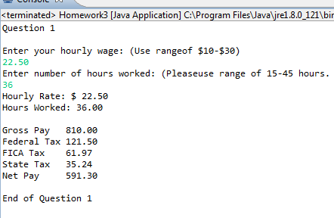

**2) [10 points]** You've been hired by *Metal Marketeers* to write a Java console application that calculates sales data. Prompt for and read the following information from a salesman:

● Appliance name (String) – they sell washers, dryers, refrigerators, microwaves, etc.

● Wholesale price (double) – the price *Metal Marketeers* paid for the appliance. Use a validation loop to insure that the price is at least zero.

● Retail price (double) – the price *Metal Marketeers* is selling the appliance for. Use a validation loop to insure that the price is at least the wholesale price.

Format the following output in two columns with the first column containing a label and the second column containing the result. Format any dollar values to two decimal places.

● The three inputs.

● The profit *Metal Marketeers* will earn selling the appliance (retail – wholesale).

● The 2% commission the *Metal Marketeers* salesman will earn selling the appliance (profit * 0.02).

● The 6% Michigan sales tax on the appliance (retail * 0.06).

● The total cost to the customer (retail + sales tax).

Use constants for the 2% commission rate and the 6% sales tax rate. Use these inputs for your last run:

Appliance name: dryer

Wholesale price: $525.00

Retail price: $725.00

*[your program code here]\**

System.***out***.println("Start of Question 2");

//declare variables

String appName;

**double** wholesalePrice;

**double** retailPrice;

//get name of App

System.***out***.println("Name of Appliance:");

appName=keyboard.nextLine();

//get wholesale price and convert it to double

System.***out***.println("Wholesale price of appliance: ");

wholesalePrice=Double.*parseDouble*(keyboard.nextLine());

//validation loop

**while**(wholesalePrice<0)

{

System.***out***.println("Wholesale price cannot be less"

+ "than zero. Enter correct value: ");

wholesalePrice=Double.*parseDouble*(keyboard.nextLine());

}

//get retail price and convert it to double

System.***out***.println("Retail price of appliance: ");

retailPrice=Double.*parseDouble*(keyboard.nextLine());

//validation loop

**while**(retailPrice<wholesalePrice)

{

System.***out***.println("Retail price cannot be less"

+ "than wholesale price. Enter correct value:");

retailPrice=Double.*parseDouble*(keyboard.nextLine());

}

//declare variables

**double** profit=retailPrice-wholesalePrice;

**double** commission=profit*0.02;

**double** salesTax=retailPrice*0.06;

**double** totalCost=retailPrice+salesTax;

//print results

System.***out***.printf("%-10s %7s %n","Appliance Name:",appName);

System.***out***.printf("%-10s %-13.2f %n","Wholesale Price: ",wholesalePrice);

System.***out***.printf("%-10s %9.2f %n","Retail Price: ",retailPrice);

System.***out***.printf("%-10s %13.2f %n","Profit:",profit);

System.***out***.printf("%-10s %10.2f %n","Commission:",commission);

System.***out***.printf("%-10s %12.2f %n","Sales Tax:",salesTax);

System.***out***.printf("%-10s %12.2f %n","Total Cost:",totalCost);

System.***out***.println("End of Question 2");

System.***out***.println();

*[your program output here]\*\**

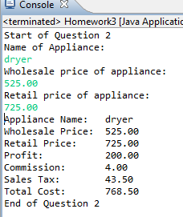

**3) [5 points]** You've been hired by *Number Knights* to write a Java console application that investigates how well Java handles large integers. Write two loops that iterate from 0 through 35. Before each loop, set an integer variable (IV) to 1. Within each loop, print the loop count and the value of IV formatted in two columns. Within the first loop, multiply IV by 2. Within the second loop, multiply IV by the appropriate StrictMath method. The second loop will not complete since there will eventually be an integer overflow.

*[your program code here]\**

System.***out***.println("Start Of Question 3");

**int** IV1=1;

System.***out***.println("Loop 1");

**for**(**int** i=0;i<35;i++)

{

IV1=IV1*2;

System.***out***.printf("%-10s %7d %n","Loop 1 Count:",i);

System.***out***.printf("%-10s %7d %n","Value of IV:",IV1);

System.***out***.println();

}

System.***out***.println();

**int** IV2=1;

System.***out***.println("Loop 2");

**for**(**int** i=0;i<35;i++)

{

IV2=StrictMath.*multiplyExact*(IV2, 2);

System.***out***.printf("%-10s %7d %n","Loop 2 Count:",i);

System.***out***.printf("%-10s %7d %n","Value of IV:",IV2);

System.***out***.println();

}

*[your program output here]\*\**

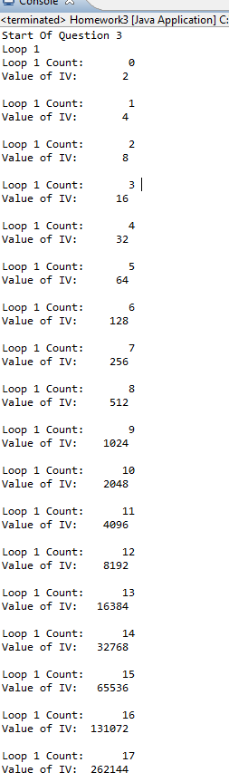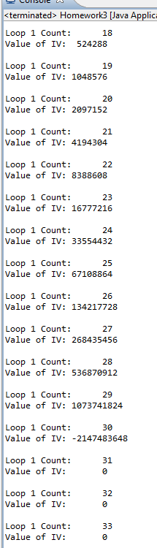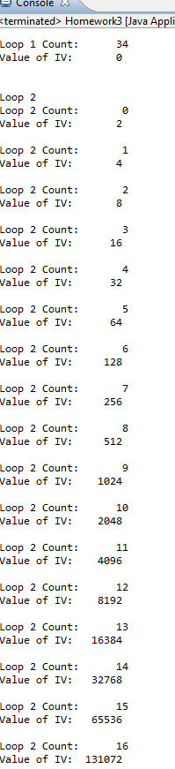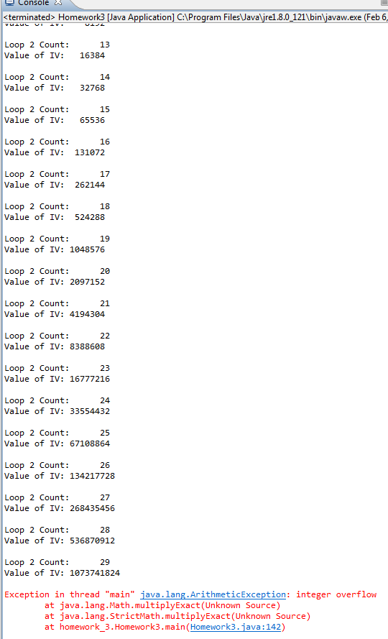

* **Copying-and-pasting application code to a Word document**

1) From the program editor window, press **CTRL-A** and press **CTRL-C**.

2) From within the Word document, press **CTRL-V**.

** **Copying-and-pasting application output to a Word document**

1) From the Eclipse main screen, maximize the Console window.

2) From the Console window, press **ALT-PrintScreen**.

3) From within the Word document, press **CTRL-V**.