# CSC 3110 – Homework 4

1. Find the order of growth for solutions of the following recurrences:
   1. 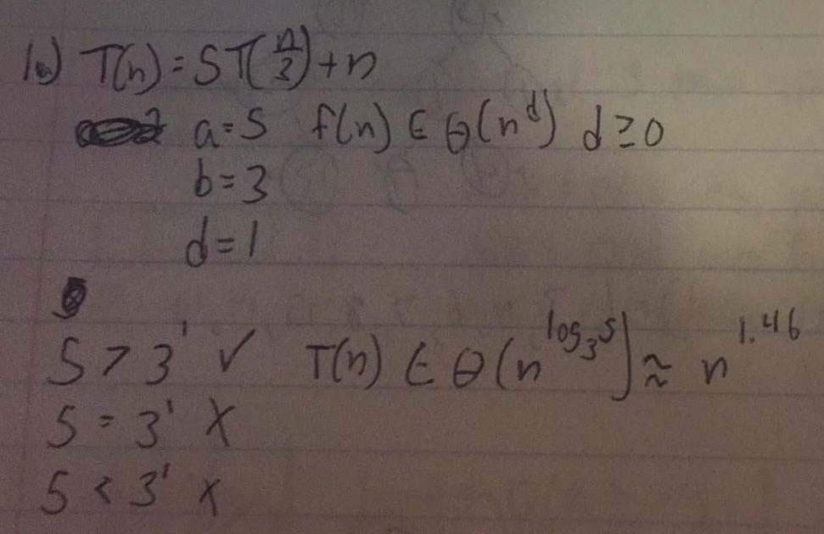T(n) = 5T(n/3)+n
   2. 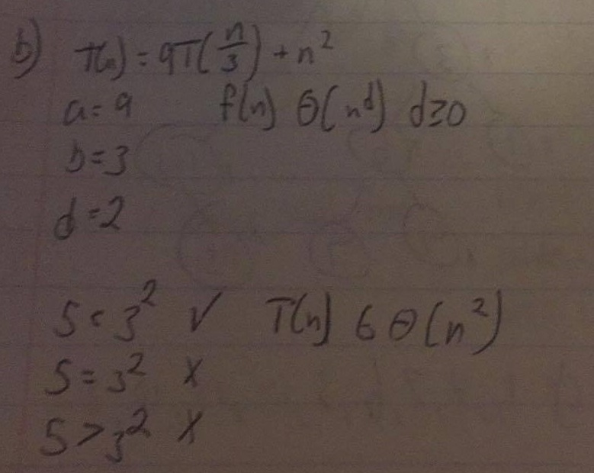T(n) = 9T(n/3)+n2
   3. 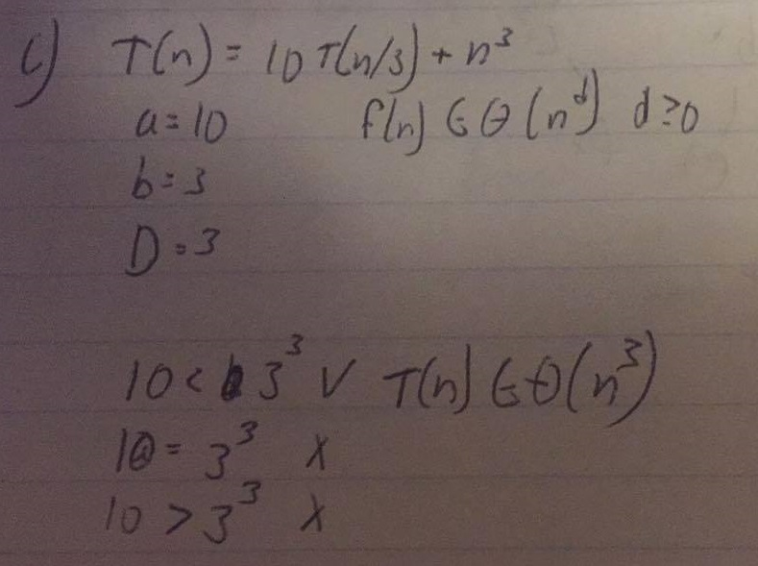T(n) = 10T(n/3)+n3
2. 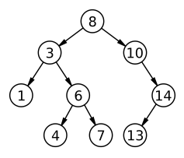Traverse the following binary tree in
   1. Preorder = 8,3,1,6,4,7,10,14,13
   2. Inorder = 1,3,4,6,7,8,10,13,14
   3. Postorder = 1,4,7,6,3,13,14,10,8
3. Indicate the time efficiency classes of the three main operations of the priority queue implemented as
   1. Unsorted array
      1. Insert = O(1)
      2. Delete = O(n)
      3. Peek = O(n)
   2. Sorted array
      1. Insert = O(log n)
      2. Delete = O(1)
      3. Peek = O(1)
   3. Binary Search Tree
      1. Insert = O(log n)
      2. Delete = O(log n)
      3. Peek = O(log n)
   4. AVL tree
      1. Insert = O(log n)
      2. Delete = O(log n)
      3. Peek = O(log n)
   5. Heap
      1. Insert = O(log n)
      2. Delete = O(log n)
      3. Peek = O(1)
4. Construct both an AVL tree and a 2-3 tree for the values 3 6 5 1 2 4
   1. 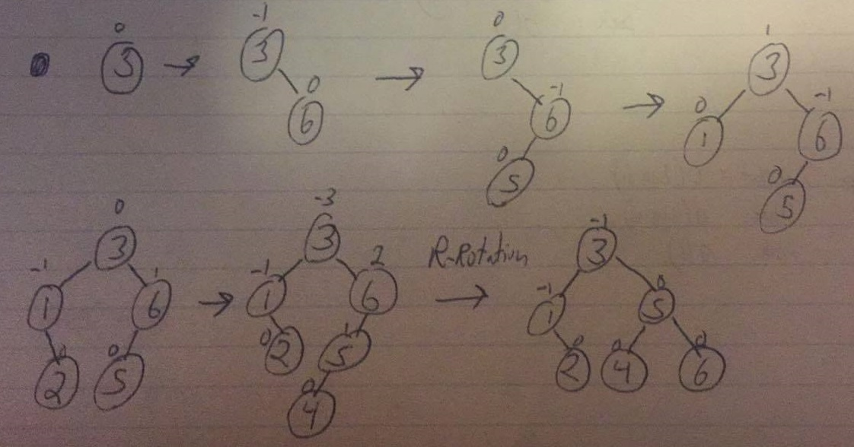AVL tree
   2. 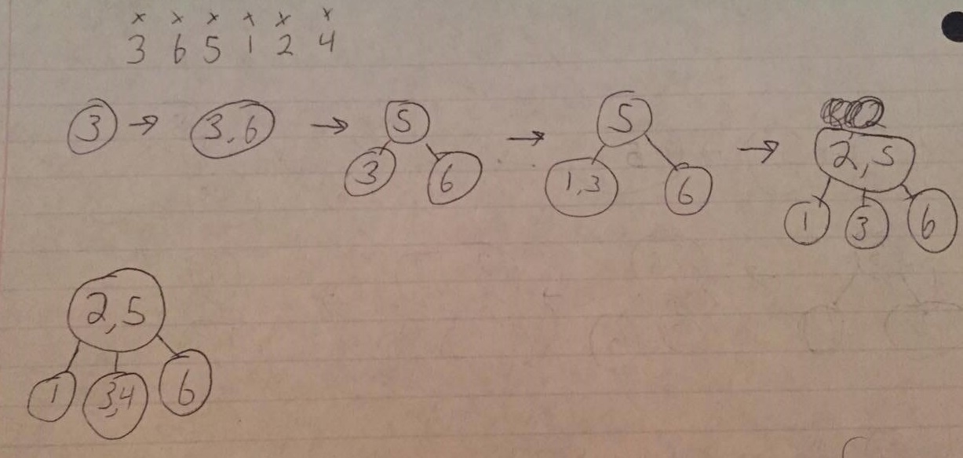2-3 Tree
5. Apply Quicksort using both Lomuto’s and Hoare’s partitioning algorithms on 3 6 5 1 2 4
   1. 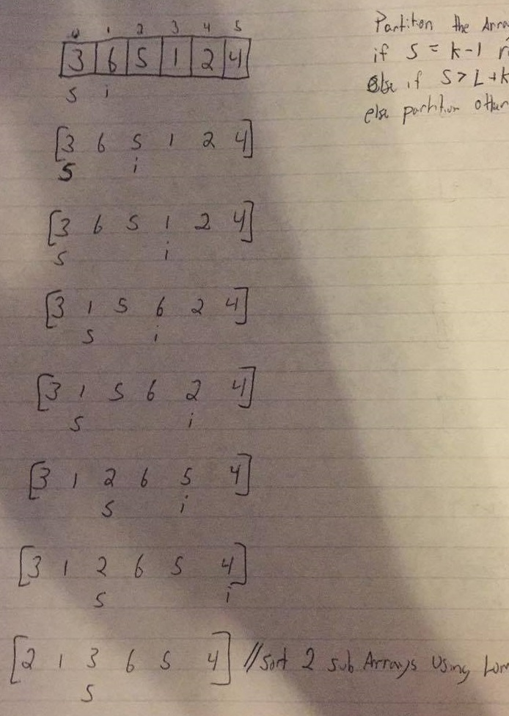Lomuto’s

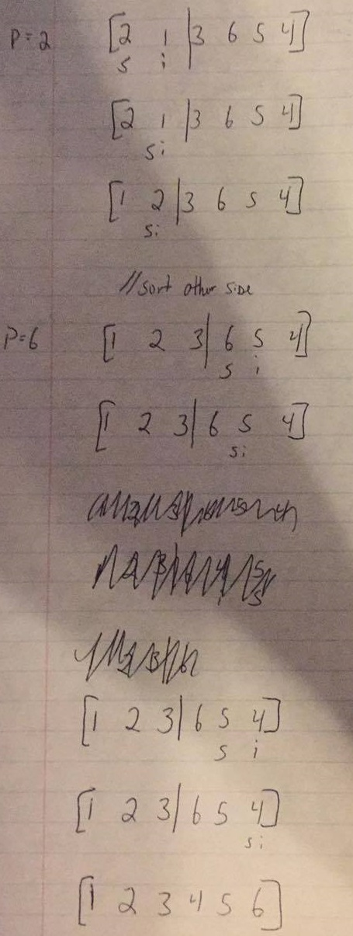

* 1. 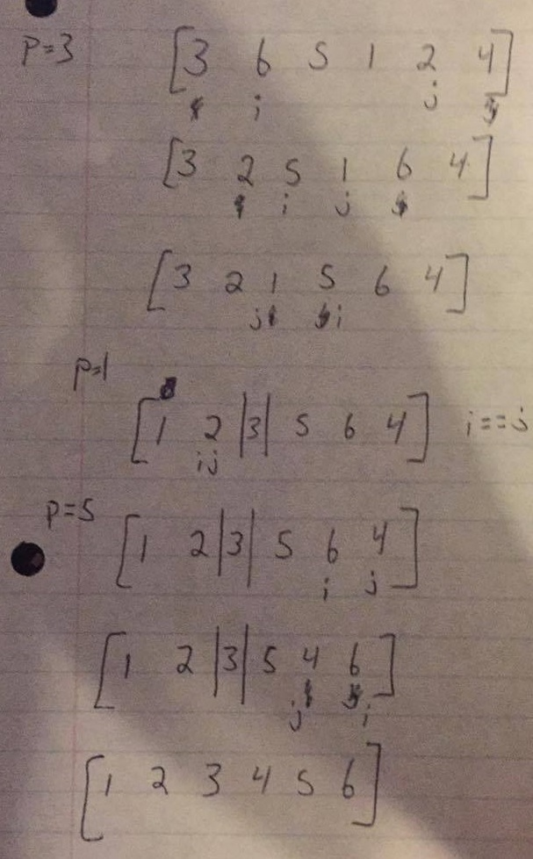Hoare’s