# TODO Application

* Functional requirements
  + View tasks
  + Add tasks
  + Delete tasks
* Non-functional requirements
  + Security
    - Runs on localhost. Only root password needed
    - No encryption
  + Capacity
    - Low throughput – personal use. Application will only need to be able to handle single user
  + Performance
    - Query/Response times are minimal. Application handles small database queries
  + Availability
    - Only available locally
  + Usability
    - Minimal to zero training required due to limited functionality

# System architecture diagram

# LAMP Stack

* Ubuntu 16.04.3
* Apache 2 Web Server
* PHP 7

Response

Request

* MySQL



# Data flow diagram

USER/WEBPAGE

Response

Update

Store/Delete

Request

User Action

ADD/DELETE

WEBSERVER

DATABASE

# Use case

Webpage Update

Click “Delete” button next to desired task

DELETE TASK

Enter task details:

-Name

-Description

-Priority level

Click Submit

ADD TASK

VIEW TASKS

Open localhost/index.php in Firefox

USER

# Sequence Diagram

USER

CLIENT

DATABASE

Return data

Query

Delete Task

Add Task

Return data

Query

Return data

Query

Request

# Database design

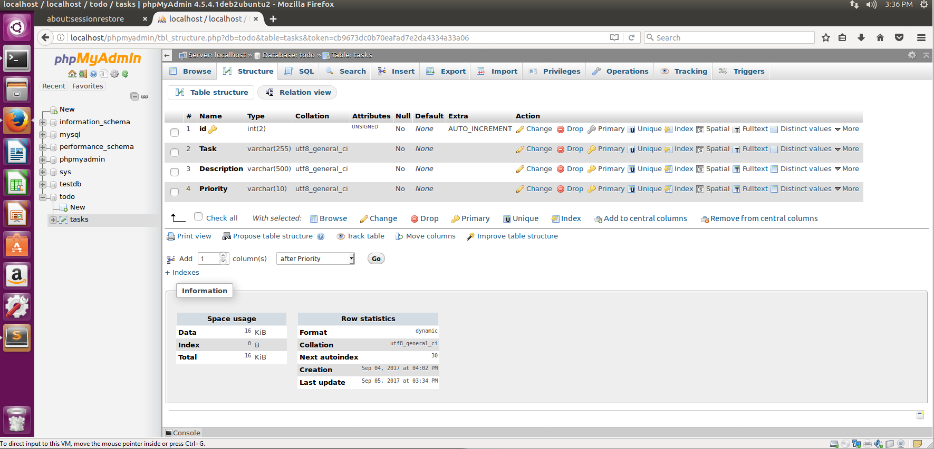

# Class diagram

|  |
| --- |
| Tasks |
| id: int(2)  Task: varchar(255)  Description: varchar(500)  Priority: varchar(10) |

|  |
| --- |
| View Task |
| SELECT * FROM tasks ORDER BY FIELD(Priority,'High','Medium','Low') asc |

|  |
| --- |
| Delete Task |
| DELETE FROM tasks WHERE id='$_POST[id]' |

|  |
| --- |
| Add Task |
| INSERT INTO tasks (Task,Description,Priority) VALUES ('$_POST[taskname]','$_POST[desc]','$_POST[priority]') |

# Test cases

**TC01 – View tasks from TODO database via web browser**

Last updated: 9/5/17, saved by Mike Torchia

*Local user should be able to successfully view tasks saved in database on web browser*

Assumption: user is running linux OS on windows virtual machine

Test steps:

1. Press Ctrl+Alt+T to open command line
2. In the command line type ‘cd /var/www’
3. In the command line type ‘firefox localhost/index.php

Expected result:

Firefox should open and display a webpage with database entries from TODO database

**TC02 – Add tasks from TODO database via web browser**

Last updated: 9/5/17, saved by Mike Torchia

*Local user should be able to successfully add tasks to database on web browser*

Assumption: user is running linux OS on windows virtual machine

Test steps:

1. On the webpage, in the “Add Task” textbox, type name of task to add
2. From the “Priority Level” drop down menu, select desired priority level
   1. Default priority is “High”
3. In the “Task Description (optional)” text box, type a description for task.
4. Click “Submit” button under “Task Description (optional)” text box.

Expected result:

Webpage should refresh, resetting “Add Task”,”Priority Level” and “Task Description” while also

displaying the new task in the table sorted by priority (High to Low).

**TC01 – Delete tasks from TODO database via web browser**

Last updated: 9/5/17, saved by Mike Torchia

*Local user should be able to successfully delete tasks saved in database on web browser*

Assumption: user is running linux OS on windows virtual machine

Test steps:

1. Locate task to be deleted in table.
2. Directly to the right of the respective row, click the “Delete” button

Expected result:

Webpage should refresh, resetting “Add Task”,” Priority Level” and “Task Description” while also

displaying the table without the recently deleted task sorted by priority (High to Low).