ROAD MAP
Title: Explainable Real Estate Analytics: A Comparative Analysis of Machine Learning Frameworks for House Price Prediction

Domain

Real Estate Analytics | Machine Learning | Data Science
Dataset
I recommend using benchmark house price datasets:
- House price prediction (Kaggle)
  - https://www.kaggle.com/datasets/shree1992/housedata
- House Price Prediction Dataset (Kaggle)
  - https://www.kaggle.com/datasets/zafarali27/house-price-prediction-dataset
- House Prices India (Kaggle)
  - https://www.kaggle.com/datasets/sukhmandeepsinghbrar/house-prices-india?utm_source=chatgpt.com
These datasets contain important housing attributes such as area, number of bedrooms, bathrooms, location, year built, lot size, and selling price, making them suitable for comparative machine learning analysis.
Abstract

The real estate industry generates large volumes of property-related data that can be leveraged to estimate house prices accurately. Traditional valuation methods often rely on expert knowledge and manual analysis, which may produce inconsistent results. This project proposes a machine learning-based framework for House Price Prediction by performing comprehensive Exploratory Data Analysis (EDA), data preprocessing, feature engineering, and comparative evaluation of multiple machine learning models.
Initially, the collected housing datasets undergo preprocessing, including handling missing values, removing duplicate records, encoding categorical attributes, and normalizing numerical features. A detailed Exploratory Data Analysis (EDA) is then conducted to understand the data through dataset overview, descriptive statistics, data quality assessment, missing value analysis, duplicate detection, outlier detection, univariate analysis, bivariate analysis, multivariate analysis, correlation analysis, feature engineering, and feature selection.
Multiple machine learning algorithms, including Decision Tree, Random Forest, XGBoost, and CatBoost, are trained and evaluated for predicting house prices. Their performance is compared using MAE, MSE, RMSE, R² Score, and MAPE, and the best-performing model is selected.
To improve model interpretability, the project incorporates SHAP and LIME, providing both global and local explanations of predictions. These techniques help identify the most influential features affecting house prices.
Finally, the analytical results are presented through interactive visualizations such as heatmaps, boxplots, feature importance graphs, correlation plots, and dashboards. A comparative analysis is conducted across all machine learning models to determine the most accurate and interpretable approach for house price prediction.
Approach:
Problem Definition
•Define project objectives
• Collect the house price dataset
• Understand dataset attributes and target variable
Dataset Overview
• Shape
• Features
• Data Types
• Target Variable
Data Quality Assessment
• Missing Values
• Duplicate Records
• Inconsistent Data
• Outlier Detection
• Encode categorical features
Exploratory Data Analysis (EDA)
• Descriptive Statistics
• Univariate Analysis
• Bivariate Analysis
• Multivariate Analysis
• Correlation Analysis
Feature Engineering
• Create New Features
• Transform Variables
Feature Selection
• Correlation-Based Selection
• Feature Importance
• Remove Irrelevant Features

Data Preprocessing
• Missing Value Imputation
• Encoding Categorical Features
• Feature Scaling
• Data Cleaning
Train-Test Split
• Training Dataset (80%)
• Testing Dataset (20%)

Model Training
- Decision Tree
- Random Forest
- XGBoost
- CatBoost
Model Evaluation
• MAE
• MSE
• RMSE
• R² Score
Comparative Analysis
• Compare Model Performance
• Select Best Model
Model Explainability
• SHAP Analysis
• LIME Analysis

Visualization
• Heatmap
• Boxplot
• Feature Importance
• Prediction vs Actual
• Dashboard
Final House Price Prediction

End
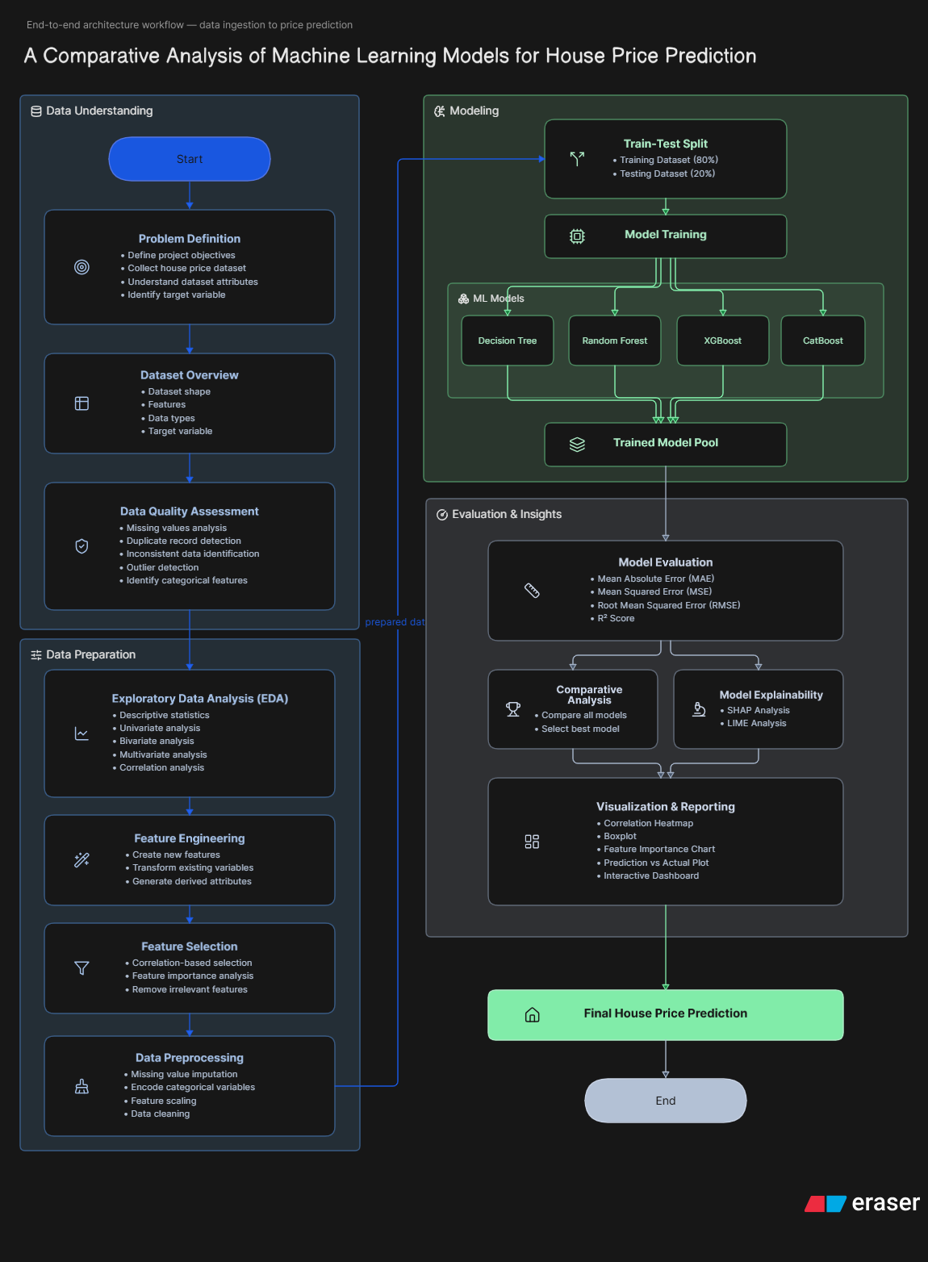

Preprocessing
- Missing Value Handling
- Duplicate Removal
- Encoding
- Normalization / Standardization

Machine Learning Models
- Decision Tree Regressor
- Random Forest Regressor
- XGBoost Regressor
- CatBoost Regressor

Explainability
- SHAP
- LIME

Visualization
- Heatmap
- Boxplot
- Correlation Matrix
- Feature Importance
- Distribution Plots
- Dashboard

Comparative Analysis
Compare Models
- Decision Tree
- Random Forest
- XGBoost
- CatBoost
Evaluation Metrics
- MAE (Mean Absolute Error)
- MSE (Mean Squared Error)
- RMSE (Root Mean Squared Error)
- R² Score
- MAPE
Recommended Research Pipeline:
Benchmark Dataset

Data Cleaning

Exploratory Data Analysis (EDA)

Feature Engineering

Feature Selection

Train-Test Split

Machine Learning Models
(Decision Tree
Random Forest
XGBoost
CatBoost)

Performance Evaluation
(MAE, MSE, RMSE, R², MAPE)

Explainable AI
(SHAP + LIME)

Visualization Dashboard

Comparative Analysis

Research Conclusions

TEAM DETAILS:

2420030284 - CH.SHALINI
2420030453 - M.J.U.HARIKA
2420030589 - K.ANEESHA

