A short summary of Breiman’s main ideas and claims about Random Forests.
Random Forests are an ensemble learning technique that enhances predictive accuracy by generating multiple decision trees and aggregating their results. Each tree is constructed using randomly selected subsets of the data and features, leading to a diverse range of trees. This diversity is crucial as it fortifies the overall model, making it more robust and dependable compared to a single decision tree.
Breiman explains that the success of a Random Forest depends on two things:
- How good each tree is on its own
- How different (uncorrelated) the trees are from each other
The effectiveness of a Random Forest hinges on two key factors: the individual performance of each decision tree and the degree of independence among them. As more trees are added to the forest, the model’s stability and accuracy improve, while the risk of overfitting is minimized. This is important because it ensures that the model generalizes well to new, unseen data rather than simply memorizing the training dataset.

Additionally, Random Forests utilize out-of-bag (OOB) error to evaluate model accuracy without necessitating a separate test set, streamlining the validation process. Research by Breiman indicates that Random Forests often outperform other algorithms, such as AdaBoost, particularly in scenarios involving noisy data or numerous weak predictors. This makes Random Forests a powerful tool in various data analysis applications.
A short description of heart disease dataset and the preprocessing steps you applied.
- The Heart Disease UCI dataset is utilized to predict the presence of heart disease in patients, with 297 records and 13 features.
- Key features include demographic data, medical indicators, and exercise-related metrics, such as age, sex, and maximum heart rate.
- The target variable indicates heart disease status, with 0 for absence and 1 for presence.
- Data preprocessing involved checking for and addressing any missing values to ensure dataset integrity.
- Continuous features underwent scaling using StandardScaler to normalize the data for improved model performance.
- Categorical variables were either retained as numeric or encoded to facilitate analysis and modeling.
- The dataset was split into training and testing subsets to evaluate model accuracy and performance effectively.
- After preprocessing, the dataset is prepared for modeling with algorithms like Random Forests, allowing for predictive analysis of heart disease.
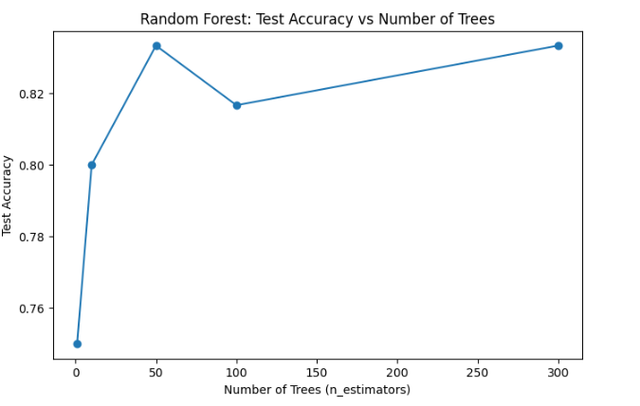
Figure 1: Heart Disease Test Accuracy
A short description of Intel Image dataset and the preprocessing steps you applied.
- The dataset consists of images belonging to six distinct categories: Buildings, Forest, Glacier, Mountain, Sea, and Street.
- It contains a total of 14,034 training images and 3,000 testing images.
- All images were standardized to a size of 64×64 pixels and represented in RGB color format.
- Preprocessing involved resizing images for uniformity across the dataset.
- Images were converted into numeric arrays to facilitate machine learning model input.
- Each image was flattened into a one-dimensional vector, enabling compatibility with Random Forest algorithms.
- Principal Component Analysis (PCA) was applied to reduce dimensionality to 200 components, enhancing training efficiency and minimizing redundancy.
- The dataset was already organized into training and testing subsets, eliminating the need for an additional split.
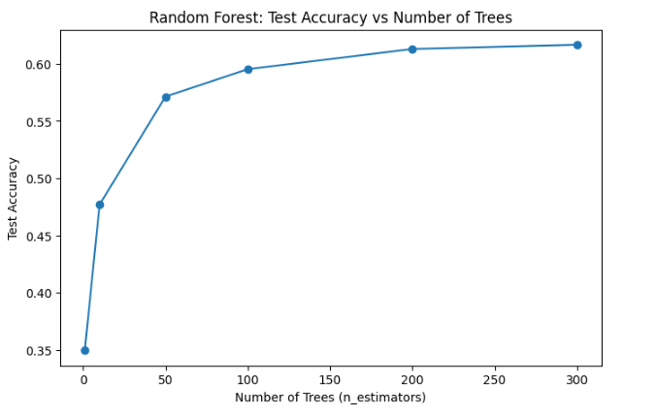
Figure 2: Intel Image Processing Test Accuracy
How does increasing the number of trees affect accuracy and stability?
Adding more trees in a Random Forest usually makes the model more accurate because more trees reduce the effect of errors from individual trees. It also makes the results more stable and less affected by small changes in the data. After a certain number of trees, adding more does not improve accuracy much.
How does the Random Forest compare to a single tree in terms of accuracy and training time?
A Random Forest is usually more accurate than a single decision tree because it combines many trees to reduce errors. However, it takes more time to train since multiple trees are built, while a single tree is faster but less reliable.
What insights did you gain about the effect of randomness and ensemble size on model performance?
- Using randomness (different data samples and feature subsets for each tree) reduces overfitting and makes the model more robust.
- Increasing the number of trees (ensemble size) improves accuracy and stability, as more trees provide better “voting” and average out errors.
- However, after a certain number of trees, adding more doesn’t significantly increase accuracy, only training time.

