# Group 3

### Mikaela June

### Hector Lara

### Ian Lewis

### Robert Minkler

Bacchus Winery

## Reports

##### Report 1: Employee Data

Employee time history showing each employee and how many hours they worked each quarter for the last four quarters.

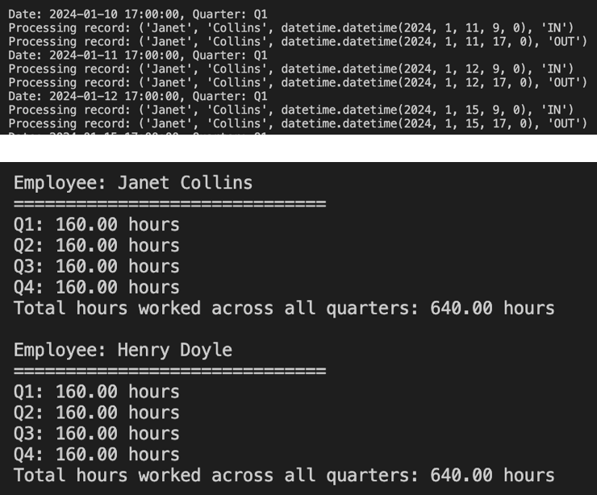

##### Report 2: Sales Data

What wines and how much of each wine has each distributor purchased over the last year?

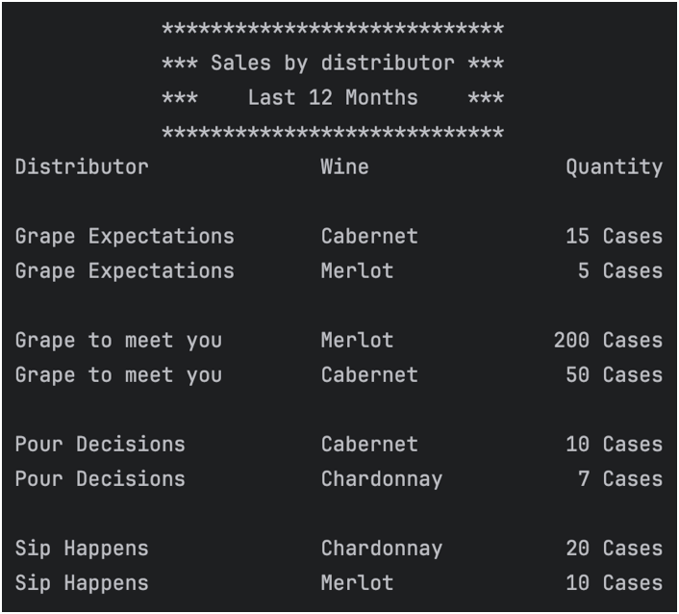

##### Report 3: Supplier Delivery

Suppliers delivery report: show each month for each supplier.

Are all deliveries on time this month? If not, how many days late are their deliveries on average for the month?

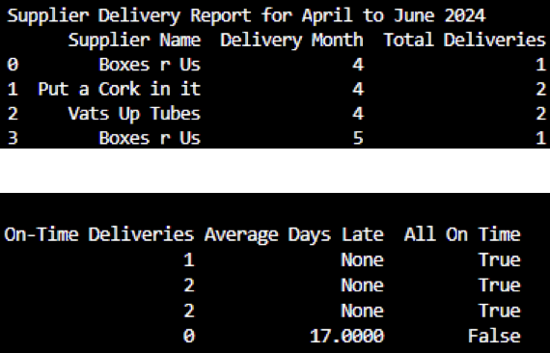

##### Report 4: Supplier Delivery

How much of each wine has sold over the last year.

