- Query
SELECT APP_NUMBER,
CASE WHEN LOCATE('txt_Rating";s:', APP_DATA) = 0 THEN NULL
ELSE SUBSTRING( APP_DATA,
LOCATE(':"', APP_DATA, LOCATE('txt_Rating";s:', APP_DATA)) + 2,
LOCATE( '"', APP_DATA, LOCATE(':"', APP_DATA, LOCATE('txt_Rating";s:', APP_DATA)) + 2 ) - (LOCATE(':"', APP_DATA, LOCATE('txt_Rating";s:', APP_DATA)) + 2) ) END AS rating, '1B' AS Kategori FROM APPLICATION WHERE APP_DATA LIKE '%txt_Rating%';
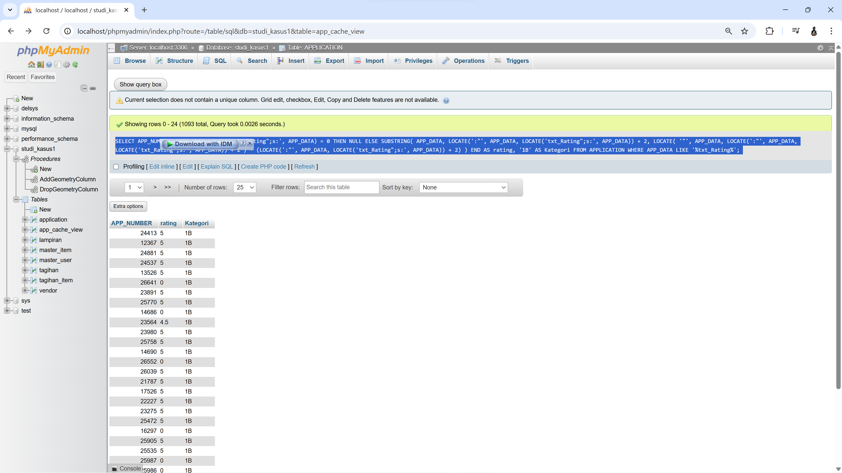

- Query
SELECT
acv.USR_UID,
CASE
WHEN DATEDIFF(CURDATE(), STR_TO_DATE(et.est_time, '%Y-%m-%d')) <= 7 THEN 1
WHEN DATEDIFF(CURDATE(), STR_TO_DATE(et.est_time, '%Y-%m-%d')) <= 14 THEN 2
WHEN DATEDIFF(CURDATE(), STR_TO_DATE(et.est_time, '%Y-%m-%d')) <= 21 THEN 3
ELSE 4
END AS overdue_status,
COUNT(*) AS total_case
FROM APP_CACHE_VIEW acv

-- ambil status terakhir (max update date)
JOIN (
SELECT
APP_NUMBER,
MAX(APP_UPDATE_DATE) AS last_update
FROM APP_CACHE_VIEW
GROUP BY APP_NUMBER
) last ON last.APP_NUMBER = acv.APP_NUMBER
AND last.last_update = acv.APP_UPDATE_DATE

-- extract txt_estTime dari APP_DATA
JOIN (
SELECT
APP_NUMBER,
CASE
WHEN LOCATE('txt_estTime";s:', APP_DATA) = 0 THEN NULL
ELSE SUBSTRING(
APP_DATA,
LOCATE(':"', APP_DATA, LOCATE('txt_estTime";s:', APP_DATA)) + 2,
LOCATE(
'"',
APP_DATA,
LOCATE(':"', APP_DATA, LOCATE('txt_estTime";s:', APP_DATA)) + 2
) - (LOCATE(':"', APP_DATA, LOCATE('txt_estTime";s:', APP_DATA)) + 2)
)
END AS est_time
FROM APPLICATION
) et ON et.APP_NUMBER = acv.APP_NUMBER

WHERE
acv.APP_STATUS NOT IN ('COMPLETED', 'CANCELED') -- belum selesai
AND et.est_time IS NOT NULL
AND STR_TO_DATE(et.est_time, '%Y-%m-%d') < CURDATE() -- sudah lewat est time

GROUP BY
acv.USR_UID,
overdue_status

ORDER BY
acv.USR_UID,
overdue_status;
