# Data Collection android app

## Starting dev

* Set up arcgis for android package

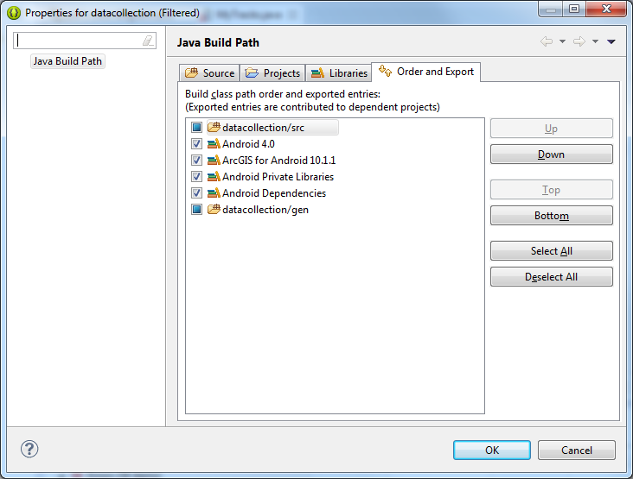

* If you have Problems in the MyTracks files, just delete them for now.
  + E.g. 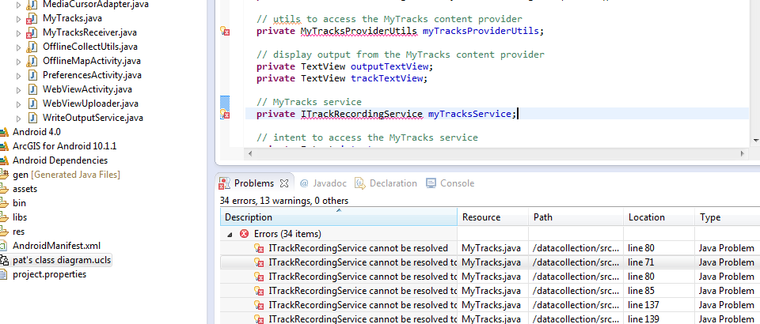
* To view/make class diagrams, you can install the ObjectAid UML plugin <http://objectaid.com/class-diagram> .

## Working with devices

You might have a problem with drivers:

## 

In that case, Miles or someone hopefully still has the SAMSUNG_USB_DRIVER_FOR_MOBILE_PHONES_V1.5.14.0 driver install file. (Maybe at \\astro\PCCOMMON\ISB\MILES\SAMSUNG_USB_DRIVER_FOR_MOBILE_PHONES_V1.5.14.0.EXE)

If you still have problems:

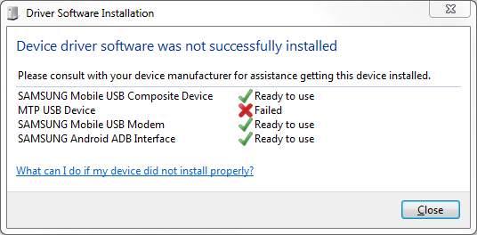

Then, +++++++++++++