MINNESOTA BRIDGES EXERCISE
Created by MaryJo Webster
Updated April 2014

The Access database called “MNBridges” contains one record for each bridge in Minnesota that is 20 feet or longer in length. These are the ones that bridge inspectors focus on. This data was obtained from the Minnesota Department of Transportation in June 2009 and reflects the current inspection status of bridges as of that date. The data doesn’t include the inspection date or have any history beyond this one year, so it doesn’t let us look at trends over time or determine whether inspectors are looking at these bridges frequently enough. But it does provide good insight into the current condition of bridges in the state.

The DOT sends this information, along with more detailed fields and data on smaller bridges, to the federal Department of Transportation which compiles the National Bridge Inventory database (available from the NICAR Database Library)

Here is the Record Layout:
COUNTY | County where bridge is located
FacilityCarried | Road or railroad that runs on top of the bridge
FeatureCrossed | Road, river, lake, etc that the bridge goes over
BridgeNbr | Bridge number
DefStat | Deficiency status (see codes)
SuffRate | Sufficiency rating
ADT | Average daily traffic
DIST | DOT District it's located in
LENGTH | Length (in feet)
YrBuilt | Year constructed
InspectAgency | Agency responsible for inspections
OWNER | Bridge owner

Here are some codes you will need to know:
DefStat:
ADEQ = adequate
S.D. = structurally deficient
F.O. = functionally obsolete (essentially that the design of the bridge is not appropriate for the current traffic needs or that there is a flaw in the design that causes traffic problems)

SuffRate:
This is a number from 0 to 100 that represents the overall rating for the bridge tha was calculated using a complex mathematical formula. Anything less than 50% is eligible for replacement funds. Anything between 50% and 80% is eligible for rehabilitation funds only. The fact that a bridge is eligible for funds doesn’t mean the funds will be available immediately. This rating just gets them on the list for future funding.

Owner:
TWP= township
COUNTY = county where it is located
OTHER = other entity (might be privately owned)
STATE = state government

NOTE: This assignment is for practicing how to use SQL. Although there might be other ways to obtain some of these answers, please use SQL to obtain each answer.

LEVEL 1:
For each question, provide the answer and also the SQL used to get the answer.
1) How many bridges are included in this data?

2) How many bridges are located in the metro district?

3) How many bridges statewide are considered structurally deficient? What would that be in terms of the percentage of all bridges included in this data?

4) How many bridges, built before 1970, are considered structurally deficient?

5) How many bridges cross over the Little Fork River or the Little Knife River in St. Louis County?

6) How many bridges in Ramsey County have sufficiency ratings low enough to make them eligible for replacement?

7) How many bridges statewide are eligible for replacement money? What would that be in terms of the percentage of all bridges included in this data?

8) How many bridges are owned by the state?
9) What is the oldest bridge and where is it located?

LEVEL 2:
For each question, provide the answer and also the SQL used to get the answer.

This section requires you to use Group By in your queries to get the correct answer. Although there may be other ways to get the answer (without using Group By), please create queries that use Group By. The goal of this assignment is to practice using Group By queries.

1) Do a query that shows the total number of bridges that fall into each “deficiency status” category. (Note: You could copy this answer out to Excel and then do the math to figure out what percentage of all bridges each category accounts for.)

2) In what year were the most bridges constructed?

3) How many bridges are there in each county that are longer than 500 feet? Which county has the greatest number of these long bridges?

4) Which county has the most structurally deficient bridges?

5) Which district has the most structurally deficient bridges (as a percentage of their total bridges)? (hint: you’ll need two queries to get this answer)

LEVEL 3:
In this section, there is one question to answer at the bottom.
The first question in the Level 2 section looked at the total number of structurally deficient bridges in each county. But that wouldn’t be a fair comparison, would it? We really need to see which county has the greatest proportion of its bridges that are structurally deficient.

That requires more information. There are several ways you could go at this -- some being more advanced than others. Let’s use an intermediate level approach.

First run the same query you did for question 1 in Level 2 section. Save that as a query called “SDByCounty”

Select county, count(*) as SDBridges
From Bridges2009
Where defstate= “S.D.”
Group by county

Then create a new query to show the total bridges in each county. Save that as a query called “AllByCounty”

Select county, count(*) as TotBridges
From Bridges2009
Group by county

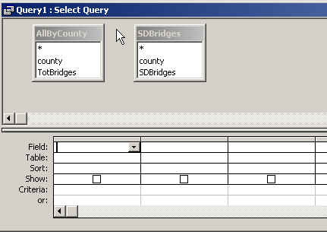
Now start a new query and instead of using the table, use the two queries as the basis for your new query.

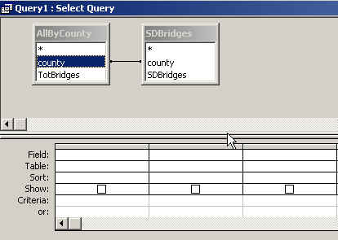

Then join the two tables by linking “county” in one table to “county” in the other. To do that in design view, click with your mouse on one of the fields and hold down your left mouse. Then, while holding down, drag across to the “county” field in the other table and let go when the cursor is on top of the field name. This will draw a line between the two tables and it will look like this in Design View.

Now we need to adjust this a little bit. Here’s why: If you look at the SDBridges query, you’ll see that there are 85 records. If you look at the AllByCounty query there are 87 queries (which happens to be the number of counties in Minnesota). So what happened? There must be 2 counties that don’t have any structurally deficient bridges. But we’d like to see them in our answer, right?

The join we created above is called an “inner join” -- this means that it will only return records where it finds matches in both tables. So in this case, if we use this inner join it will only return 85 records -- only the ones where it finds a match in the “SDBridges” query.

But we can adjust the join a little bit so it will return all the records from the “AllByCounty” query and it will display matches where it finds them from the “SDBridges” query.

In your Design View, move the tables apart a bit so there’s some space and the join line gets longer. Then right-mouse click on the line so that you get a menu that includes “Join Properties”

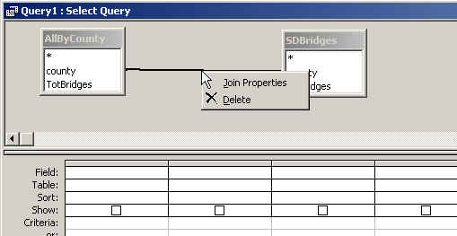
Choose Join Properties and select the radio button that says “Include all records from ‘AllbyCounty’ and only those records from ‘SDBridges’ where the joined fields are equal.

Now we can build our query.

Let’s have it display the county name from the AllByCounty table (because remember that’s the one that has the complete list), and then have it display the “TotBridges” field and the “SDBridges” field. Then we can do math in the select line of our field. Use the forward slash to indicate division -- in this case we’re dividing the number of structurally deficient bridges by the total bridges in each county. Order it by this new field descending so we can quickly see which county has the greatest percentage.

Select allbycounty.county, SDBridges, TotBridges, SDBridges/TotBridges as PctSD
FROM AllByCounty LEFT JOIN SDBridges ON AllByCounty.county = SDBridges.county
Order by 4 desc

For this 3rd section: Provide the answer – which county had the greatest percentage increase and how much was that increase?

