Introduction to Linear Regression in SPSS

Holly Hacker, IRE and NICAR
holly@nicar.org
Advanced CAR Statistics Workshop, Phoenix 2004

A health group complains to the zoning board that alcohol and tobacco billboards are concentrated in black and Hispanic neighborhoods. You, as the local health reporter, want to see if that’s true.

Schools in wealthy areas tend to score higher on state tests than schools in poor areas. Are affluent schools doing a better job or do their students have inherent advantages?

It sure has been hot lately, so your editor orders you to write the dreaded weather story. You decide to find out whether ice cream sales rise along with the mercury.

Journalists can tackle these kinds of questions using a powerful statistical tool called regression. First, regression helps you find or confirm relationships between two or more variables, such as ice cream sales and temperature or test scores and family income. Second, regression tells you in detail how strong (or weak) the relationship is. Third, regression lets you make predictions based on that relationship. So if people really do buy more ice cream as the temperature climbs, you can predict how much ice cream will be sold on a 98-degree day.

Step-by-step example: School test scores

Let’s focus on the relationship between school test scores and family income. This exercise uses SPSS 1l.5 to analyze scores of St. Louis-area schools on a Missouri state test: seventh-grade communication arts (a fancy education term for reading and writing).

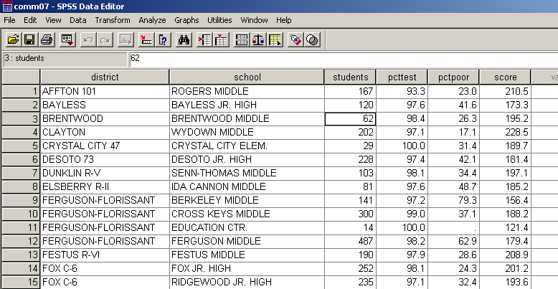
Open the file called comm07.sav and you should see this:

Each row contains several variables: the name of a school and its district; the number of students who took the test (students); the percent of students tested (pcttest); the percent of children from low-income families (pctpoor); and the average test score (score), which ranges from a low of 100 to a high of 300.

We suspect that family income is linked to test scores: As the percent of poor children in a school rises, the average test score will decline. We call the test score (score) the dependent variable and family income (pctpoor) the independent variable. That’s because we believe scores depend partly on income.

It’s tempting to jump right into regression. But just as you’d check out human sources before trusting information they give you, you should check out your data. For regression to work, the variables need to do just that: vary. It’s pointless to measure the relationship between test scores and poverty if every school aced the exam. SPSS can give us a better sense of how our data are distributed. At the top of the data screen, go to Analyze, scroll down to Descriptive Statistics, and then choose Frequencies.

Let’s examine the variables with numeric data, denoted by the # sign. Select students, pcttest, pctpoor and score and move each over by clicking on the arrow.
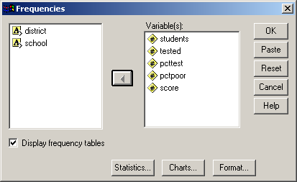
Next, click on the Statistics box. Check Mean and Median under Central Tendency, and Std. Deviation, Range, Minimum and Maximum under Dispersion.

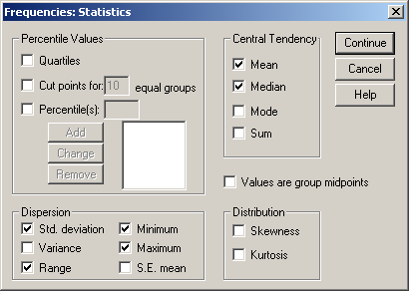

Click Continue, then click on the Charts box. Select Histograms.
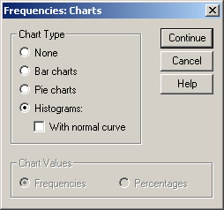
Click Continue to return to the main dialog box. Uncheck the box next to Display frequency tables. Then Click OK.

SPSS will chug away and produce a table and some charts in the Ouput window. The Statistics table gives you an overview of the data.

Statistics

 |  | STUDENTS | PCTTEST | PCTPOOR | SCORE
N | Valid | 115 | 115 | 112 | 115
N | Missing | 0 | 0 | 3 | 0
Mean |  | 201.65 | 96.509 | 45.953 | 182.868
Median |  | 190.00 | 98.054 | 34.834 | 191.300
Std. Deviation |  | 135.563 | 6.1105 | 30.6996 | 30.0246
Range |  | 608 | 42.9 | 94.3 | 129.6
Minimum |  | 1 | 57.1 | 5.7 | 100.0
Maximum |  | 609 | 100.0 | 100.0 | 229.6

For each variable, we have the number of valid and missing cases. Note that three schools are missing values for family income (pctpoor). Unless we can track down their poverty rates, they can’t be included in the regression.

Next, look at the mean and median for each variable. For instance, the mean (or average) test score (score) is 182.9. The median score is 191.3, which means that half of schools scored above that figure and half scored below. Ideally, the mean and median should be close together.

The standard deviation measures the amount of variation in a set of numbers. The smaller the standard deviation, the more closely most (about 2/3) of values cluster toward the average. The standard deviation of score is 30.0, which means that most schools scored within 30 points of the average test score, 182.9. The standard deviation should be less than the mean.
The range is the difference between the minimum and maximum value of each variable. Check these numbers to see if they make sense. For instance, the percent tested (pcttest) and percent poor (pctpoor) should not exceed 100 percent. That sounds obvious, but strange things can happen. Because Missouri collects poverty figures (based on kids who receive free or reduced-price school lunches) in two phases, a few schools have topped 100 percent in the past. In those cases, it makes sense to lower those values to 100.

Also note that the number of students tested ranges from 1 to 609. Because we’re analyzing schools, we should be careful about drawing conclusions based on a handful of test-takers. We might want to leave out schools that tested few students. To determine that cutoff, check with experts in the field – in this case, it might be researchers at the state education department. You could also look at the histogram you created for students.

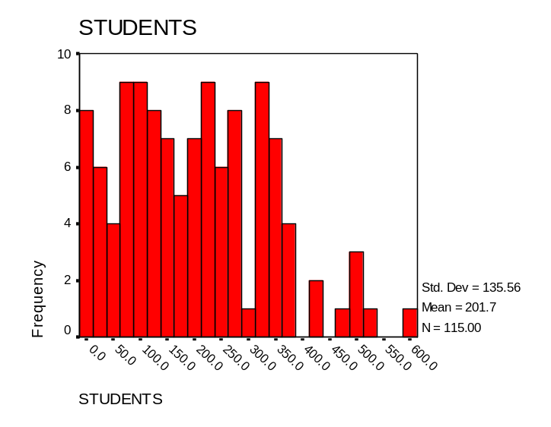

For this exercise, let’s select schools that tested at least 20 students. Go back to the data editor screen and click on Data, then Select Cases. Click on the If button, then the If box. Select cases where the number of kids tested (students) is greater than or equal to 20.

Click Continue, then OK. See what happens in the data table:

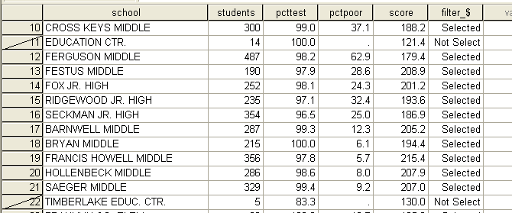

Schools with fewer than 20 students are slashed out, and SPSS added a new column, filter_$, to show selected cases. Run Analyze, Descriptive Statistics, Frequencies again.

Statistics

 |  | STUDENTS | PCTTEST | PCTPOOR | SCORE
N | Valid | 106 | 106 | 106 | 106
N | Missing | 0 | 0 | 0 | 0
Mean |  | 218.14 | 97.064 | 43.925 | 187.046
Median |  | 206.00 | 97.924 | 34.359 | 193.200
Std. Deviation |  | 128.233 | 4.0040 | 29.7155 | 26.1696
Range |  | 589 | 32.3 | 94.3 | 103.7
Minimum |  | 20 | 67.7 | 5.7 | 125.9
Maximum |  | 609 | 100.0 | 100.0 | 229.6

We lost nine schools using this filter (Valid N=106 vs. Valid N=115). One problem went away – the three schools with no reported lunch had fewer than 20 test-takers, so they’re not in our filtered data set. Dropping those schools changes some statistics slightly. Take score: the minimum reported score is now 125.9 instead of 100. The mean score is now 187, the median score is 193.2 and the standard deviation of score is 26.2.

Let’s look at the other histograms we created (remember, a histogram shows the distribution of a single variable). Here’s the histogram for score:
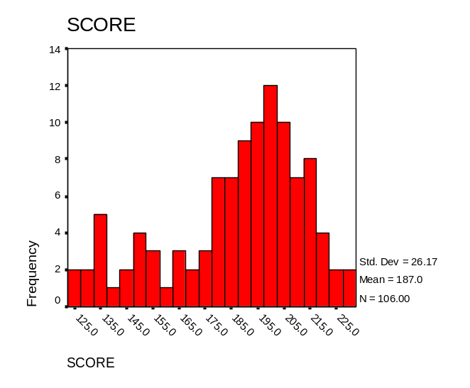

Again, we want to be sure the variable varies. If we think poverty is tied to test scores, it helps to have a wide range of both. Now look at our poverty variable, pctpoor:
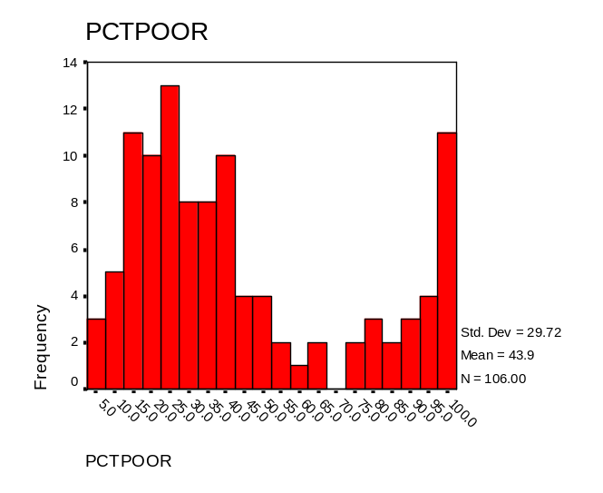
The peak on the left indicates that many schools have relatively low poverty rates, around 20 percent. Few schools are in the 50 percent to 85 percent range, but the number of schools spikes again for poverty levels of 100 (Heck, that could be a whole other story).

Now that we’ve looked at poverty and test scores separately, let’s look at them together on a graph. We need to plot the dependent variable, score, on the vertical (Y) axis and the independent variable, pctpoor, on the horizontal (X) axis.

To do that, go to the data editor window (the one with your table) and select Graphs, then Scatter. Make sure the Simple box is highlighted, then click the box that says Define. You want to show score on the Y axis and pctpoor on the X axis, like so:
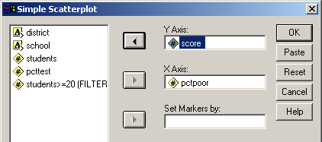

Click OK and the scatterplot appears in the Output window.

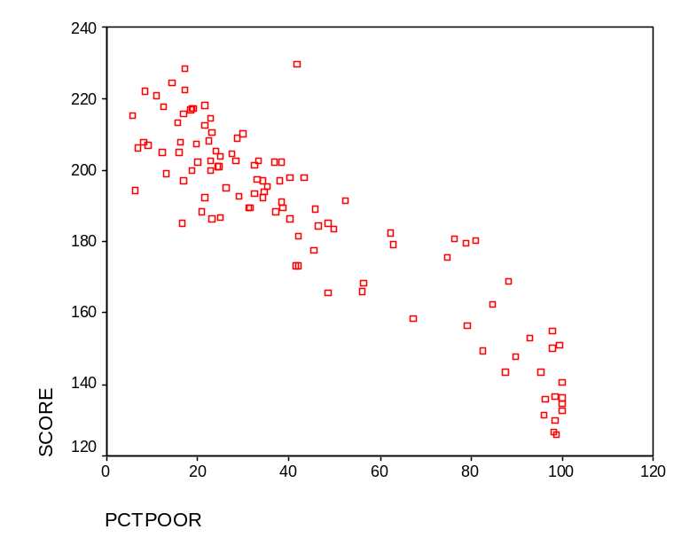
Each point represents a school. Its location on the graph indicates its poverty rate (on the X axis) and average test score (on the Y axis). See how the points follow a pattern: As the percent poor increases, the average test score declines. So, we’re on the right track thinking family income is related to test scores.

We can draw a line to represent the pattern. Click on the scatterplot in the Output viewer and right-click on the mouse. Choose SPSS Chart Object, Open. The chart editor pops up. In that editor, select Chart, Options. Under Fit Line, check the box next to Total. Click OK.

Voila, SPSS draws a line that follows the pattern of the points. This is called the regression line. It is the line that best fits all the points on the graph. Still, we don’t know how accurate the line is – that is, how well does it describe the relationship between family income and test scores?
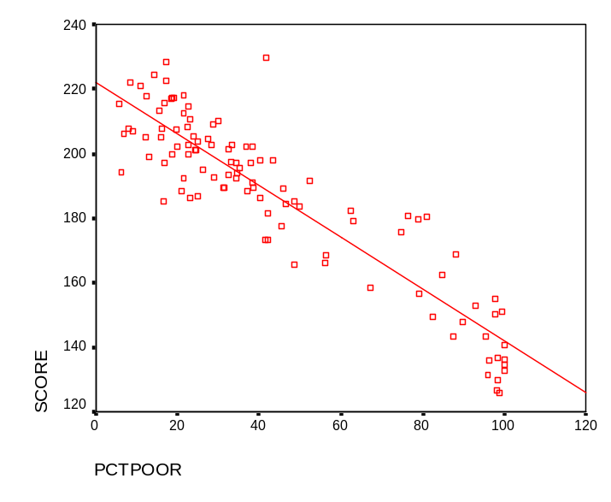
Ready to regress

To answer that question, we get to the fun part: Running the actual regression. To do that, go to Analyze, Regression, Linear. In the dialog box that pops up, select score as the dependent variable and pctpoor as the independent variable.

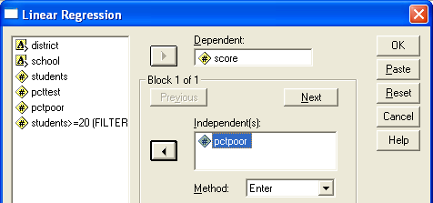

Next, click the Statistics box. Make sure the Estimates and Model fit boxes are checked, then also check Confidence intervals.

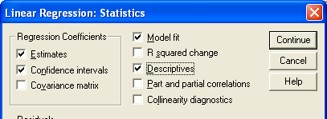

Click Continue, then OK. Look at table in the output called Model Summary:

Model Summary

Model | R | R Square | Adjusted R Square | Std. Error of the Estimate
1 | .911(a) | .830 | .829 | 10.8330
a Predictors: (Constant), PCTPOOR

Focus on the Adjusted R Square, .829 in this case. What the heck does this mean, and why should you care? The R-square measures the accuracy of the regression line and ranges from 0 to 1. An R-square of 1 means that the line fits perfectly. If poverty predicted test scores perfectly, the scatterplot would look like this:

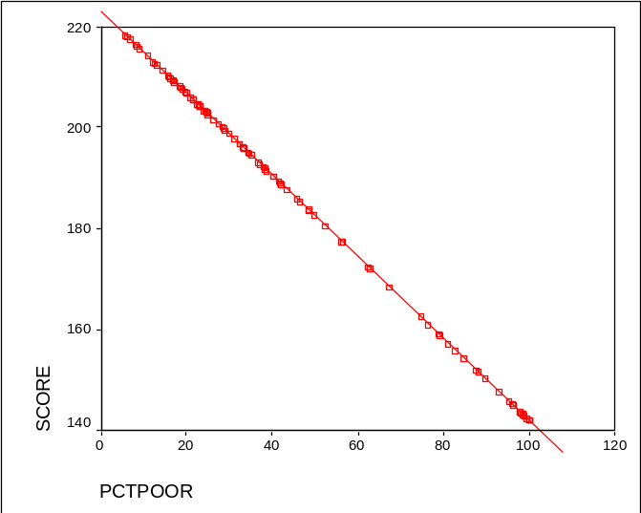

At the other extreme, an R-square of 0 means the line fits terribly. The points would be randomly scattered, with no discernible pattern. So the Adjusted R-square of .829 shows a strong relationship. The best way to understand it – and to explain it to readers – is to say that 83 percent of the variation in test scores depends on family income. That means only 17 percent is explained by other factors. Our theory seems to be right on.

R-square vs. Adjusted R-square
Get in the habit of using the Adjusted R-square. It adjusts the R-square in a way that more accurately measures how well the regression line fits the data.
Next we want to know just how much income affects test scores. To determine that, look at the Coefficients table:

Coefficients(a)

Model |  | Unstandardized Coefficients |  | Standardized Coefficients | t | Sig. | 95% Confidence Interval for B
Model |  | B | Std. Error | Beta | t | Sig. | Lower Bound | Upper Bound
1 | (Constant) | 222.294 | 1.884 |  | 117.995 | .000 | 218.558 | 226.030
1 | PCTPOOR | -.802 | .036 | -.911 | -22.556 | .000 | -.873 | -.732
a Dependent Variable: SCORE

Look at the first number listed for PCTPOOR, -.802. This is the slope of your regression line. Huh? Think back to algebra when you learned the formula for a line:

y = mx + b

y is the value along the vertical axis – in our case, the predicted test score
x is the value along the horizontal axis – in our case, the low-income rate
m is the slope of the line. It measures how much y changes in relation to x. The steeper the line, the stronger the effect. In our example, for every one-point increase in the poverty rate, we expect a school’s test score to decline 0.8 points.
b is the y-intercept. It represents the value of y when x is 0. So a school with zero poverty should have a test score of 222.3 (shown as the B coefficient for the constant in our table).

We can plug the values from our Coefficients table into that equation, y = mx + b, to get the specific equation to predict school test scores based on poverty.

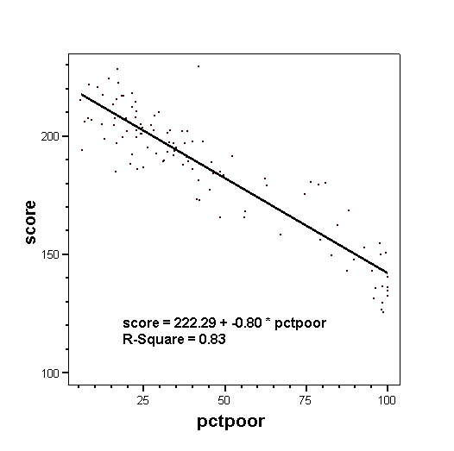
We’re not done yet, though. We need to make sure our model is significant – that this relationship between poverty and test scores does not exist by chance. Look at the ANOVA (analysis of variance) table.

ANOVA(b)

Model |  | Sum of Squares | df | Mean Square | F | Sig.
1 | Regression | 59704.532 | 1 | 59704.532 | 508.759 | .000(a)
1 | Residual | 12204.731 | 104 | 117.353
1 | Total | 71909.263 | 105
a Predictors: (Constant), PCTPOOR
b Dependent Variable: SCORE

The ANOVA table tells us if the relationship between test scores and income could have happened by chance. Because the significance (Sig.) is less than .05, we can say that our model is significant – that poverty does help predict test scores.

We also need to make sure poverty predicts test scores as strongly as we suspect. Our model says that a one-point increase in the poverty rate should result in test scores declining eight-tenths of a point. Go back to the Coefficients table.

Model |  | Unstandardized Coefficients |  | Standardized Coefficients | t | Sig. | 95% Confidence Interval for B
Model |  | B | Std. Error | Beta | t | Sig. | Lower Bound | Upper Bound
1 | (Constant) | 222.294 | 1.884 |  | 117.995 | .000 | 218.558 | 226.030
1 | PCTPOOR | -.802 | .036 | -.911 | -22.556 | .000 | -.873 | -.732

Look at the Significance (Sig.) and the 95% Confidence Interval. The significance level is below .05, which means our results were in all likelihood not due to chance. The Confidence Interval gives us the range we’d expect if we took repeated samples of test scores. We can be 95 percent certain that the true effect of poverty on test scores is between -.87 and -.73. That is, for every one-point increase in a school’s poverty rate, we expect its test score to decline between .87 and .73 points.
Hint: When the significance level is .05 or below, the lower and upper bounds of the 95% Confidence Interval will always have the same sign. In this case, we know that the relationship between poverty and test scores is negative; poverty goes up, test scores go down. If the confidence interval crossed zero, you wouldn’t know if your independent variable had a positive or negative effect.

Predicting individual scores

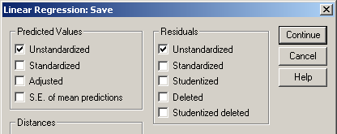
Remember, the beauty of regression is that we can predict test scores for each school based on its poverty rate. To do that, go to Analyze, Regression, Linear. Click on Statistics and select Casewise Diagnostics in addition to the boxes already checked. Click on the Save box. Under both Predicted Values and Residuals, check Unstandardized.

Click Continue, then OK. Go to the Data Editor to view your school data. You’ll see two new fields at the end, pre_1 and res_1. SPSS used the regression line formula to predict each school’s score. The residual is the difference between the actual and predicted score.
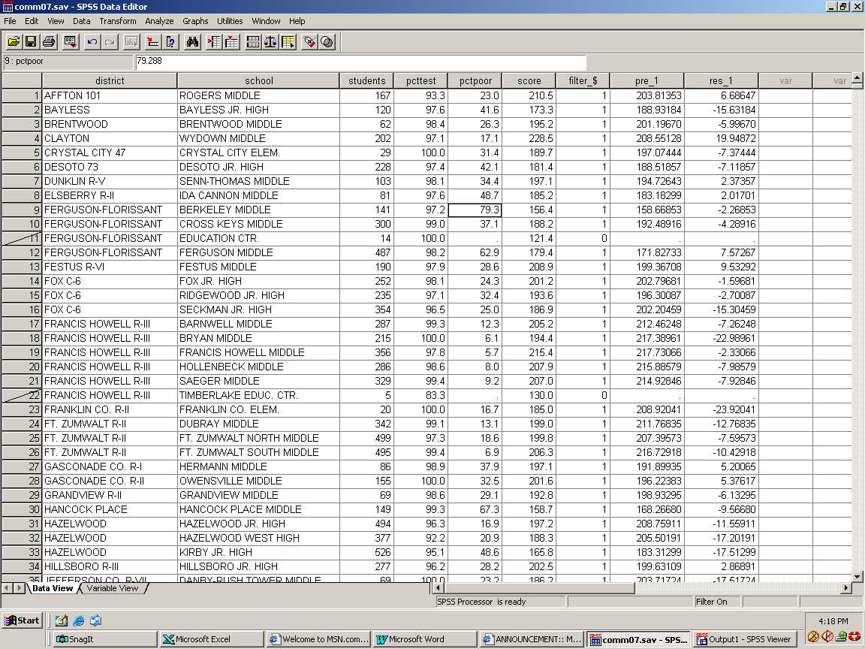

Take the fourth school on the list, Wydown Middle in the Clayton School District. It had an average score of 228.5 and a poverty rate of 17.1 percent. So, go back to our formula. We want to know our predicted score:
Predicted score = 222.3 + (-.802 * Pctpoor)
Predicted score = 222.3 + (-.802 * 17.1)
Predicted score = 222.3 – 13.7
Predicted score = 208.6

But Wydown actually scored 228.5. So it did better than expected:
Actual score – Predicted score = Residual
228.5 – 208.6 = 19.9

Here’s Wydown circled on the scatterplot. Note how it sets well above the line, showing it did better than expected.
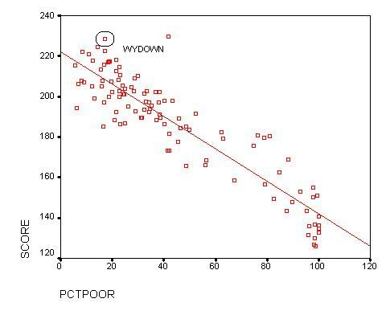
We can even rate schools based on how much better or worse they did than expected. People can set different criteria, but one is called the Standard Deviation of the Residual, which appears in the Residuals Statistics box generated in your last regression.

Residuals Statistics(a)

 | Minimum | Maximum | Mean | Std. Deviation | N
Predicted Value | 142.048 | 217.731 | 187.046 | 23.8456 | 106
Residual | -23.920 | 40.945 | .000 | 10.7813 | 106
Std. Predicted Value | -1.887 | 1.287 | .000 | 1.000 | 106
Std. Residual | -2.208 | 3.780 | .000 | .995 | 106
a Dependent Variable: SCORE

The standard deviation of the residual is 10.8. That means about two-thirds of schools scored within 10.8 points of their predicted score. Any schools that scored more than 10.8 points above their predicted score exceed their expectations. Any schools scoring more than 10.8 points below their predicted score fell below expectations. The St. Louis Post-Dispatch used this measure in its yearly school guide to give schools some wiggle room – almost no one ever scores exactly as predicted.

The distance of each point to the line represents error. In other words, something not in our model is explaining the difference. The stories lie in the points far above or below the line. You can look at high-poverty schools that may not do great overall, but they clearly exceed their expectations. Similarly, you can look at affluent schools that don’t look so hot compared to schools of similar wealth.

We can focus on outliers -- schools that did particularly well or poorly -- by looking at the Casewise diagnostics box:

Casewise Diagnostics(a)

Case Number | Std. Residual | SCORE | Predicted Value | Residual
88 | 3.780 | 229.6 | 188.655 | 40.945
a Dependent Variable: SCORE

The 88th school on our list, McKinley, outpeformed the most, scoring 41 points above its predicted score.

But wait, there’s more

Any linear regression you run is based on certain assumptions about your data. If those assumptions aren’t met, your results could be misleading or flat-out wrong. This section goes over three of those assumptions and how to see if you’ve violated them.

Assumption 1: The relationship between your dependent and independent variables is linear.
Regression is based upon the formula for a line. We already added a line to our scatterplot to see how the data points fall around it, but there are more sophisticated ways to check

Plot the residuals from the regression (res_1) against the independent variable (pctpoor) and the predicted scores (pre_1).

Go to Graphs and Scatter. Be sure Simple is set, then click Define. Put Understandardized Residual (res_1) on the Y Axis and pctpoor on the X Axis.

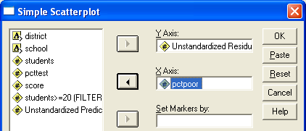

Click OK. In the Output window, double-click inside the scatterplot to get to the chart editor. Select Chart from the pull-down menu, then Options. Under Mean of Y Reference Line, check Total. Under Fit Line, click Total.

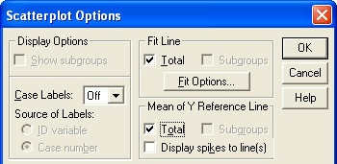

Click the box that says Fit Options. Select Lowess line.

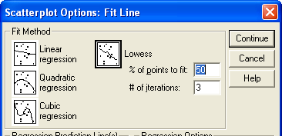

Click Continue, then OK. You should see a scatterplot like this:

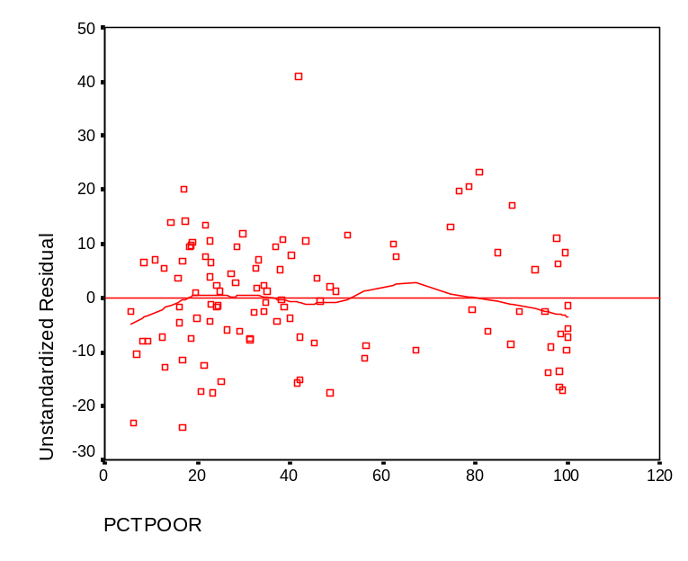

The straight line shows where the residuals (i.e., the difference between observed and predicted test scores for each school) are zero. The Lowess line follows the overall trend of the residuals. If the relationship between poverty and test scores is indeed linear, the Lowess line will hover close to straight line, without any major deviations above or below. Plotting the residuals of the test scores, instead of the test scores themselves, magnifies any signs of a non-linear relationship.

It also makes outliers easier to see. You can identify them by making sure you’re in the chart editor. Click on the icon called Point Id, on the very left of the second row of tools. Clicking on a point and will tell you its case number.

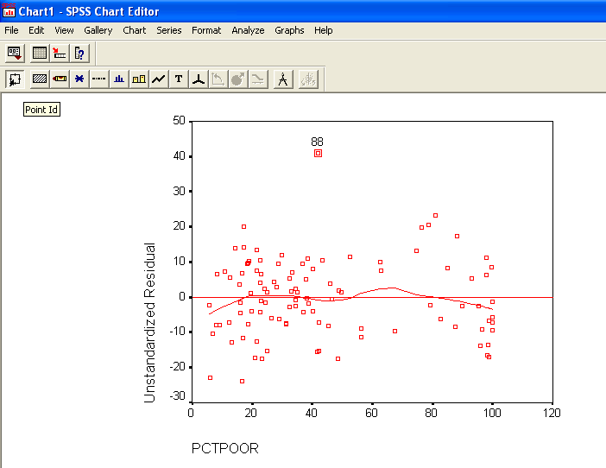

The point labeled 88 corresponds to case 88 – our overachiever, McKinley.

Create the same chart but instead of putting pctpoor in the X Axis, select Unstandardized Predicted Value (pre_1).

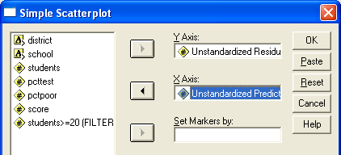

Follow the steps we used with pctpoor to get into the chart editor and select the Mean of Y Reference Line and the Lowess Line. Your results should look like this:

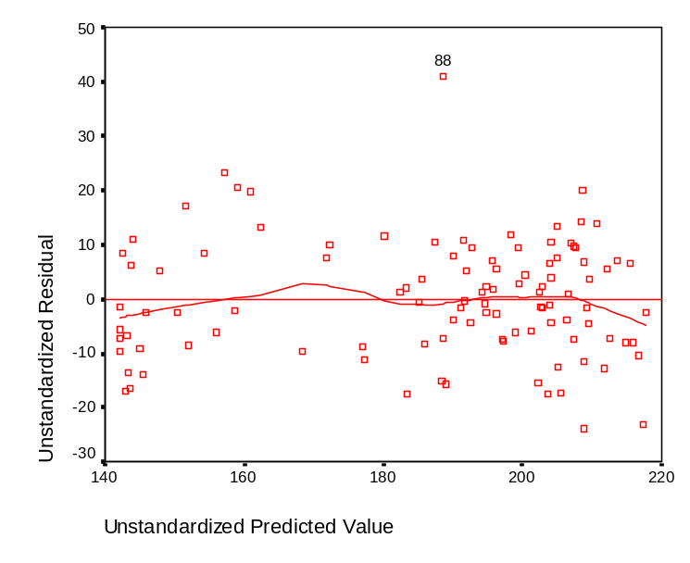

Here our big outlier, McKinley, is selected again.

If the results from a given regression aren’t linear, don’t panic. There are ways to transform data to straighten it out. For instance, if the data points formed a curve, you might take the logarithm of each independent variable and plot against the dependent variable. You might look at other possible independent variables. We won’t get into that here, but know it can be done!
Assumption 2: The residuals have equal variance.

This assumption goes by the oh-so-lovely term of homoscedasticity. Homo for equal, scedastic for variance. For our example, this means that whether we pick a school with a low poverty rate, a medium one or a high one, we should see the same spread in how those schools performed. The good news is we can use the same scatterplots we produced for Assumption 1, minus the Lowess lines.

In the output window, double-click on the chart that plots the residuals (res_1) against the poverty rate (pctpoor). Go to Chart, Options and uncheck the Total box under Fit Line.

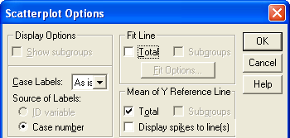

Click OK.

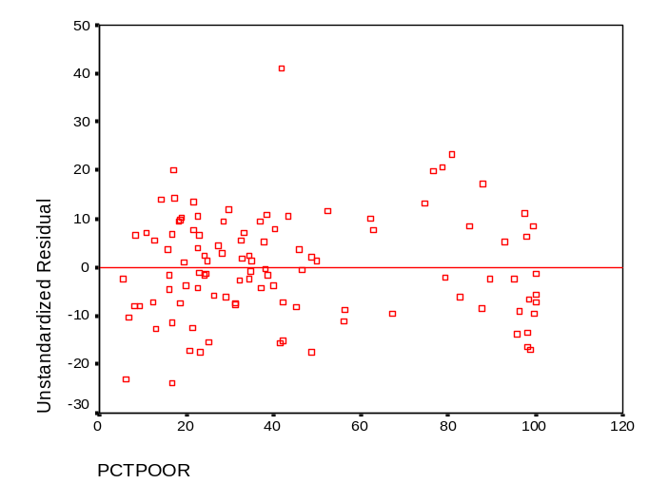

We want the points to look random. We don’t want them to cluster at the zero-line in some places and scatter far out in others. For instance, a funnel shape like this would be bad.

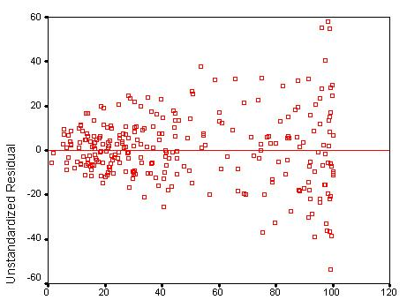

This funnel shape tells us that our model does a great job of predicting at low values of X, but an increasingly bad job as X increases. Guess what this is called? Heteroscedasticity, or unequal variance. You can try to fix this problem using something called Weighted Least Squares, which gives greater weight to cases with smaller variance.

Assumption 3: The error terms are normally distributed.

If we plot the distribution of our residuals, they should form a bell-shape curve or something close to it. If they don’t, it’s a sign there could be something inherently wrong with our model. You can check it another way using something called a normal probability plot.

You would create these plots when setting up your regression. Go back to Analyze, Regression, Linear. Check the box that says Plots. Under Standardized Residual Plots, check Histogram and Normal probability plot.

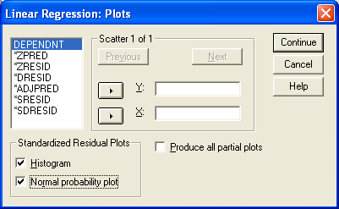

Run the regression again and jump to the charts at the end of the output. First, you’ll see a histogram of your standardized residuals (So 0 would represent schools that scored just as predicted. Predicted score – Actual score = 0).
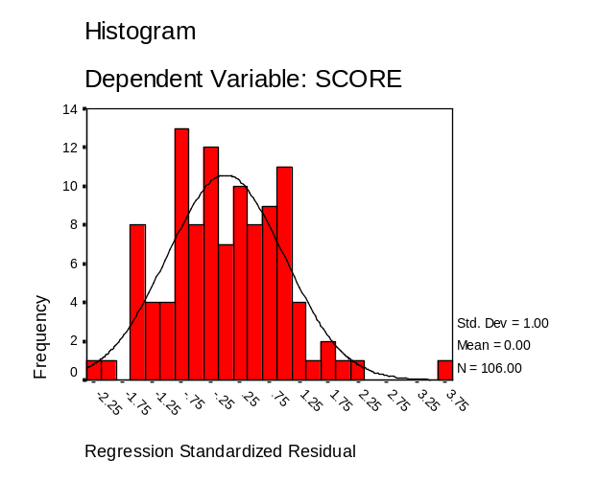
Then look at the normal probability (P-P) plot. This is just another way of looking at the residuals.

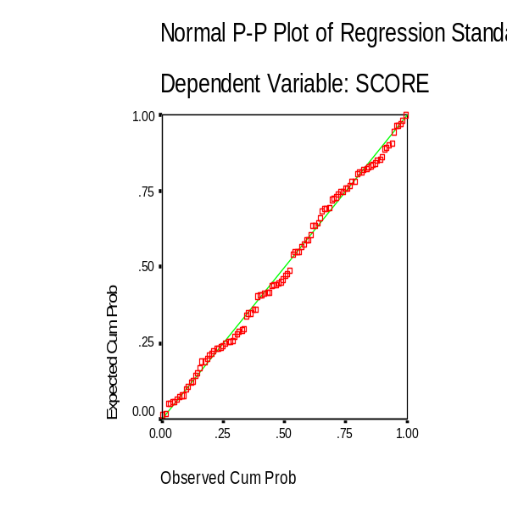

The residuals (they’ll be red in the Output) should closely follow the line (which will be green).

Go forth and regress!

Whew. Bet you didn’t think this would take so long to explain. But as with many concepts in statistics, it’s fairly simple to click a few buttons in SPSS and run an analysis. The hard work lies in all of the interpretation and double-checking. Of course, it’s always a good idea to run your results by an expert. For the test score regressions in the Post-Dispatch, we showed our findings to professors in economics, education or political science. We also checked with researchers at Missouri’s education department.

As you get more comfortable with regression, you may want to add more independent variables that could improve your model. Multiple linear regression, as it’s called, builds on simple linear regression but with a whole new set of concerns and caveats. Come back to us when you’d like to know more.

