ENSF381 – Lab10

**Section:** L01/L02/L03 *[Keep only one] [They must keep only one, if they made mistake write a note in the feedback section. Don’t deduct any mark for wrong value]*

**Date:** 2024-03-25/27 *[They must write the correct date. For L01 March 18, for L02/L03 March 20. If they made mistake write a note in the feedback section. Don’t deduct any mark for wrong value]*

|  |  |  |
| --- | --- | --- |
| Created by: | | |
| First name | Last name | UCID |
| A | B | C |
| D | E | F |

*[Check the name. If they made mistake write a note in the feedback section. Don’t deduct any mark for wrong name or wrong UCID]*

# 2.9.1

[Sample solution is here. Please notice the path and the picture to be the same. 5 marks]

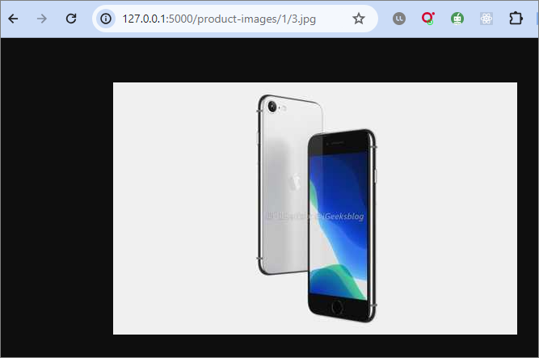

# 2.9.2

[Sample solution is here. Please notice the path, method to be the same. 5 marks]

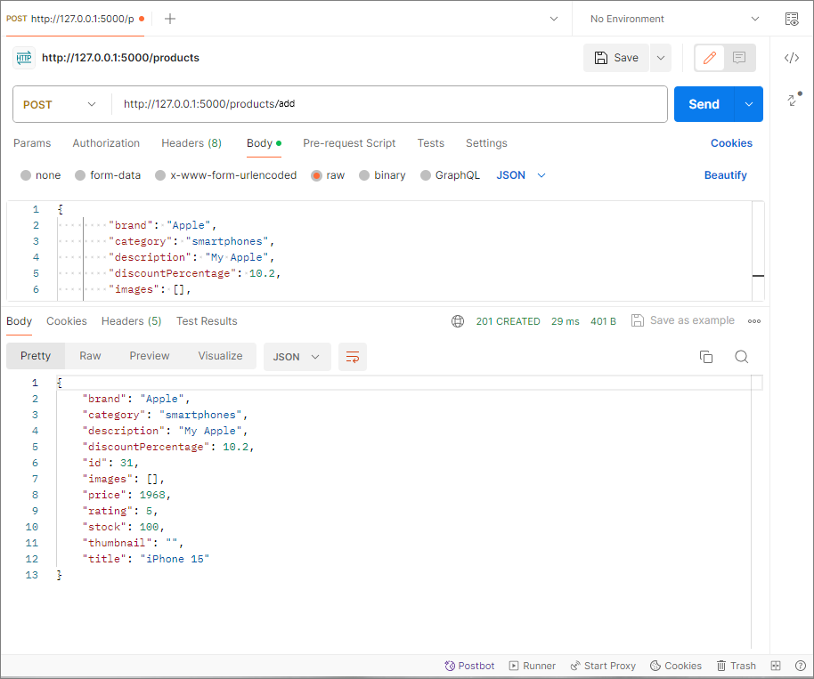

2.9.3

[Sample solution is here. Please notice the path, method to be the same. 5 marks]

# 2.9.4

[Sample solution is here. Please notice the path, method to be the same. 5 marks]

# 3.4.1

[Check their server.py file. If they provided almost similar logic give 10 marks]

# 3.4.2

[Sample solution is here. Please notice the path and the picture to be the same. 5 marks]

4.2

[Check their video, give 15 marks if it shows the application works]