ENSF381 – Lab02

**Section:** L01/L02/L03 *[Keep only one] [They must keep only one, if they made mistake write a note in the feedback section. Don’t deduct any mark for wrong value]*

**Date:** 2024-01-22 *[They must write the correct date. For L01 Jan 22, for L02/L03 Jan 24. If they made mistake write a note in the feedback section. Don’t deduct any mark for wrong value]*

|  |  |  |
| --- | --- | --- |
| Created by: | | |
| First name | Last name | UCID |
| X | Y | Z |
| A | B | C |

*[Check the name. If they made mistake write a note in the feedback section. Don’t deduct any mark for wrong name or wrong UCID]*

# 2.3.1

*[Check the URL. It must be accessible.  
The repository should have the following features:*

*The repository should be accessible; the students' repositories must have public access.*

*It should contain both a README file and an MIT License, 3 HTML files, 1 gif file, an images folder and 1 favicon.ico file.*

*The repository should include a collaborator with the appropriate access permissions.*

*If it provides all give 10 marks, otherwise deduct 1 mark for each missing and write down in the feedback form.  
]*

Sample solution:

This is my GitHub repository: <https://github.com/z-arabi/Lab2.git>.

# 3.3.6

*[Sample solution is here. Give 5 marks for picture. Check the images.html file in GitHub, if it has right content then give 5 marks. In total 10 marks.]*

It is the final result of the image page:

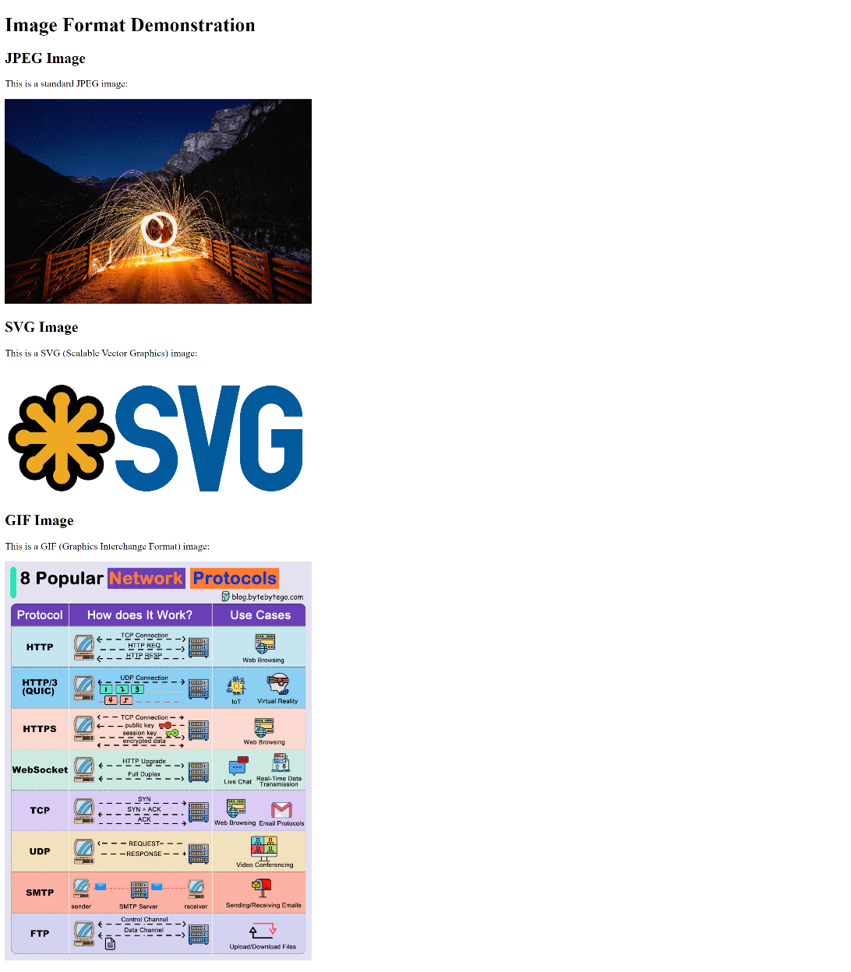

# 4.2.2

*[Sample solution is here. Give 5 marks for picture. Check the news.html file in GitHub, if it has right content then give 10 marks. In total 15 marks.]*

This is the final result of the news page:

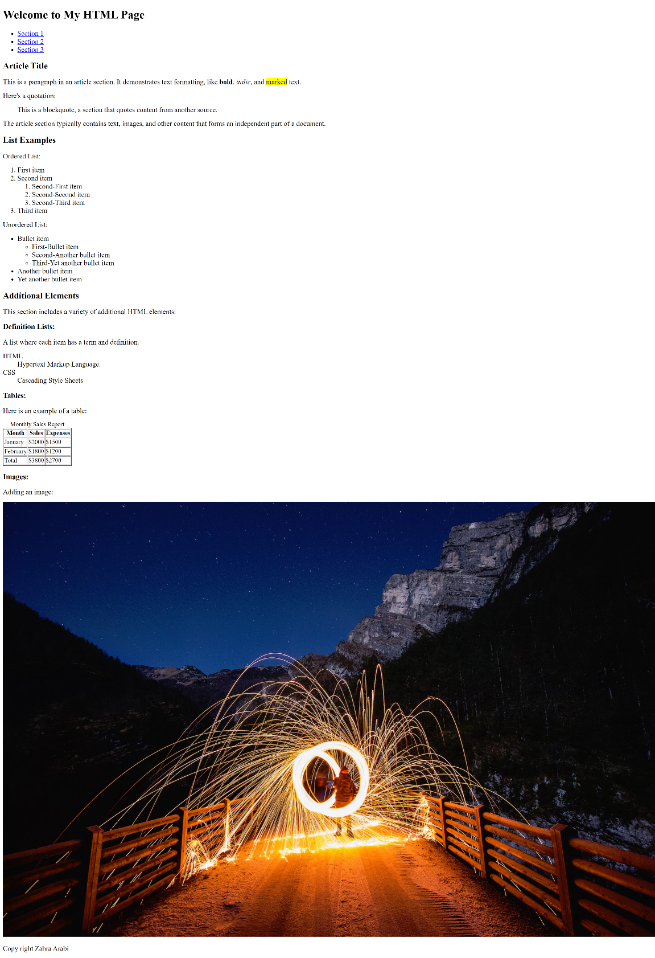

# 5.2.3.e

# *[5 marks]*

When accessing the webpage via a file explorer, only the backlink pointing to "index.html" functions as expected. The backlink indicated by "./" does not work and instead redirects to a directory listing page displaying the contents of the "Lab2" directory, including files, subdirectories, sizes, and modification dates.

# 5.2.3.f

# *[5 marks, don’t be rigid]*

Both backlinks working properly. Because in the situation, where a hyperlink operates without explicitly stating the "index.html" file name in the href attribute, is a result of how web servers and web browsers manage default or "index" files. In numerous web server setups, there exists a default filename that is automatically presumed when a URL points to a directory without specifying a particular file. "index.html" stands out as one of the frequently used default filenames for HTML files.

# 5.3.2

# *[Check the gif image in repository, if it shows correct linking of pages then give 5 marks]*

This is the final result of index.html file:

