ENSF381 – Lab02

**Section:** L01/L02/L03 *[Keep only one]*

**Date:** 2024-01-22

|  |  |  |
| --- | --- | --- |
| Created by: | | |
| First name | Last name | UCID |
| Zahra | Arabi Narei | 30191990 |
|  |  |  |

# 2.3.1

This is my GitHub repository: <https://github.com/z-arabi/Lab2.git>.

The repository should have the following features:

* The repository should be accessible; the students' repositories must have public access.
* It should contain both a README file and an MIT License.
* The repository should include a collaborator with the appropriate access permissions.

# 3.3.6

It is the final result of the image page:

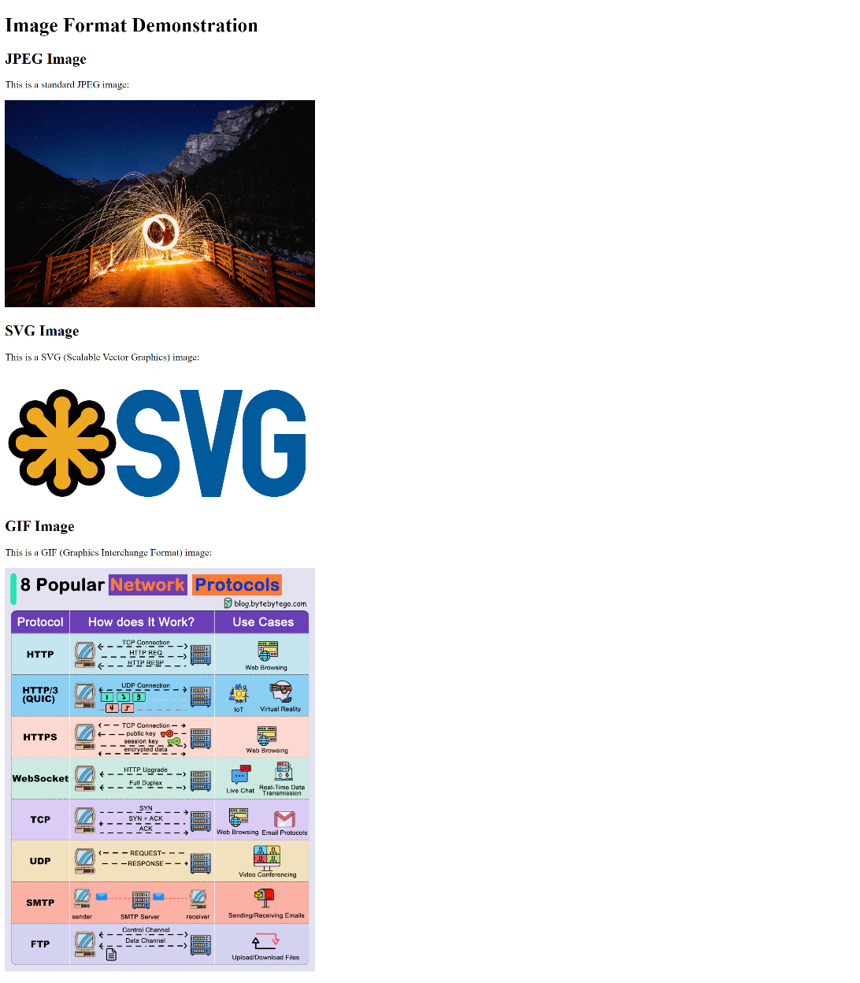

# 4.2.2

This is the final result of the news page:

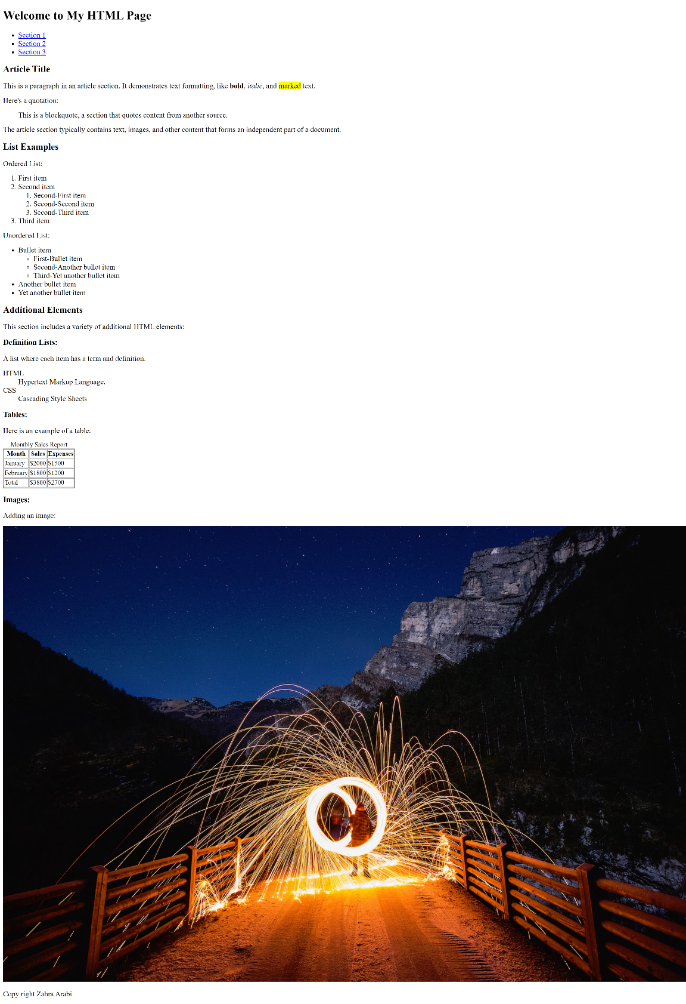

# 5.2.3.e

When accessing the webpage via a file explorer, only the backlink pointing to "index.html" functions as expected. The backlink indicated by "./" does not work and instead redirects to a directory listing page displaying the contents of the "Lab2" directory, including files, subdirectories, sizes, and modification dates.

# 5.2.3.f

Both backlinks working properly. Because in the situation, where a hyperlink operates without explicitly stating the "index.html" file name in the href attribute, is a result of how web servers and web browsers manage default or "index" files. In numerous web server setups, there exists a default filename that is automatically presumed when a URL points to a directory without specifying a particular file. "index.html" stands out as one of the frequently used default filenames for HTML files.

# 5.3.2

This is the final result of index.html file:

