ENSF381 – Lab03

**Section:** L01/L02/L03 *[Keep only one] [They must keep only one, if they made mistake write a note in the feedback section. Don’t deduct any mark for wrong value]*

**Date:** 2024-01-29 *[They must write the correct date. For L01 Jan 29, for L02/L03 Jan 31. If they made mistake write a note in the feedback section. Don’t deduct any mark for wrong value]*

|  |  |  |
| --- | --- | --- |
| Created by: Fatemeh Ghaffarpour | | |
| First name | Last name | UCID |
| X | Y | Z |
| A | B | C |

*[Check the name. If they made mistake write a note in the feedback section. Don’t deduct any mark for wrong name or wrong UCID]*

# 2.5.1

*[Check the URL. It must be accessible.  
The repository should have the following features:*

*The repository should be accessible; the students' repositories must have public access.*

*It should contain both a README file and a LICENSE file, 3 HTML files, an images folder with 4 files.*

*The repository should include a collaborator with the appropriate access permissions.*

*If it provides all give 4 marks, otherwise deduct 0.5 mark for each missing and write down in the feedback form.  
]*

Sample URL

https://bitbucket.com/GHFATEMEH/Lab3

# 2.5.2

[Sample image, give 1 mark if they provided similar picture from SourceTree.]

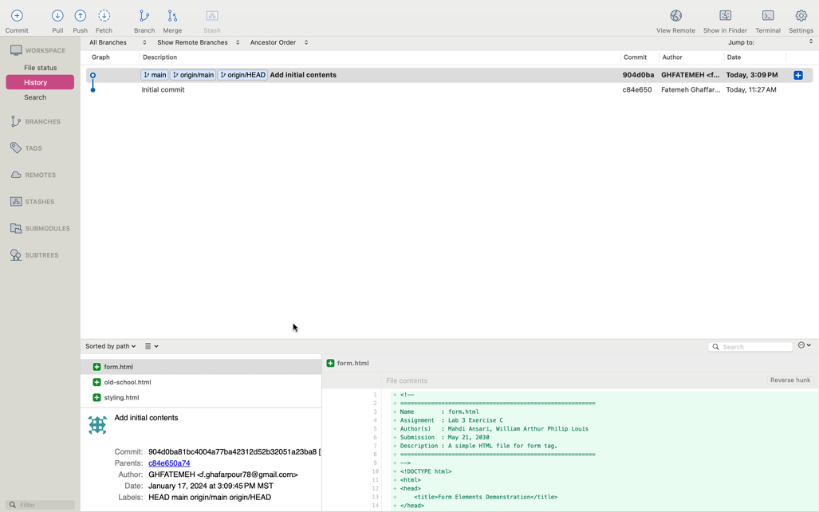

# 3.2.6

[give 2 marks if they provided similar answer]

They are not effective because we are trying to apply those classes (*large, medium* and *small*) on table columns. However, all cells in a column adopt the width of the largest cell. Therefore, as soon as the first column in the first row get 100% width due to the *large* class, the second cell in the second row also get the same width size.

# 3.2.9

[give 3 marks if they provided some answer]

By testing different mobile views using device mode on Google Chrome, the content was appropriately adjusted for smaller screens.

Observing different mobile sizes for the HTML page:

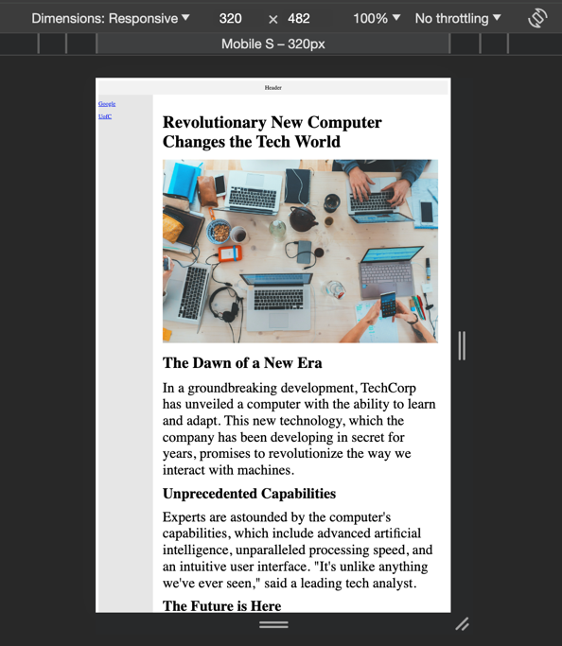

# 3.3.1

[give 10 marks if they changed my name (the circle in picture), provided final output and explained what they did. If they provided a picture without changing the name, then check the html file in their repo. Make sure the picture they provided is authenticate. If the old-schold.html in their repo does not provide suitable resizing behavior (i.e., 30-70%), then give a zero. If they just uploaded the original file with no changes, then zero.] Sample Screenshot of the final webpage:

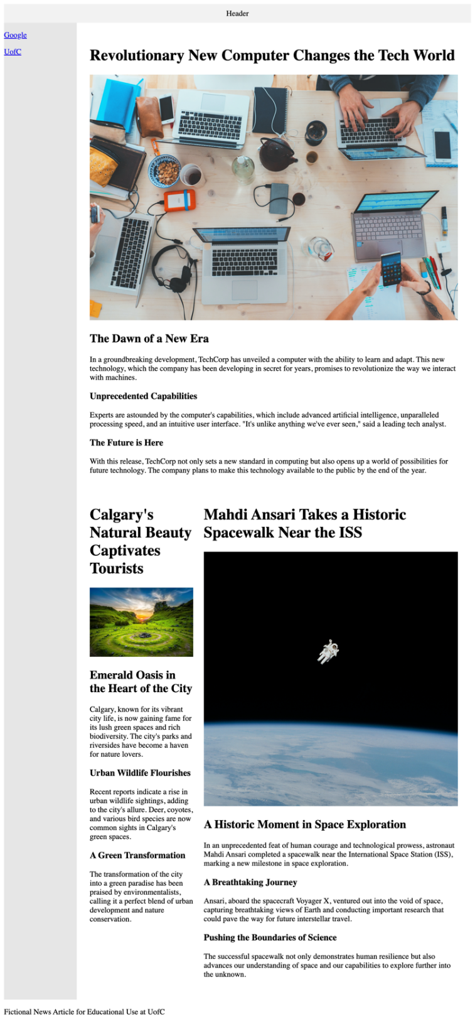

Changes and observations:

* The lines of .large { width: 100%; } .medium { width: 70%; } .small { width: 30%; } were uncommented.
* For achieving the 30-70% split for small and medium parts, a new table was created and it contains the part of code related to class="small news-item" and td class="medium news-item". Adding this table led to achieving the width for small, medium and large images.

* The name of Mehdi Ansari was changed to Fatemeh Ghaffarpour in the header of the medium item.

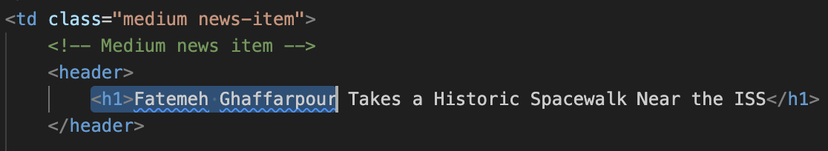

* The changes were committed and pushed to Git.

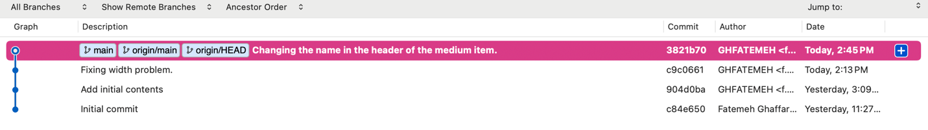

# 4.2.1

[**The screenshot must be from the output not from the code not the code itself.** If they provided an authenticate screenshot, then give 15 marks. Check the form.html file in their repo. Make sure they provided changes. The commit and push to their repo must be done by the second person in the group.]

# 5.2.1 [10 marks if they provided correct screenshots including their address bar. Check the code also.]

# 5.2.2

[5 marks. Sample answer is here. Having no reference is not a problem.]

Why does this margin exist by default in web browsers?

There is a default margin in web browsers that provides a consistent layout for web content. The margin helps the readability of web browsers by making space between the content and the edges of the browser window.

Ref: <https://www.quora.com/Why-do-web-browsers-style-the-HTML-body-tag-to-have-a-margin-by-default#:~:text=If%20there%20was%20no%20default,just%20look%20like%20normal%20text>.

If there was no margin/padding on the body/html then the text would run up against the window border and toolbar where it would be very hard to read.

Ref: <https://stackoverflow.com/questions/19567547/why-do-browsers-style-a-predefined-margin-into-all-webpages>

How this default margin can be removed or overridden?

We can edit the style of the body.

body {

margin: 0; /* Remove body margins */

}

Or you could use this useful Global reset

*,

*::before,

*::after {

margin: 0;

padding: 0;

box-sizing: border-box;

}

Ref: <https://stackoverflow.com/questions/9547291/how-to-remove-margin-space-around-body-or-clear-default-css-styles>