ENSF381 – Lab03

**Section:** L01/L02/L03 *[Keep only one]*

**Date:** 2024-01-29

|  |  |  |
| --- | --- | --- |
| Created by: Fatemeh Ghaffarpour | | |
| First name | Last name | UCID |
|  |  |  |
|  |  |  |

# 2.5.1

https://github.com/GHFATEMEH/Lab3

# 2.5.2

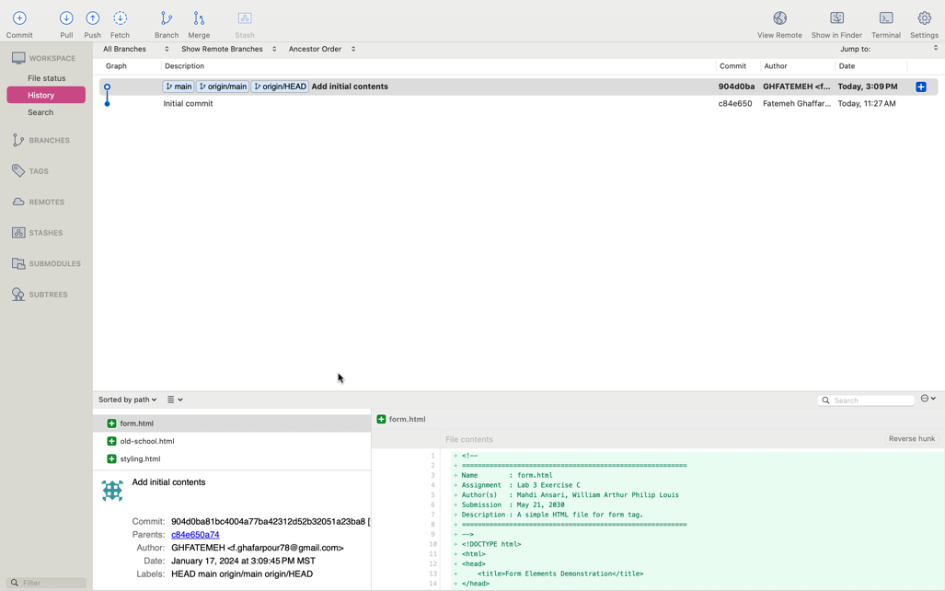

# 3.2.6

The page contains three rows (head, middle of page and footer). The middle of the page contains two cells (menu and main). The main is a table with two rows (class="large news-item") and (class="small news-item", td class="medium news-item"). So, as the table width is set to 100% in the style, the sum of the width for elements in each row of the table should be 100%. In the code, .small 30% and .medium 70% are calculated as percentages of the entire table width, not their containing row. So, to achieve a 30%-70% split between small and medium they should be in a table.

The layout of the HTML page:

|  |  |  |
| --- | --- | --- |
| Header | | |
| menu | large news-item | |
| small news-item | medium news-item |
| Footer | | |

# 3.2.9

By testing different mobile views using device mode on Google Chrome, the content was appropriately adjusted for smaller screens.

Observing different mobile sizes for the HTML page:

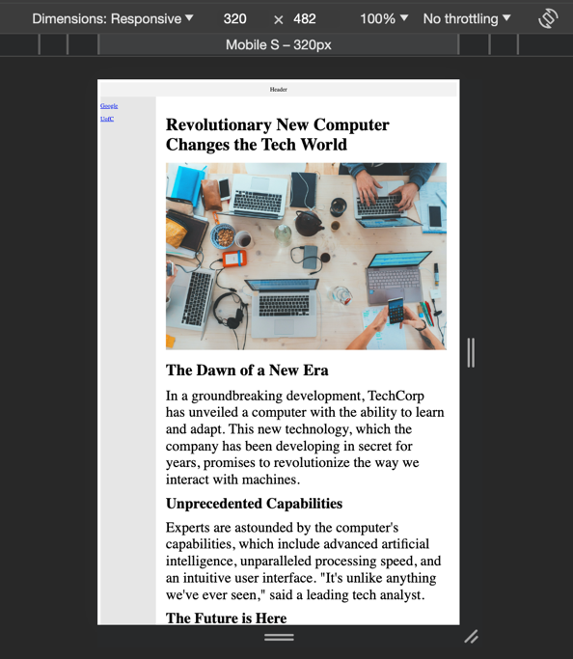

# 3.3.1

Screenshot of final webpage layout:

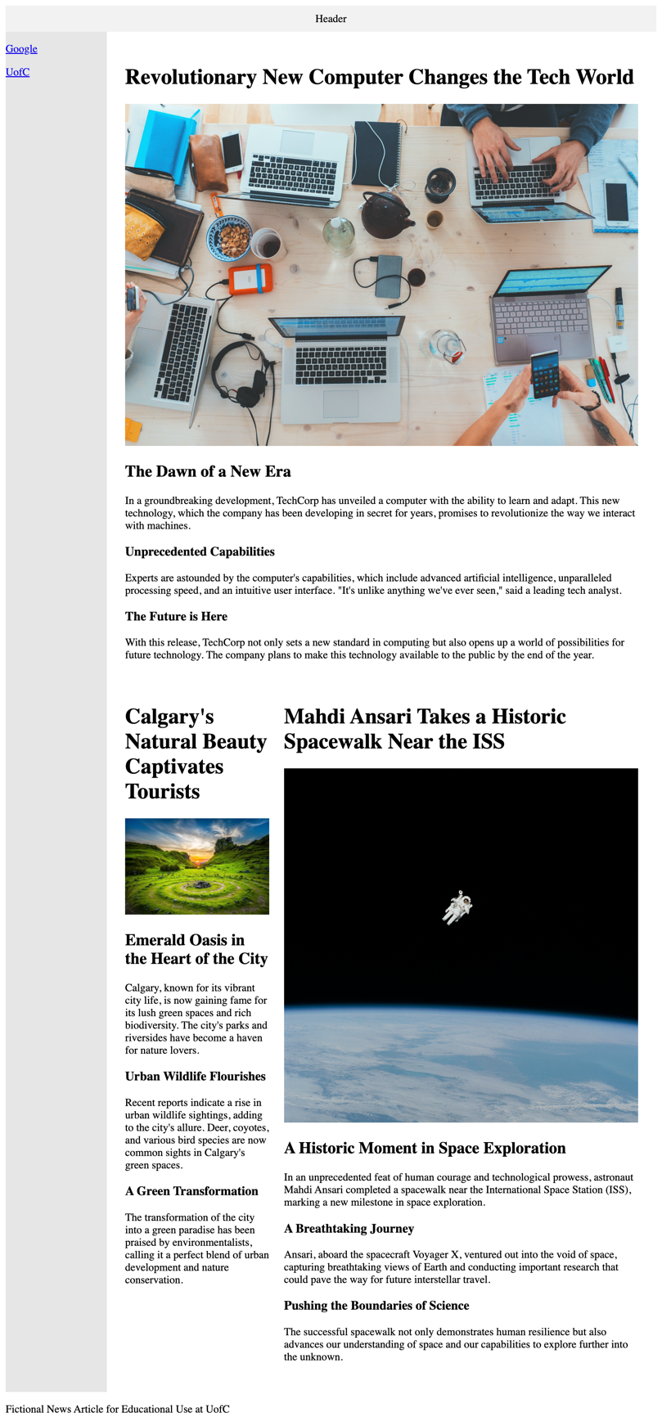

Changes and observations:

* The lines of .large { width: 100%; } .medium { width: 70%; } .small { width: 30%; } were uncommented.
* For achieving the 30-70% split for small and medium parts, a new table was created and it contains the part of code related to class="small news-item" and td class="medium news-item". Adding this table led to achieving the width for small, medium and large images.

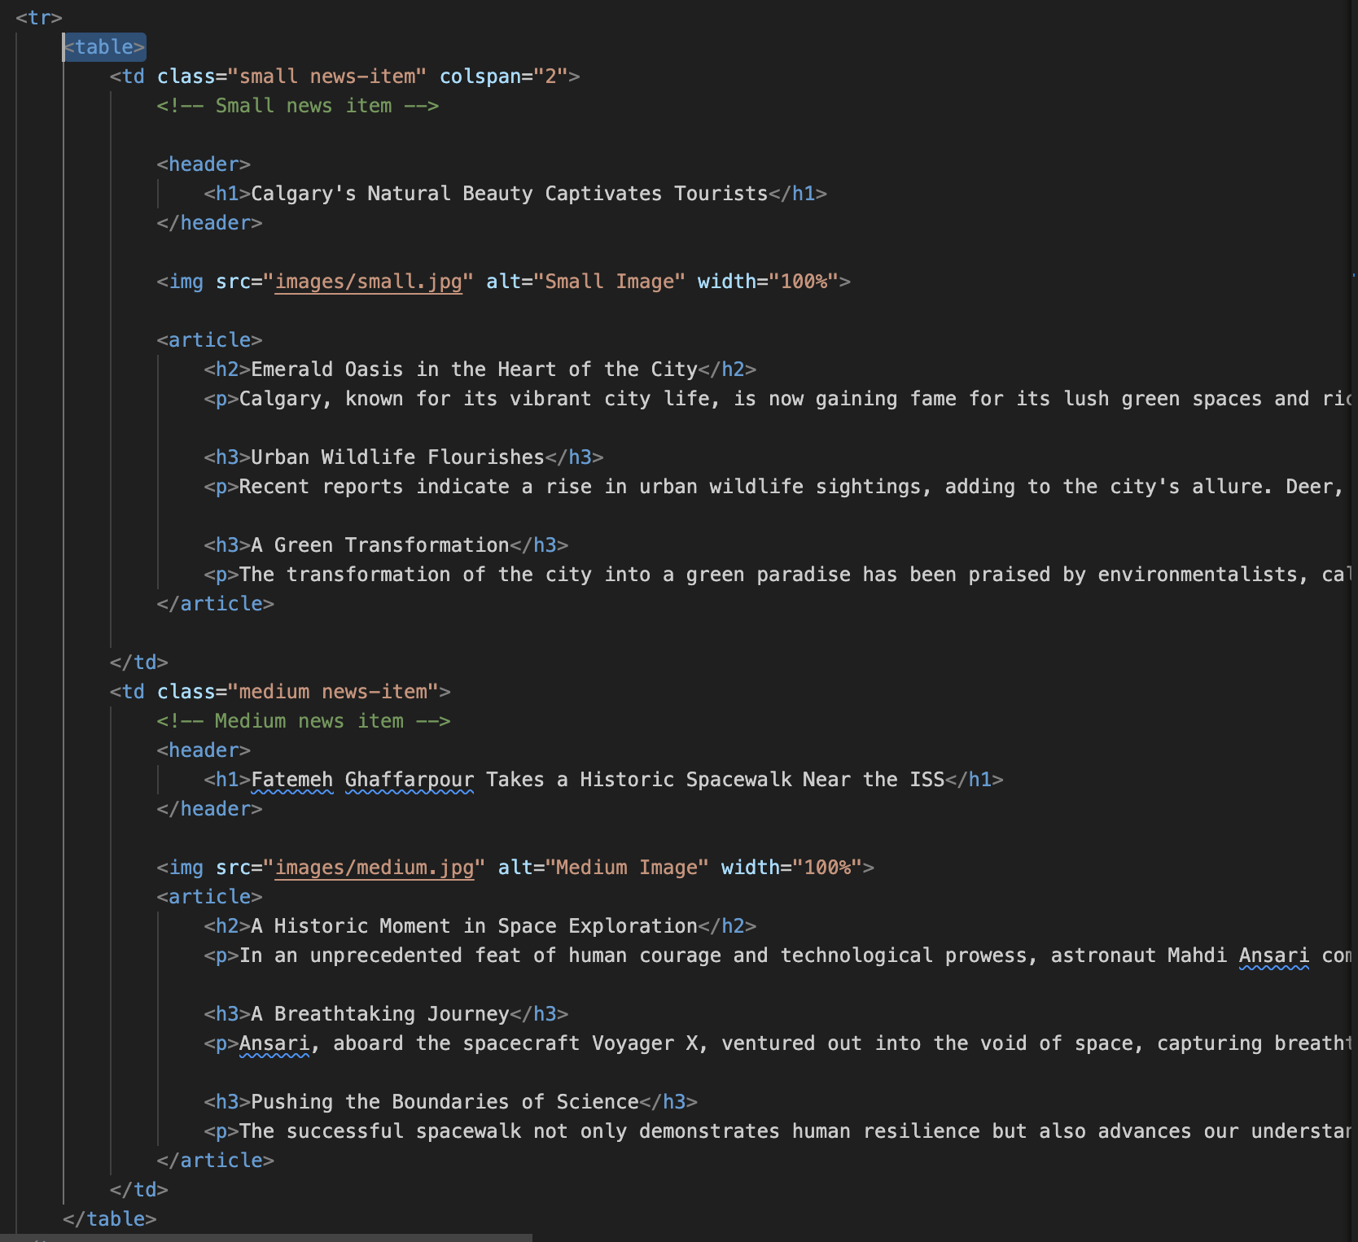

* The name of Mehdi Ansari was changed to Fatemeh Ghaffarpour in the header of the medium item.

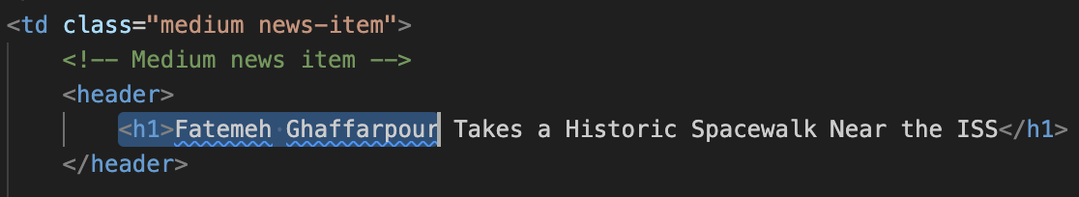

* The changes were committed and pushed to Git.

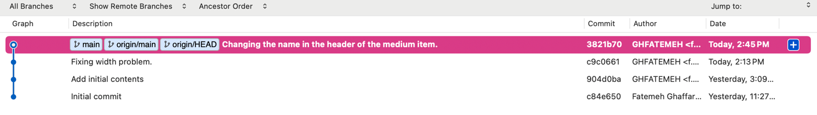

# 4.2.1

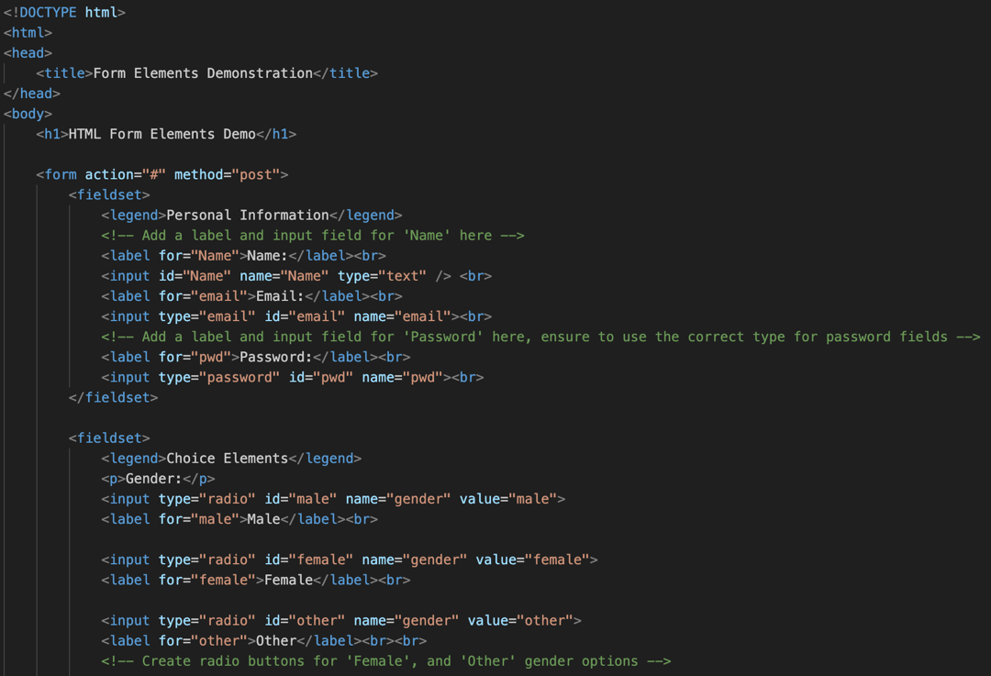

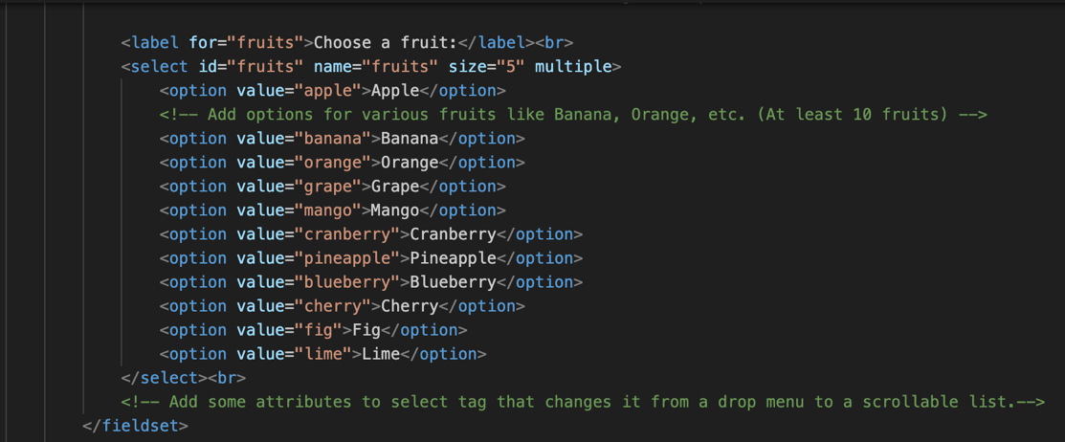

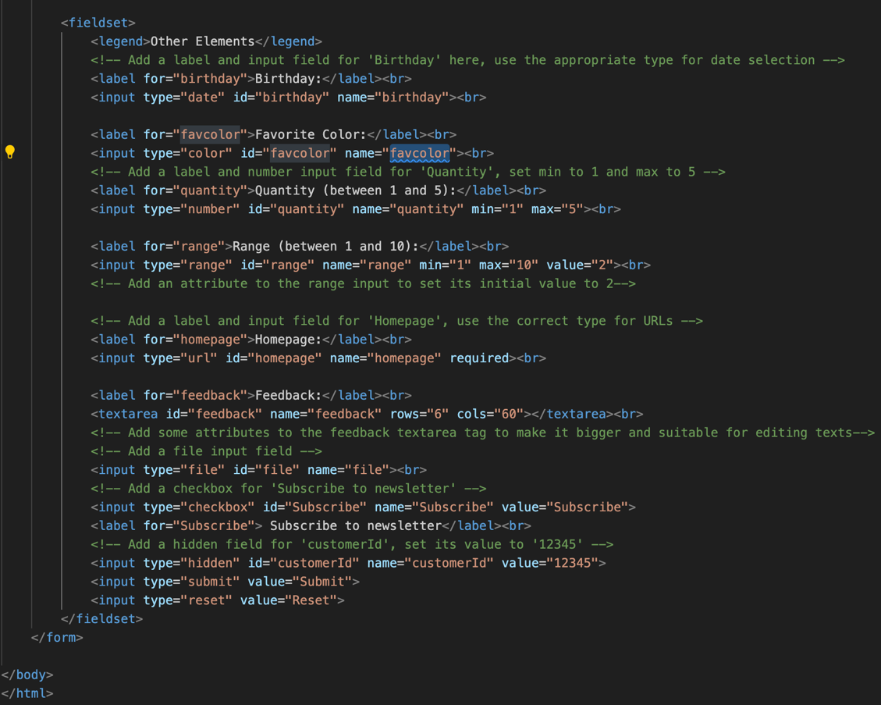

# 5.2.1

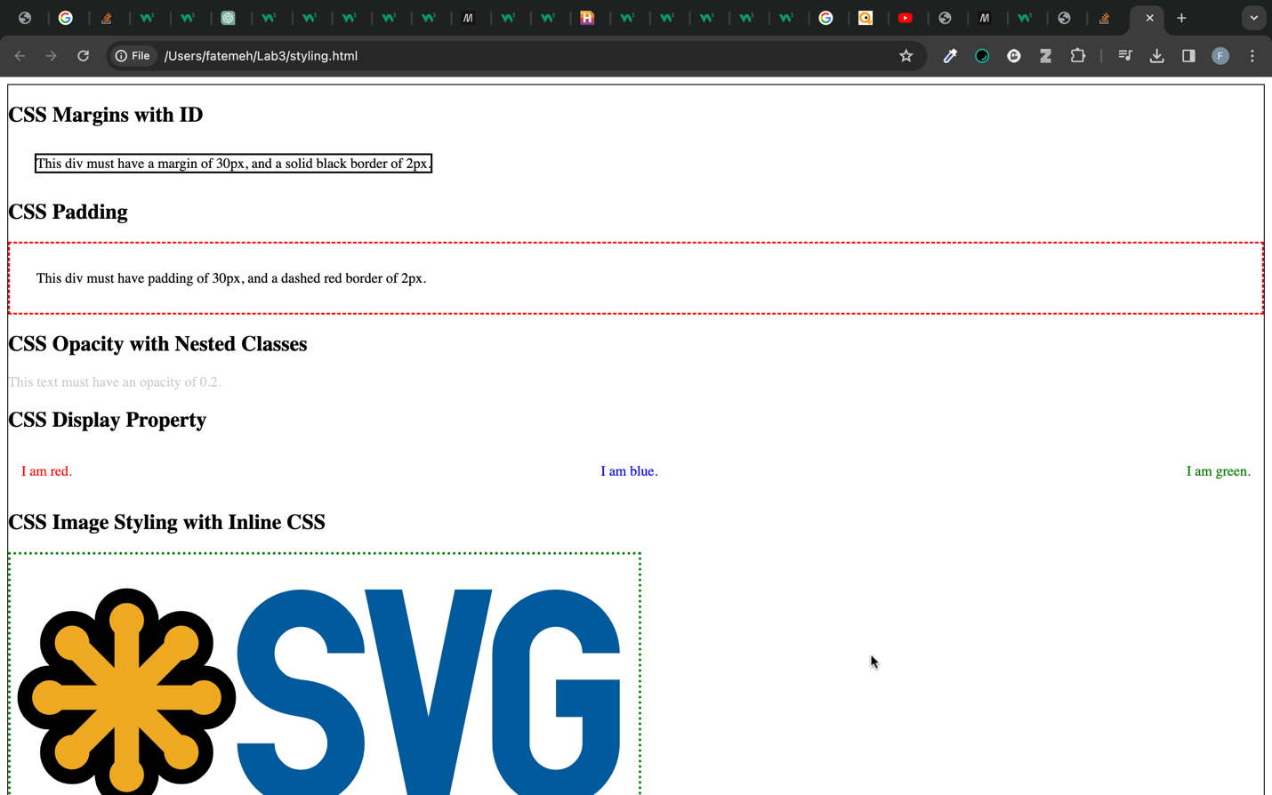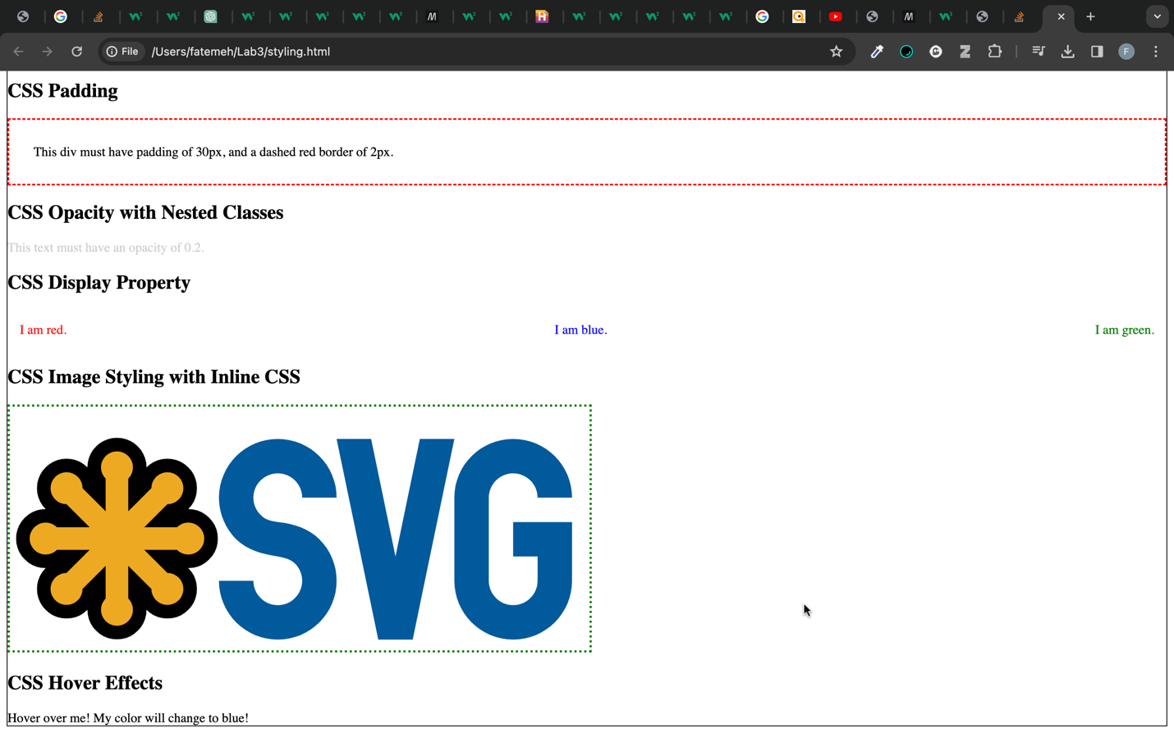

# 5.2.2

Why does this margin exist by default in web browsers?

There is a default margin in web browsers that provides a consistent layout for web content. The margin helps the readability of web browsers by making space between the content and the edges of the browser window.

Ref: <https://www.quora.com/Why-do-web-browsers-style-the-HTML-body-tag-to-have-a-margin-by-default#:~:text=If%20there%20was%20no%20default,just%20look%20like%20normal%20text>.

If there was no margin/padding on the body/html then the text would run up against the window border and toolbar where it would be very hard to read.

Ref: <https://stackoverflow.com/questions/19567547/why-do-browsers-style-a-predefined-margin-into-all-webpages>

How this default margin can be removed or overridden?

We can edit the style of the body.

body {

margin: 0; /* Remove body margins */

}

Or you could use this useful Global reset

*,

*::before,

*::after {

margin: 0;

padding: 0;

box-sizing: border-box;

}

Ref: <https://stackoverflow.com/questions/9547291/how-to-remove-margin-space-around-body-or-clear-default-css-styles>