ENSF381 – Lab04 Answer

**Section:** L01/L02/L03 *[Keep only one] [They must keep only one, if they made mistake write a note in the feedback section. Don’t deduct any mark for wrong value]*

**Date:** 2024-02-05 *[They must write the correct date. For L01 Feb 05, for L02/L03 Feb 07. If they made mistake write a note in the feedback section. Don’t deduct any mark for wrong value]*

|  |  |  |
| --- | --- | --- |
| Created by: | | |
| First name | Last name | UCID |
| A | B | C |
| D | E | F |

*[Check the name. If they made mistake write a note in the feedback section. Don’t deduct any mark for wrong name or wrong UCID]*

# 2.5.1

*[Check the URL. It must be accessible.*

*The repository should have the following features:*

*The repository must be in GitHub.*

*It must contain README.md, LICENSE, 2 HTML files (flex.html, responsive.html) and menu.css.*

*The repository should be accessible; the students' repositories must have public access.*

*If all criteria are there give 5 marks]*

*Sample answer:*

https://github.com/ESDiep/lab4.git

# 2.5.2

*[Sample answer. If an image from Source Control panel of the VSC has been provided give 5 marks]*

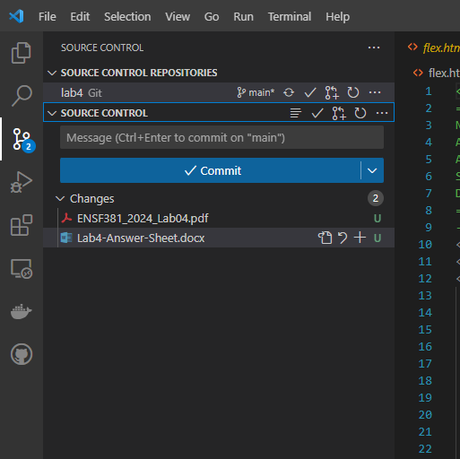

# 3.3.1

*[Check the code, run the responsive.html page from their GitHub, it must provide a responsive 30-70% for screens bigger than 769 px and 40-60% for screens less than 76px and 100% for small screens with maximum 480 px. If the functionality is there, and no float or flex used then give 15 marks. For using float reduce 5 marks. If used flex, then give a zero. Here is a sample answer]*

<style>

        body { margin: 0; padding: 0;}

        img { max-width: 100%; height: auto; }

        .container { width: 100%; box-sizing: border-box;}

        .header, .footer { background-color: #f2f2f2; text-align: center; padding: 10px; }

        .main { padding: 15px; margin-left: 150px;}

        .gap {height: 50px; width: 100%; box-sizing: border-box; clear: both;}

        .footer { position: fixed; bottom: 0; width: 100%;}

        .news-item { padding: 10px;

        .row{

            display: block;

            box-sizing: border-box;

        }

        .large, .medium, .small {

            box-sizing: border-box;

            float: left;

        }

        @media screen and (min-width: 769px) {

            .large { width: 100%;}

            .medium { width: 70%;}

            .small { width: 30%;}

        }

        @media screen and (max-width: 768px) {

            .menu { width: 100%; display: inline-block;}

            .main { margin-left: 0; }

            .large { width: 100%;}

            .medium { width: 60%;}

            .small { width: 40%;}

        }

        @media screen and (max-width: 480px) {

            .news-item header h1 { font-size: 18px; }

            .medium, .small {

                width: 100%;

                float: none;

            }

        }

    </style>

# 4.2.1

*[Similar to previous question but this time with flex. Check the code, run the flex.html page from their GitHub, it must provide a responsive 30-70% for screens bigger than 769 px and 40-60% for screens less than 76px and 100% for small screens with maximum 480 px. If the functionality is there, and no float used then give 15 marks. For using float reduce 5 marks. If they haven’t used flex give a zero. Here is a sample answer.]*

<style>

        * {

            /*

            To have the borders included in the total width calculation of your elements,

            so that a 70% width and a 30% width element truly add up to 100% including their borders,

            Apply border-box to all elements

            */

            box-sizing: border-box;

        }

        body { margin: 0; padding: 0; }

        img { max-width: 100%; height: auto; }

        .container { display: flex; flex-direction: column; min-height: 100vh; }

        .header, .footer { background-color: #f2f2f2; text-align: center; padding: 10px; width: 100%;}

        .body { display: flex; flex-direction: row;}

        .main { flex: 1; display: flex; flex-direction: column; padding: 15px; }

        .menu { background-color: #e6e6e6; }

        .menu ul {

            list-style-type: none;

            margin: 0;

            padding: 0;

            display: flex;

            flex-direction: column;

        }

        .menu ul li {

            padding: 5px 0;

        }

        .menu ul li a {

            padding: 10px;

            text-decoration: none;

            color: #315eff;

        }

        .news-item { padding: 10px; }

        .row { display: flex; flex-wrap: wrap; width: 100%;}

        @media screen and (min-width: 769px) {

            .menu { width: 150px; }

            .large { width: 100%; }

            .medium { width: 70%; }

            .small { width: 30%; }

        }

        @media screen and (max-width: 768px) {

            .body { flex-direction: column;}

            .menu ul { flex-direction: row; }

            .medium { width: 60%; }

            .small { width: 40%; }

        }

        @media screen and (max-width: 480px) {

            .news-item header h1 { font-size: 18px; }

            .medium, .small { width: 100%; }

        }

    </style>

# 5.2.1

[Sample output. Image must contain 2 screenshots. Check the repo to have 2 gif files of the html pages. If it has the same structure give 10 marks. For each missing deduct 1 mark and provide feedback. ]  
  
