ENSF381 – Lab05

**Section:** L01/L02/L03 *[Keep only one] [They must keep only one based on their section, if they made mistake write a note in the feedback section. Don’t deduct any mark for wrong value.]*

**Date:** 2024-02-12 *[They must write the correct date. For L01 Feb 12, for L02/L03 Feb 14. If they made mistake write a note in the feedback section. Don’t deduct any mark for wrong value]*

|  |  |  |
| --- | --- | --- |
| Created by: | | |
| First name | Last name | UCID |
| A | B | C |
| D | E | F |

*[Check the name. If they made mistake write a note in the feedback section. Don’t deduct any mark for wrong name or wrong UCID. They must do the lab in group. If they did it individually, inform the instructor of that section, maybe the student got a permission.]*

# 2.4.1

*[Check the URL. It must be accessible.*

*The repository should have the following features:*

*The repository must be in GitHub.*

*It must contain README.md, LICENSE, 3 HTML files (lab5_exe_B.html, lab5_exe_C.html, lab5_exe_D.html) and matrix.js. Optionally can have index.html also.*

*The repository should be accessible; the students' repositories must have public access.*

*The must be commits by both team members.*

*If all criteria are there give 2 marks]*

Sample solution:

Address of the repository - https://github.com/xxx/Lab5

# 2.4.2

[They had to take a picture from WEBIDE of their GitHub. Notice the address bar in their picture, if the repo address was <https://github.com/xxx/Lab5> then the address in picture must be <https://github.dev/xxx/Lab5>. If all are correct, then give 3 marks]

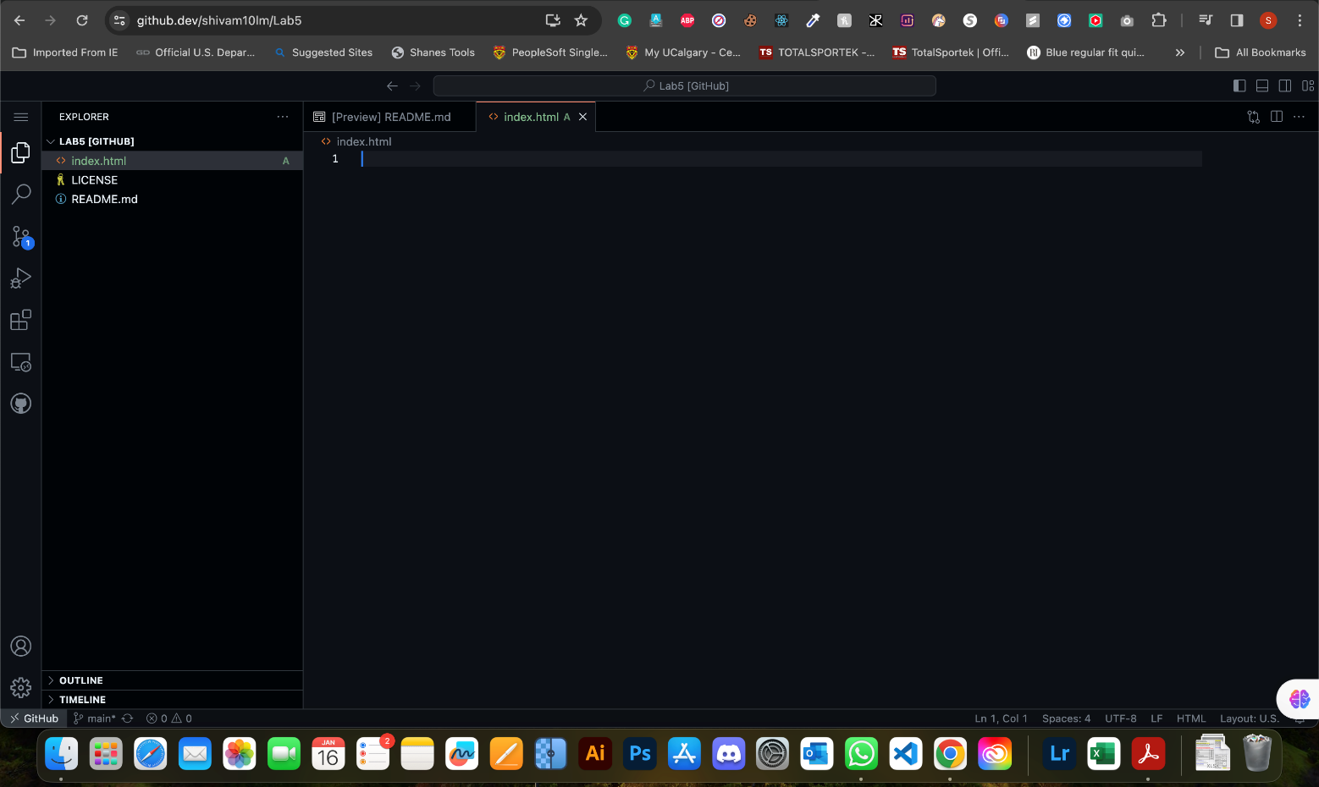

# 3.5.1

[Check the repository. They had to push a *lab5_exe_B.html* file. The content of the file must be something like the provided solution. They didn’t need to copy their code in their answer sheet file. But they needed to provide a screenshot like the following. Look at the console section of the picture. The output must be like these lines:  
  
John Doe

1999

8

JOHN DOE

Hello, my name is John Doe and I am 25 years old. I was born in 1999.

I am eligible to vote: true

If the file in the repository is correct and the picture has the above lines, then give 15 marks in total. If they only provided the picture with now file in the repository, then give a zero. Otherwise, for each missing line deduct 2 marks. For the picture 12 marks and for the file in the repository we assigned 3 marks.]

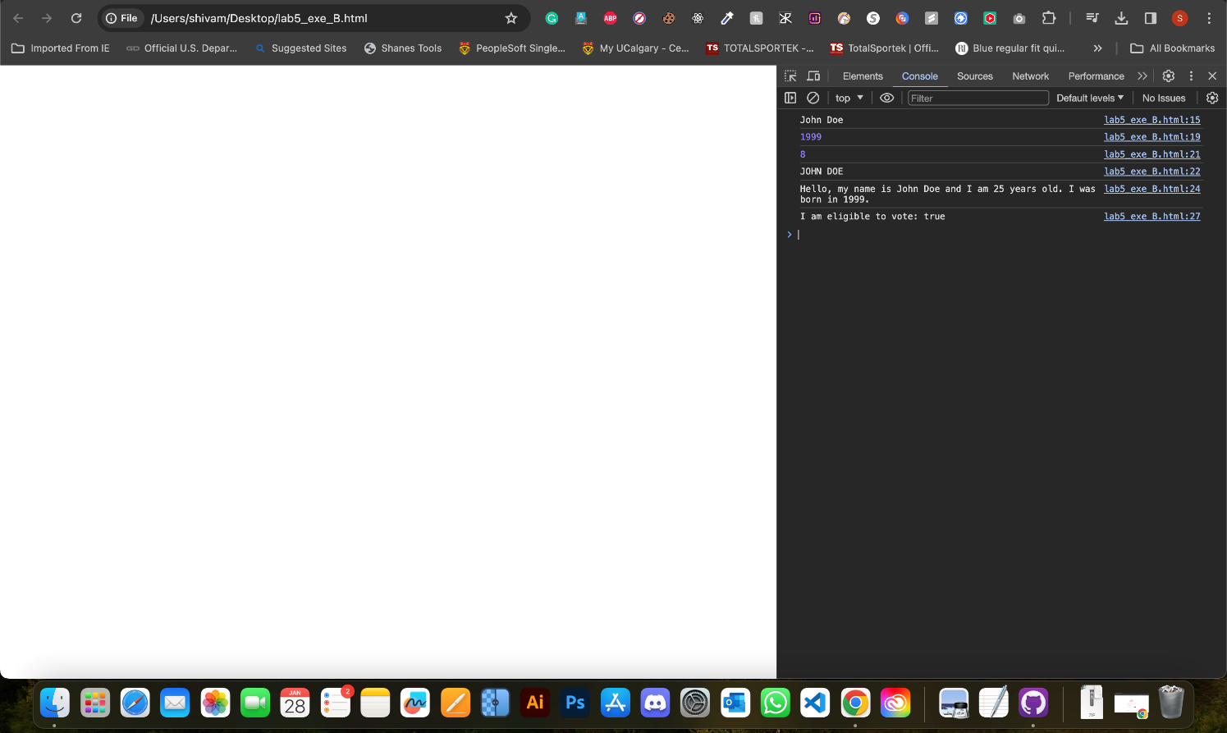

# 4.4.2

[Again, compare the sample answer with their code and if both are similar and they provided a screenshot like the following give 15 marks. For any missing points deduct 1.5 mark. For example, if they forgot to provide their name in header or changing the background color of the menu. They had to do 10 tasks. Here is the list of the tasks:

* + - * 1. Task 1: Set the text content of all elements with the class 'companyName' and remove their border
        2. Task 2: Change the background color of the navigation bar
        3. Task 3: Hide the section titled 'What is full-stack?'
        4. Task 4: Create a new <p> element and append it to the 'About Us' section
        5. Task 5: Add placeholders to input elements based on their corresponding label IDs
        6. Task 6: Set the src attribute of the image
        7. Task 7: Add a new item in the navigation menu
        8. Task 8: Change the submit button text upon clicking and make it disabled
        9. Task 9: Change the text color of each item in the 'Related Links' to green
        10. Task 10: Add a red solid border to the footer]



# 5.3.2

[If they provided a picture of one of their executions give 3 marks]

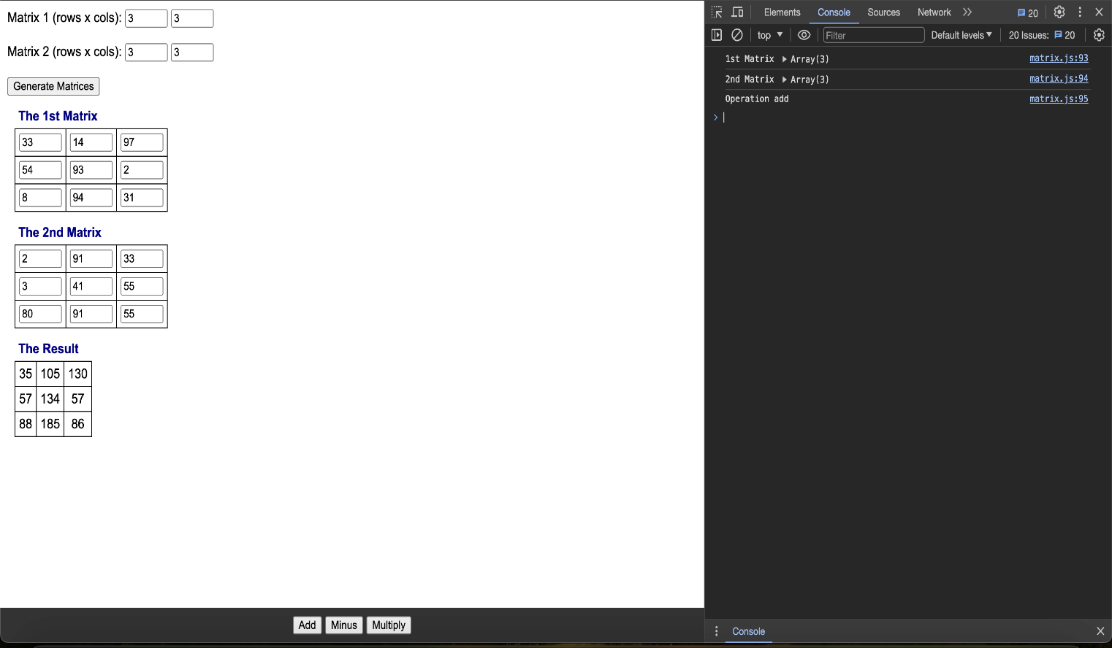

# 5.3.3

[If they provided their code for showResult2D, addMatrices, subtractMatrices, and multiplyMatrices methods give 12 marks in total. Each 3 marks.]

const showResult2D = (title, containerId, dataArray) => {

// dataArray is a 2D array

// complete this function based on the showResult function

let container = document.getElementById(containerId);

container.innerHTML = ''; // Clear previous content

let table = document.createElement('table');

for (let i = 0; i < dataArray.length; i++) {

let tr = document.createElement('tr');

for (let j = 0; j < dataArray[i].length; j++) {

let td = document.createElement('td');

let span = document.createElement('span');

span.textContent = dataArray[i][j]; // Set the text content from the 2D array

td.appendChild(span);

tr.appendChild(td);

}

table.appendChild(tr);

}

let caption = table.createCaption();

caption.textContent = title;

container.appendChild(table);

}

function addMatrices(matrix1, matrix2){

// provide the code

if (matrix1.length !== matrix2.length || matrix1[0].length !== matrix2[0].length) {

console.error("Matrices have incompatible dimensions for addition.");

return;

}

let result = [];

for (let i = 0; i < matrix1.length; i++) {

let row = [];

for (let j = 0; j < matrix1[i].length; j++) {

row.push(matrix1[i][j] + matrix2[i][j]);

}

result.push(row);

}

return result;

}

const subtractMatrices = function (matrix1, matrix2) {

// provide the code

if (matrix1.length !== matrix2.length || matrix1[0].length !== matrix2[0].length) {

console.error("Matrices have incompatible dimensions for subtraction.");

return;

}

let result = [];

for (let i = 0; i < matrix1.length; i++) {

let row = [];

for (let j = 0; j < matrix1[i].length; j++) {

row.push(matrix1[i][j] - matrix2[i][j]);

}

result.push(row);

}

return result;

};

const multiplyMatrices = (matrix1, matrix2) => {

// provide the code

if (matrix1[0].length !== matrix2.length) {

console.error("Matrices have incompatible dimensions for multiplication.");

return;

}

let result = [];

for (let i = 0; i < matrix1.length; i++) {

let row = [];

for (let j = 0; j < matrix2[0].length; j++) {

let sum = 0;

for (let k = 0; k < matrix2.length; k++) {

sum += matrix1[i][k] * matrix2[k][j];

}

row.push(sum);

}

result.push(row);

}

return result;

};