ENSF381 – Lab06

**Section:** L01/L02/L03 *[Keep only one] [They must keep only one based on their section, if they made mistake write a note in the feedback section. Don’t deduct any mark for wrong value.]*

**Date:** 2024-02-26 *[They must write the correct date. For L01 Feb 26, for L02/L03 Feb 28. If they made mistake write a note in the feedback section. Don’t deduct any mark for wrong value]*

|  |  |  |
| --- | --- | --- |
| Created by: Sampreet Vaidya | | |
| First name | Last name | UCID |
| A | B | C |
| D | E | F |

*[Check the name. If they made mistake write a note in the feedback section. Don’t deduct any mark for wrong name or wrong UCID. They must do the lab in group. If they did it individually, inform the instructor of that section, maybe the student got a permission.]*

# 2.5.1

*[Check the URL. It must be accessible.*

*The repository should have the following features:*

*The repository must be in GitLab.*

*It must contain README.md, LICENSE, one HTML files (lab6_exe_D.html).*

*The repository should be accessible publicly.*

*There must be commits by both team members.*

*If all criteria are there give 2 marks, deduct 0.5 for each missing point and provide comments in feedback box]*

Sample solution:

https://gitlab.com/xxx/lab6

# 2.5.2

*[A screenshot from the History tab of their Git client application. It must at least show two commits to their GitLab repository in this step. Following figure is snapshot of GitLab webapp, so if they show commits history in any means accept it. Give 2 mark if it has been provided.]*

# 2.5.3

*[Give 1 mark for any reason that they mention. Don’t be rigid for this one.]*

I selected X git client because it is:

1. Popular
2. Easy UI (for Mac as well)
3. MIT license
4. Always up to date (as some have stopped development)
5. Free
6. ….

# 3.6.1

*[Check the link, when you open it, you must see a list of students that the first 2 students must be the team members as we said, “Edit the names of the first two students for the group members.” If any name is missing deduct 1 mark and provide feedback. Give 10 marks if they provided all conditions.]*

Link: <https://65a4b80a52f07a8b4a3d99dd.mockapi.io/students>

# 3.6.2

*[Give 2.5 marks if the picture of the student service has been provided if the picture is not legible do not deduct any marks.]*

# 3.6.3

*[Give 2.5 marks if the picture of the courses service for the second student has been provided, and the first course is ENSF381. Deduct 1 mark for each missing point.]*

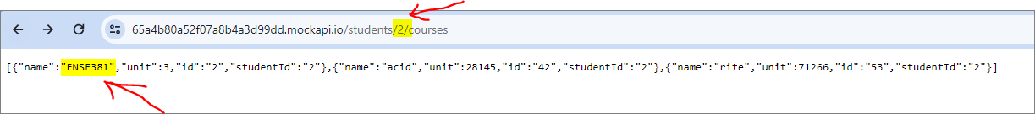

# 4.7.1 *[If they executed the GET student API in Postman give 3 marks]*

# 4.7.2 *[If they executed the GET students/1 API in Postman give 3 marks]*

# 4.7.3 *[If they executed the POST students API in Postman give 3 marks]*

# 4.7.4*[If they executed the PUT students API in Postman give 3 marks]*

# 4.7.5

*[If they executed the DELETE students/1 API in Postman give 3 marks]*

# 5.4.2

*[Check the repository, if they provided correct code in lab6 exe D.html file and if they provided some picture like the following, then give them 15 marks. If code is not provided and just the picture has been provided, then deduct 10 marks and just give them 5 marks.]*

