ENSF381 – Lab07

**Section:** L01/L02/L03 *[They must keep only one, if they made mistake write a note in the feedback section. Don’t deduct any mark for wrong value]*

**Date:** 2024-03-04 *[They must write the correct date. For L01 March 04, for L02/L03March 06. If they made mistake write a note in the feedback section. Don’t deduct any mark for wrong value]*

|  |  |  |
| --- | --- | --- |
| Created by: | | |
| First name | Last name | UCID |
| X | Y | Z |
| A | B | C |

*[Check the name. If they made mistake write a note in the feedback section. Don’t deduct any mark for wrong name or wrong UCID]*

# 2.4.1

*[Check the URL. It must be accessible.*

*The repository should have the following features:*

*The repository must be in Bitbucket website, and not any other website like GitHub.*

*The repository should be accessible; the students' repositories must have public access.*

*It should contain a structure like this figure.*

*The repository should include a collaborator with the appropriate access permissions.*

*If it provides all give 4 marks, otherwise deduct 0.5 mark for each missing and write down in the feedback form.  
]*

Sample URL

https://bitbucket.org/ensf381-mjbza/lab07/

# 2.4.2

*[They must provide a figure like the following. It must contain 2 collaborators. Give 1 mark if they provide an answer like the following.]*

Sample answer:

3.1.2.6

*[Please don’t be rigid, accept any answer if they refer to the following points somehow. If they provided some acceptable answer give 5 marks.]*

**Dependencies Versioning:** The dependencies of a project are managed by package.json and package-lock.json files. These files keep track of the exact versions of each package you are using. When someone else clones your repository, they can run npm install to install the exact versions of the dependencies listed in these files, ensuring consistency across environments.

**Platform Specificity:** Some dependencies in node_modules may be compiled for a specific platform (like Windows, macOS, or Linux). If you push these files and someone on a different platform tries to run the code, it may fail due to platform incompatibilities.

**.gitignore:** To prevent node_modules from being pushed to a remote repository, it's included in a .gitignore file. The .gitignore file tells Git which files or directories to ignore in a project. By including node_modules in .gitignore, it ensures that these files are not tracked by Git and not pushed to the remote repository.

# 3.2.4.3

*[The board must contain digits 0 to 8. And console must contain Clicked 0 to Clicked 8. If picture has these criteria give 5 marks]*

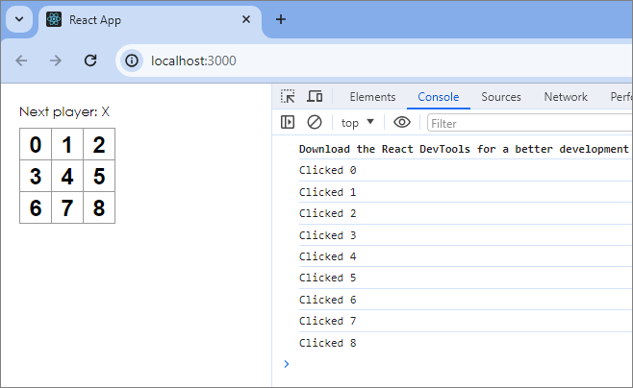

# 3.2.4.7

*[The board must contain Xs. If picture has these criteria give 5 marks]*

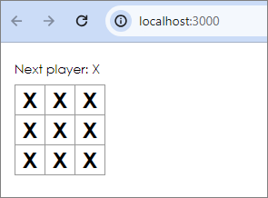

# 3.7.3

[The gif must show a correct behavior of tic-tac-toe game. Then check the index.js file with the file we provided for you. Use a text diff comparator and if all are correct give 25 marks. If they provided only a gif file and the code is not complete and has more than 20% differences with the provided file, give zero and mention the provided code is not complete, therefore it is not clear how this gif file has been made.]

https://bitbucket.com/xyz.gif

# 3.7.4

*[Sample output, take care the position of Xs and Os. If the picture has these criteria give 5 marks]*

