[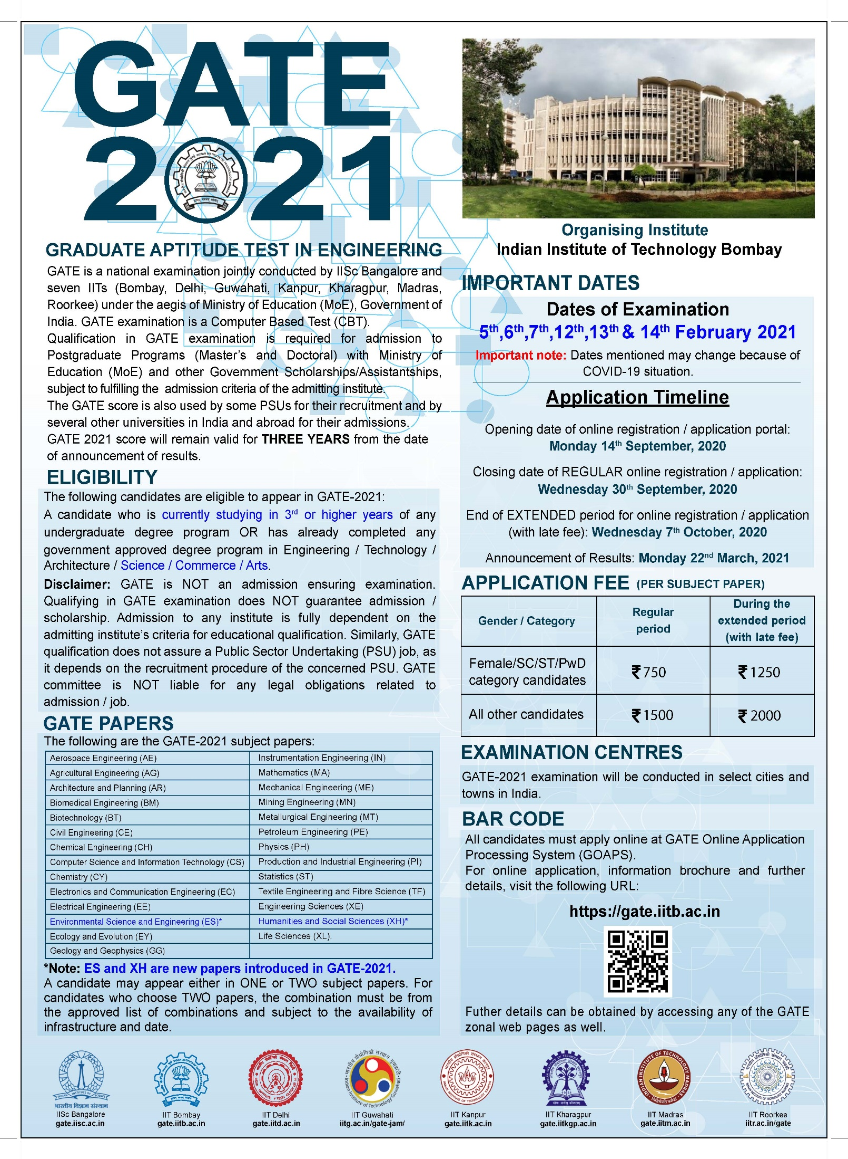](https://www.gate.iitb.ac.in/index.php)

**GATE 2021**

* [GATE2021Website](https://www.gate.iitb.ac.in/index.php)
* [GATE2021 Information Brochure](https://drive.google.com/file/d/17uIFEXEgCX0DM2s0_z0ZdK5CucCdddn8/view)
* [GATE2021 DATES](https://www.gate.iitb.ac.in/impdate.php)

FAQ (BE CS Students) :

* Eligibility : NO age limit, NO attempt limit.
* 2 PAPERS : Any ONE or TWO.
  + Primary – CS (Compulsory : fees [female: 750/- , others: 1500/-])
  + Secondary – MA (Optional : fees [female: 750/- , others: 1500/-])
* Types or Questions
  + MCQ (1m or 2m : Negative Marking (deduction of 1/3rd of weighted marks)
  + MSQ (1m or 2m : NO Negative Marking)
  + NAT (1m or 2m : NO Negative Marking)
* [GA : General Aptitude (10Q’s [5Q’s 1m each & 5Q’s 2m each]=15m Compulsory Section) Click to check Syllabus of this sections.](https://drive.google.com/file/d/1DncG_JgZvPn0immT6Du-eoQdSmqokVU5/view)
* Subject ( CS / MA )
  + [CS Syllabus](https://drive.google.com/file/d/15m1czm6LIqRhskbqLPNvcfqY0ot_8ZdT/view)
  + [MA Syllabus](https://drive.google.com/file/d/1i6B27ipRNGPbEAsKZ35Y7V3r1V2vwAVQ/view)
* Paper1 CS :
  + GA Section (10Q’s Total 15M)
    - 5Q’s MCQ (1m each)
    - 5Q’s MCQ (2m each)
  + CS Section (55Q’s Total 85M)
    - 25Q’s : some MCQ some MSQ (1m each)
    - 30Q’s : some MCQ some MSQ some NAT(1m or 2m each)
* Paper2 MA:
  + GA Section (10Q’s Total 15M)
    - 5Q’s MCQ (1m each)
    - 5Q’s MCQ (2m each)
  + CS Section (55Q’s Total 85M)
    - 25Q’s : some MCQ some MSQ (1m each)
    - 15Q’s : some MCQ some MSQ (2m each)
    - 15Q’s NAT(2m each)
* 3
* [List Of Examinations in Cities](https://www.gate.iitb.ac.in/exam_cities.php)
* Previous Year Papers
  + [GATE 2020 CS](https://drive.google.com/file/d/1aY4vbSqrBjJzYBahBq6dKBU3G5jWYiLX/view) && [Answer Key](https://drive.google.com/file/d/1EFhHXxyYCOC0XeAXKmtCQJZ2I6n9XREk/view) ;; [GATE 2020 MA](https://drive.google.com/file/d/1SxcXEkrOrnB2XmgrFPgWeQ07mngfbbcN/view) && [Answer Key](https://drive.google.com/file/d/11rTJdvHq_CJBgkY1zvDPsA_RJY-l8ZcD/view)
  + [GATE 2019 CS](https://drive.google.com/file/d/150P7u2AvVuafV7JI_eGB5YDOcpgwPl1s/view) && [Answer Key](https://drive.google.com/file/d/1VtB4NwlBAdX7QQnjYLGrXz39l1yxYnfv/view) ;; [GATE 2019 MA](https://drive.google.com/file/d/1OD_JRJfeefJGW_OxVWIDn5utyiYjA9Bl/view) && [Answer Key](https://drive.google.com/file/d/1Tt12l_6h3CZ25LI1wrBD0NohzP71CrjF/view)
  + [GATE 2018 CS](https://drive.google.com/file/d/1CboGjdOkvPzijQk8IXzsE6LdJst-xv9M/view) && [Answer Key](https://drive.google.com/file/d/1IqzR1oBuWFssrnPt7O61dxmKUQeT06gK/view) ;; [GATE 2018 MA](https://drive.google.com/file/d/1S2YVkgiUUgV5l4adTmF-WJHX_T2HmMx9/view) && [Answer Key](https://drive.google.com/file/d/1Fubeu1YHPAvR6FySzqhEBI4zGEdX9FKK/view)
* 2
* CONTACT (Mon-Fri : 10AM-6PM): Chairperson, GATE Indian Institute of Technology Bombay, Powai, Mumbai 400 076 ; 022-25767068 ,022-25767022 ; gate2021 @ iitb.ac.in <https://www.linkedin.com/in/gate-jam-3104201a9/>

**GATE 2021 CS : Computer Science and Information Technology**

**PRIMARY PAPER : COMPULSORY**

**Marks : 100M total (15m:GA , 85m : CS)**

[**syllabus**](https://drive.google.com/file/d/15m1czm6LIqRhskbqLPNvcfqY0ot_8ZdT/view)