EXPIREMENT-5
Name : M.K.RAGHAVAN Roll No:240701408

Task Analysis-Subscription Management System Task Analysis
Task Analysis is the process of breaking down how users interact with a Subscription Management System into smaller and manageable steps. It helps understand how users subscribe to services, manage their subscriptions, make payments, and cancel or renew plans.
This analysis helps identify user needs, improve system performance, and ensure a smooth subscription experience.

Key Aspects of Task Analysis
- Understanding the tasks performed by users such as subscribing, renewing, or cancelling plans.
- Identifying the sequence of actions required to complete a subscription.
- Analyzing issues such as payment failures, expired subscriptions, or incorrect billing.
- Improving the user experience by simplifying subscription management.
- Ensuring secure payment processing and proper subscription tracking.

User Flow
User Flow shows how users navigate through the Subscription Management System to successfully subscribe to a service.

User Flow for Subscription Management System
Start → Open Application → Create Account / Login → Browse
Subscription Plans → Select Plan → View Plan Details → Choose
Payment Method → Confirm Payment → Activate Subscription →
Manage Subscription → Renew / Cancel Subscription → End

User Flow – Step by Step Step 1: Start
- The user opens the application or website that offers subscription services.
Step 2: Open Application
- The system displays the homepage with available services.

Step 3: Create Account / Login
- The user creates a new account or logs in using existing credentials.
- The system verifies user details.

Step 4: Browse Subscription Plans
- The user views different subscription plans such as:
o Basic Plan o
Standard Plan o
Premium Plan
Step 5: Select Plan
- The user selects a suitable subscription plan.

Step 6: View Plan Details
• The system displays details of the selected plan such as:
o Price o Duration o
Features included

Step 7: Choose Payment Method
• The user selects a payment option such as:
o UPI o Credit Card o Debit
Card o Online
Wallet

Step 8: Confirm Payment
- The system processes the payment transaction.
Decision Step:
- If payment fails → Retry payment.
- If payment succeeds → Activate subscription.

Step 9: Activate Subscription
- The system activates the user's subscription plan.
- The subscription validity period is displayed.

Step 10: Manage Subscription
- The user can manage the subscription such as:
o View subscription details o Upgrade or downgrade plan o Check billing history Step 11: Renew / Cancel Subscription Decision Step:
- If the user renews → The subscription continues.
- If the user cancels → The subscription is terminated.

Step 12: End
• The subscription process is completed.
Flow chart:
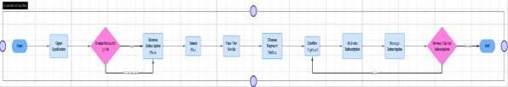
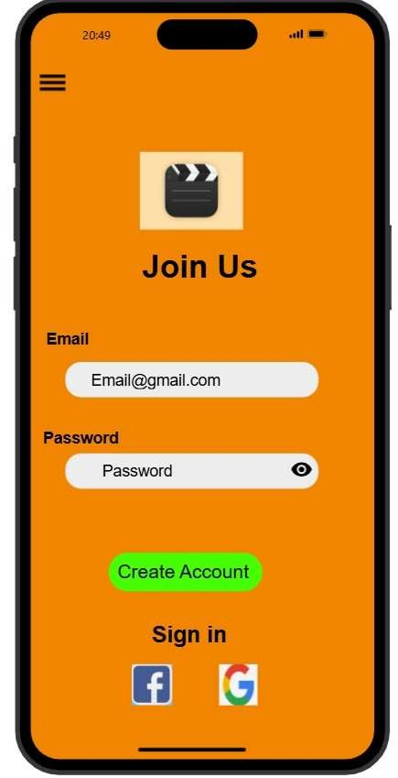
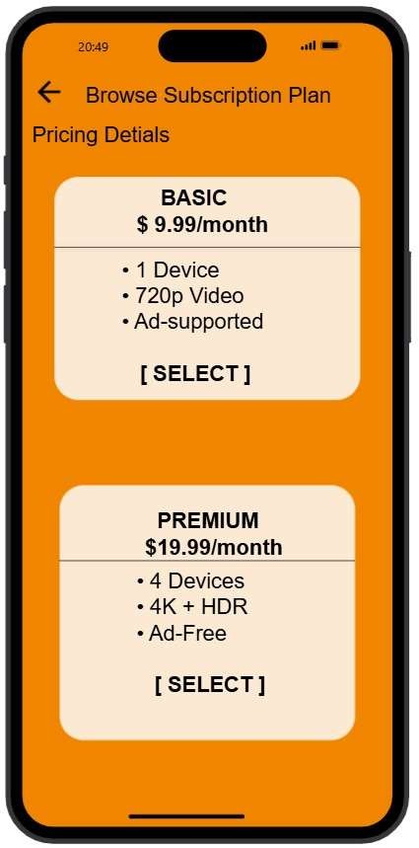
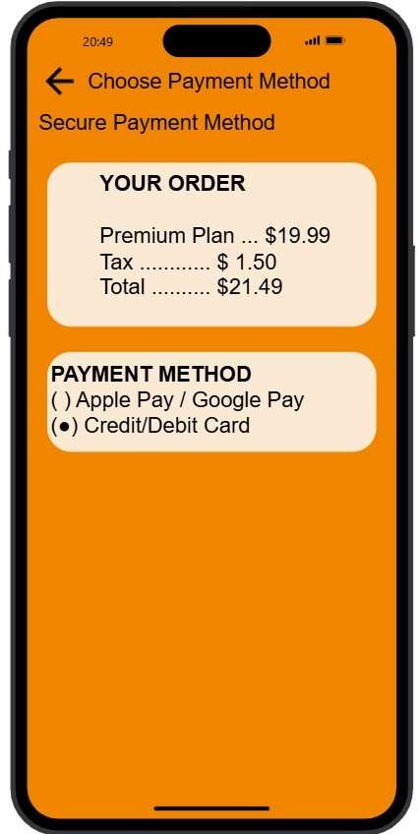
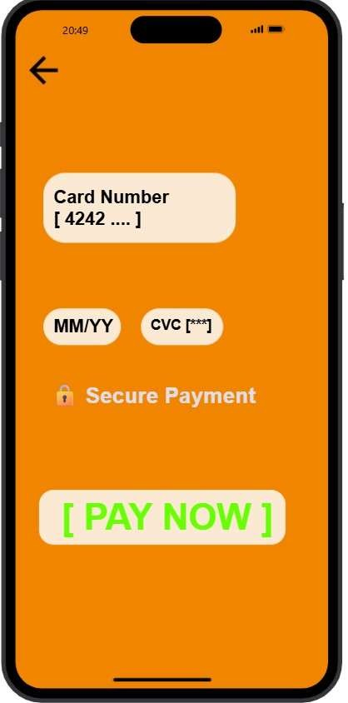
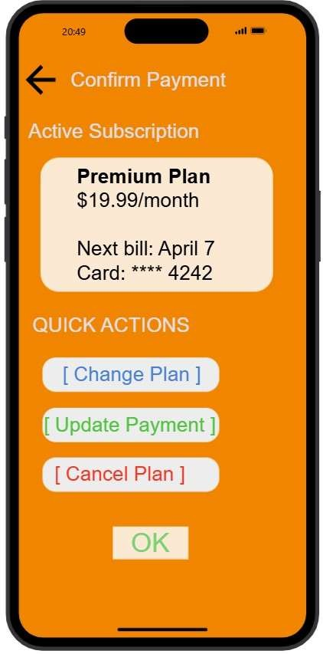
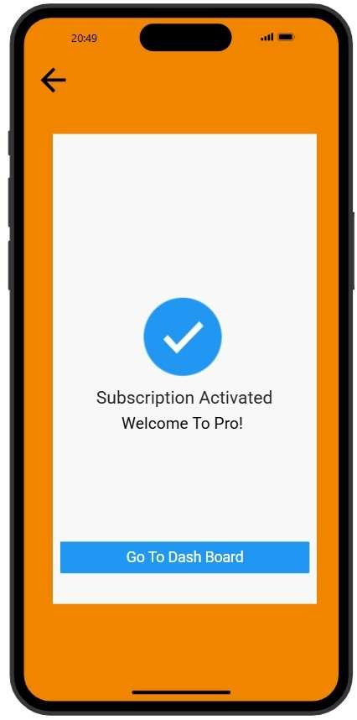
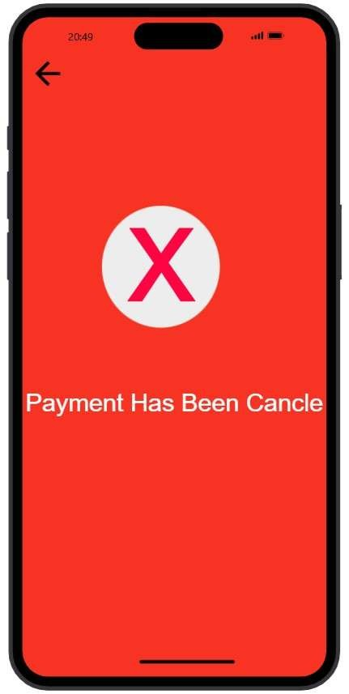
Proto type Link: https://pr.to/MY14Y9/

