EXPERIMENT-7
NAME: M.K.Raghavan ROLL NO: 240701408
AIM:
To design and compare different bus booking mobile app layouts using GIMP and evaluate user feedback on aesthetics and usability.
PROCEDURE:
- Installed GIMP software from the official website.
- Created a mobile canvas with size 1080 × 1920 pixels.
- Designed UI layout including header, search section, and bus listing cards.
- Added UI elements such as text fields, buttons, icons, and navigation bar.
- Organized each component into separate layers for easy editing.
- Created two different layout designs with different color schemes (Light and Dark theme).
- Exported the layouts as PNG images.
LAYOUT DESIGNS:
Layout 1: Light Theme Design

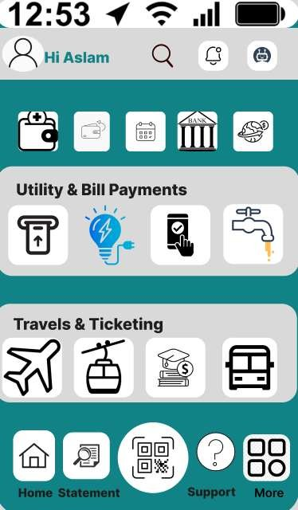

Layout 2: Dark Theme Design
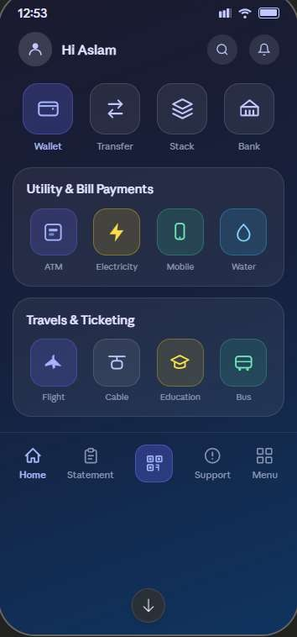
USER FEEDBACK:
- Layout 1: Clean and simple interface, easy readability, but less modern appearance.
- Layout 2: Attractive dark theme with modern UI, better visual appeal but slightly less readability.
https://docs.google.com/forms/d/e/1FAIpQLSfldJSYEcc2rwBTSTsR3dzcR0hyT6O0DzcWv i I5KL4e7T6GtQ/viewform?usp=publish-editor
FINAL RECOMMENDATION:
Preferred Layout: Layout 2 (Dark Theme) due to its modern appearance, better visual hierarchy, and engaging user interface.
CONCLUSION:
The experiment demonstrates that visual design and color schemes significantly affect user experience. Iterating designs based on feedback helps in selecting the most effective UI layout.

