EXPERIMENT-1
Roll No : 240701408 Name : M.K.RAGHAVAN

USER INTERFACE AND DESIGN

COMAPARSION OF UI DESIGN BETWEEN TWO FIGMA CREATION

BAD WEBSITE


GOOD WEBSITE

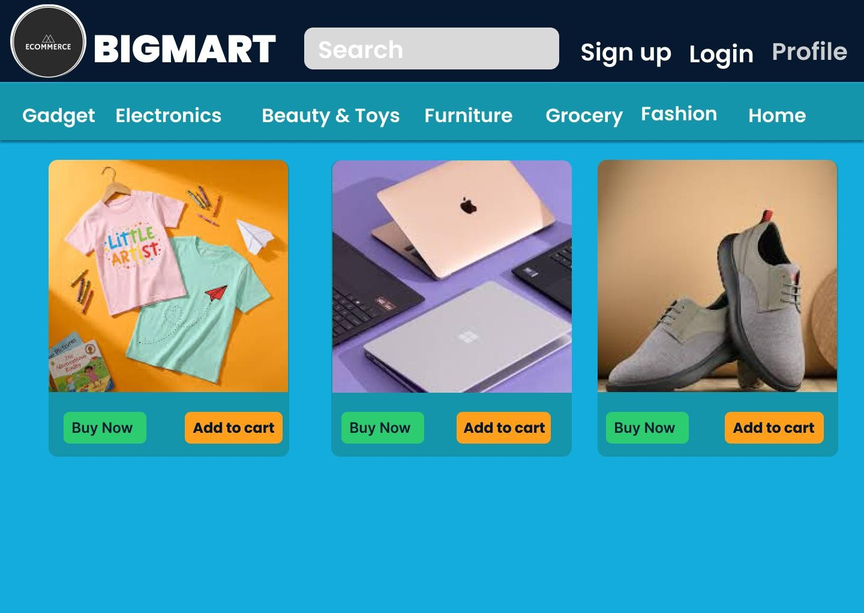

PROTOTYPE LINK:
Bad Website
https://www.figma.com/proto/k2k9znsKWw1O6GvE5hB1AE/Ex.No.01-UID?nodeid=1-2&p=f&t=hW4glx9h6GwAkL3j-0&scaling=min-zoom&contentscaling=fixed&page-id=0%3A1

Good Website :
https://www.figma.com/design/k2k9znsKWw1O6GvE5hB1AE/Ex.No.01UID?node-id=26-86&p=f&t=hW4glx9h6GwAkL3j-0

Bad Website Analysis – BIGMART Website :
- Design Style:
  - The website uses many bright colors that do not match properly, which makes the design look unattractive.
  - Poor alignment and uneven spacing make the layout look unbalanced and incomplete.
- Content:
  - Product cards show only images and “Add to Cart” buttons without important details like product name and price.
  - There is no proper product description, size information, or clear categorization of items.
- Usability & User Experience:
  - “Add to Cart” buttons are shown without enough product information, making users confused to click.
- Purpose:
  - Although the website looks like an e-commerce shopping site, it does not meet basic e-commerce requirements.
  - Poor design, missing content, and weak navigation reduce user trust.

GOOD WEBSITE ANALYSIS – BIGMART Website :

- Design Style:
  - The website has a clean and neat layout.
  - Colors and spacing are used properly.
  - Product images are of the same size.

- Content:
  - Products are shown clearly with action buttons.
  - Categories are easy to understand.

- Navigation:
  - Menu bar helps users move easily.
  - Search bar is clearly visible.

- Purpose:
• The website is made for online shopping.

Key Differences
- Focus:
The bad website only focuses on showing products, while the good website focuses on design, presentation, and user experience.
- Design:
The bad website has a simple and unattractive design, whereas the good website has a clean, modern, and well-organized layout.
- Content:
The bad website shows very little product information, while the good website provides clear and useful details.
- Navigation:
The bad website has poor navigation, while the good website allows users to move easily between pages.
- User Trust:
The bad website does not build user trust, whereas the good website looks professional and reliable.

